1.Argentina flag



Graph: 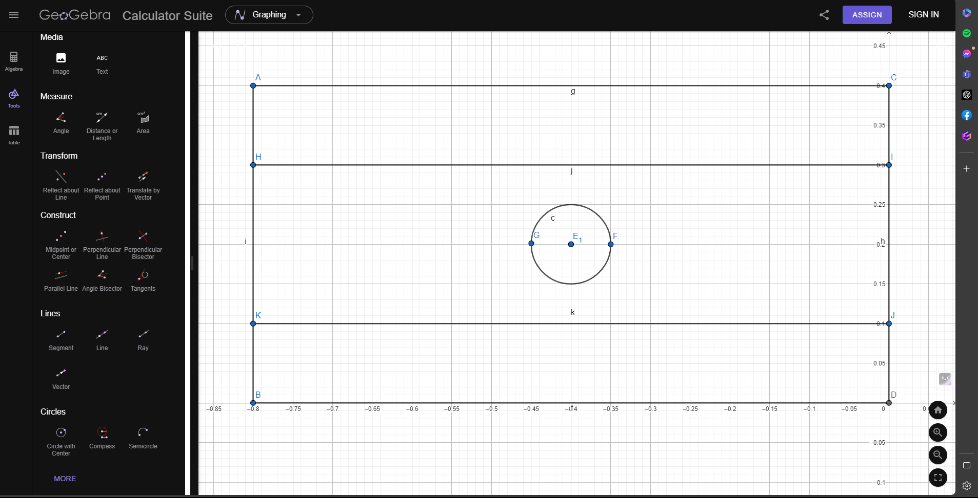
Code: #include <windows.h>
#include<math.h>
#include <GL/glut.h>

void initGL() {

glClearColor(0.0f, 0.0f, 0.0f, 0.0f);

}

void display() {
glClearColor(0.0f, 0.0f, 0.0f, 0.0f);
glClear(GL_COLOR_BUFFER_BIT);
glLineWidth(7.5);

glBegin(GL_POLYGON);

glColor4f(0.0f, 1.0f, 1.0f, 1.0f);
glVertex2f(-0.8f, 0.4f);
glVertex2f(-0.8f, 0.3f);

glVertex2f(-0.8f, 0.3f);
glVertex2f(0.0f, 0.3f);

glVertex2f(0.0f, 0.3f);
glVertex2f(0.0f, 0.4f);

glVertex2f(0.0f, 0.4f);
glVertex2f(-0.8f, 0.4f);

glEnd();
glBegin(GL_POLYGON);
glColor4f(0.0f, 1.0f, 1.0f, 1.0f);
glVertex2f(-0.8f, 0.0f);
glVertex2f(0.0f, 0.0f);

glVertex2f(0.0f, 0.0f);
glVertex2f(0.0f, 0.1f);

glVertex2f(0.0f, 0.1f);
glVertex2f(-0.8f, 0.1f);

glVertex2f(-0.8f, 0.1f);
glVertex2f(-0.8f, 0.0f);
glEnd();

glBegin(GL_POLYGON);
glColor3f(1.0f, 1.0f, 1.0f);
glVertex2f(-0.8f, 0.3f);
glVertex2f(-0.8f, 0.1f);

glVertex2f(-0.8f, 0.1f);
glVertex2f(0.0f, 0.1f);

glVertex2f(0.0f, 0.1f);
glVertex2f(0.0f, 0.3f);

glVertex2f(0.0f, 0.3f);
glVertex2f(-0.8f, 0.3f);
glEnd();
glBegin(GL_POLYGON);

float xOffset = -0.4f;
float yOffset = 0.2f;

for (int i = 0; i < 300; i++)
{
glColor4f(1.0f, 1.0f, 0.0f, 0.0f);;

float pi = 3.1416;
float a = (i * 2 * pi) / 300;
float r = 0.05;
float x = r * cos(a) + xOffset;
float y = r * sin(a) + yOffset;
glVertex2f(x, y);
}

glEnd();
glFlush();

glEnd();

}

int main(int argc, char** argv) {

glutInit(&argc, argv);

glutCreateWindow("Vertex, Primitive & Color");

glutInitWindowSize(320, 320);

glutDisplayFunc(display);

initGL();

glutMainLoop();

return 0;

}
Output:
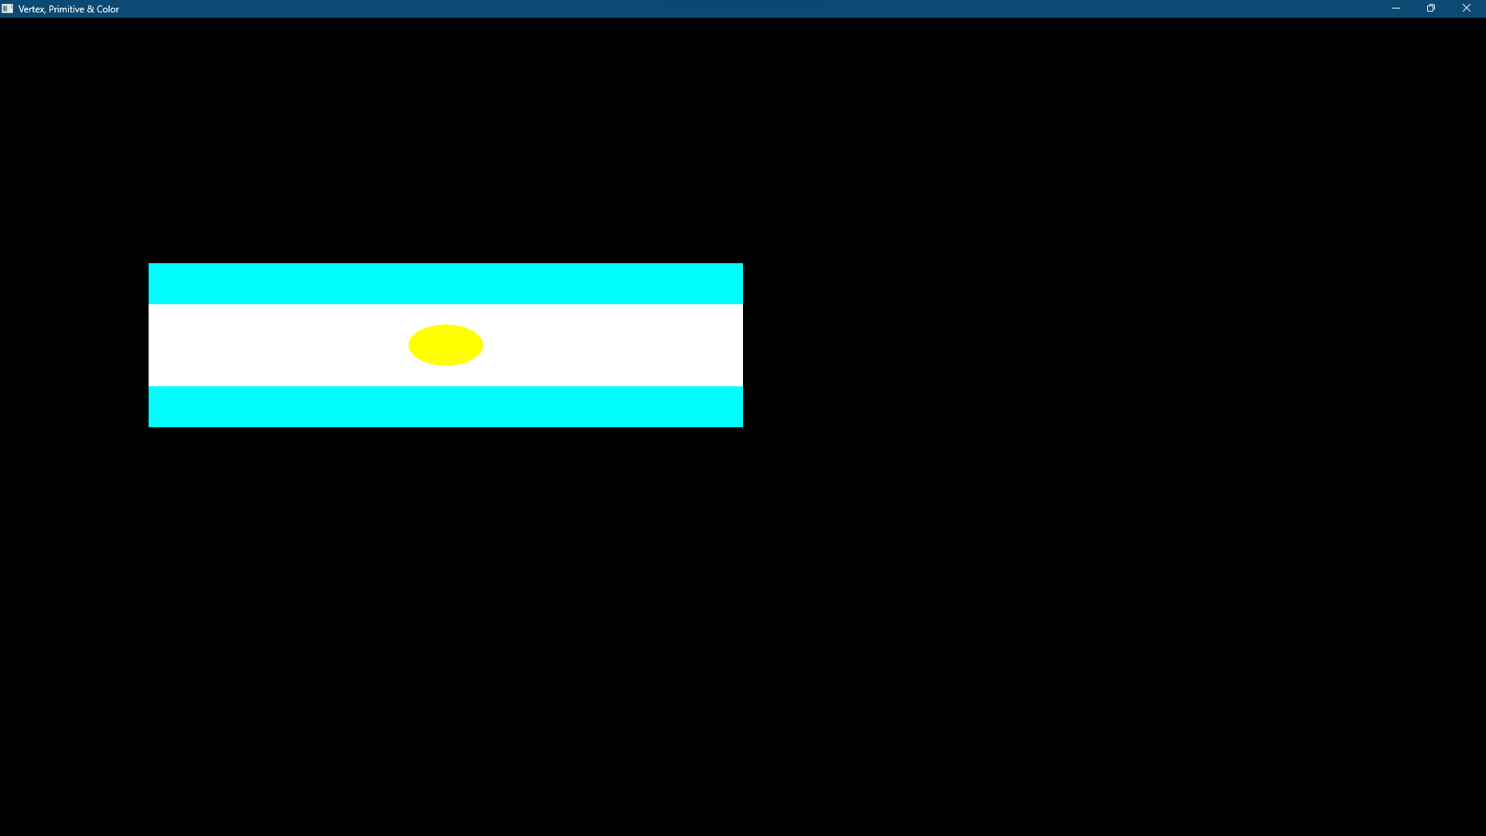

2.Brazil

Graph:
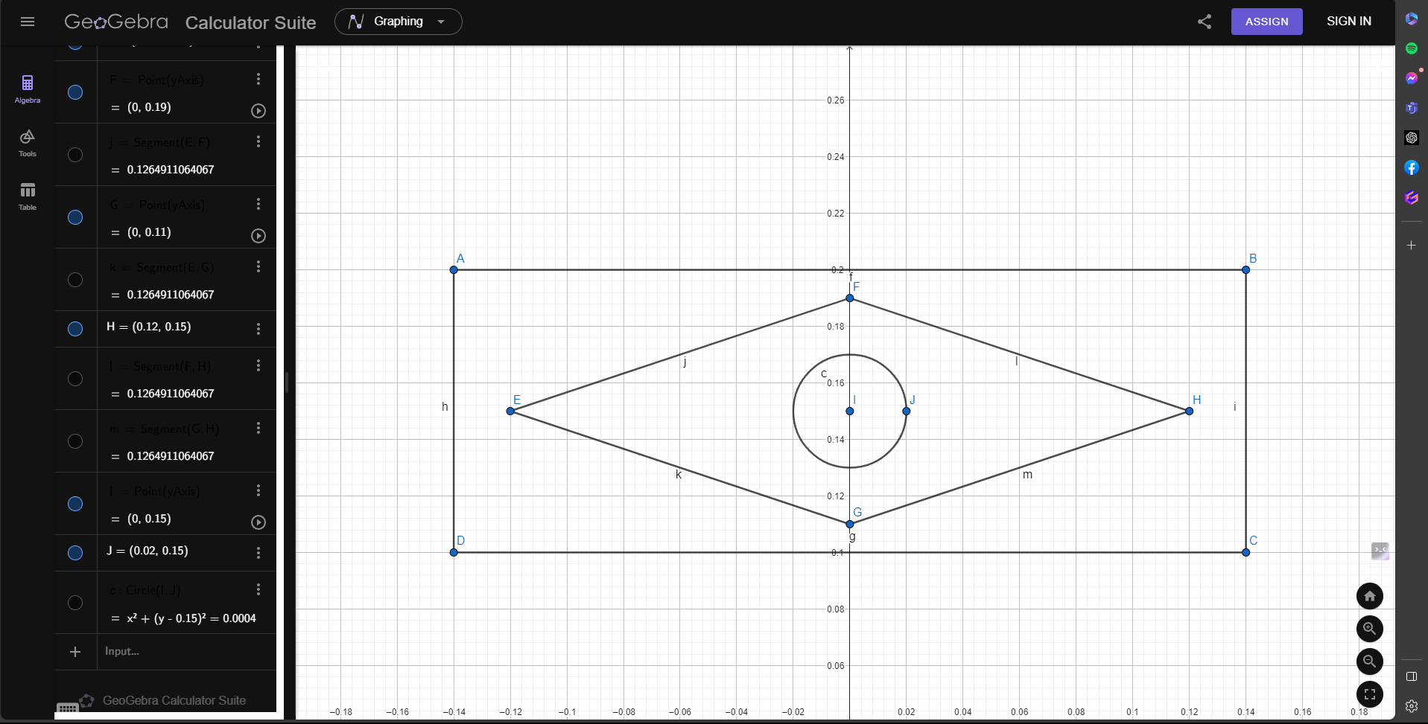
Code:
#include <windows.h>
#include<math.h>
#include <GL/glut.h>

void initGL() {

glClearColor(0.0f, 0.0f, 0.0f, 0.0f);

}

void display() {
glClearColor(0.0f, 0.0f, 0.0f, 0.0f);
glClear(GL_COLOR_BUFFER_BIT);
glLineWidth(7.5);

glBegin(GL_POLYGON);

glColor3f(0.0f, 1.0f, 0.0f);
glVertex2f(-0.14f, 0.2f);
glVertex2f(-0.14f, 0.1f);

glVertex2f(-0.14f, 0.1f);
glVertex2f(0.14f, 0.1f);

glVertex2f(0.14f, 0.1f);
glVertex2f(0.14f, 0.2f);

glVertex2f(0.14f, 0.2f);
glVertex2f(-0.14f, 0.2f);

glEnd();
glBegin(GL_POLYGON);
glColor4f(1.0f, 1.0f, 0.0f, 0.0f);
glVertex2f(-0.12f, 0.15f);
glVertex2f(0.0f, 0.19f);

glVertex2f(0.0f, 0.19f);
glVertex2f(0.12f, 0.15f);

glVertex2f(0.12f, 0.15f);
glVertex2f(0.0f, 0.11f);

glVertex2f(0.0f, 0.11f);
glVertex2f(-0.12f, 0.15f);
glEnd();

glBegin(GL_POLYGON);

float xOffset = 0.0f;
float yOffset = 0.15f;

for (int i = 0; i < 300; i++)
{
glColor3f(0.5f, 0.5f, 0.5f);

float pi = 3.1416;
float a = (i * 2 * pi) / 300;
float r = 0.02;
float x = r * cos(a) + xOffset;
float y = r * sin(a) + yOffset;
glVertex2f(x, y);
}

glEnd();
glFlush();

glEnd();

}

int main(int argc, char** argv) {

glutInit(&argc, argv);

glutCreateWindow("Vertex, Primitive & Color");

glutInitWindowSize(320, 320);

glutDisplayFunc(display);

initGL();

glutMainLoop();

return 0;

}
Output:
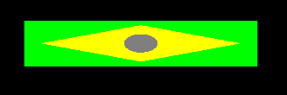
3.Bangladesh

Graph:
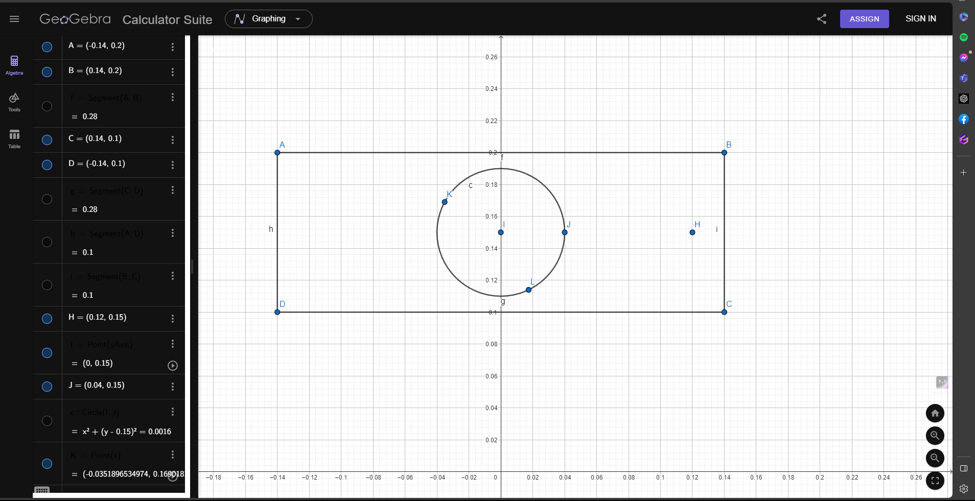
Code: #include <windows.h>
#include<math.h>
#include <GL/glut.h>

void initGL() {

glClearColor(0.0f, 0.0f, 0.0f, 0.0f);

}

void display() {
glClearColor(0.0f, 0.0f, 0.0f, 0.0f);
glClear(GL_COLOR_BUFFER_BIT);
glLineWidth(7.5);

glBegin(GL_POLYGON);

glColor3f(0.0f, 1.0f, 0.0f);
glVertex2f(-0.14f, 0.2f);
glVertex2f(-0.14f, 0.1f);

glVertex2f(-0.14f, 0.1f);
glVertex2f(0.14f, 0.1f);

glVertex2f(0.14f, 0.1f);
glVertex2f(0.14f, 0.2f);

glVertex2f(0.14f, 0.2f);
glVertex2f(-0.14f, 0.2f);

glEnd();

glBegin(GL_POLYGON);

float xOffset = 0.0f;
float yOffset = 0.15f;

for (int i = 0; i < 300; i++)
{
glColor4f(1.0f, 0.0f, 0.0f, 0.0f);

float pi = 3.1416;
float a = (i * 2 * pi) / 300;
float r = 0.04;
float x = r * cos(a) + xOffset;
float y = r * sin(a) + yOffset;
glVertex2f(x, y);
}

glEnd();
glFlush();

glEnd();

}

int main(int argc, char** argv) {

glutInit(&argc, argv);

glutCreateWindow("Vertex, Primitive & Color");

glutInitWindowSize(320, 320);

glutDisplayFunc(display);

initGL();

glutMainLoop();

return 0;

}

Output:
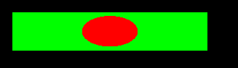
4.Japan

Graph:
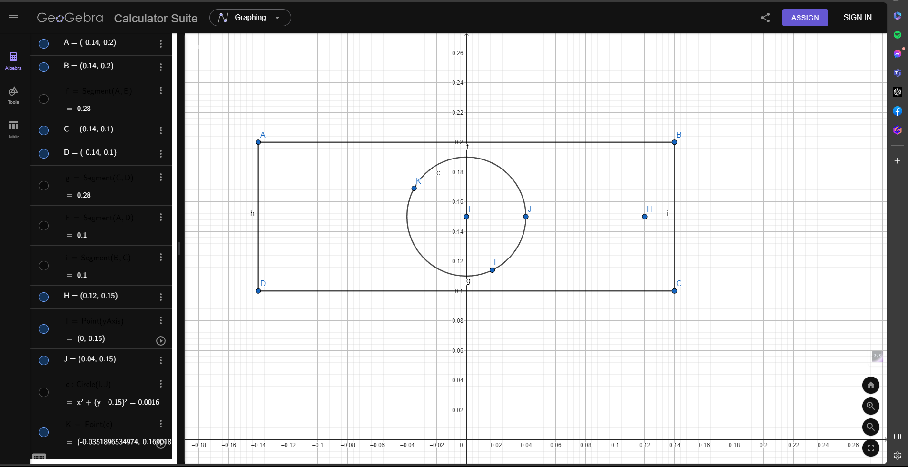
Code:
#include <windows.h>
#include<math.h>
#include <GL/glut.h>

void initGL() {

glClearColor(0.0f, 0.0f, 0.0f, 0.0f);

}

void display() {
glClearColor(0.0f, 0.0f, 0.0f, 0.0f);
glClear(GL_COLOR_BUFFER_BIT);
glLineWidth(7.5);

glBegin(GL_POLYGON);

glColor3f(1.0f, 1.0f, 1.0f);
glVertex2f(-0.14f, 0.2f);
glVertex2f(-0.14f, 0.1f);

glVertex2f(-0.14f, 0.1f);
glVertex2f(0.14f, 0.1f);

glVertex2f(0.14f, 0.1f);
glVertex2f(0.14f, 0.2f);

glVertex2f(0.14f, 0.2f);
glVertex2f(-0.14f, 0.2f);

glEnd();

glBegin(GL_POLYGON);

float xOffset = 0.0f;
float yOffset = 0.15f;

for (int i = 0; i < 300; i++)
{
glColor4f(1.0f, 0.0f, 0.0f, 0.0f);

float pi = 3.1416;
float a = (i * 2 * pi) / 300;
float r = 0.04;
float x = r * cos(a) + xOffset;
float y = r * sin(a) + yOffset;
glVertex2f(x, y);
}

glEnd();
glFlush();

glEnd();

}

int main(int argc, char** argv) {

glutInit(&argc, argv);

glutCreateWindow("Vertex, Primitive & Color");

glutInitWindowSize(320, 320);

glutDisplayFunc(display);

initGL();

glutMainLoop();

return 0;

}
Output:

5. Russian


Graph:
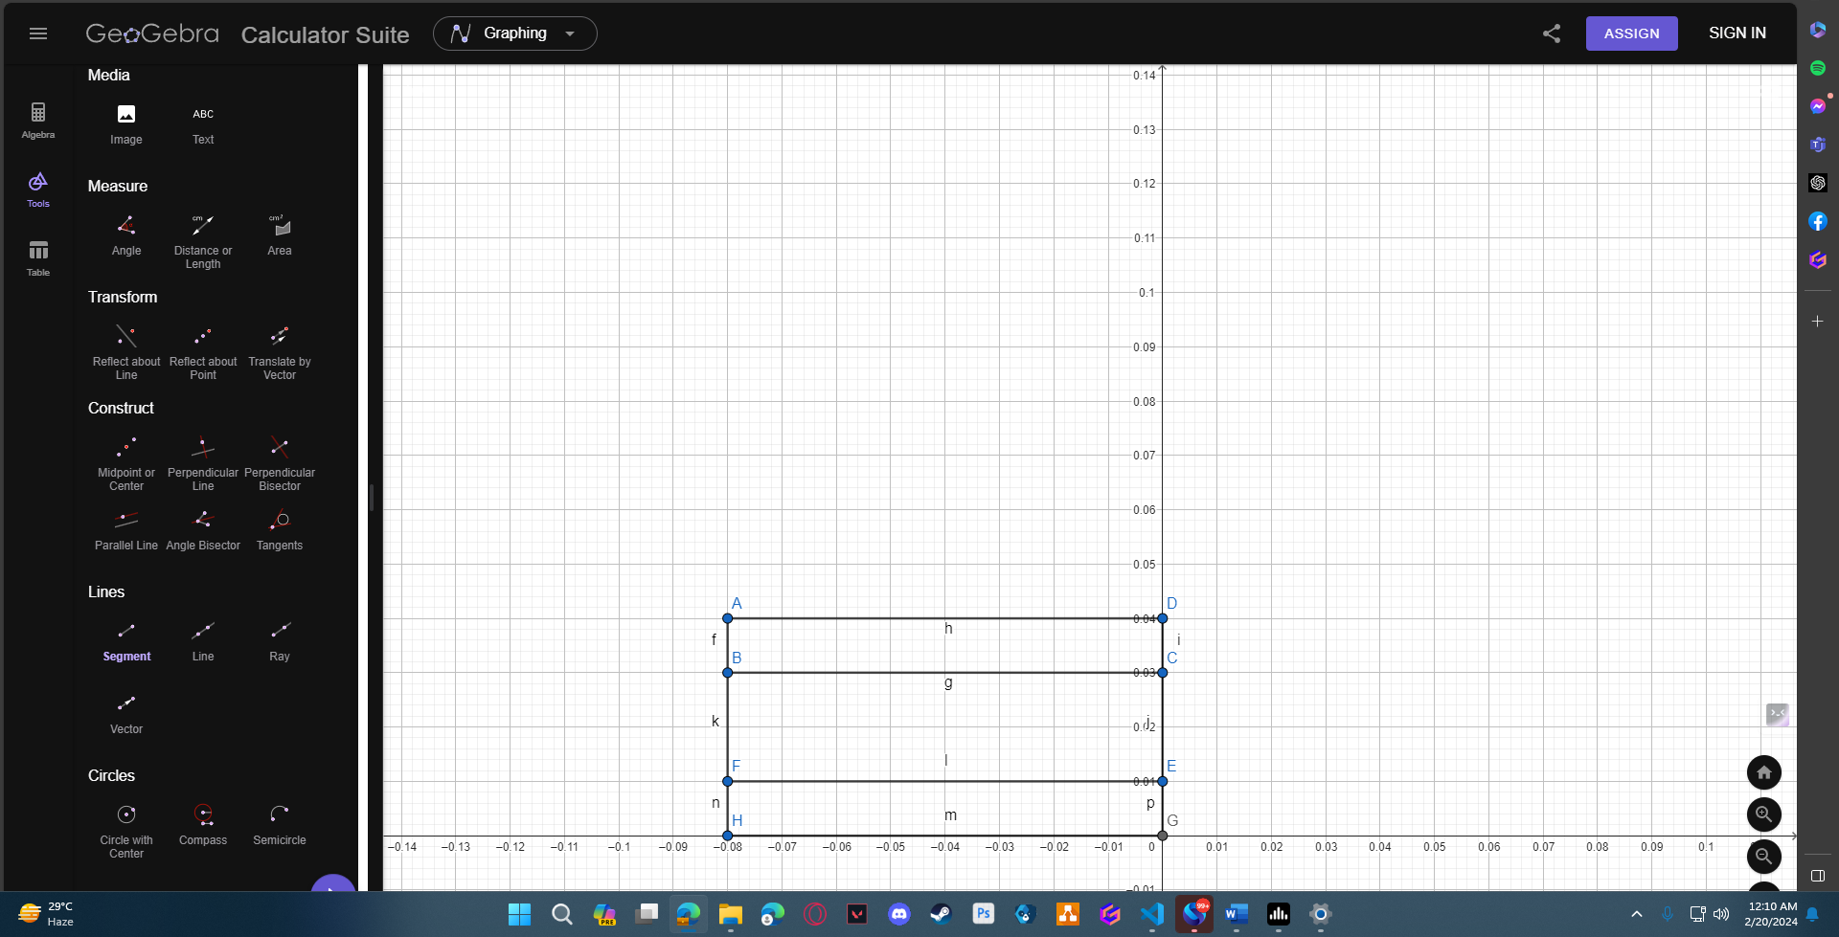
Code:
#include <windows.h>
#include<math.h>
#include <GL/glut.h>

void initGL() {

glClearColor(0.0f, 0.0f, 0.0f, 0.0f);

}

void display() {
glClearColor(0.0f, 0.0f, 0.0f, 0.0f);
glClear(GL_COLOR_BUFFER_BIT);
glLineWidth(7.5);

glBegin(GL_POLYGON);

glColor3f(1.0f, 1.0f, 1.0f);
glVertex2f(-0.8f, 0.4f);
glVertex2f(-0.8f, 0.3f);

glVertex2f(-0.8f, 0.3f);
glVertex2f(0.0f, 0.3f);

glVertex2f(0.0f, 0.3f);
glVertex2f(0.0f, 0.4f);

glVertex2f(0.0f, 0.4f);
glVertex2f(-0.8f, 0.4f);

glEnd();
glBegin(GL_POLYGON);
glColor3f(1.0f, 0.0f, 0.0f);
glVertex2f(-0.8f, 0.0f);
glVertex2f(0.0f, 0.0f);

glVertex2f(0.0f, 0.0f);
glVertex2f(0.0f, 0.1f);

glVertex2f(0.0f, 0.1f);
glVertex2f(-0.8f, 0.1f);

glVertex2f(-0.8f, 0.1f);
glVertex2f(-0.8f, 0.0f);
glEnd();

glBegin(GL_POLYGON);
glColor3f(0.0f, 0.0f, 1.0f);
glVertex2f(-0.8f, 0.3f);
glVertex2f(-0.8f, 0.1f);

glVertex2f(-0.8f, 0.1f);
glVertex2f(0.0f, 0.1f);

glVertex2f(0.0f, 0.1f);
glVertex2f(0.0f, 0.3f);

glVertex2f(0.0f, 0.3f);
glVertex2f(-0.8f, 0.3f);
glEnd();

glEnd();
glFlush();

glEnd();

}

int main(int argc, char** argv) {

glutInit(&argc, argv);

glutCreateWindow("Vertex, Primitive & Color");

glutInitWindowSize(320, 320);

glutDisplayFunc(display);

initGL();

glutMainLoop();

return 0;

}
Output:
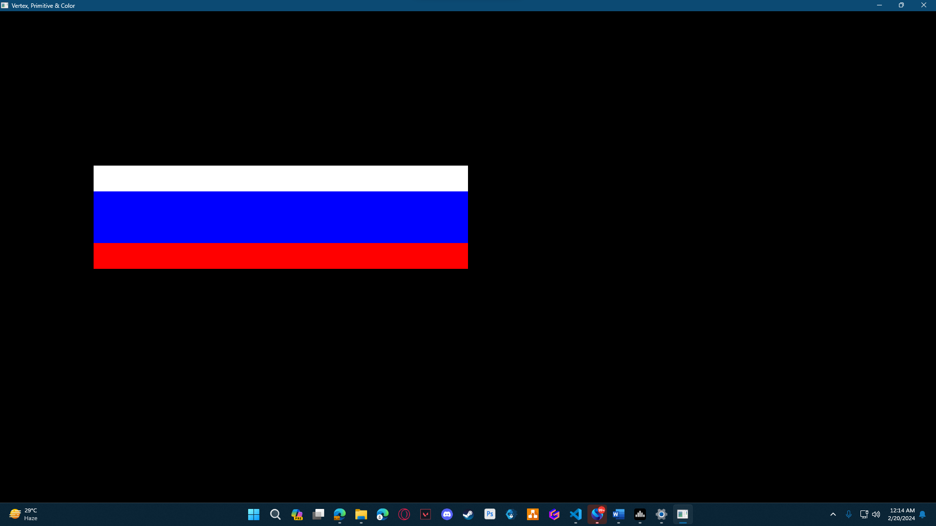

1:Name:HABIB
Graph:
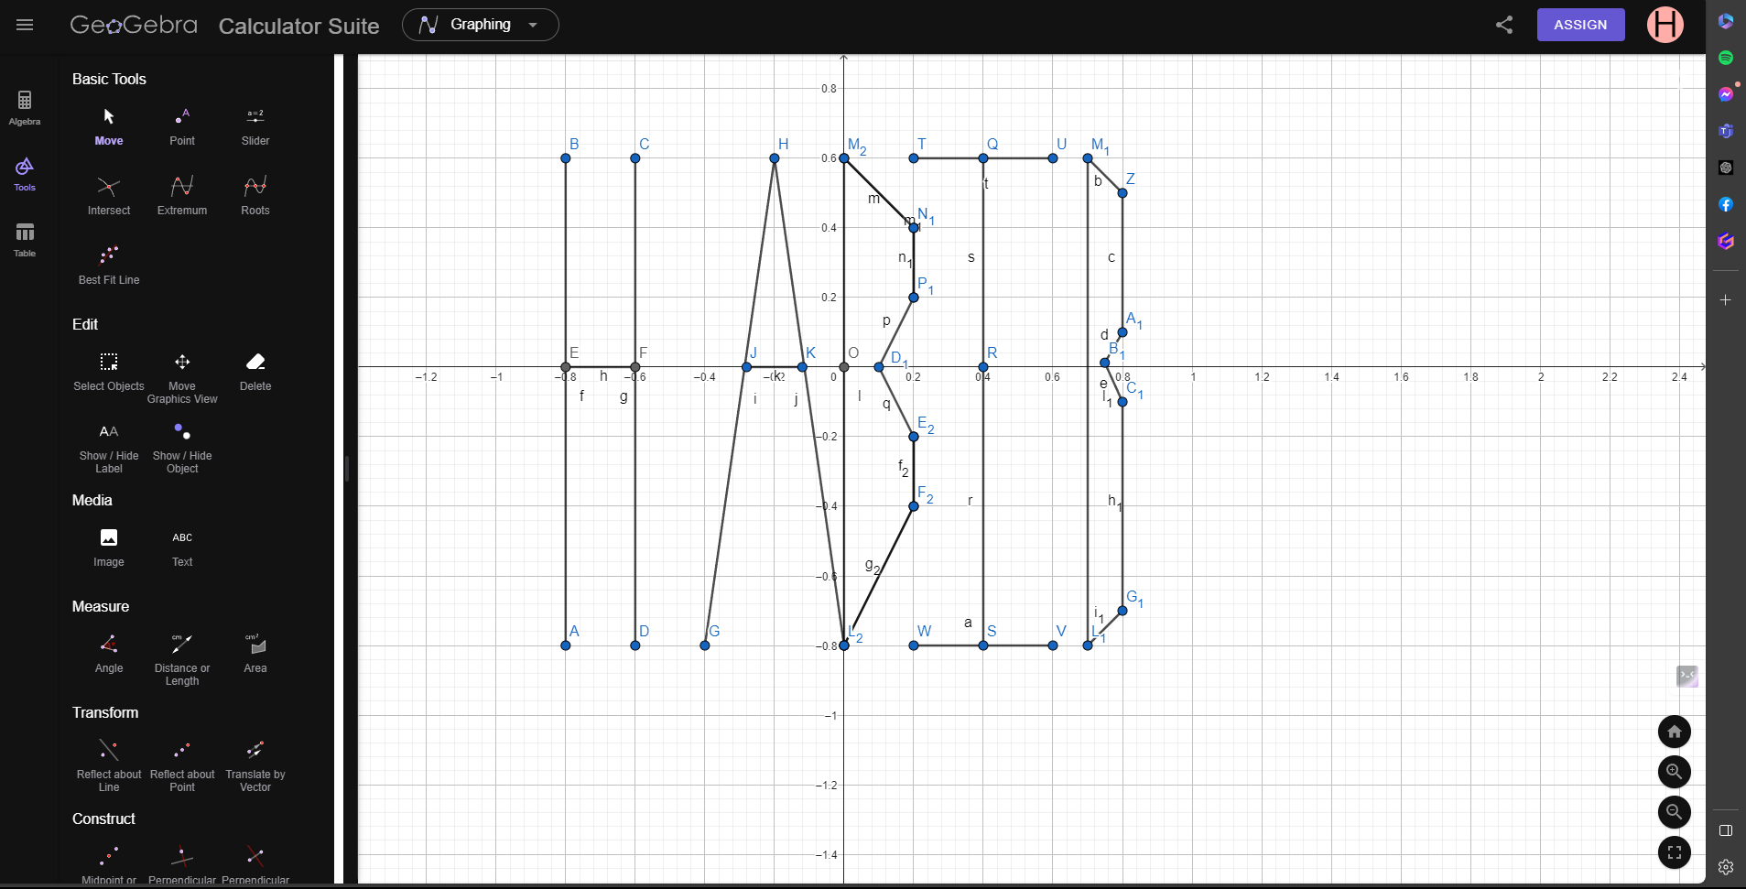
Code:
#include <windows.h>
#include <GL/glut.h>

void display() {

glClearColor(1.0f, 1.0f, 1.0f, 1.0f);

glClear(GL_COLOR_BUFFER_BIT);

glLineWidth(1);

glBegin(GL_LINES);

glColor3f(0.0f, 0.0f, 0.0f);

//H
glVertex2f(-0.8, 0.6);
glVertex2f(-0.8, -0.8);

glVertex2f(-0.6, 0.6);
glVertex2f(-0.6, -0.8);

glVertex2f(-0.8, 0);
glVertex2f(-0.6, 0);

//A
glVertex2f(-0.2, 0.6);
glVertex2f(-0.4, -0.8);

glVertex2f(-0.2, 0.6);
glVertex2f(0, -0.8);

glVertex2f(-0.28, 0);
glVertex2f(-0.12, 0);

//B
glVertex2f(0, 0.6);
glVertex2f(0, -0.8);

glVertex2f(0, 0.6);
glVertex2f(0.2, 0.4);

glVertex2f(0.2, 0.4);
glVertex2f(0.2, 0.2);

glVertex2f(0.2, 0.2);
glVertex2f(0.10, 0);

glVertex2f(0.10, 0);
glVertex2f(0.2, -0.2);

glVertex2f(0.2, -0.2);
glVertex2f(0.2, -0.4);

glVertex2f(0.2, -0.4);
glVertex2f(0, -0.8);

//I
glVertex2f(0.4, 0.6);
glVertex2f(0.4, -0.8);

glVertex2f(0.2, 0.6);
glVertex2f(0.6, 0.6);

glVertex2f(0.2, -0.8);
glVertex2f(0.6, -0.8);

//B
glVertex2f(0.7, -0.8);
glVertex2f(0.7, 0.6);

glVertex2f(0.7, 0.6);
glVertex2f(0.8, 0.5);

glVertex2f(0.8, 0.1);
glVertex2f(0.8, 0.5);

glVertex2f(0.8, 0.1);
glVertex2f(0.7491266196605, 0.0125389939406);

glVertex2f(0.8, -0.1);
glVertex2f(0.7491266196605, 0.0125389939406);

glVertex2f(0.8, -0.1);
glVertex2f(0.8, -0.7);

glVertex2f(0.7, -0.8);
glVertex2f(0.8, -0.7);

glEnd();
glFlush();

}

int main(int argc, char** argv) {

glutInit(&argc, argv);

glutCreateWindow("OpenGL Setup");

glutInitWindowSize(5000, 4000);

glutDisplayFunc(display);
glutMainLoop();

return 0;

}
Output:

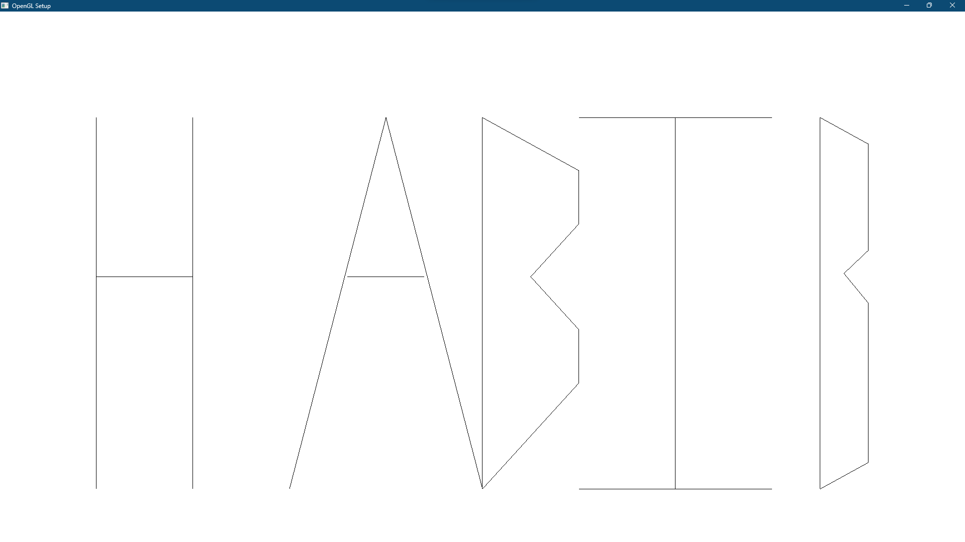

2:AIUB
Graph:
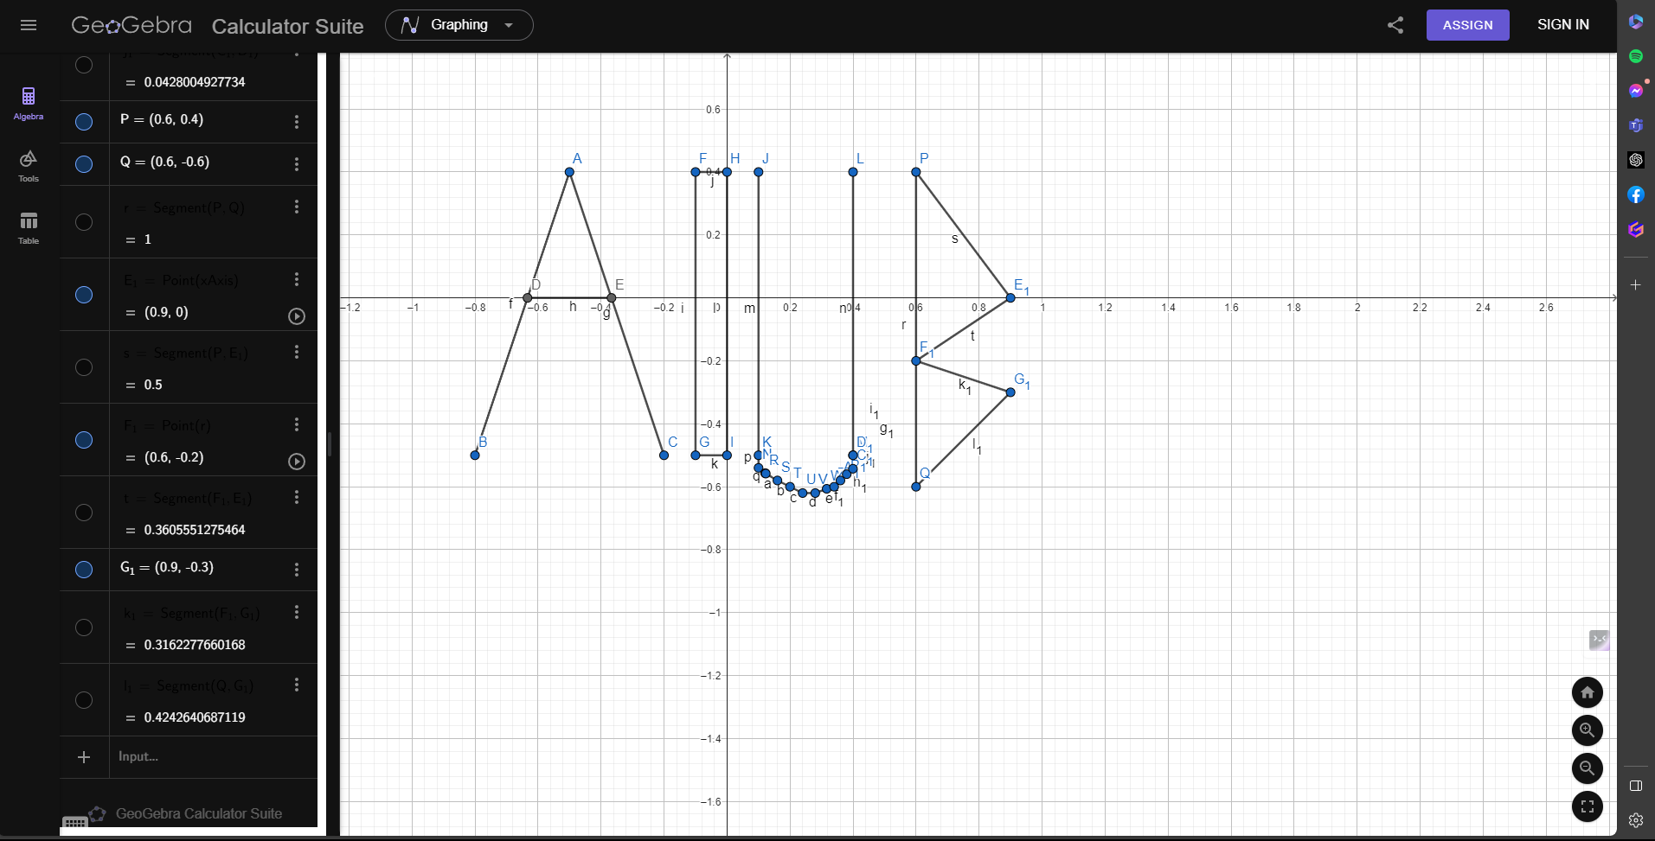
Code: #include <windows.h>
#include <GL/glut.h>

void display() {

glClearColor(1.0f, 1.0f, 1.0f, 1.0f);

glClear(GL_COLOR_BUFFER_BIT);

glLineWidth(5);

glBegin(GL_LINES);

glColor3f(0.0f, 0.0f, 0.0f);
glVertex2f(-0.5, 0.4);

glVertex2f(-0.8, -0.5);

glVertex2f(-0.5, 0.4);
glVertex2f(-0.2, -0.5);

glVertex2f(-0.63333333333333, 0);
glVertex2f(-0.36666666666666, 0);

glVertex2f(-0.1, 0.4);
glVertex2f(-0.1, -0.5);

glVertex2f(-0.1, -0.5);
glVertex2f(0, -0.5);

glVertex2f(0, -0.5);
glVertex2f(0, 0.4);

glVertex2f(0, 0.4);
glVertex2f(-0.1, 0.4);

glVertex2f(0.1, 0.4);
glVertex2f(0.1, -0.5);

glVertex2f(0.1, -0.5);
glVertex2f(0.1, -0.54);

glVertex2f(0.1211025036733, -0.556751052333);
glVertex2f(0.1, -0.54);

glVertex2f(0.1211025036733, -0.556751052333);
glVertex2f(0.16, -0.58);

glVertex2f(0.2, -0.6);
glVertex2f(0.16, -0.58);

glVertex2f(0.2, -0.6);
glVertex2f(0.24, -0.62);

glVertex2f(0.28, -0.62);
glVertex2f(0.24, -0.62);

glVertex2f(0.28, -0.62);
glVertex2f(0.3164277686293, -0.6065124888813);

glVertex2f(0.34, -0.6);
glVertex2f(0.3164277686293, -0.6065124888813);

glVertex2f(0.34, -0.6);
glVertex2f(0.36, -0.58);

glVertex2f(0.3996735363129, -0.5427992476932);
glVertex2f(0.36, -0.58);

glVertex2f(0.4, -0.5);
glVertex2f(0.36, -0.58);

glVertex2f(0.4, -0.5);
glVertex2f(0.4, 0.4);

glVertex2f(0.6, 0.4);
glVertex2f(0.6, -0.6);

glVertex2f(0.6, 0.4);
glVertex2f(0.9, 0);

glVertex2f(0.6, -0.2);
glVertex2f(0.9, 0);

glVertex2f(0.6, -0.2);
glVertex2f(0.9, -0.3);

glVertex2f(0.6, -0.6);
glVertex2f(0.9, -0.3);

glEnd();

glFlush();

}

int main(int argc, char** argv) {

glutInit(&argc, argv);

glutCreateWindow("OpenGL Setup");

glutInitWindowSize(5000, 4000);

glutDisplayFunc(display);
glutMainLoop();

return 0;

}
Output: 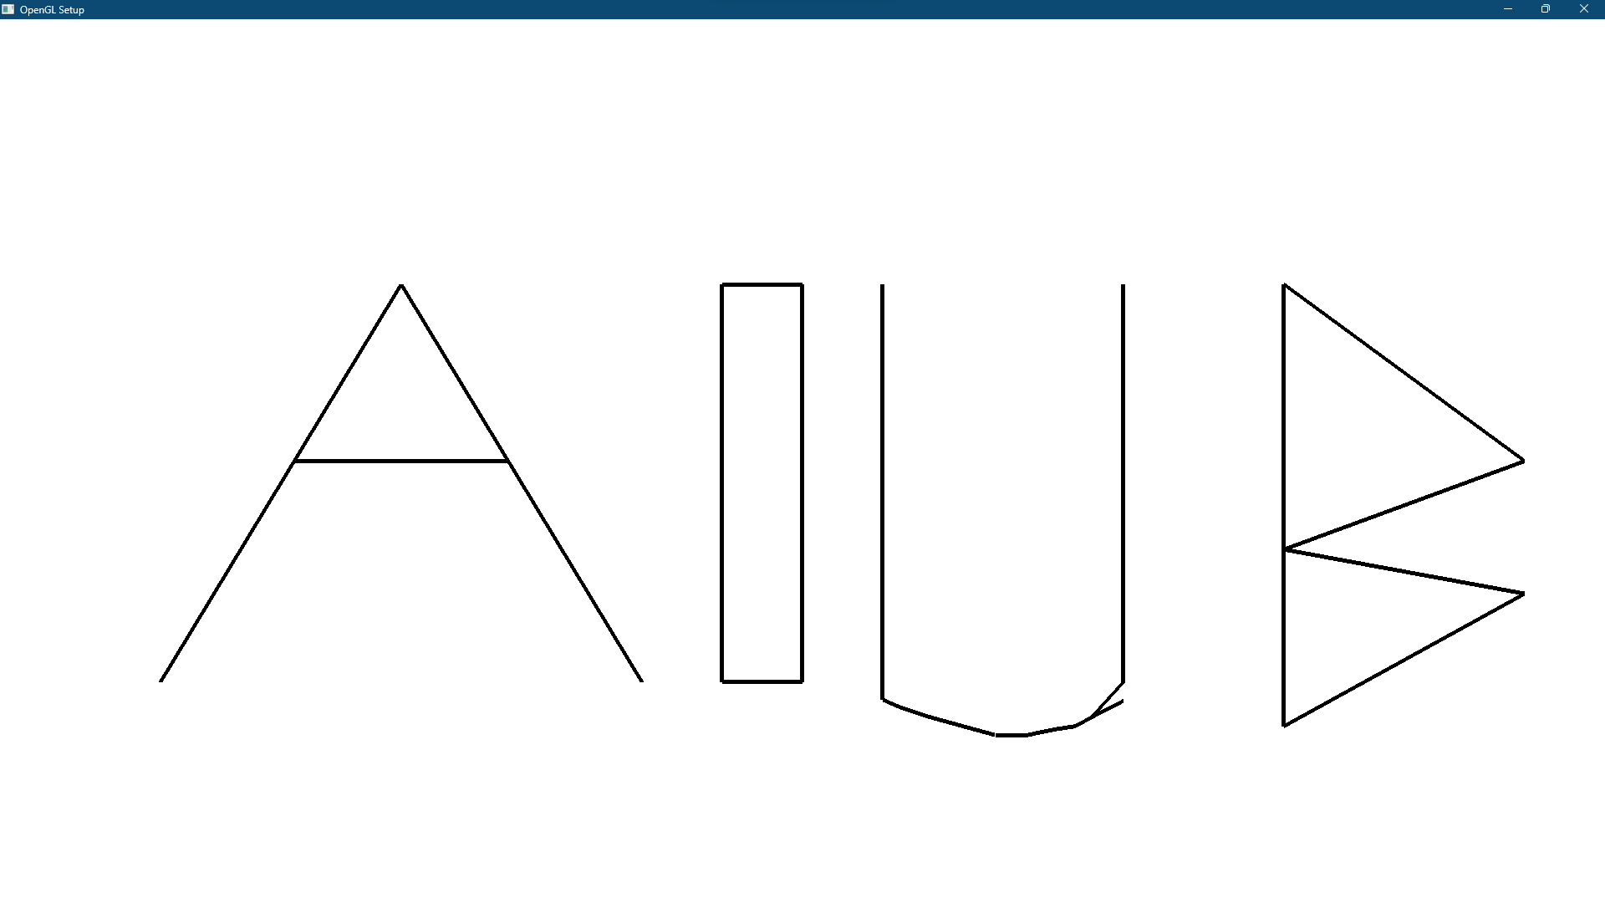

3.BRAVO
Graph:
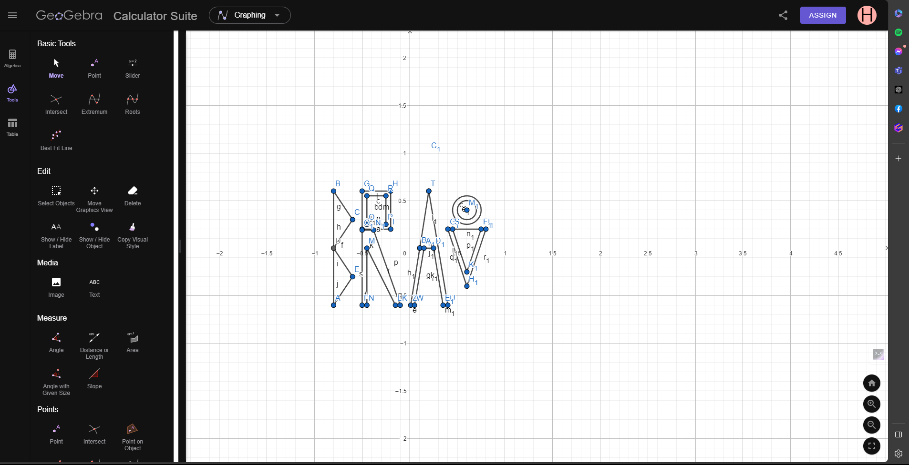
Code:
#include <windows.h>
#include <GL/glut.h>
#include<math.h>

void display() {

glClearColor(1.0f, 1.0f, 1.0f, 1.0f);

glClear(GL_COLOR_BUFFER_BIT);

glLineWidth(5);

//B
glBegin(GL_POLYGON);

glColor3f(0.0f, 0.0f, 0.0f);
glVertex2f(-0.8, 0.6);
glVertex2f(-0.8, -0.6);

glVertex2f(-0.8, -0.6);
glVertex2f(-0.6, -0.3);

glVertex2f(-0.6, -0.3);
glVertex2f(-0.8, 0);

glVertex2f(-0.8, 0);
glVertex2f(-0.6, 0.3);

glVertex2f(-0.6, 0.3);
glVertex2f(-0.8, 0.6);

glEnd();
//R Head
glBegin(GL_POLYGON);

glColor3f(0.0f, 0.0f, 0.0f);
glVertex2f(-0.5, 0.6);
glVertex2f(-0.2, 0.6);

glVertex2f(-0.2, 0.6);
glVertex2f(-0.2, 0.2);

glVertex2f(-0.2, 0.2);
glVertex2f(-0.5, 0.2);

glVertex2f(-0.5, 0.2);
glVertex2f(-0.5, 0.6);

glEnd();

glBegin(GL_POLYGON);

glColor3f(1.0f, 1.0f, 1.0f);
glVertex2f(-0.45, 0.55);
glVertex2f(-0.25, 0.55);

glVertex2f(-0.25, 0.55);
glVertex2f(-0.25, 0.25);

glVertex2f(-0.25, 0.25);
glVertex2f(-0.45, 0.25);

glVertex2f(-0.45, 0.25);
glVertex2f(-0.45, 0.55);

glEnd();

//R leg
glBegin(GL_POLYGON);

glColor3f(0.0f, 0.0f, 0.0f);

glVertex2f(-0.5, 0.19);
glVertex2f(-0.5, -0.6);

glVertex2f(-0.5, -0.6);
glVertex2f(-0.45, -0.6);

glVertex2f(-0.45, -0.6);
glVertex2f(-0.45, 0);

glVertex2f(-0.45, 0);
glVertex2f(-0.15, -0.6);

glVertex2f(-0.15, -0.6);
glVertex2f(-0.1, -0.6);

glVertex2f(-0.1, -0.6);
glVertex2f(-0.38, 0.19);

glVertex2f(-0.38, 0.19);
glVertex2f(-0.5, 0.19);
glEnd();
//A
glBegin(GL_POLYGON);

glColor3f(0.0f, 0.0f, 0.0f);

glVertex2f(0.2, 0.6);
glVertex2f(0.01, -0.6);

glVertex2f(0.01, -0.6);
glVertex2f(0.05, -0.6);

glVertex2f(0.15, 0);
glVertex2f(0.25, 0);

glVertex2f(0.25, 0);
glVertex2f(0.35, -0.6);

glVertex2f(0.35, -0.6);
glVertex2f(0.4, -0.6);

glVertex2f(0.4, -0.6);
glVertex2f(0.2, 0.6);

glEnd();

//v
glBegin(GL_POLYGON);

glColor3f(0.0f, 0.0f, 0.0f);

glVertex2f(0.4, 0.2);
glVertex2f(0.6, -0.4);

glVertex2f(0.6, -0.4);
glVertex2f(0.8, 0.2);

glVertex2f(0.8, 0.2);
glVertex2f(0.75, 0.2);

glVertex2f(0.75, 0.2);
glVertex2f(0.6, -0.25);

glVertex2f(0.6, -0.25);
glVertex2f(0.45, 0.2);

glVertex2f(0.45, 0.2);
glVertex2f(0.4, 0.2);

glEnd();

glBegin(GL_POLYGON);

glColor3f(1.0f, 1.0f, 1.0f);

glVertex2f(0.45, 0.2);
glVertex2f(0.6, -0.25);

glVertex2f(0.6, -0.25);
glVertex2f(0.75, 0.2);

glVertex2f(0.75, 0.2);
glVertex2f(0.75, 0.2);

glVertex2f(0.75, 0.2);
glVertex2f(0.45, 0.2);

glEnd();
//O
glBegin(GL_POLYGON);

float xOffset = 0.6f;
float yOffset = 0.4f;

for (int i = 0; i < 300; i++)
{
glColor3f(0.0f, 0.0f, 0.0f);;

float pi = 3.1416;
float a = (i * 2 * pi) / 300;
float r = 0.15;
float x = r * cos(a) + xOffset;
float y = r * sin(a) + yOffset;
glVertex2f(x, y);
}

glEnd();

glBegin(GL_POLYGON);

float xOffse = 0.6f;
float yOffse = 0.4f;

for (int i = 0; i < 300; i++)
{
glColor3f(1.0f, 1.0f, 1.0f);;

float pi = 3.1416;
float a = (i * 2 * pi) / 300;
float r = 0.10;
float x = r * cos(a) + xOffse;
float y = r * sin(a) + yOffse;
glVertex2f(x, y);
}

glEnd();

glFlush();

}

int main(int argc, char** argv) {

glutInit(&argc, argv);

glutCreateWindow("OpenGL Setup");

glutInitWindowSize(5000, 4000);

glutDisplayFunc(display);
glutMainLoop();

return 0;

}
Output:
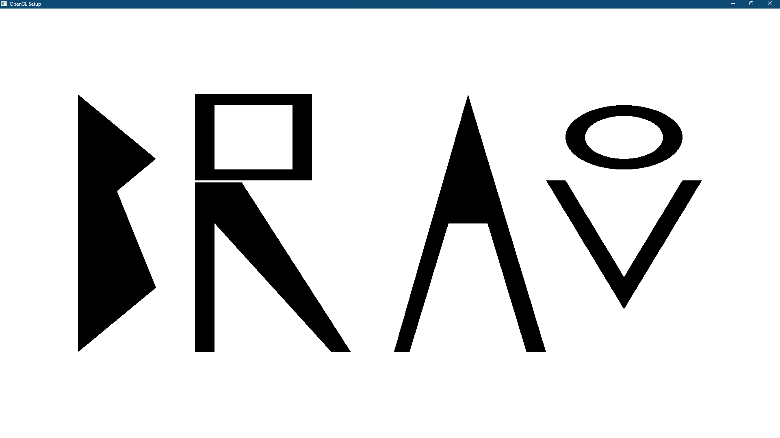

4:Naptune
Graph:
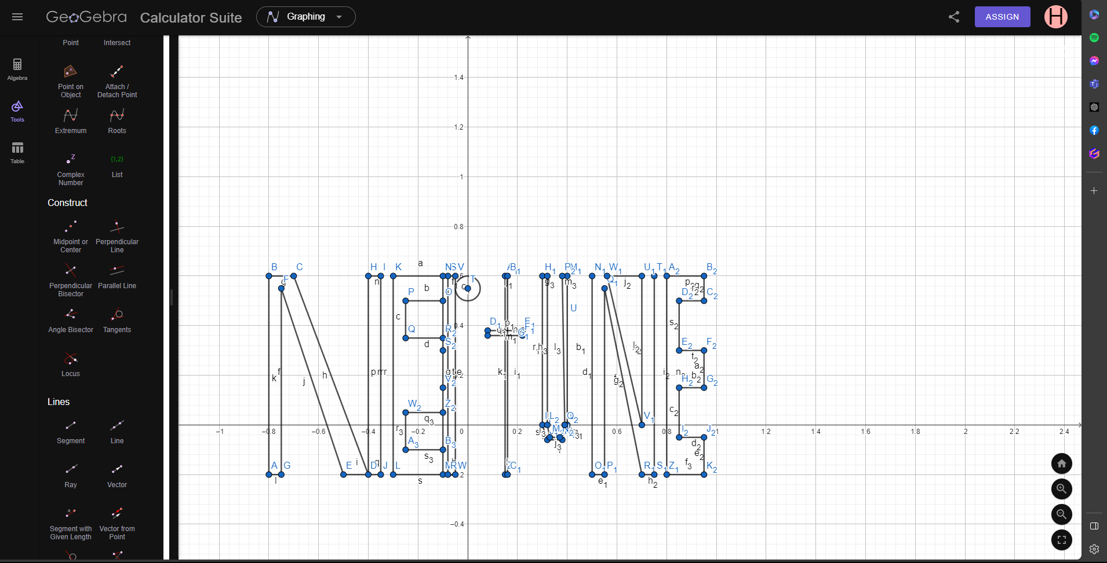
Code:
#include <windows.h>
#include <GL/glut.h>
#include<math.h>

void display() {

glClearColor(1.0f, 1.0f, 1.0f, 1.0f);

glClear(GL_COLOR_BUFFER_BIT);

glLineWidth(5);

//N
glBegin(GL_POLYGON);

glColor3f(0.0f, 0.0f, 0.0f);
glVertex2f(-0.8, 0.6);
glVertex2f(-0.8, -0.2);

glVertex2f(-0.8, -0.2);
glVertex2f(-0.75, -0.2);

glVertex2f(-0.75, -0.2);
glVertex2f(-0.75, 0.55);

glVertex2f(-0.75, 0.55);
glVertex2f(-0.5, -0.2);

glVertex2f(-0.5, -0.2);
glVertex2f(-0.4, -0.2);

glVertex2f(-0.4, -0.2);
glVertex2f(-0.7, 0.6);

glVertex2f(-0.7, 0.6);
glVertex2f(-0.8, 0.6);

glEnd();

glBegin(GL_POLYGON);

glColor3f(0.0f, 0.0f, 0.0f);
glVertex2f(-0.4, 0.6);
glVertex2f(-0.4, -0.2);

glVertex2f(-0.4, -0.2);
glVertex2f(-0.35, -0.2);

glVertex2f(-0.35, -0.2);
glVertex2f(-0.35, 0.6);

glVertex2f(-0.35, 0.6);
glVertex2f(-0.4, 0.6);

glEnd();

//A
glBegin(GL_POLYGON);

glColor3f(0.0f, 0.0f, 0.0f);
glVertex2f(-0.3, 0.6);
glVertex2f(-0.3, -0.2);

glVertex2f(-0.3, -0.2);
glVertex2f(-0.1, -0.2);

glVertex2f(-0.1, -0.2);
glVertex2f(-0.1, 0.6);

glVertex2f(-0.1, 0.6);
glVertex2f(-0.3, 0.6);

glEnd();

glBegin(GL_POLYGON);

glColor3f(1.0f, 1.0f, 1.0f);
glVertex2f(-0.25, 0.5);
glVertex2f(-0.25, 0.35);

glVertex2f(-0.25, 0.35);
glVertex2f(-0.1, 0.35);

glVertex2f(-0.1, 0.35);
glVertex2f(-0.1, 0.50);

glVertex2f(-0.1, 0.50);
glVertex2f(-0.25, 0.5);

glEnd();

glBegin(GL_POLYGON);

glColor3f(1.0f, 1.0f, 1.0f);
glVertex2f(-0.25, 0.5);
glVertex2f(-0.25, 0.35);

glVertex2f(-0.25, 0.35);
glVertex2f(-0.1, 0.35);

glVertex2f(-0.1, 0.35);
glVertex2f(-0.1, 0.50);

glVertex2f(-0.1, 0.50);
glVertex2f(-0.25, 0.5);

glEnd();

glBegin(GL_POLYGON);

glColor3f(1.0f, 1.0f, 1.0f);
glVertex2f(-0.25, 0.05);
glVertex2f(-0.25, -0.1);

glVertex2f(-0.25, -0.1);
glVertex2f(-0.1, -0.1);

glVertex2f(-0.1, -0.1);
glVertex2f(-0.1, 0.05);

glVertex2f(-0.1, 0.05);
glVertex2f(-0.25, 0.05);

glEnd();

//p

glBegin(GL_POLYGON);

glColor3f(0.0f, 0.0f, 0.0f);
glVertex2f(-0.08, 0.6);
glVertex2f(-0.08, -0.2);

glVertex2f(-0.08, -0.2);
glVertex2f(-0.05, -0.2);

glVertex2f(-0.05, -0.2);
glVertex2f(-0.05, 0.6);

glVertex2f(-0.05, 0.6);
glVertex2f(-0.08, 0.6);

glEnd();

glBegin(GL_POLYGON);

float xOffse = 0.0f;
float yOffse = 0.55f;

for (int i = 0; i < 300; i++)
{
glColor3f(0.0f, 0.0f, 0.0f);;

float pi = 3.1416;
float a = (i * 2 * pi) / 300;
float r = 0.09;
float x = r * cos(a) + xOffse;
float y = r * sin(a) + yOffse;
glVertex2f(x, y);
}

glEnd();

//T

glBegin(GL_POLYGON);

glColor3f(0.0f, 0.0f, 0.0f);
glVertex2f(0.15, 0.6);
glVertex2f(0.15, -0.2);

glVertex2f(0.15, -0.2);
glVertex2f(0.16, -0.2);

glVertex2f(0.16, -0.2);
glVertex2f(0.16, 0.6);

glVertex2f(0.16, 0.6);
glVertex2f(0.15, 0.6);

glEnd();

glBegin(GL_POLYGON);

glColor3f(0.0f, 0.0f, 0.0f);
glVertex2f(0.08, 0.38);
glVertex2f(0.08, 0.36);

glVertex2f(0.08, 0.36);
glVertex2f(0.22, 0.36);

glVertex2f(0.22, 0.36);
glVertex2f(0.22, 0.38);

glVertex2f(0.22, 0.38);
glVertex2f(0.08, 0.38);

glEnd();

//u
glBegin(GL_POLYGON);

glColor3f(0.0f, 0.0f, 0.0f);
glVertex2f(0.3, 0.6);
glVertex2f(0.30, 0);

glVertex2f(0.30, 0);
glVertex2f(0.32, -0.06);

glVertex2f(0.32, -0.06);
glVertex2f(0.38, -0.06);

glVertex2f(0.38, -0.06);
glVertex2f(0.40, 0);

glVertex2f(0.38, -0.06);
glVertex2f(0.40, 0);

glVertex2f(0.40, 0);
glVertex2f(0.4, 0.6);

glVertex2f(0.4, 0.6);
glVertex2f(0.38, 0.6);

glVertex2f(0.38, 0.6);
glVertex2f(0.39, 0);

glVertex2f(0.39, 0);
glVertex2f(0.37, -0.05);

glVertex2f(0.37, -0.05);
glVertex2f(0.33, -0.05);

glVertex2f(0.33, -0.05);
glVertex2f(0.32, 0);

glVertex2f(0.32, 0);
glVertex2f(0.32, 0.6);

glVertex2f(0.32, 0.6);
glVertex2f(0.3, 0.6);

glEnd();

glBegin(GL_POLYGON);

glColor3f(1.0f, 1.0f, 1.0f);

glVertex2f(0.38, 0.6);
glVertex2f(0.39, 0);

glVertex2f(0.39, 0);
glVertex2f(0.37, -0.05);

glVertex2f(0.37, -0.05);
glVertex2f(0.33, -0.05);

glVertex2f(0.33, -0.05);
glVertex2f(0.32, 0);

glVertex2f(0.32, 0);
glVertex2f(0.32, 0.6);

glVertex2f(0.32, 0.6);
glVertex2f(0.38, 0.6);

glEnd();

glBegin(GL_POLYGON);

glColor3f(0.0f, 0.0f, 0.0f);
glVertex2f(0.3, 0.6);
glVertex2f(0.30, 0);

glVertex2f(0.30, 0);
glVertex2f(0.32, -0.06);

glVertex2f(0.32, -0.06);
glVertex2f(0.38, -0.06);

glVertex2f(0.38, -0.06);
glVertex2f(0.40, 0);

glVertex2f(0.38, -0.06);
glVertex2f(0.40, 0);

glVertex2f(0.40, 0);
glVertex2f(0.4, 0.6);

glVertex2f(0.4, 0.6);
glVertex2f(0.38, 0.6);

glVertex2f(0.38, 0.6);
glVertex2f(0.39, 0);

glVertex2f(0.39, 0);
glVertex2f(0.37, -0.05);

glVertex2f(0.37, -0.05);
glVertex2f(0.33, -0.05);

glVertex2f(0.33, -0.05);
glVertex2f(0.32, 0);

glVertex2f(0.32, 0);
glVertex2f(0.32, 0.6);

glVertex2f(0.32, 0.6);
glVertex2f(0.3, 0.6);

glEnd();

//N
glBegin(GL_POLYGON);

glColor3f(0.0f, 0.0f, 0.0f);
glVertex2f(0.5, 0.6);
glVertex2f(0.5, -0.2);

glVertex2f(0.5, -0.2);
glVertex2f(0.55, -0.2);

glVertex2f(0.55, -0.2);
glVertex2f(0.55, 0.55);

glVertex2f(0.55, 0.55);
glVertex2f(0.7, -0.2);

glVertex2f(0.7, -0.2);
glVertex2f(0.75, -0.2);

glVertex2f(0.75, -0.2);
glVertex2f(0.75, 0.6);

glVertex2f(0.75, 0.6);
glVertex2f(0.7, 0.6);

glVertex2f(0.7, 0.6);
glVertex2f(0.7, 0);

glVertex2f(0.7, 0);
glVertex2f(0.55, 0.55);

glVertex2f(0.55, 0.55);
glVertex2f(0.5, 0.6);

glEnd();

glBegin(GL_POLYGON);

glColor3f(1.0f, 1.0f, 1.0f);
glVertex2f(0.56, 0.6);
glVertex2f(0.7, 0);

glVertex2f(0.7, 0);
glVertex2f(0.7, 0.6);

glVertex2f(0.7, 0.6);
glVertex2f(0.56, 0.6);

glEnd();

//E

glBegin(GL_POLYGON);

glColor3f(0.0f, 0.0f, 0.0f);
glVertex2f(0.8, 0.6);
glVertex2f(0.8, -0.2);

glVertex2f(0.8, -0.2);
glVertex2f(0.95, -0.2);

glVertex2f(0.95, -0.2);
glVertex2f(0.95, -0.05);

glVertex2f(0.95, -0.05);
glVertex2f(0.85, -0.05);

glVertex2f(0.85, -0.05);
glVertex2f(0.85, 0.15);

glVertex2f(0.85, 0.15);
glVertex2f(0.95, 0.15);

glVertex2f(0.95, 0.15);
glVertex2f(0.95, 0.3);

glVertex2f(0.95, 0.3);
glVertex2f(0.85, 0.3);

glVertex2f(0.85, 0.3);
glVertex2f(0.85, 0.5);

glVertex2f(0.85, 0.5);
glVertex2f(0.95, 0.5);

glVertex2f(0.95, 0.5);
glVertex2f(0.95, 0.6);

glVertex2f(0.95, 0.6);
glVertex2f(0.8, 0.6);

glEnd();

glBegin(GL_POLYGON);

glColor3f(1.0f, 1.0f, 1.0f);
glVertex2f(0.85, 0.5);
glVertex2f(0.85, 0.3);

glVertex2f(0.85, 0.3);
glVertex2f(0.95, 0.3);

glVertex2f(0.95, 0.3);
glVertex2f(0.95, 0.5);

glVertex2f(0.95, 0.5);
glVertex2f(0.85, 0.5);

glEnd();

glBegin(GL_POLYGON);

glColor3f(1.0f, 1.0f, 1.0f);
glVertex2f(0.85, 0.15);
glVertex2f(0.85, -0.05);

glVertex2f(0.85, -0.05);
glVertex2f(0.95, -0.05);

glVertex2f(0.95, -0.05);
glVertex2f(0.95, 0.15);

glVertex2f(0.95, 0.15);
glVertex2f(0.85, 0.15);

glEnd();

//u2nd

glBegin(GL_POLYGON);

glColor3f(1.0f, 1.0f, 1.0f);

glVertex2f(0.32, 0.6);
glVertex2f(0.38, 0.6);

glVertex2f(0.38, 0.6);
glVertex2f(0.39, 0);

glVertex2f(0.39, 0);
glVertex2f(0.36, -0.06);

glVertex2f(0.36, -0.06);
glVertex2f(0.32, 0);

glVertex2f(0.32, 0);
glVertex2f(0.32, 0.6);

glEnd();

glEnd();

glFlush();

}

int main(int argc, char** argv) {

glutInit(&argc, argv);

glutCreateWindow("OpenGL Setup");

glutInitWindowSize(5000, 4000);

glutDisplayFunc(display);
glutMainLoop();

return 0;

}

Output:


