BESTLINK COLLEGE OF THE PHILIPPINES BULACAN CAMPUS - SCHOOL MANAGEMENT (SCHOOL DIRECTRESS)

A Thesis
Presented of Faculty of
The College of Computing Studies
Bestlink College of the Philippines - Bulacan Campus

ANDRIE S. ELBAMBUENA
ANGEL C. HANTOC
JANN KARL DELA CRUZ
JOHN ROBERT MATAPA
RHEA F. VILLONES

CHAPTER 1
INTRODUCTION
The evolution of information technology has greatly impacted how educational institution handle their administrative tasks. Many schools now use web-based management system to organize data, enhance communication, and support decision making. These systems enable administrators to perform their duties more effectively by offering timely access to organized data and simplifying various administrative processes.
School management plays an important role in ensuring the effective operation of an educational institution. School administrators are responsible for overseeing both academic and administrative functions, coordinating with different departments, monitoring school performance, and implement school policies and goals. As the responsibilities of administrative continues to grow, the need for a centralized system for facilitating effective management and enhanced collaboration of the authorized personnel becomes increasingly clear.
This study proposed the development of the Bestlink College of the Philippines Bulacan Campus – School Management (School Directress), a web-based management system designed to assist the School Directress in performing management responsibilities. The proposed system integrates dashboard and analytics, user and access management, department and unit management, approval and decision support, communication and announcements, report submission and management, summary level student monitoring, and concerns and issue tracking by providing these features in a centralized platform, the system aims to support effective school management and improve administrative efficiency.

  - Background of the Capstone Project
Bestlink College of the Philippines is a higher education institution dedicated to providing quality education and fostering the academic and personal development of its students. To achieve its mission and vision, the institution relies on effective leadership and efficient administrative operations. One of the key administrators is the School Directress, who is responsible for providing leadership, supervising school operations, coordinating with department heads, monitoring institutional activities, reviewing reports, and ensuring that school policies, goals, and objectives are properly implemented. These responsibilities require accurate information, organized records, and effective communication among different offices and departments. Based on the initial requirements gathered from interview conducted during the early stage of the project and consultations with department professor, the School Directress Office performs various administrative functions involving the coordination of department heads, review of reports, monitoring of institutional activities, and communication of important information through official memoranda, meetings, and online communication platforms. The office also receives reports related to student enrollment, attendance, and other administrative matters from authorized departments. These reports are essential in supporting administrative planning, monitoring, and decision-making within the institution. However, managing institutional information, reports, approvals, and other administrative records requires continuous coordination to support the daily responsibilities of the School Directress. As the volume of administrative information continues to increase, maintaining organized records, monitoring reports, and providing timely access to relevant information become increasingly important in supporting effective administrative operations and decision-making. While the current administrative process supports the functions of the School Directress Office, there remain opportunities to further enhance the organization, accessibility, monitoring, and management of institutional information. These organizational concerns serve as the foundation of this capstone project and highlight the need to explore improved approaches to supporting the administrative responsibilities of the School Directress.

  - Context and Scope
The Bestlink College of the Philippines Bulacan Campus – School Management (School Directress) is a proposed web-based management system designed to support the administrative responsibilities of the School Directress. The project focuses on providing a centralized platform that organizes essential administrative information, improves coordination among authorized personnel, and supports monitoring and decision making. The system is intended for use by the School Directress and authorized users, including department coordinators and designated staff, to facilitate the management of reports, approvals, communication, and other administrative activities.
The scope of the project includes the development of eight major functional modules.
- Dashboard and Analytics module provide an overview of important institutional information, such as submitted reports, pending approvals, and other administrative data to support monitoring and decision-making.
- User and Access Management module manages user accounts and role-based access to ensure that only authorized personnel can access specific system functions.
- Department and Unit Management module organizes departments, assigns personnel, and manages administrative units within the institution.
- Approval and Decision Support module enables the review, approval, and tracking of submitted reports and requests.
- Communication and Announcements module allows the posting of official announcements and important updates for authorized users.
- Report Submission and Management module serves as the core feature of the system by allowing departments to submit, organize, review, and monitor reports electronically.
- Student Monitoring (Summary Level) module provides summarized information on student enrollment, attendance, and other monitoring data received from authorized offices.
- Concerns and Issue Tracking module records, monitors, and tracks school-related concerns until they are resolved.
The project is limited to the administrative functions of the School Directress Office. The system is intended only for the School Directress and authorized personnel assigned by the administration. Students, and the general public do not have direct access to the system. Furthermore, the project does not include enrollment processing, grading, accounting, payroll, library services, learning management, or other academic and financial operations that are outside the defined scope of the study.

  - Problem and Statement
The School Directress Office of Bestlink College of the Philippines – Bulacan Campus manages various school information and administrative processes to support the institution's daily operations. Based on the initial requirements gathered, consultations, and observations conducted by the researchers, the following organizational problems were identified:
- Organization of School Information - The School Directress Office manages different types of school information, including departmental records, memoranda, reports, and other institutional documents. As the amount of information continues to increase, keeping these records organized and ensuring that they can be easily accessed and monitored becomes a growing concern. An organized information management process is essential to support accurate record-keeping and timely administrative decisions.
- Coordination of Report Processing and Approval - The School Directress regularly receives reports and administrative requests from different departments for review and approval. Since these reports are submitted by multiple offices, monitoring their submission, approval status, and completion requires continuous coordination. Without a more structured process, tracking reports and maintaining complete approval records can become more challenging as administrative activities increase.
- Consolidation of School Operational Information - The School Directress oversees school operations by reviewing information related to departmental activities, student summaries, and institutional concerns. Because this information is generated by different offices, obtaining a complete and up-to-date overview requires gathering information from multiple sources. This may affect the timely monitoring of school operations and administrative decision-making.
- Consistency of Administrative Communication - Official announcements, memoranda, reminders, and other administrative updates are communicated through different communication channels. While these methods support daily operations, managing important information across multiple channels may make it more challenging to maintain consistency, monitor announcements, and ensure that all authorized personnel receive the necessary updates in a timely manner.
- Organization and Accessibility of Institutional Records - Institutional records play an important role in supporting planning, monitoring, reporting, and decision-making within the School Directress Office. As more reports and administrative documents are generated, maintaining organized records and providing timely access to the required information become increasingly important. Strengthening the organization and accessibility of these records can further support the administrative responsibilities of the School Directress.

  - Objectives and Goals
Objectives
The objectives of this capstone project are based on the organizational problems identified in the School Directress Office of Bestlink College of the Philippines- Bulacan Campus. These objectives define the specific outcomes that the project intends to accomplish within the scope of the proposed system.
- Develop an Organized School Information Management Process - To establish a well-organized process for managing institutional information, departmental records, and administrative data that supports the daily responsibilities of the School Directress.
- Simplify the Report Processing and Approval Process - To provide a clear and organized process for submitting, reviewing, approving, and monitoring reports from different departments.
- Support Better Monitoring of School Operations - To provide timely and organized access to information related to school operations, student summaries, and institutional concerns to assist the School Directress in administrative supervision and decision-making.
- Promote Effective Administrative Communication - To provide a more organized approach for communicating official announcements, memoranda, reminders, and administrative updates among authorized users.
- Maintain Well-Organized Institutional Records - To ensure that institutional records remain organized, accessible, and properly managed to support efficient information retrieval and administrative planning.

Goals
The goals of this capstone project describe the proposed solutions that will address the organizational problems identified in the School Directress Office. Through the implementation of the proposed web-based system, the project aims to improve the management of school information and support the administrative responsibilities of the School Directress.
- Improve the Organization of School Information - Develop a centralized system for managing school information, departmental records, and administrative data to make information easier to organize, access, and maintain.
- Improve Report Processing and Approval - Develop a report management process that simplifies the submission, review, approval, and tracking of reports, making the overall workflow more organized and efficient.
- Improve Monitoring of School Operations - Provide a monitoring feature that gives timely updates on school activities, student information, and institutional concerns to support effective administrative oversight and decision-making.
- Improve Administrative Communication - Provide a communication platform for distributing official announcements, memoranda, reminders, and other important updates promptly and efficiently.
- Improve the Management of Institutional Records - Develop an organized record management process that enables the secure storage, quick retrieval, monitoring, and maintenance of institutional records needed for administrative operations.

  - Significance and Relevance
The proposed Bestlink College of the Philippines Bulacan Campus – School Management (School Directress) is expected to provide significant benefits to the institution by improving the organization and management of school information. Through a centralized web-based platform, the project aims to support administrative processes, enhance communication, and provide timely access to institutional information. The following are the beneficiaries of the proposed capstone project:
- For the School Directress, the proposed system will assist the School Directress in managing institutional information, monitoring reports, reviewing approvals, and accessing school records through a centralized platform. It will support administrative supervision and decision making by providing organized and readily available information.
- For the Department Coordinators, the system will provide department coordinators with an organized process for submitting reports, monitoring submission status, and receiving announcements and updates from the School Directress Office. This will improve coordination between departments and the administration.
- For the Authorized Staff, they will benefit from a centralized platform for managing assigned tasks, institutional records, and administrative information based on their assigned roles and responsibilities. The system will also provide secure access to information necessary for their daily administrative functions.
- For the school Bestlink College of the Philippines Bulacan Campus, the institution will benefit from improved organization of administrative information, better coordination among offices, and more efficient monitoring of school operations. The proposed system will support the institution's efforts to strengthen administrative management and information accessibility.
- For the Future Researchers, the results of this capstone project may serve as a useful reference for future researchers who intend to develop similar school management systems or conduct studies related to educational administration, information management, and web-based information systems. The project may also provide ideas for further improvements and future system enhancements.

  - Structure of the Document
METHOD | DESCRIPTION
Introduction | Presents the overview of the capstones project, including the background of the study, context and scope, problem statement, objectives and goals, significance and relevance, and the structure of the document.
Literature Review | Presents the related literature, related studies, existing systems, and other references that support the development of the proposed project.
Methodology | Describes the research methodology, requirements gathering, system development process, data collection procedures, and other methods used in conducting the project.
TOGAF | Presents the application of The Open Group Architecture Framework (TOGAF) in analyzing, designing, and developing the proposed School Management System for the School Directress.
System Design and Development | Describes the system architecture, database design, process flow, interface design, implementation, and testing of the proposed system.
References | Sources cited and used in the preparation of the capstone project.
Appendices | Contains the supporting documents of the study, including interview questionnaires, interview documentation, and other relevant project materials.

CHAPTER 2
RELATED STUDIES AND LITERATURE REVIEW
Educational institutions continue to adopt information systems to support administrative management, improve information organization, and assist in institutional decision-making. As schools handle increasing amounts of administrative information, reports, and organizational records, web-based systems have become valuable tools for managing information efficiently while supporting communication, monitoring, and reporting activities. Several studies have emphasized the contribution of information systems for educational administration. Ghavifekr, Afshari, Siraj and Seger (2013) state that Information and Communication Technology (ICT) has been beneficial for educational institutions in terms of information management, communication, planning and administrative processes. ICT use, their study explained, allows administrators to manage institutional information more effectively and support the goals of the organization. Similarly, Tatnall and Davey (2014) stated that Management Information Systems (MIS) help educational institutions by providing organized access to the information needed for planning, monitoring, reporting and decision-making. Their findings emphasize the significance of information systems in assisting administrative functions and improving the overall management of educational institutions. Executive dashboards help school administrators monitor institutional information and support informed decision-making by presenting data in a clear and organized manner (Teo, 2011). Likewise, effective user and access management protects sensitive information by assigning access based on user roles (Alotaibi & Federico, 2017). Digital approval features also provide a more organized process for reviewing, approving, and monitoring administrative reports and requests. In addition, effective communication and report management support better administrative coordination. A dedicated communication platform helps distribute announcements and important updates consistently (Sultan, 2014), while digital report management provides timely access to administrative information for monitoring and decision-making. Furthermore, issue tracking systems assist educational institutions in recording, monitoring, and resolving concerns before they become more serious.

2.1 Agile Scrum Methodology Overview
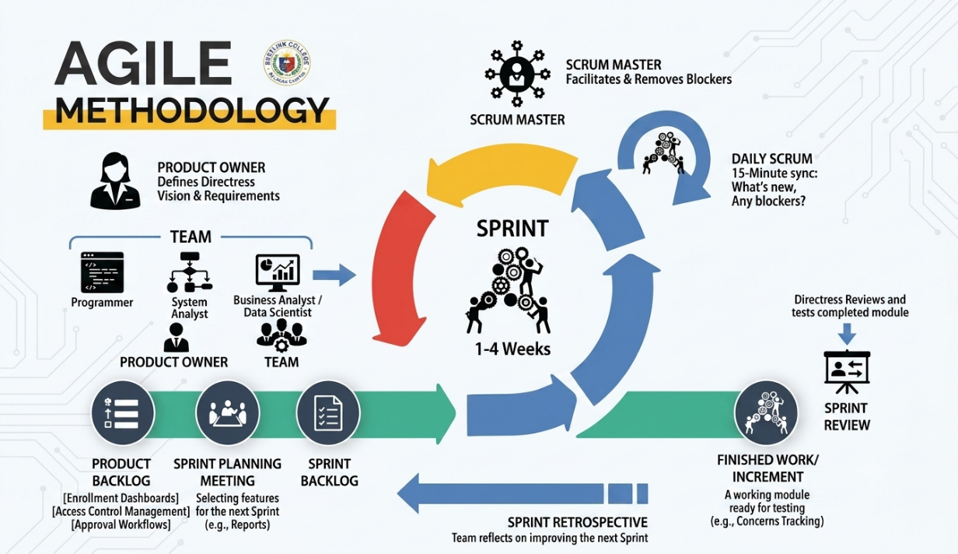
Agile Scrum is a method used to manage and build complex software projects. Instead of trying to build the entire system all at once, Scrum breaks the work down into short, timed cycles called sprints, which usually last two to four weeks. During each sprint, the team designs, codes, tests, and delivers small but working parts of the software. Scrum focuses heavily on teamwork, flexibility, and constant feedback. It relies on three key roles to get the job done: the Product Owner (who manages what the system needs), the Scrum Master (who guides the process), and the Development Team (who actually build the software).
Scrum is very popular because it easily handles changing requirements, which happen often in software projects. Older methods (like the Waterfall model) make people wait until the very end to see the finished product. In contrast, Scrum delivers working features early and often. This gives school leaders the chance to test the system and give feedback while it is still being built. This approach lowers project risks, improves software quality, and ensures the final system truly matches what the users need. It also creates a workspace built on openness, teamwork, and accountability, with the flexibility to change priorities before every new sprint starts.
Using Agile Scrum to build the School Management System (SMS) brings major benefits to both the project team and the Bulacan campus administration. By using a step-by-step approach, Scrum allows the team to break down the large requirements of the School Directress platform into small, manageable pieces. This protects the project from big delays and ensures that no important feature is missed.

2.2 Enterprise Architecture Concepts

2.3 Microservice Architecture

2.4 DevOps and CI/CD
1. Code Development
- What happens: Developers work together with the School Directress, coordinators, and school staff to build or improve parts of the system.
- Purpose: To make sure the software truly helps the school by speeding up report approvals, keeping files safe, and making information easier to find.
- Key activity: Writing and updating code based on how the school operates, feedback from the staff, and changing school rules.
2. Repository
- What happens: A central online storage space (like GitHub) stores and tracks all the system's code, updates, and technical notes for each module.
- Purpose: To allow the development team to work together easily, keep an accurate history of all changes, and quickly roll back to older versions if a mistake happens.
- Key activity: Organizing code inside the repository by using clean branching, merging, and committing methods for all 8 modules.
3. CI Testing
- What happens: Automated pipelines test the independent system modules (like approval forms, report uploads, and user access) every time a developer submits new code.
- Purpose: To stop bugs or connection issues before they can ruin school workflows or cause errors in important school data.
- Key activity: Setting up automatic tests (unit, integration, and regression tests) for every important feature of the system.
4. Deployment
- What happens: After passing all tests, the updated system builds are sent directly to the staging and live servers so the Directress and staff can use the new features.
- Purpose: To deliver system improvements, like faster dashboard charts or smoother report uploads, with little to no system downtime.
- Key activity: Running deployment scripts, setting up server environments, and packaging the code into virtual boxes (containers) using tools like Docker and Kubernetes.
5. Production
- What happens: The live School Directress System runs in a very secure and stable environment to serve the Directress, deans, coordinators, and office staff.
- Purpose: To ensure that official announcements, digital approvals, and submitted department reports are always accurate and ready to use.
- Key activity: Maintaining database speed, applying safety updates to protect data, and monitoring system uptime even during busy school hours.
6. Monitoring
- What happens: Monitoring dashboards constantly watch over the system to check its health, speed, and how much server memory it is using.
- Purpose: To keep the system running smoothly and catch hidden errors or slowdowns before they bother the users.
- Key activity: Adjusting server resources, checking system logs, and setting up automatic alerts to keep the software fast and dependable.

2.5 Relevant Studies and Research
Local
"Designing and Implementing e-School Systems: An Information Systems Approach to School Management of a Community College"
Author: Alenogro et al. Year: 2021 This research project was developed to assist administrative leaders and executive boards of localized community colleges in the Philippines who encounter severe operational bottlenecks due to manual, paper-heavy processing. The study presents the conceptualization and deployment of a centralized e-school platform built to replace traditional filing methods with automated student data storage and administrative tracking. The solution directly tackles the vulnerabilities faced by academic institutions, such as data redundancy, physical file misplacement, and slowed transactional speeds across different departments. By introducing role-based modules, the system demonstrated that integrating technology into institutional workflows dramatically reduces the heavy paper workloads of school registrars and administrative assistants. Ultimately, the study concludes that a centralized web system significantly enhances institutional transparency, data security, and ease of document retrieval, providing executive officers with a dependable tool for strategic decision-making and quality institutional oversight.
Foreign
"An Efficient Web-Based School Management System for Educational Institutions"
Author: Kumar, S. & Sharma, A. Year: 2026 This project was structured to address the operational challenges within academic ecosystems where school principals, directresses, and department heads face systemic delays in monitoring institutional activities via manual oversight. The authors targeted the specific operational limitations caused by paper registers, physical form routing, and disjointed departmental communications. The proposed solution introduced a 3-tier web-based architecture featuring specialized, role-based dashboards engineered specifically for high-level administration to monitor school-wide summaries in real time. Key modules evaluated in the study included computerized attendance tracking, digital leave approvals, automated report generation, and data visualization tools. The deployment verified that transitioning from fragmented, manual procedures to an automated framework completely eliminates administrative paperwork delays. It allows executive leadership to evaluate periodic institutional performance metrics and sign off on operational requests instantaneously, leading to improved administrative efficiency and more precise institutional planning.

2.6 Integration of Information Systems in Enterprise Environment
Colleges use different systems because they have various departments to handle different administrative and academic operations. Making this campus systems stand alone may result in mistakes, slowness, and delays in school management. Integration in an Information System (IS) means connecting the internal modules with external systems so that information can flow freely between departments. Combining the School Directress System with the other existing systems on campus ensures that institutional information flows automatically. This makes administrative processes easier, increases data accuracy, and makes executive monitoring faster and smoother.
An educational organization like Bestlink College of the Philippines - Bulacan Campus has a collection of separate Information Systems (IS). These include the Registrar’s Office Management System, Enrolment System, Library System, Laboratory System, Clinic System, Guidance System, and School Facilities Monitoring System. All of these are united into a single, centralized executive workflow, which is the School Directress System. The main school activities managed by this system are user access security, department configurations, official approvals, report submissions, student summaries, issue tracking, and dashboard analytics. This data is shared with and pulled from other external systems through integration.

CHAPTER 3
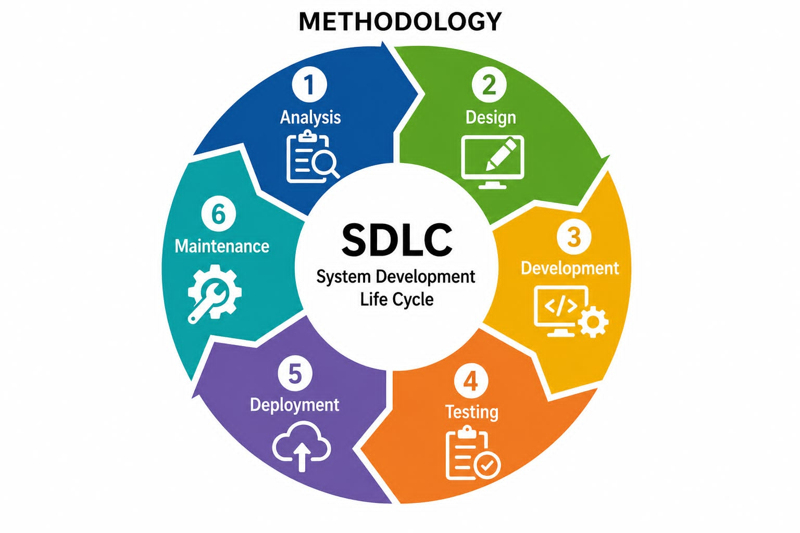
Methodology

  - Analysis Phase - In the analysis phase, the researchers collected and analyzed the information required for the development of the proposed system. Data were collected through interviews, consultations, observations and document reviews to understand the administrative processes, user requirements and existing workflow of the School Directress Office. The information collected was used to determine the system requirements and define the project’s scope.
  - Design Phase - During this phase, the researchers turned the requirements that they had gathered into system design. This involved designing the database structure, system architecture, user interface, process flow and functional modules. The design was developed to ensure the level of use for the system and to support the administrative activities for the School Directress Office.
  - Development Phase - The development phase involved the development of the web-based system based on the approved design. Each module of the system was developed by the researchers, integrated the database, and the required features and functions were implemented according to the identified requirements.
  - Testing Phase - The developed system was tested by various testing activities to verify the proper function of each module. Problems with the system and errors found during the tests were corrected to ensure the system works as specified in the requirements.
  - Deployment Phase - Once it was tested successfully, the system was ready to be deployed. The system was installed and configured for authorized users to access the system’s features and perform administrative functions in the School Directress Office.
  - Maintenance Phase - The maintenance phase is the monitoring of the performance of the system after the system has been deployed. User feedback and future management requirements are used for updates, corrections and improvements to the system to make sure it is reliable, secure and functional.

3.1 Agile Scrum Methodology in the Project
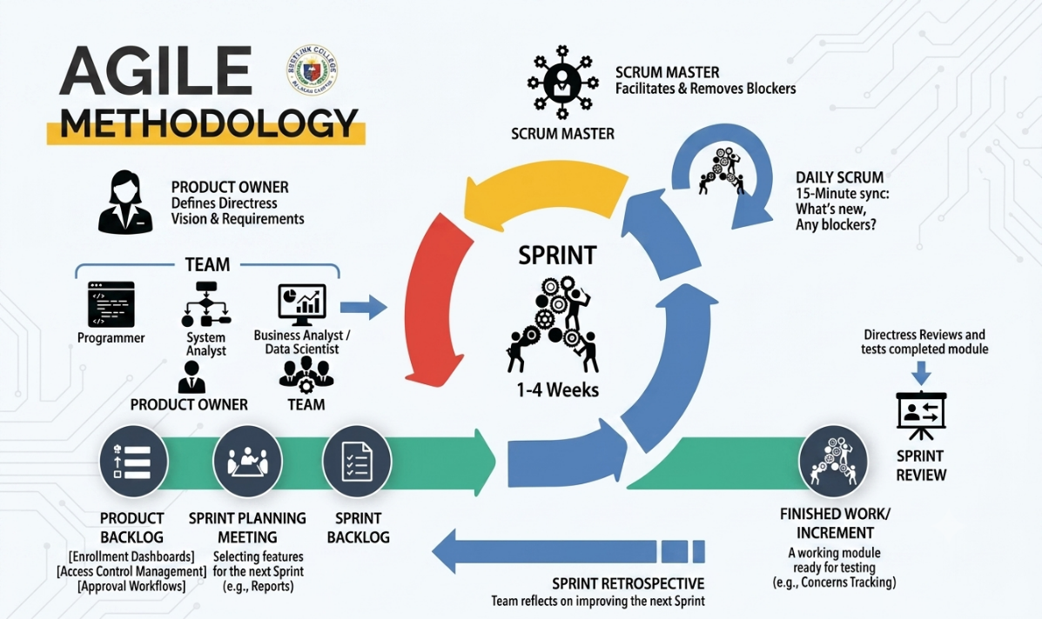

The development of the School Directress System for Bestlink College of the Philippines - Bulacan Campus will be guided by the Agile Scrum methodology, which offers a structured yet highly flexible model for managing software development. The initial step of the project involves creating a comprehensive product backlog that lists all the required features of the system, such as student enrollment monitoring, faculty performance analytics, curriculum management, and academic reporting tools. The Scrum team will then select and develop these backlog items into working software increments during Sprints, which are short development cycles averaging between two and four weeks. At the end of every sprint, a review meeting is held to demonstrate the progress such as a functional Student Records Module and receive direct feedback from the School Directress, campus administrators, and department heads. The development team remains on track through daily stand-up meetings that help them identify and resolve technical problems within a short period. To achieve continuous improvement, the team conducts a retrospective after every sprint to evaluate what went well and what can be enhanced. By delivering the system in small, specific increments, Scrum reduces project risks and ensures that the final software is reliable, secure, and perfectly tailored to the administrative needs of the institution.
The School Directress System is developed using Scrum rather than traditional project management approaches due to its high flexibility in meeting the complex and dynamic needs of an educational environment. In contrast to traditional models like the Waterfall model, which require strict adherence to sequential phases, Scrum enables the project to be developed in iterative sprints. This allows the team to release functional modules, such as the enrollment overview or reporting tools, at the early stages of the process. Consequently, testing and feedback from the School Directress and campus staff can happen quickly, enabling the team to adapt to changing institutional requirements before the project is finalized. Because Scrum relies on specific sprint cycles, reviews, and retrospectives, it guarantees absolute transparency and a steady workflow. Ultimately, this methodology promotes high collaboration, strong stakeholder engagement, and relentless improvement, which are vital in creating a dependable administrative system where data accuracy, usability, and efficient oversight are paramount.

3.2 Roles and Responsibilities
ROLES | NAME AND CONTACT INFORMATION |  | RESPONSIBILITIES
Scrum Master | Rhea F. Villones  rheavillones8@gmail.com | Scrum Master is the team member who acts as the facilitation and coordinator of the group. Serve as a bridge between stakeholders and the team
Programmer | Andrei Elbambuna  andrie.elbambuena1221@gmail.com | While a programmer focuses mainly on writing the actual code, a software developer takes the big ideas, designs how the system looks and works, and turns those conceptual ideas into a reality.
System Analyst | John Robert Matapa  romeroarjayy@gmail.com | A Systems Analyst is a professional who studies how a business works and designs the computer systems needed to make it better. They act as a bridge between the business users and the programmers.
Business  Analyst | Jann Karl Dela Cruz  jkarldc@gmail.com | A Business Specialist (often called a Business Analyst) is the team member who makes sure the software fits the needs of the organization.
Document Specialist | Angel C. Hantoc  hanangelc85@gmail.com | A Document Specialist organizes, prepares, and manages all documents for a project. Their main job is to make sure every document has the same professional style and formatting, giving all materials a neat and unified look.

3.3 Sprint Cycles
SPRINT | FEATURE | TASK/DEVELOPED | DURATION
Sprint 1 | Dashboard and Analytics | - Create UI Design for Directress Dashboard  - Layout for the overview of campus statistics (enrollment, overall performance, department statuses)  - Integrate analytics data visualization (graphs and charts for decision-making) | 15 Days
Sprint 2 | User and Access Management | - Create UI Design for User Roles and Access Levels  - Implement user management database (for Admins, Faculty, and Staff)  - Set up role-based access control (RBAC) to secure the Directress portal. | 17 Days
Sprint 3 | Department and Unit Management | - Design department list and unit management interface.  - Implement CRUD (Create, Read, Update, Delete) functions for college departments and administrative units.  - Link academic departments to their respective unit heads. | 14 Days
Sprint 4 | Approval and Decision Support | - Design approval request table and UI for Directress review  - Enable "Approve", "Disapprove", and "Defer" buttons for institutional requests, budgets, or major campus proposals  - Set up notification triggers for approved decisions | 19 Days
Sprint 5 | Communication and Announcements | - Design UI for creating and posting campus-wide announcements  - Implement announcement publishing system (targeting specific departments, faculty, or the entire campus)  - Display a real-time feed of active memos and official announcements | 13 Days
Sprint 6 | Report Submission and Management | - Design UI for academic and administrative report submission channels  - Implement document upload, categorization, and status tracking (e.g., Submitted, Under Review, Archived)  - Create a central repository for the Directress to access official institutional reports | 16 Days
Sprint 7 | Student Monitoring (Summary Level) | - Design summary UI for overall student monitoring (e.g., population count, passing/failing rates, overall attendance trends)  - * Implement search and filter functions by department, year level, or course | 15 Days
Sprint 8 | Concerns and Issue Tracking | - Design UI for receiving, reviewing, and tracking escalated campus issues and student concerns  - Create a status-tracking table (Pending, In Progress, Resolved) for school-wide resolution management | 14 Days

Daily Standups
TEAM MEMBER | ACCOMPLISHMENT | TASKS | INDEPENDENS/  CHALLENGES

3.4 Scrum Artifacts
Product Backlog
USER  STORY  NO. | USER  STORIES | USER STORIES PRIORITI ES | REVISED  PRIORITY | STATUS
1 |  | 1 | - | DONE

Sprint Backlog
FEATURES | NAME OF ROLES | DURATION

