Object-Oriented Programming Documentation
Bora NAS

1.Introduction
This document serves as the official documentation for the Wildlife Simulation and Conservation System assignment. The system models a wildlife reserve where different animals with unique temperaments and states are managed within specific habitats.
A central WildlifeSimulation manager class oversees the daily operations, including loading data from files, monitoring animal health and stress, and managing the interactions between Rangers, Poachers, and the reserve's resources like Vehicles.
Throughout this documentation, I will describe the simulation exercise, present the UML class diagram, and explain the implementation of key methods. This document aims to demonstrate the structure, logic, and behavior of the system before moving on to the unit testing results.

2.Description of the Exercise

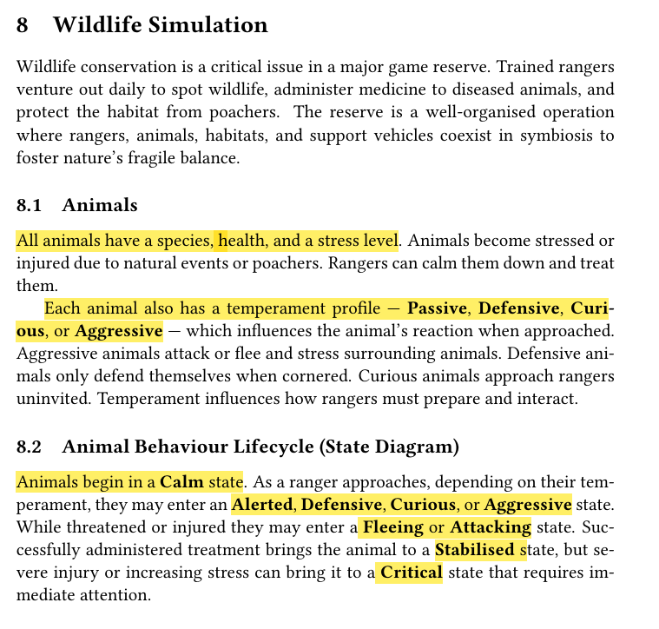

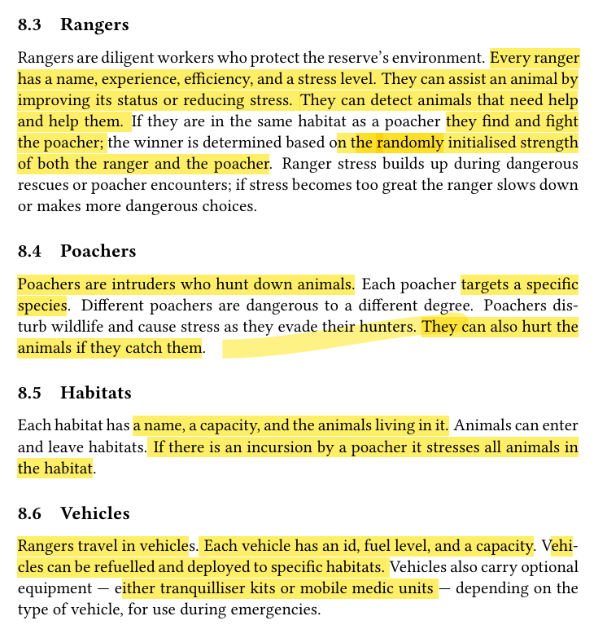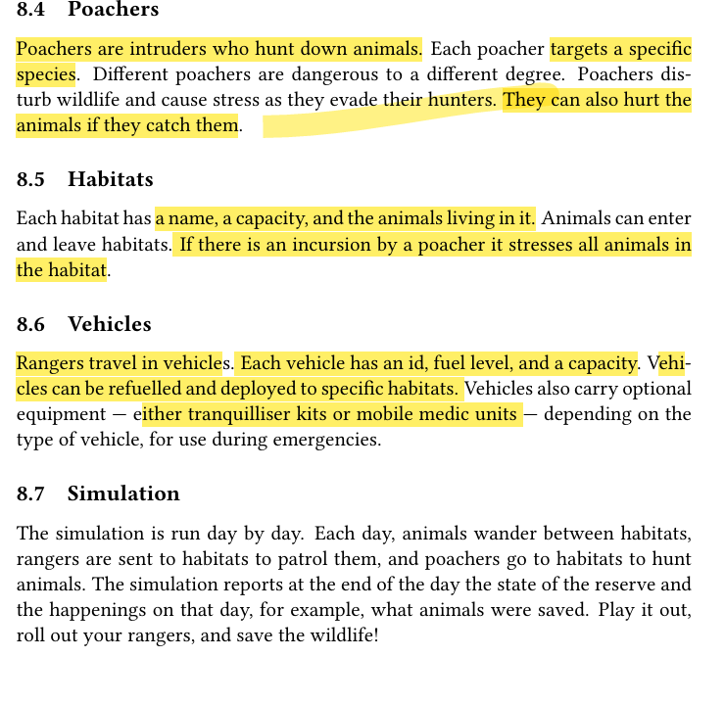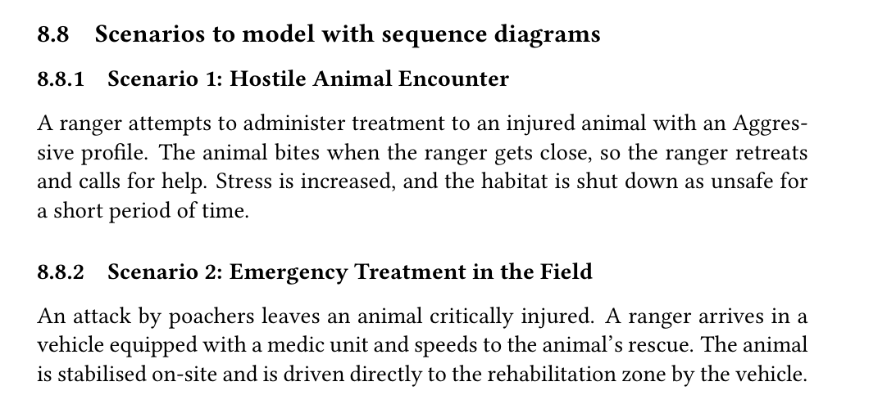

3.Diagrams

3.1 Uml Diagram
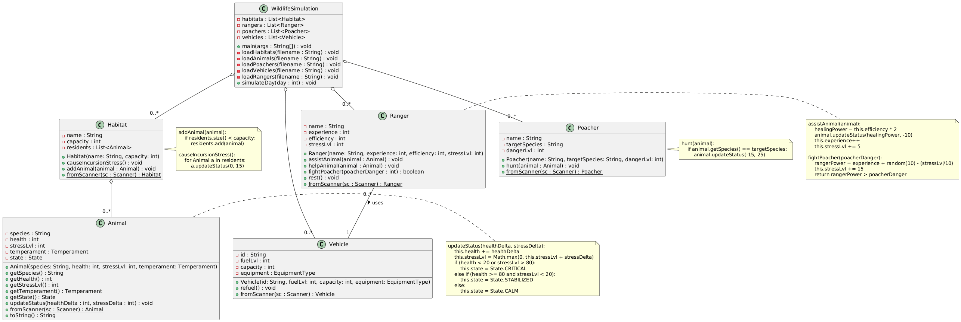

3.1.1
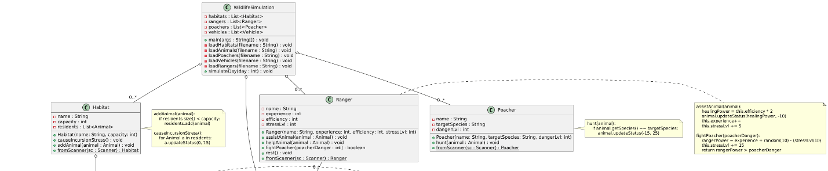

3.1.2

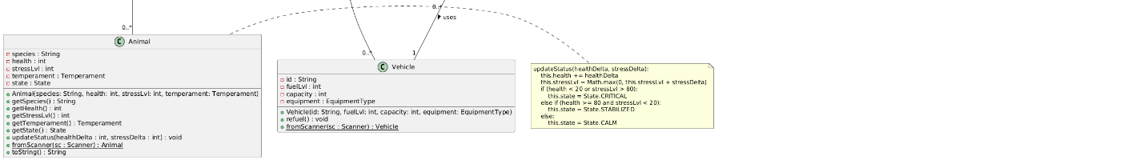

3.2 State Diagram
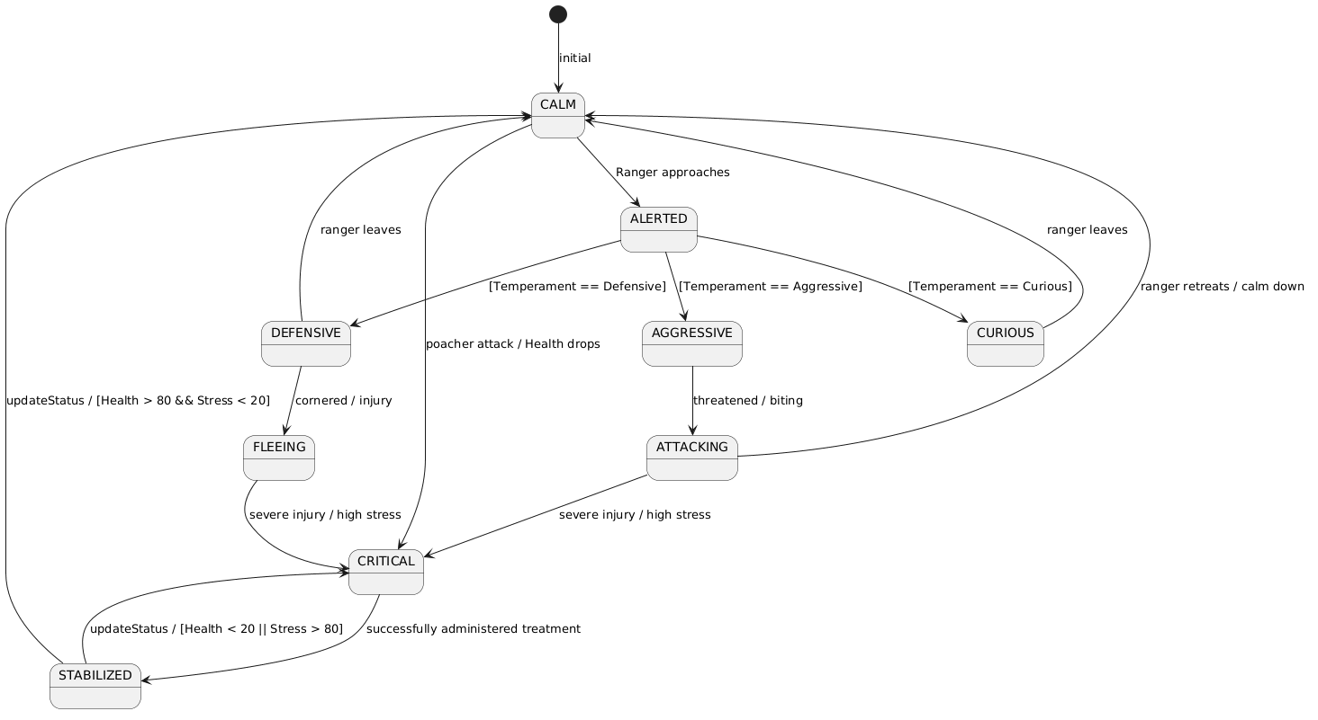

3.3 Use Case Diagram
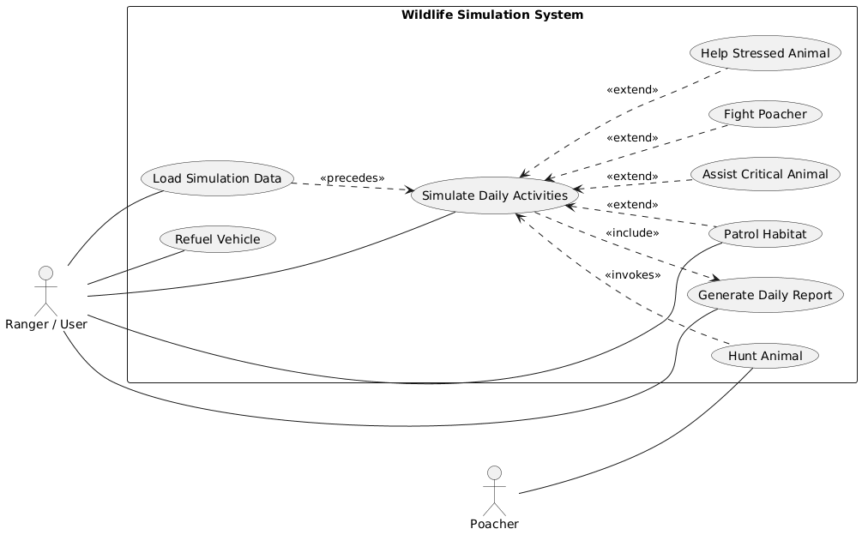

3.4 Sequence Diagram

Scenario 1 – Hostile Animal Encounter
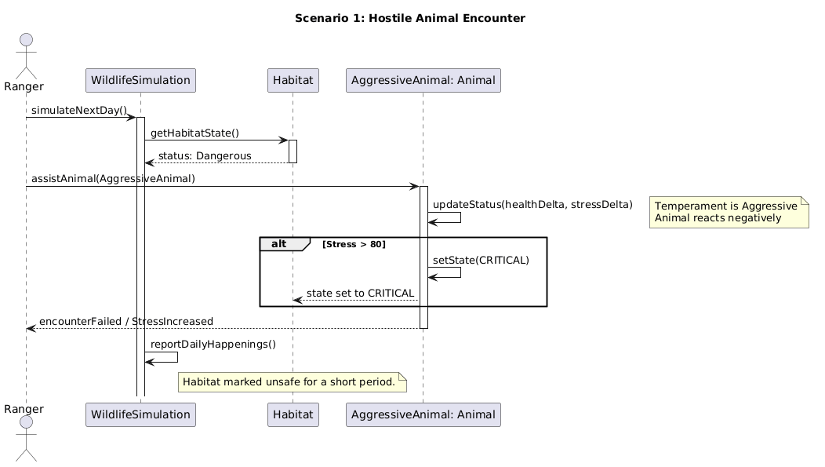

3.4.1 Sequence Diagram 2

Scenario 2 – Emergency Treatment in the Field
Scenario 2: Emergency Treatment in the Field
