**Chapter (4):**

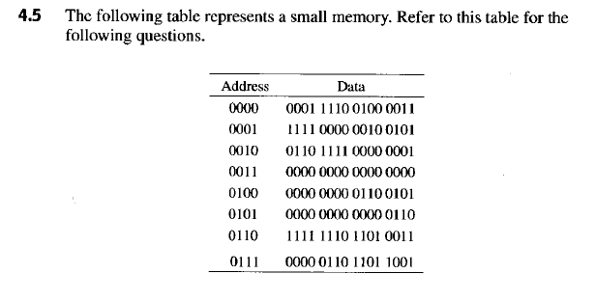

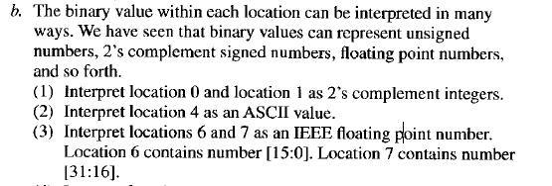

1. To obtain 2’s compliment, we must add 1 to all the bits. Which will invert, which is the intended purpose.
   1. Location 0’s Value: 0001 1110 0100 0011
      1. The sign bit is positive (0). So we convert this number into a decimal number as follows:

4.7

4.9

4.11

**Chapter (5):**

5.1

5.4

5.8

5.15