Lab 3: The Execute Pipeline Stage

George Suarez and Patrick Duggin

October 31, 2018

# Introduction

The objective of this lab is to implement and test the Execution (EX) pipeline stage and integrate it with the IF and ID stages. There are 5 components to implement for this stage which are: ADDER, TOP_MUX, BOTTOM_MUX, ALU, ALU_CONTROL. We also need to implement a EX_MEM module that connects the wires from the IF/ID stage. Then we instantiate a I_EXECUTE module in the pipeline where it will connect with the other stages.

# Interface

The ADDER module will take in two 32-bit addresses which will be added together to compute the branch target address.

Table 1: adder Inputs

|  |  |
| --- | --- |
| Name | Function |
| add_in1 | 32-bit address |
| add_in2 | 32-bit address |

Table 2: adder2 Output

|  |  |
| --- | --- |
| Name | Function |
| add_out | The 32-bit address which has the branch target address |

The TOP_MUX module takes in two 32-bit addresses and a select wire that will determine the result that will go through the ALU in which a 32-bit address will have that result.

Table 3: top_mux Inputs

|  |  |
| --- | --- |
| Name | Function |
| a | The 32-bit address (source) |
| b | The 32-bit address (target) |
| alusrc | The 1-bit select wire |

Table 4: top_mux Output

|  |  |
| --- | --- |
| Name | Function |
| y | The 32-bit address that contains the result that goes to the ALU |

The BOTTOM_MUX module works similarly to the TOP_MUX module, but the difference is that it takes in two 5-bit wires instead of a 32-bit wire.

Table 5: bottom_mux Inputs

|  |  |
| --- | --- |
| Name | Function |
| a | The 5-bit wire that will pass in instr[20:16] |
| b | The 5-bit wire that will pass in instr[15:11] |
| sel | The 1-bit select wire that will determine to use either a or b |

Table 6: bottom_mux Outputs

|  |  |
| --- | --- |
| Name | Function |
| y | The 5-bit wire that will contain either a or b that goes through to the next stage (MEM) |

The ALU module takes in two 32-bit wires that will be used to compute the result of the ALU depending what the 3 control bits that determines to perform the operations of addition, subtraction, and, or, and slt. If the result is 0, then we assign a 1 to make it true; otherwise, assign it 0 if it's a nonzero number.

Table 7: alu Inputs

|  |  |
| --- | --- |
| Name | Function |
| a | The 32-bit wire that comes from the ID/EX latch |
| b | The 32-bit wire that comes from the ID_EX latch |
| control | The 4 control bits that determines what operation to use |

Table 8: alu Outputs

|  |  |
| --- | --- |
| Name | Function |
| result | The 32-bit register that contains the result of the ALU |
| zero | The wire that contains either 1 or 0 depending on the result |

The ALU_CONTROL module takes in a 2-bit control wire that will determine if the opcode is valid or not. If it is valid, then it assigns a value to select depending on the bits of the funct field. If the control wire receives an invalid opcode, then the output of the alu will have 32 x's.

Table 9: alu_control Inputs

|  |  |
| --- | --- |
| Name | Function |
| funct | The 6-bit parameter that determines which ALU operation to perform depending on the bits that is in the funct field |
| aluop | The 2-bit control wire that determines if the opcode is valid or not. |

Table 10: alu_control Outputs

|  |  |
| --- | --- |
| Name | Function |
| select | The 3-bit register that contains the control bits to determine which action the ALU will take. |

The EX_MEM module takes in a 2-bit control wire that will go into the next stage, a 3-bit control wire that determines reading, writing, and branching from memory, a 1-bit control wire that contains a zero from the ALU, a 32-bit wire that has the result from the ALU, the 32-bit data that goes into the next stage that has not been implemented yet, and a 5-bit wire from the bottom_mux component. Note that the 3-bit control wire gets divided into 3 wires.

Table 11: ex_mem Inputs

|  |  |
| --- | --- |
| Name | Function |
| ctlwb_out | The 2-bit control wire that controls |
| ctlm_out | The 3-bit control wire that determines reading, writing, and branching memory |
| adder_out | The 32-bit wire that carries the result from the adder module |
| aluzero | The 1-bit wire that carries the result of a 1 or 0 from the ALU_CONTROL module |
| aluout | The 32-bit wire that carries the result of the ALU |
| readdata2 | The 32-bit wire that carries the data from the target register from the previous stage |
| muxout | The 5-bit wire that carries the result from the bottom_mux module |

Table 12: ex_mem Outputs

|  |  |
| --- | --- |
| Name | Function |
| wb_ctlout | The 4-bit register that contains the result from the ctlwb_out wire |
| branch | The 1-bit register that has the contents of ctlm_out[0] |
| memread | The 1-bit register that has the contents of ctlm_out[1] |
| memwrite | The 1-bit register that has the contents of ctlm_out[2] |
| add_result | The 32-bit register that has the result from adder_out |
| zero | The 1-bit register that contains whether the aluzero contains a 1 or 0 |
| alu_result | The 32-bit register that contains the result from aluout |
| rdata2out | The 32-bit register that contains the contents of readdata2 |
| five_bit_muxout | The 5-bit register that contains the result of muxout |

# Design

The design of the ADDER module two 32-bit addresses and outputs the result of those two 32-bit addresses.

Figure 4: Adder design

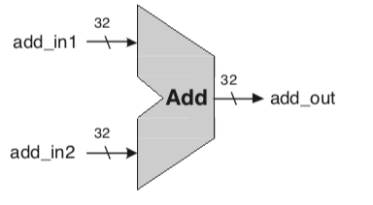

The design of the MUX module takes in two 5-bit wires with a 1-bit select wire that determines to use either of the 5-bit wires.

Figure 5: MUX design

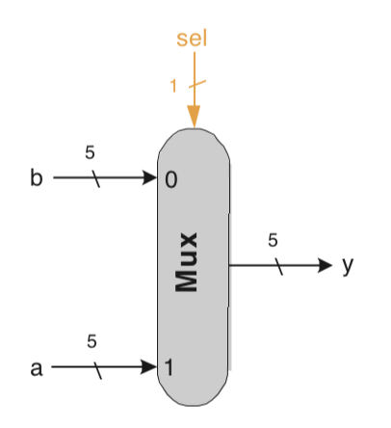

The design of the ALU module takes in two 32-bit wires with a 3-bit control wire that controls what the result will be.

Figure 6: ALU design

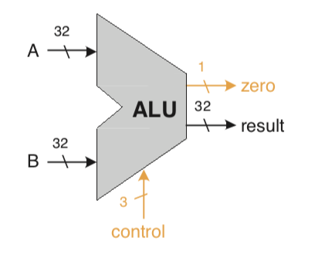

The design for the ALU CONTROL module takes in a 6-bit wire and as well a 3-bit wire that determines what actions the ALU will take.

Figure 7: ALU CONTROL module design

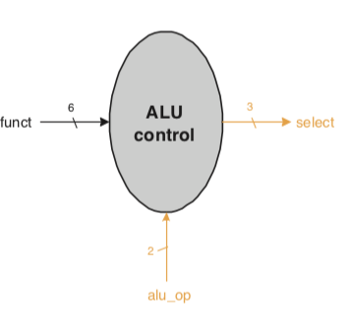

The design of the EX_MEM module takes in a 5-bit control wire in which controls reading, writing, and branching memory, a 32-bit wire that carries the result of the adder, a 1-bit wire that has either a 1 or 0, a 32-bit wire that holds the result from the ALU, a 32-bit wire that contains the data from the previous stage, and a 5-bit wire that carries the result from the mux module.

Figure 7: EX MEM module design

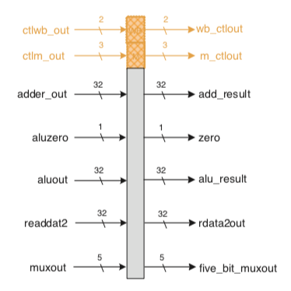

# Implementation

Listing 1: Implementation for adder

|  |
| --- |
| `timescale 1ns / 1ps  module adder (  input wire [31:0] add_in1,  input wire [31:0] add_in2,  output wire [31:0] add_out  );    assign add_out = add_in1 + add_in2;      endmodule // adder |

Listing 2: Implementation for top_mux

|  |
| --- |
| `timescale 1ns / 1ps  module top_mux(  output wire [31:0] y,  input wire [31:0] a, b,  input wire alusrc  );    assign y = alusrc ? a : b;    endmodule // top_mux |

Listing 3: Implementation for bottom_mux

|  |
| --- |
| `timescale 1ns / 1ps  module bottom_mux(  output wire [4:0] y,  input wire [4:0] a, b,  input wire sel  );    assign y = sel ? a : b;    endmodule // bottom_mux |

Listing 4: Implementation for alu

|  |
| --- |
| `timescale 1ns / 1ps  module alu (  input wire [31:0] a,  input wire [31:0] b,  input wire [2:0] control,  output reg [31:0] result,  output wire zero  );    parameter ALUadd = 3'b010,  ALUsub = 3'b110,  ALUand = 3'b000,  ALUor = 3'b001,  ALUslt = 3'b111;    // Handles negative inputs  wire sign_mismatch;  assign sign_mistach = a[31] ^ b[31];    initial  result <= 0;    always @ *  case( control )  ALUadd : result = a + b;  ALUsub : result = a - b;  ALUand : result = a & b;  ALUor : result = a || b;  ALUslt : result = a < b ? 1 - sign_mismatch : 0 + sign_mismatch;  default : result = 32'bX;  endcase    /* Check to see if result is equal to zero. If it is assign true (1),  false (0) otherwise, meaning it is a non-zero number */  assign zero = ( result == 0 ) ? 1 : 0;    endmodule // alu |
|  |

Listing 5: Implementation for the alu_control module

|  |  |
| --- | --- |
| `timescale 1ns / 1ps  module alu_control (  input wire [5:0] funct,  input wire [1:0] aluop,  output reg [2:0] select  );    parameter Rtype = 2'b10;  Radd = 2'b10,  Rsub = 2'b10,  Rand = 2'b10,  Ror = 2'b10,  Rslt = 2'b10;    parameter lwsw = 2'b00, // Since LW and SW use the same bit pattern, only way to store them as a parameter  Itype = 2'b01, // beq, branch  xis = 6'bXXXXXX;    // ALU Control Inputs Designation  parameter ALUadd = 3'b010, // For R-type instructions  ALUsub = 3'b110,  ALUand = 3'b000,  ALUor = 3'b001,  ALUslt = 3'b111;    // If the input information does not correspond to any valid instruction,  // alu_op = 2'b11 which sets control = ALUx = 3'b011  // and ALU output is 32 x's as required by lab manual  parameter unknown = 2'b11, // For invalid opcode, ALUop = 2'b11  ALUx = 3'b011;    // Funct field  parameter FUNCTadd = 6'b100000,  FUNCTsub = 6'b100010,  FUNCTand = 6'b100100,  FUNCTor = 6'b100101,  FUNCTslt = 6'b101010;    initial  select <= 0;    always @ * begin  if ( aluop == Rtype )  begin  case ( funct )  // Assign the correct select value based on the function field  // Use Fig 3.2 to aid you in this.  // Desired ALU action  FUNCTadd : select <= ALUadd;  FUNCTsub : select <= ALUsub;  FUNCTand : select <= ALUand;  FUNCTor : select <= ALUor;  FUNCTslt : select <= ALUslt;  default : select <= ALUx;  endcase  end    // For all other types. Use figure 3.2 to help you out.  // Feel free to reuse any of the parameters defined above.  else if ( aluop == lwsw )  begin  select <= ALUadd;  end    else if ( aluop == Itype )  begin  select <= ALUsub;  end    else if ( aluop == unknown )  begin  select <= ALUx;  end    else  begin  select <= select;  end  end  endmodule // alu_control  Listing 6: Implementation for the ex_mem module   |  | | --- | | `timescale 1ns / 1ps  module ex_mem(  input wire [1:0] ctlwb_out,  input wire [2:0] ctlm_out,  input wire [31:0] adder_out,  input wire aluzero,  input wire [31:0] aluout, readdata2,  input wire [4:0] muxout,  output reg [1:0] wb_ctlout,  output reg branch, memread, memwrite,  output reg [31:0] add_result,  output reg zero,  output reg [31:0] alu_result, rdata2out,  output reg [4:0] five_bit_muxout  );    initial begin  wb_ctlout <= 0;  branch <= 0; memread <= 0; memwrite <= 0;  add_result <= 0;  zero <= 0;  alu_result <= 0; rdata2out <= 0;  five_bit_muxout <= 0;  end    always @ * begin  #1 // Update Delay    // Use FIg 3.7 to assign the inputs to the outputs  wb_ctlout <= ctlwb_out;  branch <= ctlm_out[0];  memread <= ctlm_out[1];  memwrite <= ctlm_out[2];  add_result <= adder_out;  zero <= aluzero;  alu_result <= aluout;  rdata2out <= readdata2;  five_bit_muxout <= muxout;  end  endmodule // ex_mem | |

# Test Bench Design

The ALU test bench is designed to show different ALUOp codes, and the result from those ALUOp codes. It will cycle through different control bits which determines what happens to the A and B wires.

The ALU CONTROL test bench is designed to show what ALUOp codes are being used and what function fields are being used in the process.

The MUX test bench is designed to show what wire is being selected depending if the wire is 1 or 0.

Listing 6: ALU test bench

|  |  |
| --- | --- |
| `timescale 1ns / 1ps  module test ();    // Register Declarations  reg [31:0] a, b;  reg [2:0] control;    // Wire Ports  wire [31:0] result;  wire zero;    initial begin  a <= 'b1010;  b <= 'b0111;  control <= 'b011;    $display("A = %b\tB = %b", a, b);  $monitor("ALUOP = %b\tresult = %b", control, result);    #1  control <= 'b100;    #1  control <= 'b010;    #1  control <= 'b111;    #1  control <= 'b110;    #1  control <= 'b001;    #1  control <= 'b000;    #1  $finish;  end    alu alu2 ( .a( a ), .b( b ), .control( control ), .result( result ), .zero( zero ) );  endmodule    Listing 7: ALU CONTROL Test Bench   |  | | --- | | module test ();    // Wire ports  wire [2:0] select;    // Register Declarations  reg [1:0] aluop;  reg [5:0] funct;    alu_control alu_control2 ( .funct( funct ), .aluop( aluop ), .select( select ) );    initial begin  aluop = 2'b00;  funct = 6'b100000;  $monitor("ALUOp = %b\tfunct = %b\tselect = %b", aluop, funct, select);    #1  aluop = 2'b01;  funct = 6'b100000;    #1  aluop = 2'b10;  funct = 6'b100000;    #1  funct = 6'b100010;    #1  funct = 6'b100100;    #1  funct = 6'b100101;    #1  funct = 6'b101010;    #1  $finish;  end  endmodule | |

Listing 8: MUX Test Bench

|  |
| --- |
| module test ();    // Wire ports  wire [4:0] y;    // Register Declarations  reg [4:0] a, b;  reg sel;    mux mux2( .y( y ), .a( a ), .b( b ), .sel( sel ) );    initial begin  a = 5'b01010;  b = 5'b10101;  sel = 1'b1;    #10  a = 5'b00000;    #10  sel = 1'b1;    #10  b = 5'b11111;    #5  a = 5'b00101;    #5  sel = 1'b0;  b = 5'b11101;    #5  sel = 1'bx;  end    always @ ( a or b or sel )  #1  $display("At t = %0d sel = %b A = %b B = %b Y = %b", $time, sel, a, b, y);    endmodule |

# Simulation

Figure 9: ALU test results from Listing 6



Figure 10: ALU CONTROL test results from Listing 7



Figure 11: MUX test results from Listing 8



# Conclusions

<Insert Conclusion Here>