Homework 3

Yousef Jarrar

03/04/2019

Dr. Tong yu

**( 20 points )  #1**  
A DHT Chord network uses 4 bits (i.e. *m* = 4 ) to identify machines and keys of entities. At a certain time, machines with identifiers 2, 5, 9, and 11 are attached to and active in the network.

1. Draw a diagram to show the machine ids and keys of the network.
2. Find the finger table of each of the machines.
3. An application running in node 11 is looking for the entity with key value 7. Find the route the system takes to get to the node that has the entity. Show your steps clearly and draw the route on your diagram.

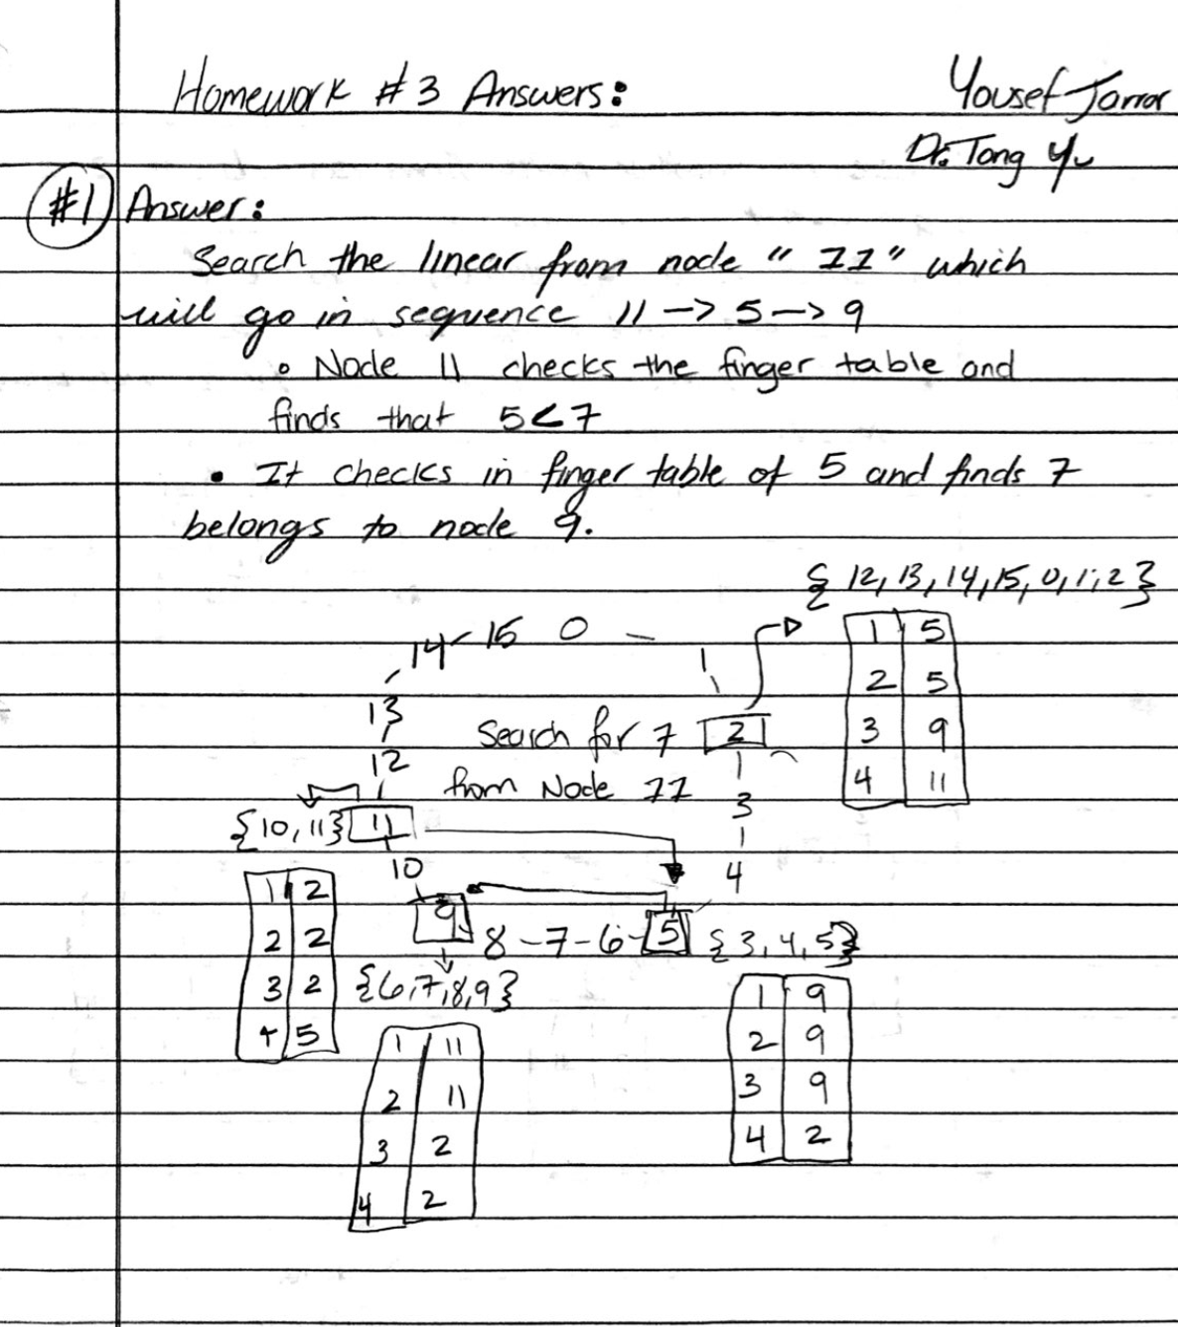

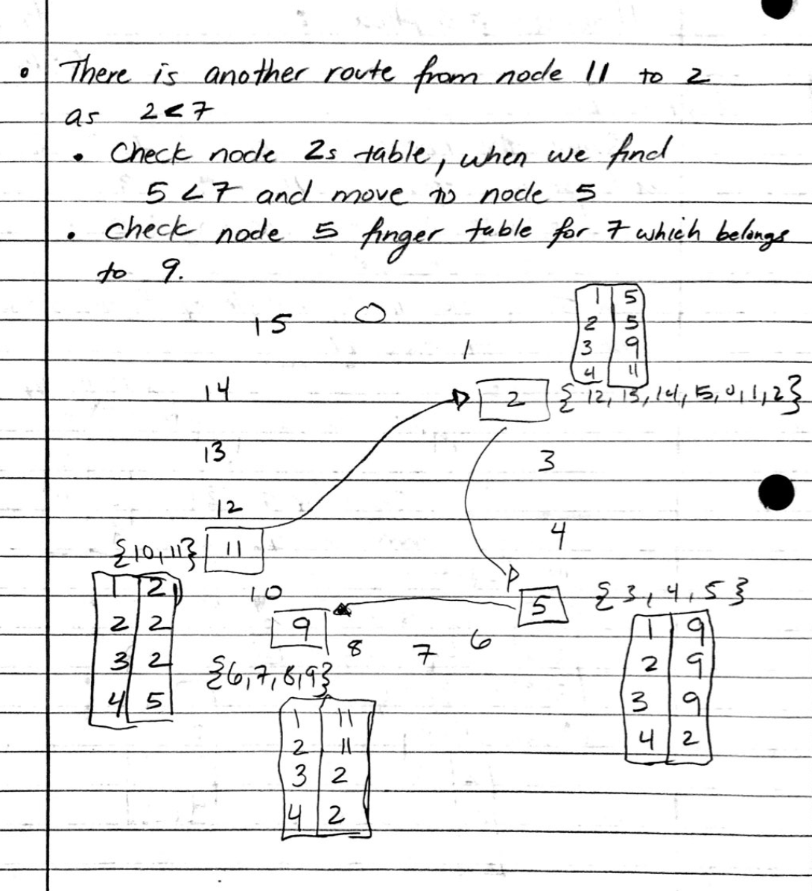

**( 10 points )  #2**

1. Would you consider a URL such as *http://www.acme.org/index.html*to be location independent? What about *http://www.acme.nl/index.html*?
2. Consider the behavior of two machines in a distributed system. Both have clocks that are supposed to tick 1000 times per millisecond. One of them actually does, but the other ticks only 990 times per millisecond. If UTC updates come in once a minute, what is the maximum clock skew that will occur?

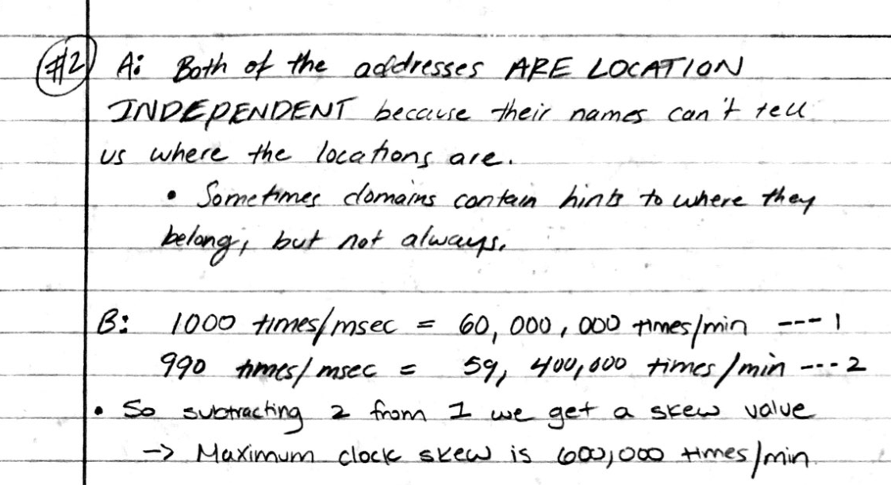

**( 10 points )  #3**   
  
 If each process uses a different value for d in the Lamport's clock and vector clock equations, will the logical clocks and vector clocks schemes satisfy the total order relation => and the relation:

a → b iff ta < tb

Explain your argument in detail. 

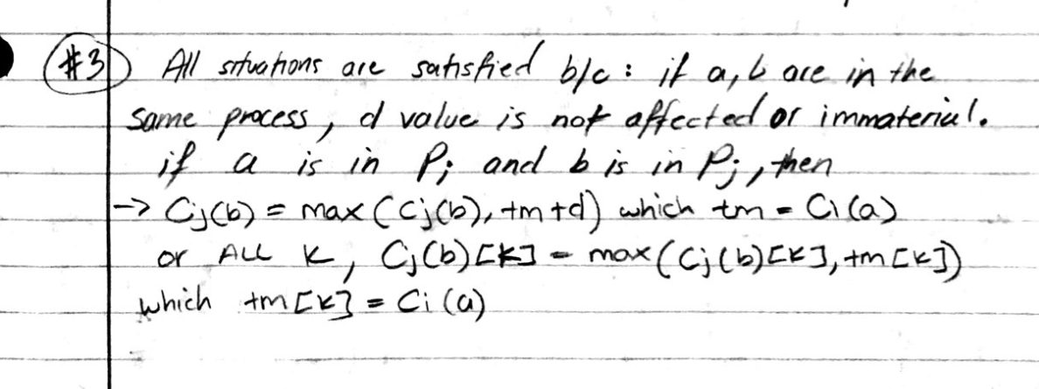

**( 10 points )  #4**  
Suppose Process P1 has events

e11, e12, e13, e14, e15 e16 e17

P2 has events

e21, e22, e23, e24, e25, e26,

P3 has events

e31, e32, e33, e34, e35 e36

There are message transits from e12 to e22, e24 to e15, e21 to e32, e35 to e25. Suppose the vector time clocks for e11, e21, and e31 are

|  |  |  |  |  |  |  |  |  |  |  |
| --- | --- | --- | --- | --- | --- | --- | --- | --- | --- | --- |
|  | 1 0 0 |  | , |  | 0 1 0 |  | , |  | 0 0 1 |  |

respectively.

a) Draw a diagram to show all the transitions and events.

b) Find the vector clocks of all the events.

c) Give an example for each of the following:

i) a strongly consistent state

ii) a consistent but not strongly consistent state

iii) an inconsistent state

Your global state should be consisted of the the events given ( e.g. e11 ) but should **not** contain any event that is sending ( e.g. e12 ) or receiving a message ( e.g. e22 ).

