Lab 5 – Write Up
Yousef Jarrar, Jose Perez
CSE 461 – Adv. Operating Systems

- What is XDR and what is it for?
  - External Data Representation, which is a standard data serialization format, for uses such as computer network protocols. Allows data to be transferred between different kinds of computer systems. Converting from the local representation to XDR is called encoding.

- How do you compile an input file into XDR routines?
  - You would use the rpcgen compiler to convert all your server programming. This is used to create routines in XDR. This converts the local data structures into XDR format and in the reverse. The RPCGen Compiler is used to generate both stub routines and XDR. For each RPC data type used in the.x file, rpcgen assumes that libnsl contains a routine with a name that is the name of the data type, prepended by the XDR routine header

SAMPLE RPC APPLICATION

/* rand.x */

program RAND_PROG {
version RAND_VERS {
void INITIALIZE_RANDOM ( long ) = 1; /* service #1 */
double GET_NEXT_RANDOM ( void ) = 2; /* service #2 */
} = 1;
} = 005845836; /* program # */
** We then ran the following command, and it compiled a bunch of .c files for us to use

rpcgen -C -a rand.x

make -f Makefile.rand

Below is the code for the first portion of the Lab, before we implement “Parallel Random Number Generator”

rand_server.c

#include "rand.h"
void *
initialize_random_1_svc(long *argp, struct svc_req *rqstp)
{
static char * result;
return (void *) &result;
}
double *
get_next_random_1_svc(void *argp, struct svc_req *rqstp)
{
static double result;
result +=0.31;
if(result >= 1.0)
result -= 0.713;
return &result;
}
rand_client.c

#include "rand.h"
double
rand_prog_1(char *host)
{
CLIENT *clnt;
void *result_1;
long initialize_random_1_arg;
double *result_2;
char *get_next_random_1_arg;
#ifndef DEBUG
clnt = clnt_create (host, RAND_PROG, RAND_VERS, "udp");
if (clnt == NULL) {
clnt_pcreateerror (host);
exit (1);
}
#endif /* DEBUG */
/*
* result_1 = initialize_random_1(&initialize_random_1_arg, clnt);
if (result_1 == (void *) NULL) {
clnt_perror (clnt, "call failed");
}
*/
result_2 = get_next_random_1((void*)&get_next_random_1_arg, clnt);
if (result_2 == (double *) NULL) {
clnt_perror (clnt, "call failed");
}
#ifndef DEBUG
clnt_destroy (clnt);
#endif /* DEBUG */
return *result_2;
}
int
main (int argc, char *argv[])
{
char *host;
if (argc < 2) {
printf ("usage: %s server_host\n", argv[0]);
exit (1);
}
host = argv[1];
//rand_prog_1 (host);
double x;
int i;
printf("\n Twenty Random Numbers");
for ( i = 0; i<20; ++i){
x = rand_prog_1(host);
printf(" %f\n, ", x);
}
exit (0);
}

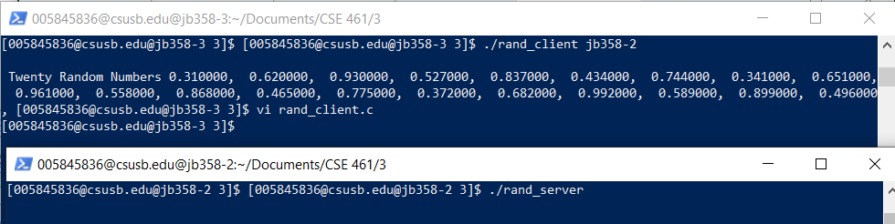

9. Parallel Random Number Generator:

rand_server.c
#include "rand.h"
int *
get_next_random_1_svc(params *argp, struct svc_req *rqstp)
{
static int result;
int xl, xr;
xl = argp->xleft;
xr = argp->xright;
result = (11 * xl + 13 * result + 5 * xr ) % 31;
return &result;
}
rand_client.c

#include <SDL/SDL.h>
#include <SDL/SDL_thread.h>
#include "rand.h"
#define N 3 //Number of hosts/threads
char *hosts[N]; //servers
SDL_mutex *mutex;
SDL_cond *barrierQueue; //Condition Variable
int count = 0;
int era = 0;
int x[N];
int rns[N][10];
int
rand_prog_1(char *host, int xl, int xr)
{
CLIENT *clnt;
int *result_1;
params get_next_random_1_arg;
get_next_random_1_arg.xleft = xl;
get_next_random_1_arg.xright = xr;
//#ifndef DEBUG
clnt = clnt_create (host, RAND_PROG, RAND_VERS, "udp");
if (clnt == NULL) {
clnt_pcreateerror (host);
exit (1);
}
//#endif DEBUG
result_1 = get_next_random_1(&get_next_random_1_arg, clnt);
if (result_1 == (int *) NULL) {
clnt_perror (clnt, "call failed");
}
//#ifndef DEBUG
clnt_destroy (clnt);
//#endif DEBUG
return *result_1;
}
void barrier(){
int myEra; //a local variable
SDL_LockMutex ( mutex );
count ++;
if ( count < N ){
myEra = era;
while ( myEra == era )
SDL_CondWait ( barrierQueue, mutex );
} else {
count = 0; //reset the count
era ++;
SDL_CondBroadcast ( barrierQueue ); // Signal all threads in queue
}
SDL_UnlockMutex ( mutex );
}
int threads ( void *data ){
int k, i_minus_1, i_plus_1, id, xleft, xright;
id = *( (int *) data );
printf ("Thread %d", id);
for ( k = 0; k < 10; k++ ){
i_minus_1 = id - 1;
if (i_minus_1 < 0 )
i_minus_1 += N;
xleft = x[i_minus_1];
i_plus_1 = ( id + 1 ) %N;
xright = x[i_plus_1];
x[id] = rand_prog_1 (hosts[id], xleft, xright );
printf ("(%d: %d )", id, x[id] );
rns[id][k] = x[id];
barrier();
}
return 0;
}
int
main (int argc, char *argv[])
{
int i, j;
SDL_Thread *ids[N];
//char *host;
if (argc < 4) {
printf ("usage: %s server_host1 host2 host3 ... \n", argv[0]);
exit (1);
}
mutex = SDL_CreateMutex();
barrierQueue = SDL_CreateCond();
for ( i = 0; i < N; i++ )
x[i] = rand() % 31; //Initial Values
for ( i = 0; i < N; i++ ){
hosts[i] = argv[i+1];
ids[i] = SDL_CreateThread ( threads, &i );
}
for ( i = 0; i < N; i++)
SDL_WaitThread ( ids[i], NULL );
//print out results in buffer
printf("\n Random Numbers: ");
for ( i = 0; i < N; i++){
printf("\n From Server %d:\n", i);
for (j = 0; j < 10; ++j )
printf("%d, ", rns[i][j] );
}
printf("\n");
//host = argv[1];
//rand_prog_1 (host);
exit (0);
}

