Lab 3 – CSE 660 – Spring 2011
Erwin Soekianto – Chenwei Xu

This lab consists of 3 parts:
- RPC (Remote Procedure Call)
- Java RMI (Remote Method Invocation)
- Android Application Development (Remote UDT Calculator)

Part 1: RPC

RPC was first implemented at Frontier at 1998.

What is RPC?

It's a spec and a set of implementations that allow software running on disparate operating systems, running in different environments to make procedure calls over the Internet. [1]
It's remote procedure calling using HTTP as the transport and XML as the encoding. XML-RPC is designed to be as simple as possible, while allowing complex data structures to be transmitted, processed and returned. [1]

RPC is very compatible, which can be implemented with various operating systems, programming languages, dynamic and static environments, open source and commercial, for Perl, Python, Java, Frontier, C/C++, Lisp, PHP, Microsoft .NET, Rebol, Real Basic, Tcl, Delphi, WebObjects and Zope, and more are coming all the time.

But the one that we are using for this lab is in C and Linux operating system.

And this is how the XML-RPC works in diagram below.

Installation and configuration:

- To check whether you have RPC installed on you machine by using $man rpcgen command on your terminal, and most of the modern linux OS have RPC installed by deafult.

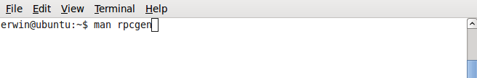
- And if you see the result something like this, that means you already have RPC installed and ready to use and you can also learn from that documentation on how to use RPC

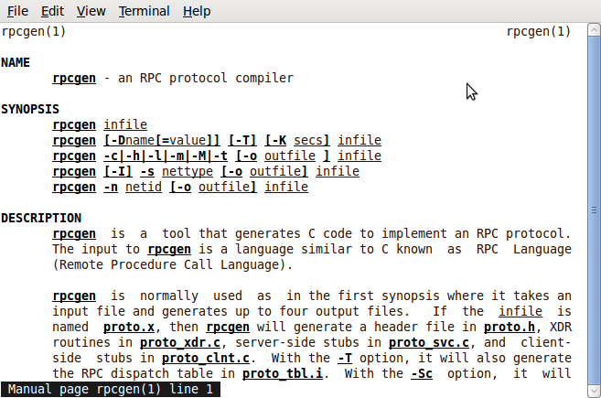
- And create a new file name name rand.x with the following content.

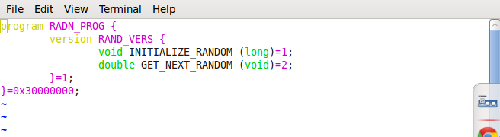
- And generated the program template by typing this command $rpcgen -C -a rand.x,
You should have generated the files:
Makefile.rand, rand_clnt.c, rand_server.c, rand_client.c, rand.h, rand_svc.c
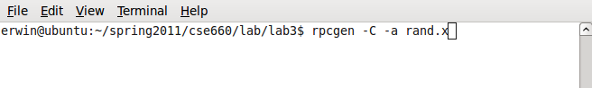
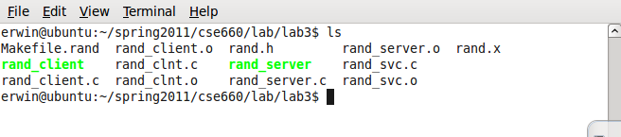
- After studying the generated files, we can edit that so that I would generate our own random numbers as assigned for this lab. And here the code from each file.

Client Code
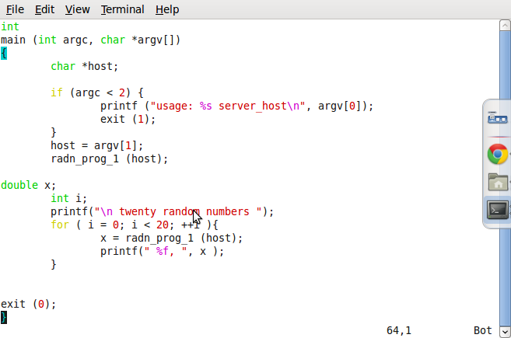

Server code
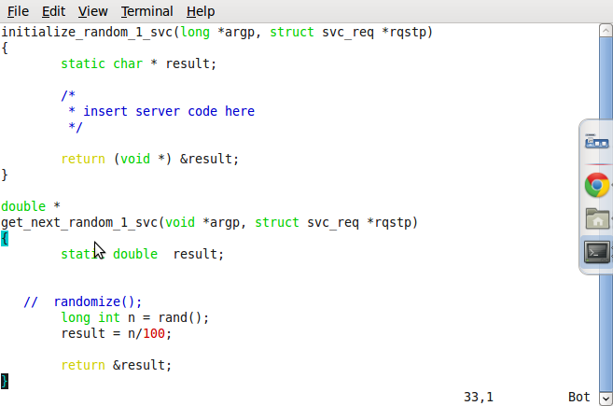

- After that, we can compile it with $make -f Makefile.rand

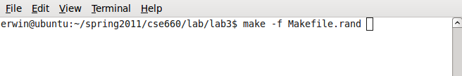
- and start the server by $./rand_server

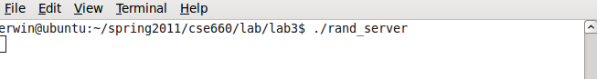

- Open another terminal or from other computer, start the client by $./rand_client localhost (or server IP address)

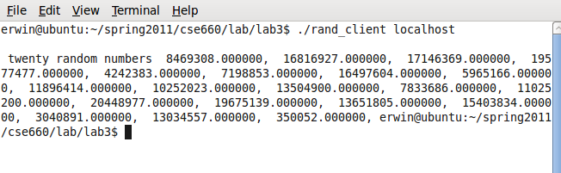
Note:
- Make sure you are in the same subnet mask when you do that remotely.
- Make sure to stop other server or connection, it could disturb the connection

Part 2: Java RMI (Remote Method Invocation)

Java RMI is a Java application programming interface that performs the object-oriented equivalent of remote procedure call (RPC).

The original implementation depends on Java Virtual Machine (JVM) class representation mechanisms and it thus only supports making calls from one JVM to another. The protocol underlying this Java-only implementation is known as Java Remote Method Protocol (JRMP)

This is the diagram how Java RMI works.

Instruction:

- Of course we need to have Java installed in our computer, we recommend to get the latest version. (As of today, June 2011, it's version 6.26)
- First, we need to create these three file: Hello.java , Server.java, and Client.java

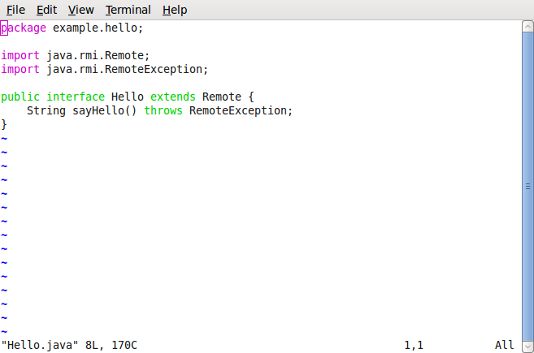
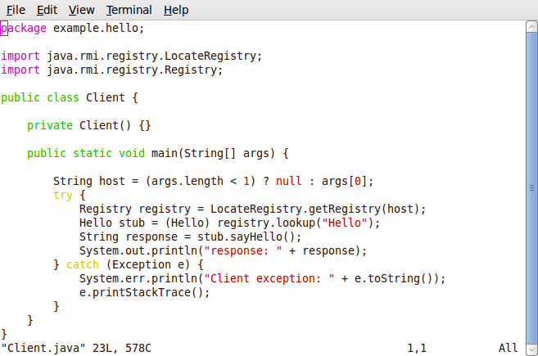

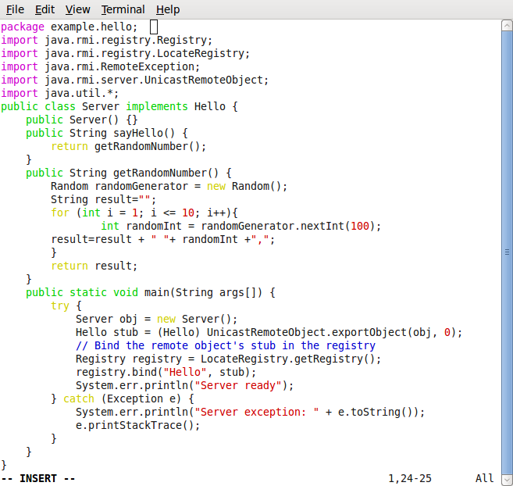
Note : If you notice that we had our custom random generator in the server side and client side.

- Then compile all the file with $javac -d destDir Hello.java Server.java Client.java

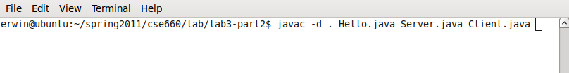

- If they are successfully compiled, we can start the RMI registry, $rmiregistry &
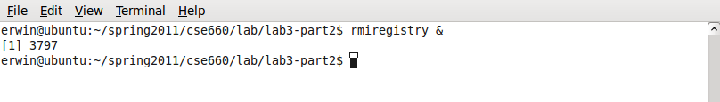
- Then start the server, $java example.hello.Server &

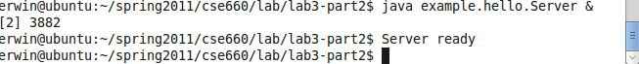

- Open another terminal or from other computer . And start the client, $ java example.hello.Client Ipaddress or empty for local host.

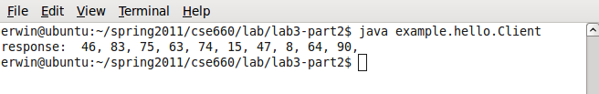
Note:
- Make sure you are in same subnet mask
- And port 1099 is open or you need to disable firewall
- And change the host file in /etc/hosts to your server ip address
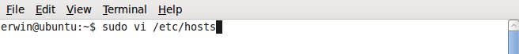

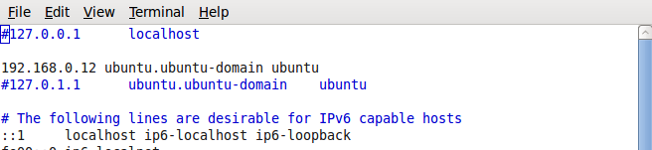

Part 3 Android Application Development

As we all know that open source has come out with the operating system for smart phone and tablet, so called Android. Android used Java as programming language where we need to use Android SDK, until today the latest version of Android is 3.1 using API 12, running in Java 6.

In developing the Application, we need to use the following and make sure you download the right thing.
- Eclipse RPC – recommend latest version <http://www.eclipse.org/downloads/>
- Java JDK and JRE (obviously) – latest version <http://www.oracle.com/technetwork/java/javase/downloads/index.html>
- Android SDK <http://developer.android.com/sdk/index.html>

Installation guide:
- Install the latest version of java
- unzip Android SDK, put it where it has write and read permission (linux) or not under C: in windows.
Eclipse Set up
- Start Eclipse, then select Help > Install new software , then this window will come out. And enter “https://dl-ssl.google.com/android/eclipse/” , and click add. This is to install ADT plug-in in eclipse

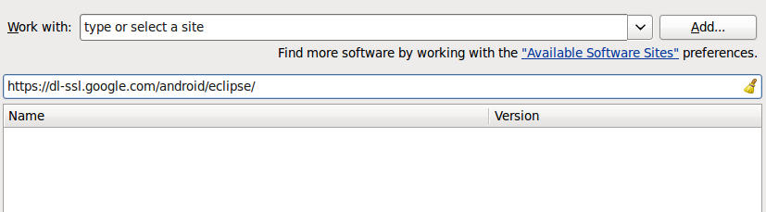
- And then we need to configure the ADT plug-in by pointing the to where we save Android SDK files. Go to Window > Preference

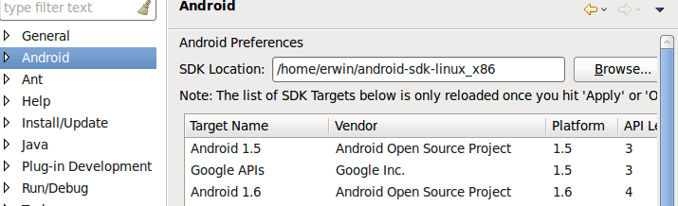
- And then we need to add Android platform and other component. By going to Window > Android SDK and AVD Manager > Available package > Repositories, then we recommend to install everything.

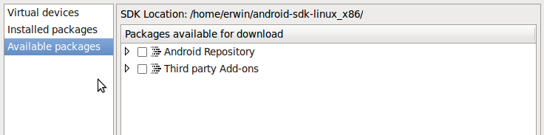
- Until this step you have successfully installed and configured Android Development tools in your computer

Building test application or Hello World application

- you can follow from this web page too <http://developer.android.com/resources/tutorials/hello-world.html> or follow my tutorial.
- First we need to create new AVD (Android Virtual Device), where the application is going to be displayed or tested on. In Eclipse, go to Window > Android SDK and AVD Manager
- Select Virtual Device in the left panel, then click New, then the New AVD dialog appears.
- Enter the name and select the Android API target and set SD card memory
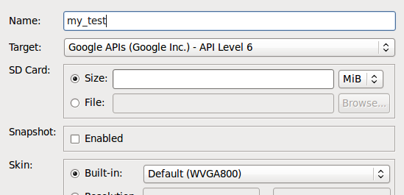
- After this, you already have Android Virtual Device for your android application, you can edit the API based on your need or create new one, depending on the application needs.

- Then we now can create new android project in Eclipse. Go to File > New > Project. Note that if you have successfully installed the ADT Plugin, there will be option to choose Android Project, then choose it.

– Fill in the project details with the following values:
- Project name: HelloAndroid
- Application name: Hello, Android
- Package name: com.example.helloandroid (or your own private namespace)
- Create Activity: HelloAndroid
- Click Finish.
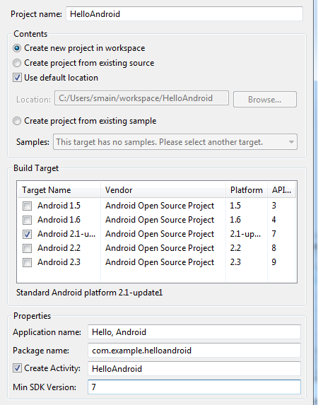

- And then under the project directory, go to HelloAndroid > src > com.example.helloandroid > HelloAndroid.java then change the source code with this code below.
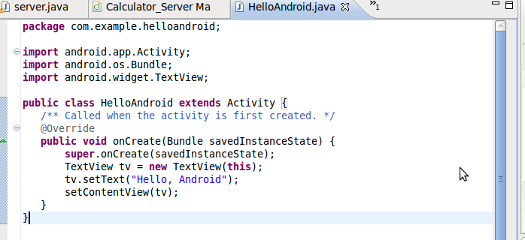

- And then save the file and run the program, Run > Run or CRTL + F11. Wait for some time, it might take a while. And you should see something like this.

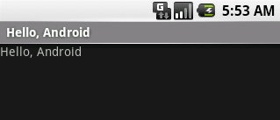

- So Congratulation! Until this point you have successfully created your first android application.

Building Remote Android Calculator.

Basically, in this lab we are tasked to build simple calculator application in Android but it has to be run remotely like client in Android enter the two numbers and operator, then they would be sent to server and being calculated then server will send back the answer.

We think that building the client calculator, would be very easy. But the difficult part is how to pass that from client to server and back to client remotely. We did some study, and there are several options on Android communication, via UDP and TCP.

We found that UDP is easier to be implemented, so we chose UDT and this is the brief introduction on how UDT works.

The User Datagram Protocol (UDP) is one of the core members of the Internet Protocol Suite, the set of network protocols used for the Internet. With UDP, computer applications can send messages, in this case referred to as datagrams, to other hosts on an Internet Protocol (IP) network without requiring prior communications to set up special transmission channels or data paths. [4]

And as the side note, to enable the android Internet communication, you need to add this line to the AndroidManifest.xml file.

<uses-permission android:name="android.permission.INTERNET" />

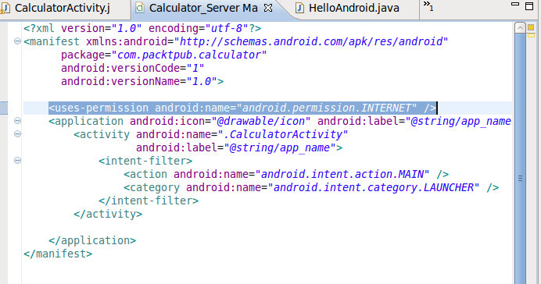

And then this is how we implemented the server side in regular java.

//UDPServer.java

import java.net.*;
import java.io.*;

class server
{
public static void main(String args[]) throws Exception
{

byte[] receive_data = new byte[1024];
byte[] send_data = new byte[1024];

int recv_port;

DatagramSocket server_socket = new DatagramSocket(5000);

System.out.println ("UDPServer Waiting for client on port 5000");

while(true)
{

DatagramPacket receive_packet = new DatagramPacket(receive_data,
receive_data.length);

server_socket.receive(receive_packet);

String data = new String(receive_packet.getData(),0,0,receive_packet.getLength());

InetAddress IPAddress = receive_packet.getAddress();

recv_port = receive_packet.getPort();

if (data.equals("q") || data.equals("Q"))
break;

else

System.out.println("( " + IPAddress + " , " + recv_port
+ " ) said :" + data );

String input1="";
String input2="";
char operator='+';
//private void handleString(String data){
if (data.length() > 0 ){
for (int i=0;i<data.length()-1;i++){
if (data.charAt(i)=='+' || data.charAt(i)=='-' || data.charAt(i)=='*' || data.charAt(i)=='/'){
input1=(data.substring(0,i));
input2=(data.substring(i+1,data.length()));
operator=(data.charAt(i));
}
}
}else{
System.out.println("empty data");
}
// }
double num1 = Double.parseDouble(input1);
double num2 = Double.parseDouble(input2);
double num=0;

if (operator=='+') {
num = num1+num2;
}
else if (operator=='-') {
num = num1-num2;
}
else if (operator=='*') {
num = num1*num2;
}
else{
num = num1/num2;
}

System.out.println("( " + input1 + Character.toString(operator)+ input2
+ " ) is : " + num);

try {
String host1 = "192.168.0.12";
int port1 = 5000;
byte[] message1 = Double.toString(num).getBytes();

// Get the internet address of the specified host
InetAddress address1 = InetAddress.getByName(host1);

// Initialize a datagram packet with data and address
DatagramPacket packet1 = new DatagramPacket(message1, message1.length,
address1, port1);

// Create a datagram socket, send the packet through it, close it.
DatagramSocket dsocket1 = new DatagramSocket();
dsocket1.send(packet1);
dsocket1.close();
} catch (Exception e) {
System.err.println(e);
}

}
}
}

And this is how we implemented the Calculator client.

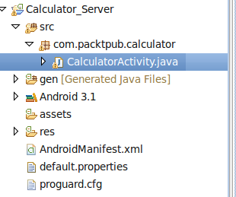

And this the code for CalculatorActivity.java

package com.packtpub.calculator;

import android.app.Activity;
import android.app.AlertDialog;
import android.os.Bundle;
import android.view.View;
import android.view.View.OnClickListener;
import android.widget.Button;
import android.widget.EditText;
import android.widget.TextView;
import java.net.DatagramPacket;
import java.net.DatagramSocket;
import java.net.InetAddress;

public class CalculatorActivity extends Activity {
private EditText input1;
private EditText input2;
private EditText solution;
private TextView operator;

private CalculatorActivity mContext;
Double operand1;
Double operand2;
String Oper1;
String Oper2;
String Operate;
private String ipAddress = "192.168.0.12";
private int port = 5000;

/** Called when the activity is first created. */
@Override
public void onCreate(Bundle savedInstanceState) {
super.onCreate(savedInstanceState);
mContext = this;
setContentView(R.layout.main);
input1 = (EditText) findViewById(R.id.input1);
input2 = (EditText) findViewById(R.id.input2);
solution = (EditText) findViewById(R.id.solution);
operator = (TextView) findViewById(R.id.operator);
/* We create anEvent in each button.*/
Button plusButton = (Button) findViewById(R.id.plus);
Button minusButton = (Button) findViewById(R.id.min);
Button prodButton = (Button) findViewById(R.id.mul);
Button divButton = (Button) findViewById(R.id.div);
Button equalButton = (Button) findViewById(R.id.equal);
Button oneButton = (Button) findViewById(R.id.one);
Button twoButton = (Button) findViewById(R.id.two);
Button threeButton = (Button) findViewById(R.id.three);
Button fourButton = (Button) findViewById(R.id.four);
Button fiveButton = (Button) findViewById(R.id.five);
Button sixButton = (Button) findViewById(R.id.six);
Button sevenButton = (Button) findViewById(R.id.seven);
Button eightButton = (Button) findViewById(R.id.eight);
Button nineButton = (Button) findViewById(R.id.nine);
Button zeroButton = (Button) findViewById(R.id.zero);

oneButton.setOnClickListener(new OnClickListener() {
public void onClick(View arg0) {
input1.append("1");
}
});
twoButton.setOnClickListener(new OnClickListener() {
public void onClick(View arg0) {
input1.append("2");
}
});
threeButton.setOnClickListener(new OnClickListener() {
public void onClick(View arg0) {
input1.append("3");
}
});
fourButton.setOnClickListener(new OnClickListener() {
public void onClick(View arg0) {
input1.append("4");
}
});
fiveButton.setOnClickListener(new OnClickListener() {
public void onClick(View arg0) {
input1.append("5");
}
});
sixButton.setOnClickListener(new OnClickListener() {
public void onClick(View arg0) {
input1.append("6");
}
});
sevenButton.setOnClickListener(new OnClickListener() {
public void onClick(View arg0) {
input1.append("7");
}
});
eightButton.setOnClickListener(new OnClickListener() {
public void onClick(View arg0) {
input1.append("8");
}
});
nineButton.setOnClickListener(new OnClickListener() {
public void onClick(View arg0) {
input1.append("9");
}
});
zeroButton.setOnClickListener(new OnClickListener() {
public void onClick(View arg0) {
input1.append("0");
}
});

plusButton.setOnClickListener(new OnClickListener() {
public void onClick(View arg0) {
operator.setText("+");
}
});
minusButton.setOnClickListener(new OnClickListener() {
public void onClick(View arg0) {
operator.setText("-");
}
});
prodButton.setOnClickListener(new OnClickListener() {
public void onClick(View arg0) {
operator.setText("*");
}
});
divButton.setOnClickListener(new OnClickListener() {
public void onClick(View arg0) {
operator.setText("/");
}
});

equalButton.setOnClickListener(new OnClickListener() {
private AlertDialog show;
public void onClick(View arg0) {
if ((input1.getText().length() == 0)
|| (input1.getText().toString() == " ")) {
show = new AlertDialog.Builder(mContext).setTitle("Error")
.setMessage("Some inputs are empty")
.setPositiveButton("OK", null).show();
}else if (operator.getText().equals("")) {
show = new AlertDialog.Builder(mContext).setTitle("Error")
.setMessage("Operator is null").setPositiveButton("OK", null).show();
}else if (operator.getText().equals("+")) {
double result = new Double(input1.getText().toString())
+ new Double(input2.getText().toString());
solution.setText(Double.toString(result));
operand1= new Double(input1.getText().toString());
operand2= new Double(input2.getText().toString());
operator.setText(operand1+"+"+operand2);
Oper1=operand1.toString()+ "+" + operand2.toString();
try{
String message=Oper1;
int server_port = 5000;
byte[] rec= new byte [100];
DatagramSocket s = new DatagramSocket();
InetAddress local = InetAddress.getByName("192.168.0.12");
int msg_length=message.length();
byte[] mess = message.getBytes();
DatagramPacket p = new DatagramPacket(mess, msg_length,local,server_port);
s.send(p);
//DatagramPacket p1 = new DatagramPacket(rec, rec.length);
//s.receive(p1);
//String t= new String(rec, 0, p1.getLength());
s.close();
//System.out.println("The Answer"+t);
//operator.setText(t);
//solution.setText(t);

}
catch(Exception e){}

} else if (operator.getText().equals("-")) {
double result = new Double(input1.getText().toString())
- new Double(input2.getText().toString());
solution.setText(Double.toString(result));
operand1= new Double(input1.getText().toString());
operand2= new Double(input2.getText().toString());
operator.setText(operand1+"-"+operand2);
Oper1=operand1.toString()+ "-" + operand2.toString();
try{
String message=Oper1;
int server_port = 5000;
byte[] rec= new byte [100];
DatagramSocket s = new DatagramSocket();
InetAddress local = InetAddress.getByName("192.168.0.12");
int msg_length=message.length();
byte[] mess = message.getBytes();
DatagramPacket p = new DatagramPacket(mess, msg_length,local,server_port);
s.send(p);
//DatagramPacket p1 = new DatagramPacket(rec, rec.length);
//s.receive(p1);
//String t= new String(rec, 0, p1.getLength());
s.close();
//System.out.println("The Answer"+t);
//operator.setText(t);
//solution.setText(t);

}
catch(Exception e){}

} else if (operator.getText().equals("*")) {
double result = new Double(input1.getText().toString())
* new Double(input2.getText().toString());
solution.setText(Double.toString(result));
operand1= new Double(input1.getText().toString());
operand2= new Double(input2.getText().toString());
operator.setText(operand1+"*"+operand2);
Oper1=operand1.toString()+ "*" + operand2.toString();
/*try{

byte[] message = new byte[1500];
byte[] sen1=new byte[100];
sen1=Oper1.getBytes();
//InetAddress local = InetAddress.getByName("192.168.1.2");
InetAddress IPAdress = InetAddress.getByName("192.168.0.20");

DatagramPacket p = new DatagramPacket(sen1, sen1.length,IPAdress,port);
DatagramSocket s = new DatagramSocket(port);
s.send(p);

s.close();
}
catch( Exception e )
{
e.printStackTrace();
}
try{

String text;

byte[] message = new byte[1500];
byte[] sen1=new byte[100];
message=Oper1.getBytes();
DatagramPacket p1 = new DatagramPacket(message, message.length);
DatagramSocket s = new DatagramSocket(4444);
s.receive(p1);

text = new String(message, 0, p1.getLength());
operator.setText(text);

s.close();
}
catch( Exception e )
{
e.printStackTrace();
} */

try{
String message=Oper1;
int server_port = 5000;
byte[] rec= new byte [100];
DatagramSocket s = new DatagramSocket();
InetAddress local = InetAddress.getByName("192.168.0.12");
int msg_length=message.length();
byte[] mess = message.getBytes();
DatagramPacket p = new DatagramPacket(mess, msg_length,local,server_port);
s.send(p);
//DatagramPacket p1 = new DatagramPacket(rec, rec.length);
//s.receive(p1);
//String t= new String(rec, 0, p1.getLength());
s.close();
//System.out.println("The Answer"+t);
//operator.setText(t);
//solution.setText(t);

}
catch(Exception e){}
}

else if (operator.getText().equals("/")) {
double result = new Double(input1.getText().toString())
/ new Double(input2.getText().toString());
solution.setText(Double.toString(result));
operand1= new Double(input1.getText().toString());
operand2= new Double(input2.getText().toString());
operator.setText(operand1 + "/" + operand2);
Oper1=operand1.toString()+ "/" + operand2.toString();
try{
String message=Oper1;
int server_port = 5000;
byte[] rec= new byte [100];
DatagramSocket s = new DatagramSocket();
InetAddress local = InetAddress.getByName("192.168.0.12");
int msg_length=message.length();
byte[] mess = message.getBytes();
DatagramPacket p = new DatagramPacket(mess, msg_length,local,server_port);
s.send(p);
//DatagramPacket p1 = new DatagramPacket(rec, rec.length);
//s.receive(p1);
//String t= new String(rec, 0, p1.getLength());
s.close();
//System.out.println("The Answer"+t);
//operator.setText(t);
//solution.setText(t);

}
catch(Exception e){}

}
}
});

}
}

And this is the UI of the android application

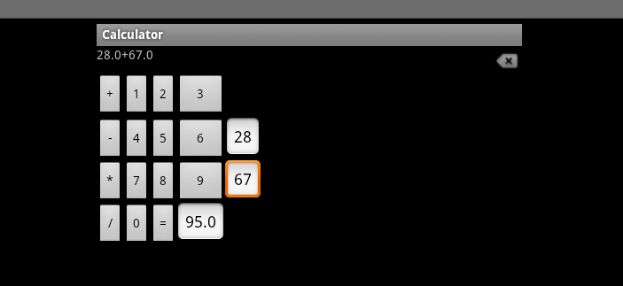

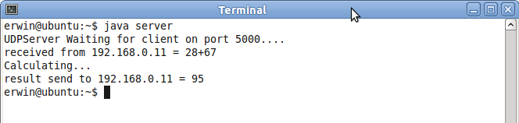
Note:
- Don't forget to add the line in AndroidManifest.xml to enable Android Internet connection
- This UDP version works best with Android 3.1 API 12.
- Change the destination IP adress in the code, and make sure to use the same port to send and receive.
- Make sure that the ports are open.

References:

[1] XML-RPC, <http://www.xmlrpc.com/>

[2] Oracle – Java RMI <http://download.oracle.com/javase/1.5.0/docs/guide/rmi/hello/hello-world.html>

[3] Android Developer Guide <http://developer.android.com/guide/index.html>

[4] Simple UDT Android <http://www.helloandroid.com/tutorials/simple-udp-communication-example>

