CSE 572 – Yousef Jarrar – Lab 04

Query #1: SB_CSE572_Q1:

SELECT A.CRSE_ID, A.ACAD_GROUP, A.SUBJECT, A.CATALOG_NBR, A.ACAD_ORG   
  FROM PS_CRSE_OFFER A   
  WHERE ( A.EFFDT =   
        (SELECT MAX(A_ED.EFFDT) FROM PS_CRSE_OFFER A_ED   
        WHERE A.CRSE_ID = A_ED.CRSE_ID   
          AND A_ED.EFFDT <= SYSDATE)   
     AND A.ACAD_ORG = '189')

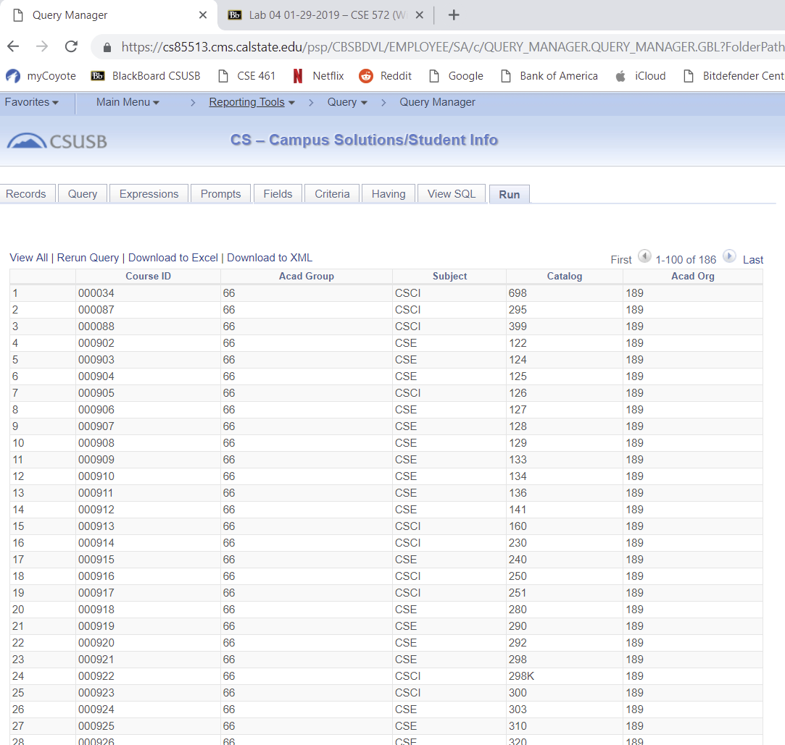

Query#2: SB_CSE572_Q2:   
SELECT A.CRSE_ID, A.ACAD_GROUP, A.SUBJECT, A.CATALOG_NBR, A.ACAD_ORG, B.ACAD_GROUP, B.DESCR, C.ACAD_ORG, C.DESCR   
  FROM PS_CRSE_OFFER A, PS_ACAD_GROUP_TBL B, PS_ACAD_ORG_TBL C   
  WHERE ( B.ACAD_GROUP = A.ACAD_GROUP   
    AND B.INSTITUTION = A.INSTITUTION   
    AND ( A.EFFDT =   
        (SELECT MAX(A_ED.EFFDT) FROM PS_CRSE_OFFER A_ED   
        WHERE A.CRSE_ID = A_ED.CRSE_ID   
          AND A_ED.EFFDT <= SYSDATE)   
     AND B.EFFDT =   
        (SELECT MAX(B_ED.EFFDT) FROM PS_ACAD_GROUP_TBL B_ED   
        WHERE B.INSTITUTION = B_ED.INSTITUTION   
          AND B.ACAD_GROUP = B_ED.ACAD_GROUP   
          AND B_ED.EFFDT <= A.EFFDT)   
     AND C.ACAD_ORG = A.ACAD_ORG   
     AND C.EFFDT =   
        (SELECT MAX(C_ED.EFFDT) FROM PS_ACAD_ORG_TBL C_ED   
        WHERE C.ACAD_ORG = C_ED.ACAD_ORG   
          AND C_ED.EFFDT <= SYSDATE)   
     AND A.ACAD_ORG = '189' ))

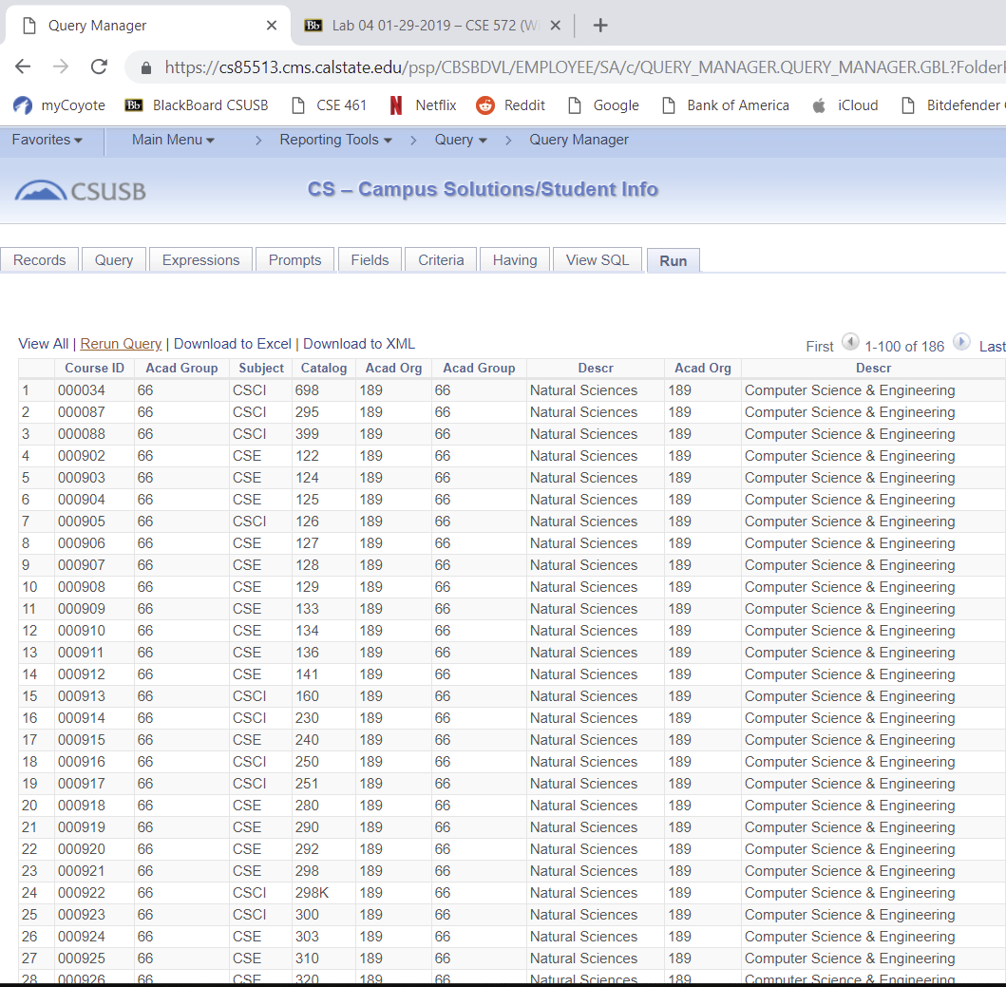

Query#3: SB_CSE572_Q3:

SELECT A.CRSE_ID, A.ACAD_GROUP, A.SUBJECT, A.CATALOG_NBR, A.ACAD_ORG, B.ACAD_GROUP, B.DESCR, C.ACAD_ORG, C.DESCR, D.CRSE_ID, D.EFF_STATUS, D.COURSE_TITLE_LONG, D.DESCRLONG   
  FROM PS_CRSE_OFFER A, PS_ACAD_GROUP_TBL B, PS_ACAD_ORG_TBL C, PS_CRSE_CATALOG D   
  WHERE ( B.ACAD_GROUP = A.ACAD_GROUP   
    AND B.INSTITUTION = A.INSTITUTION   
    AND ( A.EFFDT =   
        (SELECT MAX(A_ED.EFFDT) FROM PS_CRSE_OFFER A_ED   
        WHERE A.CRSE_ID = A_ED.CRSE_ID   
          AND A_ED.EFFDT <= SYSDATE)   
     AND B.EFFDT =   
        (SELECT MAX(B_ED.EFFDT) FROM PS_ACAD_GROUP_TBL B_ED   
        WHERE B.INSTITUTION = B_ED.INSTITUTION   
          AND B.ACAD_GROUP = B_ED.ACAD_GROUP   
          AND B_ED.EFFDT <= A.EFFDT)   
     AND C.ACAD_ORG = A.ACAD_ORG   
     AND C.EFFDT =   
        (SELECT MAX(C_ED.EFFDT) FROM PS_ACAD_ORG_TBL C_ED   
        WHERE C.ACAD_ORG = C_ED.ACAD_ORG   
          AND C_ED.EFFDT <= SYSDATE)   
     AND A.CRSE_ID = D.CRSE_ID   
     AND D.EFFDT =   
        (SELECT MAX(D_ED.EFFDT) FROM PS_CRSE_CATALOG D_ED   
        WHERE D.CRSE_ID = D_ED.CRSE_ID   
          AND D_ED.EFFDT <= SYSDATE)   
     AND A.ACAD_ORG = '189' ))

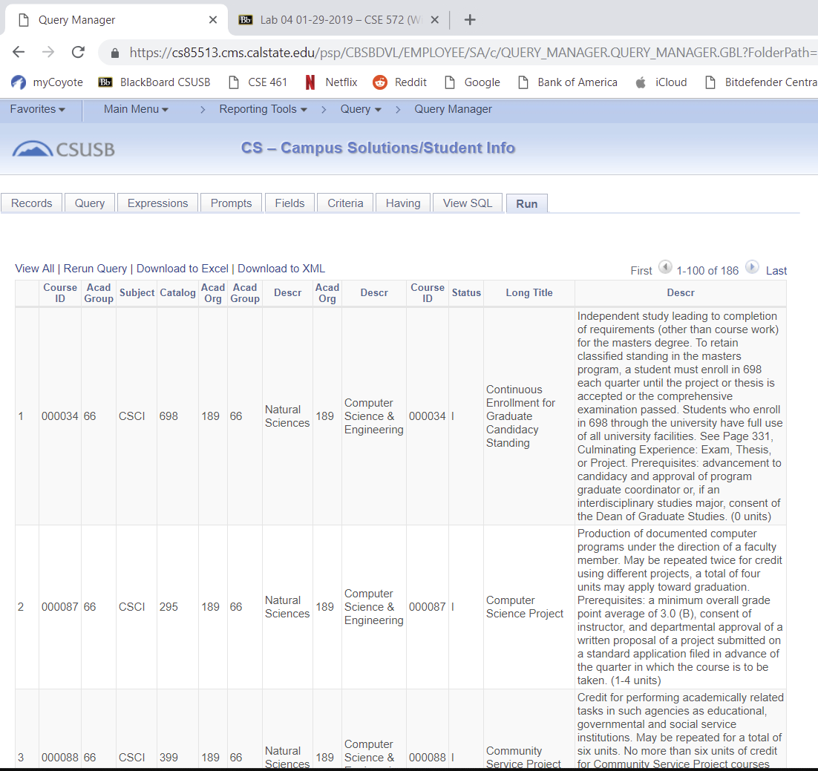

Query#4: SB_CSE572_Q4

SELECT A.CRSE_ID, A.CRSE_OFFER_NBR, A.STRM, A.SESSION_CODE, A.CLASS_SECTION, B.EMPLID, B.LAST_NAME, B.FIRST_NAME   
  FROM PS_CLASS_INSTR A, PS_NAMES_VW B   
  WHERE ( A.EMPLID = B.EMPLID   
     AND B.EFFDT =   
        (SELECT MAX(B_ED.EFFDT) FROM PS_NAMES_VW B_ED   
        WHERE B.EMPLID = B_ED.EMPLID   
          AND B.NAME_TYPE = B_ED.NAME_TYPE   
          AND B_ED.EFFDT <= SYSDATE)   
     AND A.CRSE_ID = '010057'   
     AND A.CRSE_OFFER_NBR = 2   
     AND A.STRM = '2192'   
     AND A.SESSION_CODE = '1'   
     AND B.NAME_TYPE = 'PRF'   
     AND B.EFFDT =   
        (SELECT MAX(B_ED.EFFDT) FROM PS_NAMES_VW B_ED   
        WHERE B.EMPLID = B_ED.EMPLID   
          AND B.NAME_TYPE = B_ED.NAME_TYPE   
          AND B_ED.EFFDT <= SYSDATE)) 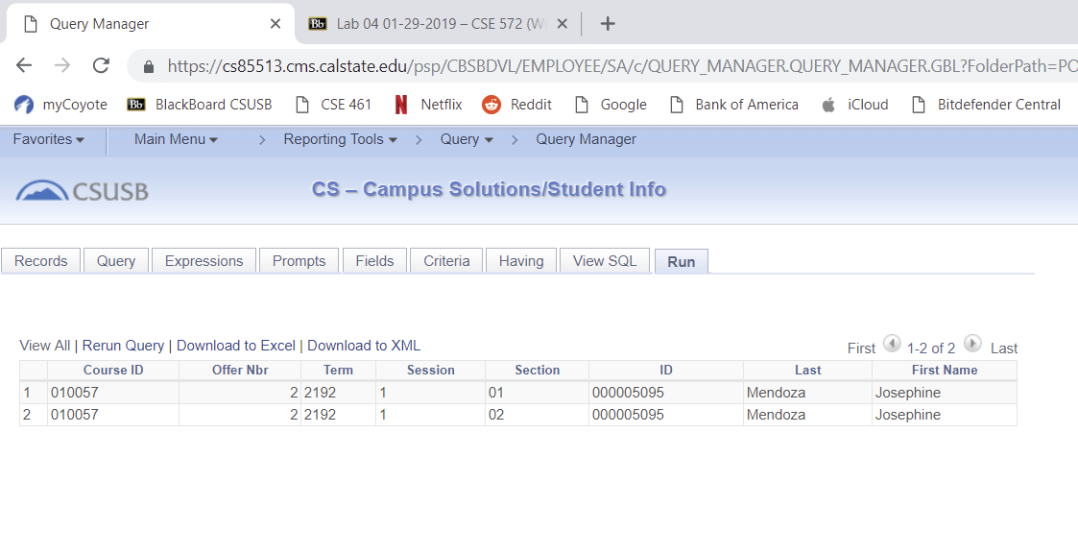

Query#5: SB_CSE572_Q5:

SELECT A.CRSE_ID, A.CRSE_OFFER_NBR, A.STRM, A.SESSION_CODE, A.CLASS_SECTION, A.SUBJECT, A.CATALOG_NBR, A.DESCR, A.CLASS_NBR, B.DESCR   
  FROM PS_CLASS_TBL A, PS_TERM_TBL B   
  WHERE ( A.STRM = B.STRM   
     AND A.SESSION_CODE = B.SESSION_CODE   
     AND B.INSTITUTION = A.INSTITUTION   
     AND B.ACAD_CAREER = A.ACAD_CAREER   
     AND A.STRM = :1)

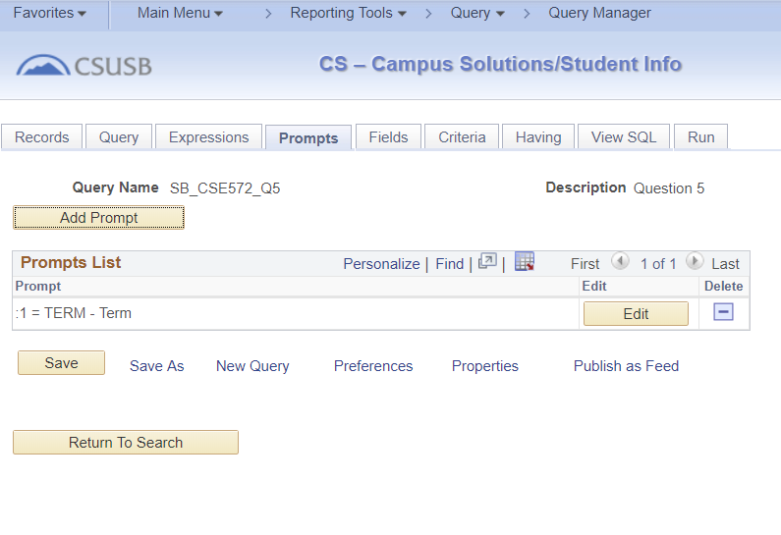

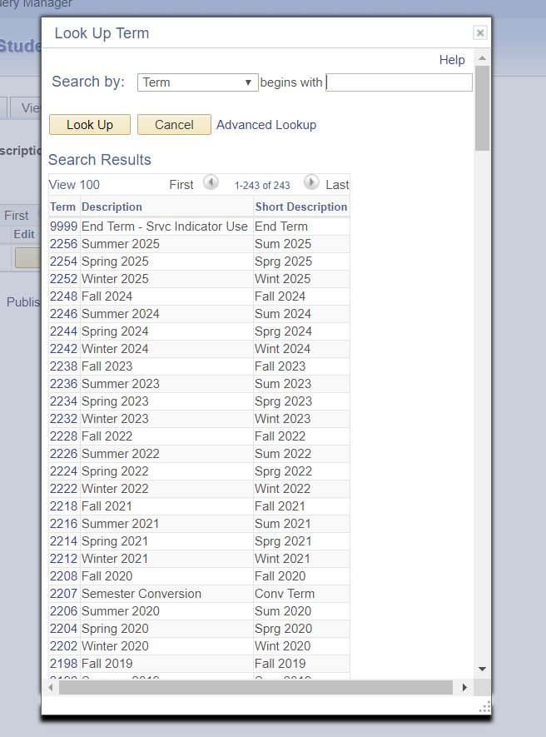

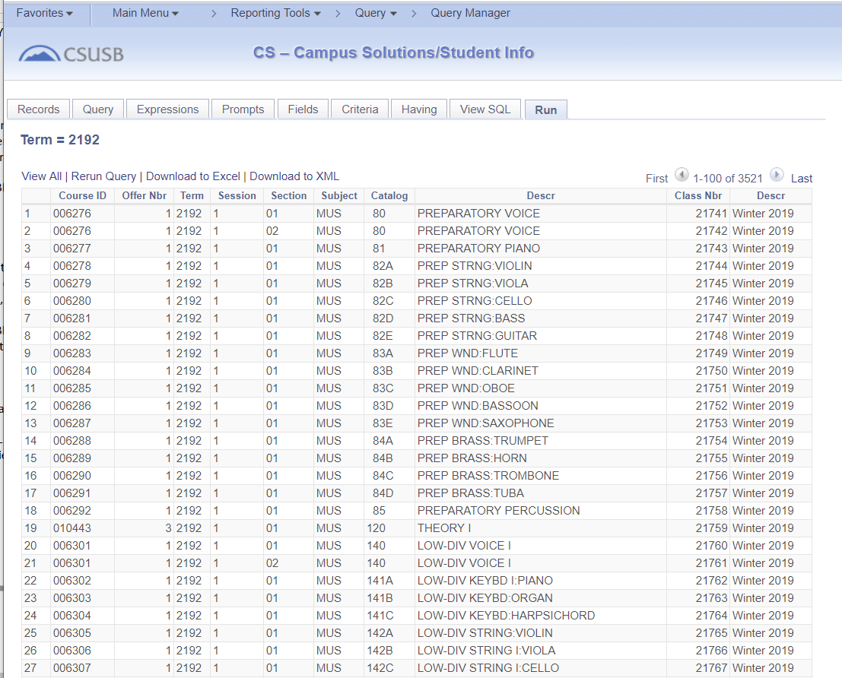

Query#6: SB_CSE572_Q6:

SELECT A.CRSE_ID, A.CRSE_OFFER_NBR, A.STRM, A.SESSION_CODE, A.CLASS_SECTION, B.DESCR, TO_CHAR(CAST((C.MEETING_TIME_START) AS TIMESTAMP),'HH24.MI.SS.FF'), TO_CHAR(CAST((C.MEETING_TIME_END) AS TIMESTAMP),'HH24.MI.SS.FF'), C.STND_MTG_PAT, D.BLDG_CD, D.ROOM, A.DESCR   
  FROM PS_CLASS_TBL A, PS_TERM_TBL B, PS_CLASS_MTG_PAT C, PS_FACILITY_TBL D   
  WHERE ( D.FACILITY_ID = C.FACILITY_ID   
    AND ( A.STRM = B.STRM   
     AND A.SESSION_CODE = B.SESSION_CODE   
     AND B.INSTITUTION = A.INSTITUTION   
     AND B.ACAD_CAREER = A.ACAD_CAREER   
     AND A.CRSE_ID = C.CRSE_ID   
     AND A.CRSE_OFFER_NBR = C.CRSE_OFFER_NBR   
     AND A.STRM = C.STRM   
     AND A.SESSION_CODE = C.SESSION_CODE   
     AND A.CLASS_SECTION = C.CLASS_SECTION   
     AND D.EFFDT =   
        (SELECT MAX(D_ED.EFFDT) FROM PS_FACILITY_TBL D_ED   
        WHERE D.SETID = D_ED.SETID   
          AND D.FACILITY_ID = D_ED.FACILITY_ID   
          AND D_ED.EFFDT <= SYSDATE)   
     AND A.CRSE_ID = '010057'   
     AND A.CRSE_OFFER_NBR = 2   
     AND A.STRM = '2192'   
     AND A.SESSION_CODE = '1'   
     AND A.STRM = :1 ))

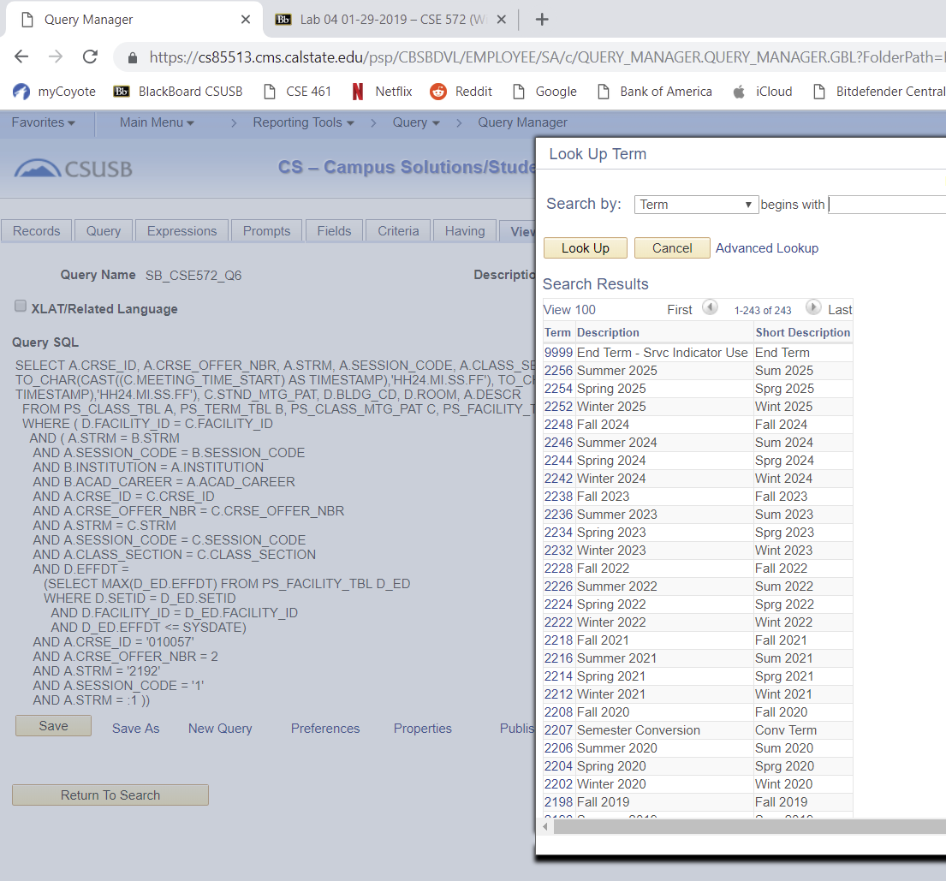

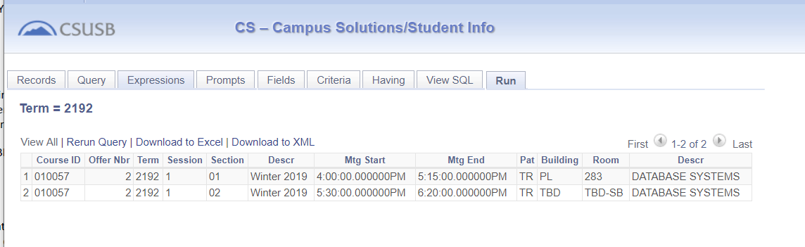

Query#7: SB_CSE572_Q7

SELECT A.ACAD_GROUP, A.ACAD_PLAN_TYPE   
  FROM PS_SB_PLN_DPT_COL A   
  WHERE ( A.ACAD_PLAN_TYPE = 'MAJ'   
     AND A.ACAD_GROUP = '66')

