Yousef Jarrar
Lab 08
CSE 572 – Professor Lin
03/05/2019

1. Create a query to display the highest, lowest, sum and average salary of all employees. Label the columns Maximum, Minimum, Sum and Average, respectively. Save your SQL statement in a text file named LAB08_1.sql. Run your query.

SELECT COUNT(*), MIN(SALARY), MAX(SALARY), AVG(SALARY), SUM(SALARY)
FROM HR.employees;
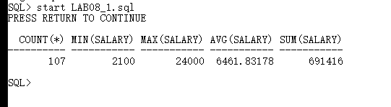

2. Modify the query in LAB08_1.sql to display the minimum, maximum, sum, and average salary for each job type. Save your SQL statement in a text file named LAB08_2.sql. Run this revised query.

SELECT department_ID, COUNT(*), MIN(SALARY), MAX(SALARY), AVG(SALARY)
FROM HR.employees
GROUP BY department_ID;

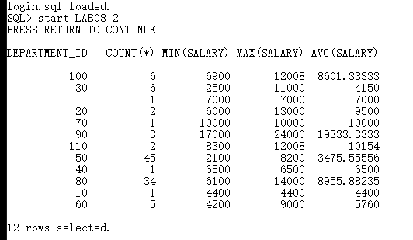

3. Create a query to display the number of employees with the same job. Save your SQL statement in a text file named LAB08_3.sql. Run your query.

SELECT job_id, COUNT(*)
FROM employees
GROUP BY job_id;

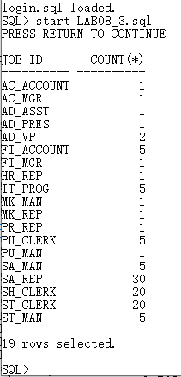

4. Determine the number of managers without listing them. Label the column Number of Managers. HINT: Use the MANAGER_ID column to determine the number of managers. Save your SQL statement in a text file named LAB08_4.sql. Run your query.

SELECT COUNT (DISTINCT manager_id) "NUMBER OF MANAGERS"
FROM employees;
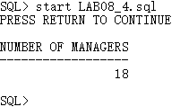

5. Write a query that displays the difference between the highest and lowest salaries. Label the column DIFFERENCE. Save your SQL statement in a text file named LAB08_5.sql. Run your query.

SELECT MAX(SALARY) - MIN(SALARY) DIFFERENCE
FROM employees;
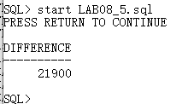

6. Display the manager number and the salary of the lowest paid employee for that manager. Exclude anyone whose manager is not known. Exclude any groups where the minimum salary is $6,000 or less. Sort the output in descending order of salary. Save your SQL statement in a text file named LAB08_6.sql. Run your query.

SELECT manager_id, MIN(SALARY)
FROM employees
WHERE manager_id IS NOT NULL
GROUP BY manager_id
HAVING MIN(SALARY) > 6000
ORDER BY MIN(SALARY) DESC;

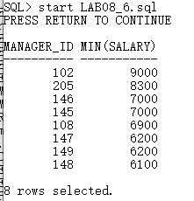

7. Write a query to display each department’s name, location, number of employees, and the average salary for all employees in that department. Label the columns Department , Location, Number of Workers, and Average Salary, respectively. Round the average salary to two decimal places. Save your SQL statement in a text file named LAB08_7.sql. Run your query.

SELECT d.department_name "NAME", d.location_id "LOCATION",
COUNT(*) "NUMBER OF PEOPLE",
ROUND (AVG(SALARY), 2) "SALARY"
FROM employees e, departments d
WHERE e.department_id = d.department_id
GROUP BY d.department_name, d.location_id;
