姓名：曾泇睷 **第五章实验**  学号：1820221053

**实验一：中国人与美国人**

// People.java

public class People {

protected double weight, height;

public void speakHello(){

System.out.println("yayayaya");

}

public void averageHeight(){

height = 173;

System.out.println("average height:" + height);

}

public void averageWeight(){

weight = 70;

System.out.println("average weight:" + weight);

}

}

//ChinaPeople.java

public class ChinaPeople extends People {

public void speakHello(){

System.out.println("您好");

}

public void averageHeight(){

height = 168.78;

System.out.println("中国人的平均身高：" + height + "厘米");

}

public void averageWeight(){

weight = 65;

System.out.println("中国人的平均体重：" + weight + "千克");

}

public void chinaGongfu(){

System.out.println("坐如钟，站如松，睡如弓");

}

}

// AmericanPeople.java

public class AmericanPeople extends People {

public void speakHello(){

System.out.println("How do you do");

}

public void averageHeight(){

height = 176;

System.out.println("American's average height：" + height + "cm");

}

public void averageWeight(){

weight = 75;

System.out.println("American's average weight：" + weight + "千克");

}

public void americanBoxing(){

System.out.println("直拳，勾拳，组合拳");

}

}

//BeijingPeople.java

public class BeijingPeople extends ChinaPeople{

public void averageHeight(){

height = 172.5;

System.out.println("北京人的平均身高：" + height + "厘米");

}

public void averageWeight(){

weight = 70;

System.out.println("北京人的平均体重：" + weight + "千克");

}

public void beijingOpera(){

System.out.println("花脸、青衣、花旦和老生");

}

}

// Example.java

public class Example {

public static void main(String args[]){

ChinaPeople chinaPeople = new ChinaPeople();

AmericanPeople americanPeople = new AmericanPeople();

BeijingPeople beijingPeople = new BeijingPeople();

chinaPeople.speakHello();

americanPeople.speakHello();

beijingPeople.speakHello();

chinaPeople.averageHeight();

americanPeople.averageHeight();

beijingPeople.averageHeight();

chinaPeople.averageWeight();

americanPeople.averageWeight();

beijingPeople.averageWeight();

chinaPeople.chinaGongfu();

americanPeople.americanBoxing();

beijingPeople.beijingOpera();

beijingPeople.chinaGongfu();

}

}

People类中的

public void speakHello()

public void averageHeight()

public void averageWeight()

3个方法的方法体中的语句是否可以省略？

**可以**

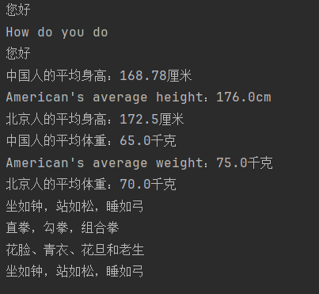

**实验二：银行与利息**

// Bank.java

public class Bank {

int savedMoney;

int year;

double interest;

double interestRate = 0.29;

public double computerInterest(){

interest = year * interestRate * savedMoney;

return interest;

}

public void setInterestRate(double rate){

interestRate = rate;

}

}

// ConstructionBank.java

public class ConstructionBank extends Bank{

double year;

public double computerInterest(){

super.year = (int)year;

double r = year - (int)year;

int day = (int)(r * 1000);

double yearInterest = super.computerInterest();

double dayInterest = day * 0.0001 * savedMoney;

interest = yearInterest + dayInterest;

System.out.printf("%d元存在建设银行%d年零%d天的利息：%f元\n", savedMoney, super.year, day, interest);

return interest;

}

}

// BankOfDalian.java

public class BankOfDalian extends Bank{

double year;

public double computerInterest(){

super.year = (int)year;

double r = year - (int)year;

int day = (int)(r * 1000);

double yearInterest = super.computerInterest();

double dayInterest = day * 0.00012 * savedMoney;

interest = yearInterest + dayInterest;

System.out.printf("%d元存在大连银行%d年零%d天的利息：%f元\n", savedMoney, super.year, day, interest);

return interest;

}

}

// SaveMoney.java

public class SaveMoney {

public static void main(String args[]){

int amount = 8000;

ConstructionBank bank1 = new ConstructionBank();

bank1.savedMoney = amount;

bank1.year = 8.236;

bank1.setInterestRate(0.035);

double interest1 = bank1.computerInterest();

BankOfDalian bank2 = new BankOfDalian();

bank2.savedMoney = amount;

bank2.year = 8.236;

bank2.setInterestRate(0.035);

double interest2 = bank2.computerInterest();

System.out.printf("两个银行利息相差%f元\n", interest2 - interest1);

//新增测试代码

BankOfShangye bank3 = new BankOfShangye();

bank3.savedMoney = amount;

bank3.year = 8.236;

bank3.setInterestRate(0.035);

double interest3 = bank3.computerInterest();

}

}

// BankOfShangye.java

public class BankOfShangye extends Bank{

double year;

public double computerInterest(){

super.year = (int)year;

double r = year - (int)year;

int day = (int)(r * 1000);

double yearInterest = super.computerInterest();

double dayInterest = day * 0.00015 * savedMoney;

interest = yearInterest + dayInterest;

System.out.printf("%d元存在商业银行%d年零%d天的利息：%f元\n", savedMoney, super.year, day, interest);

return interest;

}

}

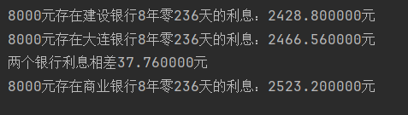

**实验三：面积之和**

// Geometry.java

public abstract class Geometry {

public abstract double getArea();

}

// TotalArea.java

public class TotalArea {

Geometry[] tuxing;

double totalArea = 0;

public void setTuxing(Geometry[] t){

tuxing = t;

}

public double computerTotalArea(){

for(int i = 0; i < tuxing.length; i++){

totalArea += tuxing[i].getArea();

}

return totalArea;

}

}

// Rect.java

public class Rect extends Geometry{

double a,b;

Rect(double a, double b){

this.a = a;

this.b = b;

}

public double getArea(){

return a * b;

}

}

// Circle.java

public class Circle extends Geometry{

double r;

Circle(double r){

this.r = r;

}

public double getArea(){

return (3.14*r*r);

}

}

// MainClass.java

public class MainClass {

public static void main(String args[]){

Geometry[] tuxing = new Geometry[29];

for (int i = 0; i < tuxing.length; i++){

if (i % 2 == 0){

tuxing[i] = new Rect(16 + i, 68);

}

else if (i % 2 == 1){

tuxing[i] = new Circle(10+i);

}

}

TotalArea computer = new TotalArea();

computer.setTuxing(tuxing);

System.out.printf("各种图形的面积之和：\n%f\n", computer.computerTotalArea());

//新增测试代码

for (int i = 0; i < tuxing.length; i++){

if (i % 3 == 0){

tuxing[i] = new Rect(16 + i, 68);

}

else if (i % 3 == 1){

tuxing[i] = new Circle(10+i);

}

else if (i % 3 == 2){

tuxing[i] = new Trapezoid(10+i,20+i, 5);

}

}

TotalArea computer2 = new TotalArea();

computer2.setTuxing(tuxing);

System.out.printf("(新)各种图形的面积之和：\n%f", computer2.computerTotalArea());

}

}

// Trapezoid.java

public class Trapezoid extends Geometry{

double a, b;

double h;

Trapezoid(double a, double b, double h){

this.a = a;

this.b = b;

this.h = h;

}

public double getArea(){

return (a+b)*h/2;

}

}

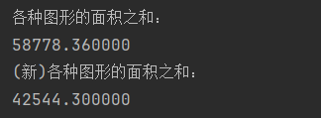

**实验四：歌手大赛**

// ComputerAverage.java

public interface ComputerAverage {

public double average(double x[]);

}

// SongGame.java

public class SongGame implements ComputerAverage{

public double average(double x[]){

int count = x.length;

double aver = 0, temp = 0;

for (int i = 0; i < count; i++){

for (int j = i; j < count; j++){

if (x[j] < x[i]){

temp = x[j];

x[j] = x[i];

x[i] = temp;

}

}

}

for (int i = 1; i < count - 1; i++){

aver = aver + x[i];

}

if (count > 2){

aver = aver/(count-2);

}

else {

aver = 0;

}

return aver;

}

}

// School.java

public class School implements ComputerAverage {

@Override

public double average(double[] x) {

int count = x.length;

double aver = 0;

for (int i = 0; i < count; i++){

aver = aver + x[i];

}

aver = aver/count;

return aver;

}

}

// Estimator.java

public class Estimator {

public static void main(String args[]){

double a[] = {9.89, 9.88, 9.99, 9.12, 9.69, 9.76, 8.97};

double b[] = {56, 55.55, 65, 50, 51.5, 53.6, 70, 49, 66, 62, 46};

ComputerAverage computer;

computer = new SongGame();

double result = computer.average(a);

System.out.printf("%n");

System.out.printf("歌手最后得分：%5.3f\n", result);

computer = new School();

result = computer.average(b);

System.out.printf("学生平均体重：%-5.2f kg", result);

}

}



School 类如果不重写 public double average(double x[])方法，程序编译时提示怎样的错误？

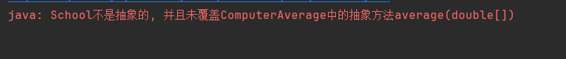

**实验五：天气预报**

//WeatherState.java

public interface WeatherState {

public void showState();

}

//Weather.java

public class Weather {

WeatherState state;

public void show(){

state.showState();

}

public void setState(WeatherState s) {

state = s;

}

}

// WeatherForecast.java

public class WeatherForecast {

public static void main(String args[]){

Weather weatherBeijing = new Weather();

System.out.print("\n今天白天：");

weatherBeijing.setState(new CloudyDayState());

weatherBeijing.show();

System.out.print("\n今天夜间：");

weatherBeijing.setState(new LightRainState());

weatherBeijing.show();

System.out.print("转：");

weatherBeijing.setState(new HeavyRainState());

weatherBeijing.show();

System.out.print("\n明天白天：");

weatherBeijing.setState(new LightRainState());

weatherBeijing.show();

System.out.print("\n明天夜间：");

weatherBeijing.setState(new CloudyLittleState());

weatherBeijing.show();

}

}

//CloudyLittleState.java

public class CloudyLittleState implements WeatherState{

@Override

public void showState() {

System.out.print("少云，有时晴。");

}

}

//CloudyDayState.java

public class CloudyDayState implements WeatherState{

public void showState() {

System.out.print("多云，有时阴。");

}

}

//HeavyRainState.java

public class HeavyRainState implements WeatherState{

public void showState() {

System.out.print("大雨。");

}

}

//LightRainState.java

public class LightRainState implements WeatherState{

public void showState() {

System.out.print("小雨。");

}

}

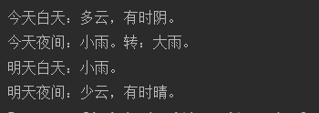

实验后的练习

//Status.java

public interface Status {

public void showStatus();

}

//Water.java

public class Water {

Status s;

public void show(){

s.showStatus();

}

public void setStatus(Status s){

this.s = s;

}

}

//WaterCup.java

public class WaterCup {

public static void main(String args[]){

Water water = new Water();

System.out.print("0°C以下：");

water.setStatus(new Ice());

water.show();

System.out.print("\n0°C以上100°C以下：");

water.setStatus(new Normal());

water.show();

System.out.print("\n100°C");

water.setStatus(new Feiteng());

water.show();

}

}

//Feiteng.java

public class Feiteng implements Status{

@Override

public void showStatus() {

System.out.print("水沸腾了。");

}

}

//Normal.java

public class Normal implements Status{

@Override

public void showStatus() {

System.out.print("正常状态的水。");

}

}

//Ice.java

public class Ice implements Status{

@Override

public void showStatus() {

System.out.print("水结成冰。");

}

}

