**University Of Lagos, Akoka, Lagos**

**Faculty Of Engineering**

**Department Of Systems Engineering**

**First Semester Examination 2023/2024 Academic Session**

**Course: Industrial Engineering (SSG 348) Marking Guide**

**QUESTION 1: General Industrial Engineering**

1. Outline and explain any 4 construct of Industrial Engineering **10 marks**

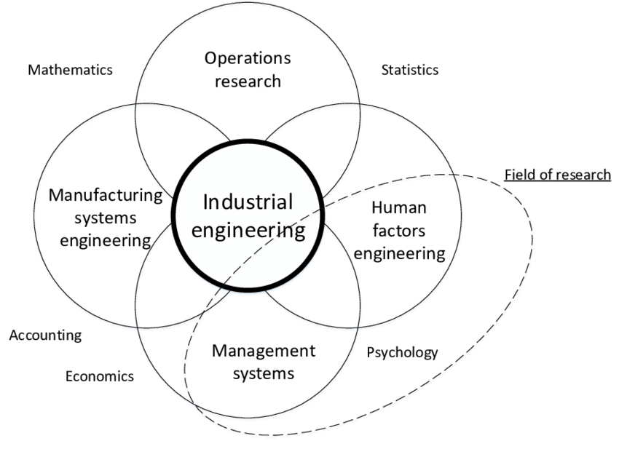(**Diagram** – **2 marks**)

Industrial engineering is an engineering profession that is concerned with the optimization of complex processes, systems, or organizations by developing, improving and implementing integrated systems of people, money, knowledge, information and equipment. Industrial engineering is central to manufacturing operations. The constructs of Industrial Engineering include component areas such as Operations Research, Human factor Engineering (Ergonomics), Manufacturing Systems Engineering, Total Quality Management, Project Management, Supply chain management, Safety Engineering, etc. **2 marks**

$1\frac{1}{2}$**marks for any 1 of the following (Student must list 4 in total - 6 marks)**

1. **Operations** **Research**: OR is a discipline that deals with the development and application of analytical methods to improve decision-making. It is considered to be a subfield of mathematical sciences because it uses techniques such as modeling, statistics, and optimization, operations research arrives at optimal or near-optimal solutions for decision-making problems. OR is also concerned with determining the extreme values of some real-world objective, e.g., the maximum (of profit, performance, or yield) or minimum (of loss, risk, or cost).
2. **Systems** **Engineering**: Is an interdisciplinary field of engineering and engineering management that focuses on how to design, integrate, and manage complex systems over their life cycles. At its core, systems engineering utilizes systems thinking principles to organize this body of knowledge.
3. **Human Factor Engineering** (Ergonomics): Is the application of psychological and physiological principles to the engineering and design of products, processes, and systems. The primary goals of human factors engineering are to reduce human error, increase productivity and system availability, and enhance safety, health and comfort with a specific focus on the interaction between the human and equipment.
4. **Manufacturing Systems Engineering**: Is a branch of professional engineering that shares many common concepts and ideas with other fields of engineering such as mechanical, chemical, electrical, and industrial engineering. Manufacturing engineering requires the ability to plan the practices of manufacturing; to research and to develop tools, processes, machines and equipment; and to integrate the facilities and systems for producing quality products with the optimum expenditure of capital.
5. **Total Quality Management**: This consists of organization-wide efforts to install and make permanent climate where employees continuously improve their ability to provide on demand products and services that customers will find of particular value.
6. **Project Management:** Project management is the application of processes, methods, skills, knowledge and experience to achieve specific project objectives according to the project acceptance criteria within agreed parameters. It includes the process of leading the work of a team to achieve all project goals within the given constraints.
7. **Supply chain management:** SCM deals with a system of procurement (purchasing raw materials/components), operations management (ensuring the production of high-quality products at high speed with good flexibility and low production cost), logistics and marketing channels so that the raw materials can be converted into a finished product and delivered to the end customer.
8. **Safety Engineering**: Is a discipline which assures that engineered systems provide acceptable levels of safety. Safety engineering assures that a life-critical system behaves as needed, even when components fail.
9. Discuss the evolution of Industrial Engineering from Industry 1.0 to industry 5.0 **5 marks**

**STUDENT MUST MENTION THE PERIOD & SIGNIFICANT INVENTION IN THAT TIME TO EARN FULL MARK**

**Industry 1.0 (Late 18th century) 1 mark**

**Mechanization**: The 1st industrial revolution (Industry 1.0) shifted from manual labor to a more mechanized manufacturing facility. The introduction of the steam engine provided a more reliable power source for both manufacturing and transportation industries.

**Industry 2.0 (late 19th to early 20th century)**

* **Electricity**: Steam power was replaced with electricity as a source of energy.
* **Communication**: The invention of the telegraph and the telephone improved long-distance communication.
* **Internal Combustion Engine**: This engine powered the growth of the automotive and transportation industries.
* **Mass Production and Assembly Line**: Innovations in manufacturing, particularly the introduction of the assembly line, streamlined production processes.

**Industry 3.0 (Late 20th Century)**

* **Computerization**: As computers became more robust, manufacturing companies used in data processing, control systems, and automated decision-making.
* **Automation**: Increased automation in manufacturing (machines and robots) took over repetitive and dangerous tasks.
* **Electronics**: Increase in sensors, microcontrollers, and other electronic devices used for monitoring and controlling machinery and processes.
* **PLCs (Programmable Logic Controllers**): The development and use of PLCs allowed for the control of machines and processes through programming, reducing the need for manual adjustments and human intervention in many cases.

Industry 4.0 (Late 20th Century to Today)

* **Internet of Things (IoT**): Sensors and devices connected to the Internet collect and exchange data for real-time monitoring and control.
* **Big Data and Analytics**: Large volume of data from IoT devices is used to gain insights, identify patterns, and make data-driven decisions.
* **Artificial Intelligence (AI) and Machine Learning**: For autonomous decisions, prediction and optimization.
* **Automation and Robotics**: Robots and automation are integrated into several manufacturing processes.
* **Digital Twins**: Creating virtual replicas of physical systems or products allows for simulation and analysis.
* **Cloud Computing**: For a centralized platform for data storage and access.
* **Cyber security**: Protecting data and systems from cyber threats is a significant aspect of Industry 4.0.
* **Augmented Reality (AR) and Virtual Reality (VR**): Used for training, remote maintenance support, and visualization of complex processes and systems.
* **Additive Manufacturing (3D Printing**): For rapid prototyping and production.

**Industry 5.0 (The next generation)**

Industry 5.0 is the next generation of manufacturing. Involves **Human Factor** (rise in the use of cobots or collaborative robots where humans work beside robots), **Sustainability** and **Mass** **customization.**

1. Explain the 3 processes involved in Quality Management **10 marks**
2. Quality Planning: This involves identifying which quality standards are relevant to the project and how to satisfy them. It involves identifying which quality standards are relevant to the project and determining how to satisfy them.

* **Input**: Quality policy, Scope statement, Product description, Standards and regulations , Other process outputs
* **Tools & Techniques**: Benefit/cost analysis, Benchmarking, Flowcharting & Design of experiments
* **Outputs**: Quality management plan, Operational definitions, Checklists, Inputs to other

Processes

1. Quality Assurance: Involves evaluating overall project performance to ensure the project will satisfy the relevant quality standards.

* **Inputs**: Quality management plan, Results of quality control measurements, Operational definitions
* **Tools & Techniques**: Quality planning tools and techniques, Quality audits
* **Output**: Quality Improvements

1. Quality Control: Involves monitoring specific project results to ensure that they comply with the relevant quality standards while identifying ways to improve overall quality.

**Input**: Work results, Quality management plan, Operational definitions, Checklists,

**Tools &Techniques**: Inspection, Control charts, Pareto diagrams, Statistical sampling, Flowcharting, Trend analysis, Six Sigma, Lean Manufacturing, FMEA, Ishikawa Diagram

**Output**: Quality improvement, Acceptance decisions, Rework, Completed checklists, Process adjustments

1. “Engineering design is both iterative and cyclic” Discuss

**STUDENTS ARE EXPECTED TO DRAW & WRITE A SHORT NOTE ON THE DIAGRAM BELOW (3 marks)**

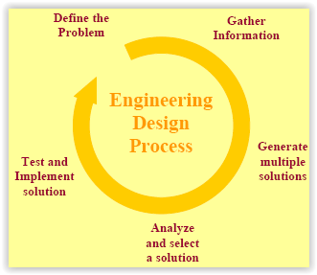

1. What do you understand by a Work Breakdown Structure **2 marks**

The Work Breakdown structure is a deliverable oriented grouping of project elements which organizes and defines the total scope of the project. The WBS is used to decompose the work involved in a project to smaller parts that cannot be broken down again. Each descending level of work represents an increasingly detailed definition of a project component. It relates the details of each subtask in a project to its task and provides the final basis for the project budget, schedule, personnel, and control..

**QUESTION 2: Quality Management**

1. Explain the term quality costs. Classify the types of quality costs and list 3 examples of each. Quality costs refers to costs associated with ensuring quality standards are maintained in a system (product or project). It could either be Cost of Conformance to Quality (Cost of Good Quality) or Cost of Non-Conformance to Quality (Cost of Poor Quality). **1 Mark**

I. **Cost Of Non-Conformance (Cost Of Poor Quality) or Failure Costs**: Costs incurred by defective parts/products or faulty services. They are either Internal or External Failure Costs.

*Internal Failure Costs*: Costs incurred to fix problems that are detected before the product/service is delivered to the customer. $\frac{1}{2}$**Mark**

Examples: Scrap, rework, failure analysis, lost/missing information, changing process, redesign, scrapping of obsolete product, downgrading, etc. $1\frac{1}{2}$**Marks**

*External Failure Costs*: All costs incurred to fix problems that are detected after the product/service is delivered to the customer. Examples: Litigation, Warranty charges, Complaint adjustment, returned materials, allowances, Penalties due to poor quality, Customer defections, New customers lost because of quality, etc. $1\frac{1}{2}$**Marks**

**II. Cost Of Conformance:** The costs of goodquality are the costs incurred in order to ensure good quality in a product/process and that standards/specifications are met. $\frac{1}{2}$**Mark**

***Appraisal Costs*:** These are costs incurred to determine the degree of conformance to quality requirements. $\frac{1}{2}$**Mark**

**Examples**: Incoming inspection and test, In-process inspection and test, Document review, Balancing, Product quality audits, Inspection and test materials and services, Evaluation of stocks, etc. $1\frac{1}{2}$**Marks**

***Prevention Costs****:* These are costs incurred to keep failure and appraisal costs to a minimum. $\frac{1}{2}$**Mark**

**Examples**: Quality audits, quality planning, customer assessment, process planning, process control, quality improvement costs to prevent defects from occurring, training, etc. $1\frac{1}{2}$**Marks**

1. Given that the average processing rate of cocoa in a beverage factory is 100 batches per day. If there are 1500 batches waiting for processing, find the processing time.
$$Process Cycle time=\frac{Work-in-Process}{Average completion rate} 1 mark$$

$$\frac{1500}{100}=15 days 1 mark$$

2. Outline the major contributions of the following Quality gurus
3. Joseph Juran: Originated the idea of **Quality trilogy**: planning, control, and improvement of quality. **1 mark**
4. Walter Edward Demings: Developed the famous **14 Management Principles** and the **7 deadly diseases** of management. **1 mark**
5. Phillip Crosby: Advocated **zero defects or first time** right in organizations **1 mark**
6. Kaoru Ishikawa: Developed the Ishikawa (fishbone) diagram **1 mark**

**QUESTION 3: Motion Study**

1. Discuss the considerations in Job Selection for Method study **5 marks**
2. **Economic Considerations**

Cost effectiveness to check whether or not the application would pay. For this, key profit giving, expensive operations with largest waste (scrap) should be focused on first, ten, bottleneck, repetitive, and repeated material handling operations should be studied.

1. **Technological Considerations**

Operations and processes where new technology is essential e.g. automation or robots should be employed.

1. **Human Considerations**

Emphasis on locating operations and processes that dissatisfy or annoy workers due to fatigue or unsafe environment or a work.

1. Explain the term Method Study and outline the steps involved in it. **5 marks**

Method Study: is the systematic recording and critical examination of ways of doing things in order to make improvements. It involves breakdown of an operation or procedure and their systematic analysis. The steps involved in it are

* **Select** the job/task/process to be studied
* **Record** all the relevant data/facts about the selected job
* **Examine** the recorded facts critically by challenging its purpose, place, sequence , person, and method
* **Develop** new most effective, practical and economic methods.
* **Define** the new method and present it to the concerned people.
* **Install** the new method and provide training to the concerned staff.
* **Maintain** the new standard practice and establish control procedures.

1. Outline 5 Objectives of Method Study **5 marks**

Finding better ways of doing things: Eliminate unnecessary procedure, avoidable delays and other forms of delay thereby increases efficiency

This is achieved by improving Layout and design of workplace, Work procedure, Utilisation of resources Men, Machines &Materials and Specification of the final product.

**QUESTION 4: Time Study**

1. Write short notes on the following
2. Time Study Board: It is a light weight board used for holding the observation sheet and stopwatch in position It is of size slightly larger than that of observation sheet used. **2 marks**

(ii) Time study observation sheet: It is a printed form with spaces provided for noting down the necessary information about the operation being studied, like name of operation, drawing number, and name of the worker, name of time study person, and the date and place of study. **2 marks**

1. Explain the term Allowances in Time Study. List the types of Allowances

Allowances are added to normal time in order to arrive at standard time (**1 mark).**  The various allowances are:

* **Process allowance**: This is an allowance provided to compensate for enforced idleness during a process. This includes loss of time due to (i) no work (ii) power failure (iii) faculty material (iv) faculty tool or equipment. **1 mark**
* **Personal and Rest allowance**: This is allowed to compensate for the time spent by worker in meeting the physical needs, for instance a periodic break in the production routine. **1 mark**

*Special Allowances*: These allowances are given under certain special circumstances. Examples are

* **Policy Allowance** This type of allowance is decided by management to give allowance to provide a satisfactory level of earnings for a specified level of performance under exceptional circumstance such as to new employees, handicap employees, workers on night shift, etc. **1 mark**
* **Small Lot Allowance** This allowance is given when the actual production period is too short to allow the worker to come out of the initial learning period. **1 mark**
* **Training Allowance**: This allowance is provided when work is done by trainee to allow him to make reasonable earnings. It may be a sliding allowance, which progressively decreases to zero over certain length of time. **1 mark**
* **Rework Allowance**: This allowance is provided on certain operation when it is known that some percent of parts made are spoiled due to factors beyond the operator's control. **1 mark**

1. Given that a worker being observed for 3 hours worked at an estimated performance level of 75% against the standard performance level of 85%.

$$Normal time=Observed time ×\frac{Performance level of worker}{Standard Performance level} 2 marks$$

$$=3×\frac{0.75}{0.85}=2.64hours 2 marks$$

**QUESTION 5: Project Management**

1. Outline and discuss the 10 Knowledge area of project management **5 marks**

Scope Management: It includes all processes necessary to ensure that the project comprises of the required work (only) for successful completion of the project. $\frac{1}{2} mark$

Cost Management: This concerns the planning, estimating, budgeting, financing, funding, managing and controlling costs in order complete a project with the given budget. $\frac{1}{2} mark$

Time Management: It includes all processes necessary to successfully complete a project under the given schedule. $\frac{1}{2} mark$

Quality Management: It involves the planning, execution and control of quality standards on a project. It determines the quality policies and standards as well as regulations that govern a project. $\frac{1}{2} mark$

Procurement Management: Includes processes involved in the purchase, acquisition of materials, services required for a project. $\frac{1}{2} mark$

Risk Management: Involves identifying, managing and controlling the risks involved in a project. $\frac{1}{2} mark$

Human Resource Management: This involves planning, organizing and controlling people involved in a project. $\frac{1}{2} mark$

Communication Management: Involves all processes in communication between project stakeholders. $\frac{1}{2} mark$

Stakeholder Management: Deals with the processes involved in identifying stakeholders and managing their expectations for a project. $\frac{1}{2} mark$

Integration Management: Comprises of all processes that recognize, define, combine, merge and coordinate project management activities in order to successfully complete a project with given resources. $\frac{1}{2} mark$

1. With the aid of a diagram, describe the level of activity during the 5 processes of project management.

**A CORRECTLY DRAWN DIAGRAM EARNS 3 marks**

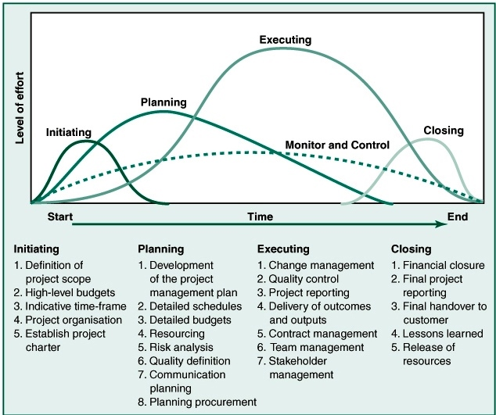

1. Write a short note on PRINCE2® and its principles **2 marks**

PRINCE2 (PRojects IN Controlled Environments) is a well-structured project management methodology that emphasizes dividing projects into manageable and controllable stages. PRINCE2® recognizes three levels of management inside the project, connected to another level above them in the organization. There are various roles defined in each layer

* Directing layer
* Managing layer
* Delivering layer

It also has the following set of 7 principles:

* + Continued business justification
  + Learn from experience
  + Defined roles and responsibilities
  + Manage by stages
  + Manage by exception
  + Focus on products
  + Tailor to suit the project

1. A project scoring model given as $Score=\frac{P_{success}+ 2 × Payoff}{Cost}$, rank the following projects according to their scores and recommend the best 3 projects. **5 marks**

|  |  |  |  |
| --- | --- | --- | --- |
| **Project** | **Cost (₦)** | **P (Success)** | **Payoff (₦)** |
| 1 | 1.45 | 2.13 | 1.42 |
| 2 | 1.62 | 1 | 1.58 |
| 3 | 1 | 2.13 | 1 |
| 4 | 1.89 | 2.67 | 3.35 |
| 5 | 2.17 | 3.33 | 2.78 |
| 6 | 2.12 | 3.38 | 2.78 |
| 7 | 2.49 | 3.67 | 1.34 |
| 8 | 2.51 | 3.88 | 2.37 |
| 9 | 3.7 | 3.61 | 3.34 |
| 10 | 3.58 | 3.56 | 4.22 |
| 11 | 4.44 | 3.78 | 3.54 |
| 12 | 6.39 | 3.88 | 5.74 |

Solution:

|  |  |  |  |  |  |
| --- | --- | --- | --- | --- | --- |
| **Project** | **Cost (₦)** | **P (Sxs)** | **Payoff ($)** | $$Score=\frac{P_{success}+ 2 × Payoff}{Cost}$$ | **Position** |
| 1 | 1.45 | 2.13 | 1.42 | **3.42** |  |
| 2 | 1.62 | 1 | 1.58 | **2.57** |  |
| 3 | 1 | 2.13 | 1 | **4.13** | **3** |
| 4 | 1.89 | 2.67 | 3.35 | **4.96** | **1** |
| 5 | 2.17 | 3.33 | 2.78 | **4.1** |  |
| 6 | 2.12 | 3.38 | 2.78 | **4.22** | **2** |
| 7 | 2.49 | 3.67 | 1.34 | **2.56** |  |
| 8 | 2.51 | 3.88 | 2.37 | **3.43** |  |
| 9 | 3.7 | 3.61 | 3.34 | **2.78** |  |
| 10 | 3.58 | 3.56 | 4.22 | **3.35** |  |
| 11 | 4.44 | 3.78 | 3.54 | **2.45** |  |
| 12 | 6.39 | 3.88 | 5.74 | **2.4** |  |

Project 4 ranked first while Projects 6 & 3 came second and third respectively.