PRN: 21070521024

NAME: Dev Chadalwada

SUBJECT: GEN AI

Q:3 Generate a model for an Insurance company to hold information on the insurer's vehicle,

and create a chart of monthly, yearly, and qtrly premiums based on no. of years of insurance

where in each year, the value of the vehicle depreciates by 7%.

CODE:

class VehicleInsurance:

def __init__(self, vehicle_value, insurance_years, monthly_rate):

self.initial_value = vehicle_value

self.years = insurance_years

self.monthly_rate = monthly_rate

def calculate_depreciation(self, year):

depreciated_value = self.initial_value * ((1 - 0.07) ** year)

return depreciated_value

def premium_chart(self):

chart = []

for year in range(1, self.years + 1):

yearly_value = self.calculate_depreciation(year)

yearly_premium = yearly_value * self.monthly_rate * 12

quarterly_premium = yearly_premium / 4

monthly_premium = yearly_premium / 12

chart.append({

"Year": year,

"Depreciated Vehicle Value": round(yearly_value, 2),

"Monthly Premium": round(monthly_premium, 2),

"Quarterly Premium": round(quarterly_premium, 2),

"Yearly Premium": round(yearly_premium, 2)

})

return chart

OUTPUT:

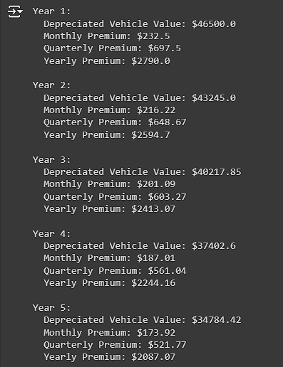

**Explanation:**

* **Depreciation**: The value of the vehicle depreciates by 7% every year.
* **Premium Calculation**: The premiums (monthly, quarterly, and yearly) are calculated based on the depreciated vehicle value at the beginning of each year.

Q:4 Generate a model to represent interest calculations of a Bank account where the process of calculating interest for 6 months is a. Find minimum balance for each month b. Make a total of all minimum balances c. Calculate interest based on interest rate d. Divide interest by 12 to find one-month interest e. Multiply interest by 6 to show interest in the account. Generate a model to represent transactions and interest calculations for 6 months.

CODE:

class BankAccount:

def __init__(self, initial_balance, interest_rate):

self.initial_balance = initial_balance

self.interest_rate = interest_rate

self.transactions = {i: [] for i in range(1, 7)} # Stores transactions for 6 months

def add_transaction(self, month, amount):

if 1 <= month <= 6:

self.transactions[month].append(amount)

else:

print("Invalid month. Please enter a month between 1 and 6.")

def calculate_minimum_balance(self, month):

balance = self.initial_balance

min_balance = balance

for transaction in self.transactions[month]:

balance += transaction

if balance < min_balance:

min_balance = balance

return min_balance

def calculate_interest(self):

total_min_balances = 0

for month in range(1, 7):

min_balance = self.calculate_minimum_balance(month)

total_min_balances += min_balance

total_interest = (total_min_balances * self.interest_rate) / 100

monthly_interest = total_interest / 12

six_month_interest = monthly_interest * 6

return {

"Total Minimum Balances": round(total_min_balances, 2),

"Total Interest": round(total_interest, 2),

"Monthly Interest": round(monthly_interest, 2),

"6-Month Interest": round(six_month_interest, 2)

}

OUTPUT:

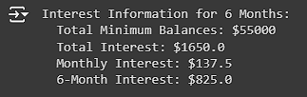

**Explanation:**

1. **Transactions**: We record deposits and withdrawals in each month.
2. **Minimum Balance Calculation**: For each month, the minimum balance is calculated after each transaction.
3. **Interest Calculation**:
   * Total interest is based on the sum of the minimum balances for 6 months.
   * The interest rate is applied to this sum to calculate the total interest.
   * We then calculate monthly interest (by dividing by 12) and 6-month interest (by multiplying by 6).