CIS 3200: Data Processing & Analytics Term Paper

Christopher Valdepena
Jiancong Zhang
My Truong
Ryan Applegate
Abstract: Our group decided to conduct analysis on a retail store dataset. The overall goal was to treat the dataset as if a new retail company had recently been established (4 years of operation). The company has been collecting data passively throughout their first four years of operating and are not sure how to utilize the information gathered. Our team produced a dashboard with a variety of metrics and visualizations to show the retail store owners the current standing of their business model/strategy and vital metrics to help aid them in making decisions for their second year of business.
We will be providing a thorough tutorial on the entire process, providing step-by-step instructions for downloading the data set, importing the dataset into Elasticsearch, and how each element of the dashboard was created and implemented.
- Introduction
The accessibility of data analytics is becoming easier every year. Over the years, processing power and data infrastructure has progressed to the point where every business has the capability of utilizing their own data by means of affordable analytical toolsets and data infrastructure. The opportunity of conducting in house analytics is no longer tied to large corporations but is now available for all to utilize. This analysis plays a vital role in showing how a small retail business starting out in their first year of operation can start leveraging their data for important business decision making within a single fiscal year. Overall, we wanted to provide a realistic scenario, using real data, to show how easily small businesses can begin reducing costs, increase revenue, and or alter or fine tune their strategic advantage by processing and analyzing their own data.
We believe this is such an important topic to cover due to the importance of data analytics regarding any business or industry. Small businesses will remain at a massive disadvantage when competing with larger corporations if they do not pursue data analysis. Small businesses are vital for the economy, providing niche services and goods that larger corporations ignore. As consumers, small businesses are entities we rely on. We urge small businesses to begin investing in in-house data processing and analysis before falling too far behind larger competitors.
- Related Work
Our project focused towards an entry level baseline analysis utilizing descriptive analytics. We wanted to primarily focus on dashboard development due to the company lacking any prior data analytic background. The dashboard would provide the retail store with basic insights to begin making strategic business decisions. We had to keep in mind this retail store had been in operation for several years collecting data with no analytical tools implemented. We had made the decision to not provide prescriptive or predictive analysis, seeing as it may be overwhelming and unnecessary for the client during this current situation. We wanted to ensure the company established a strong foundation, beginning with descriptive analytics.
There are many use cases where data analytics in the retail industry are utilized in another manner. An academic journal based out of South Africa covers their primary use of price optimisation and utilizing the granularity of their datasets to gain further insights on price points based on specific regions (Ridge et al., 2015). Our analysis did not focus on numerical sale metrics, but quantity of orders instead. Price optimisation would be an analysis the super retail restore could utilize at a later time once they establish their business objectives.
One aspect we did not focus on and is a very important aspect of a business is their physical store presence or lack thereof. A fully online e-commerce store such as this super retail store could potentially increase sales in certain regions if data was analyzed regarding their customer’s preference to shop online or in person. A great example of this could be a region located in a dense metropolitan district where many of the people residing there prefer to shop brick and mortar. Retail Super Store could utilize cross-channel analytics (comparing their online consumer data with their brick and mortar consumer data) (Cox 2012), providing insight on whether their business model would perform even better implementing brick and mortar stores than only providing their current customers online only.
- Background/Existing Work
The key to mining hidden valuable information from big data lies incorrect data analysis, which is the core of the significant data processing process. The value of big data comes from the analysis process, and the analysis process for valuable mining information from huge-scale data is big data analysis.（Sivarajah 2016）
The most important difference between big data analysis and traditional data analysis is the amount of data. The rapid growth of data volume and prominent data characteristics determine the difficulty of data storage, query, and analysis, and the requirements for data processing technology are rapidly increasing. Big data analysis is based on massive amounts of original data. It does not need to set research goals and methods in advance. Instead, it is necessary to use data mining techniques to find relationships between data and establish models from massive amounts of data, to find the root causes of the reality, and even Form theories and new cognitions, and predict and optimize the future on this basis, in order to achieve continuous improvement and innovation in various fields of social operations.
Traditional data analysis is "backward analysis," which analyzes what has happened. In the era of big data, data analysis is "forward analysis" and predictive. Traditional data analysis mainly focuses on structured data and has a complete set of practical and widely-used analysis systems: use a database to store structured data and then build a data warehouse to build a data cube for analysis.（Sivarajah 2016) The need to extract more in-depth and more valuable information from big data prompted the emergence of data mining techniques and invented a series of useful clustering, association analysis, classification, regression analysis, estimation, prediction, description, and visualization methods.
Today, the development of technology has dramatically exceeded the imagination of enterprises. Collecting unstructured information has become a possibility. Data can understand the possibilities of market segments and accurately reach each customer through truly personalized insights.
Through data mining and in-depth analysis, companies can master valuable information to discover customer thinking patterns and consumption behavior patterns.(Ajah 2019) Especially today, customers have a unique tendency to consume in order to show their individuality. Compared to being loyal to a particular brand, customers are more loyal and position themselves. If the company's brand cannot maximize customer value, it will not be easy to ensure customer continuity, even if it is patronage.
Moreover, companies cannot expect to classify customers because each customer's needs are different. Just like this, big data analysis can better grasp the consumer's consumption behavior and preferences and provide suggestions for precise marketing of enterprises.
With the advent of customer-led logic and the emergence of multi-channel shopping methods such as Internet e-commerce, customer roles and needs have changed, and the world is being perceived, interconnected, and intelligent. With the advent of the data age, not only can individual behaviors be quantified, collected, and predicted, but customers' personal opinions are likely to change the business world and the operation of society.
As a result, an era in which personalized customers dominate business needs has arrived. Under the impact of big data, market-led enterprise changes have begun to take shape.
According to Aliady‘s exciting Superstore report. (Aliady 2017). He made a conclusion in his reports, which is that the third group is Loyal Customers who Recent customers, but spent a good amount and bought more than once. So the suggestion for this customer segment is Offer membership loyalty program, recommend other products. Then the fourth group is Recent Customers who Bought most recently, but not often. This means this group is a new customer, we can give suggestions for this customer group to Provide on-boarding support, give them early success, start building relationships. Other than this, he also mentions the 5th group is Almost lost Customers are Above average recency, frequency and monetary values. May not have bought very recently though. So the suggestion for this customers segment is Make limited time offers, Recommend based on past purchases. To Reactivate them. (Aliady 2017) Moreover, the 6th Group is Lost customers who are Below average recency, frequency and monetary values. Will lose them if not reactivated. So suggestion for this customer segment is Share valuable resources, recommend popular products / renewals at discount, reconnect with them.(Aliady 2017)
4. Our work
Table 1. Quick View of The Retail Superstore Dataset.
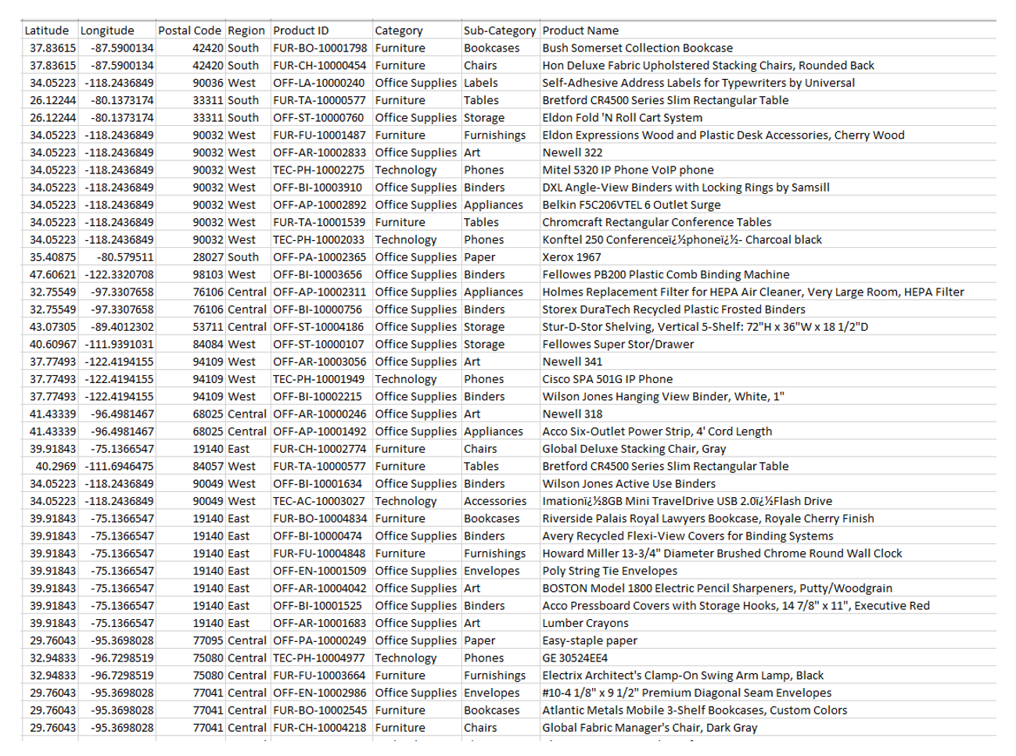
A retail superstore has been in operation for the past four years while collecting consumer and sales data. The data is managed, on-site with no data analytic tool implementation. The company has contracted our group to produce an analytical dashboard. The overall business objective focuses on developing and building a retail superstore business process to maintain future analytics. The dataset size is 3MB and holds 24 columns with 9,995 records.

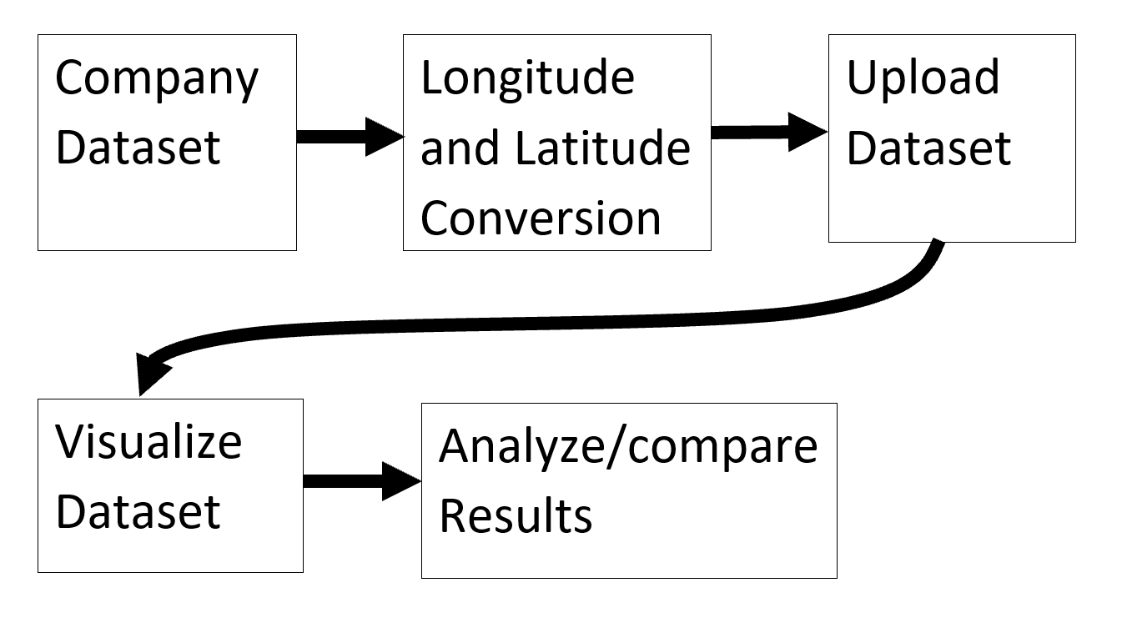
Figure 1. Data Implementation Process.

First, to implement the retail superstore dataset, we added the longitude & latitude dimensions before importing the data using a geocode algorithm supplied by “AwesomeTables”.

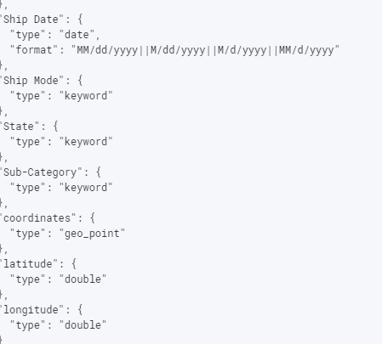
Figure 2. Example of added mapping code

Using Elasticsearch, we then uploaded the data by using the Import function from Kibana’s home page. Next, we utilized the geo-point field type, “which finds geo-points within a bounding box, a certain distance of a central point, aggregate documents geographically, integrate distance into a document’s relevance score, and to sort documents by distance” (Elastic).

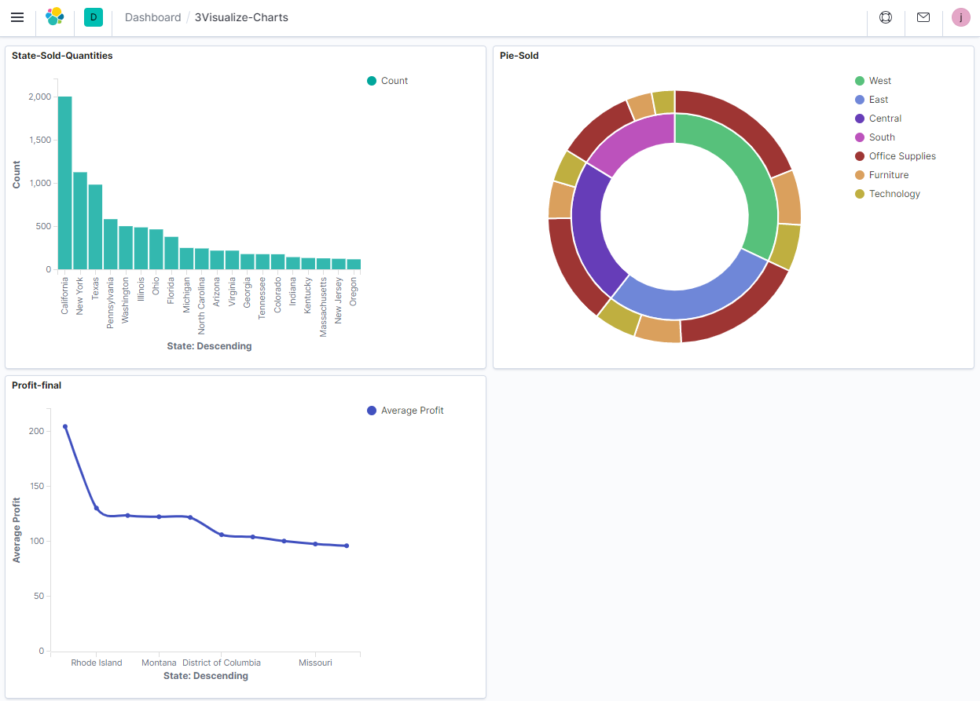
Figure 3. Data Visualizations

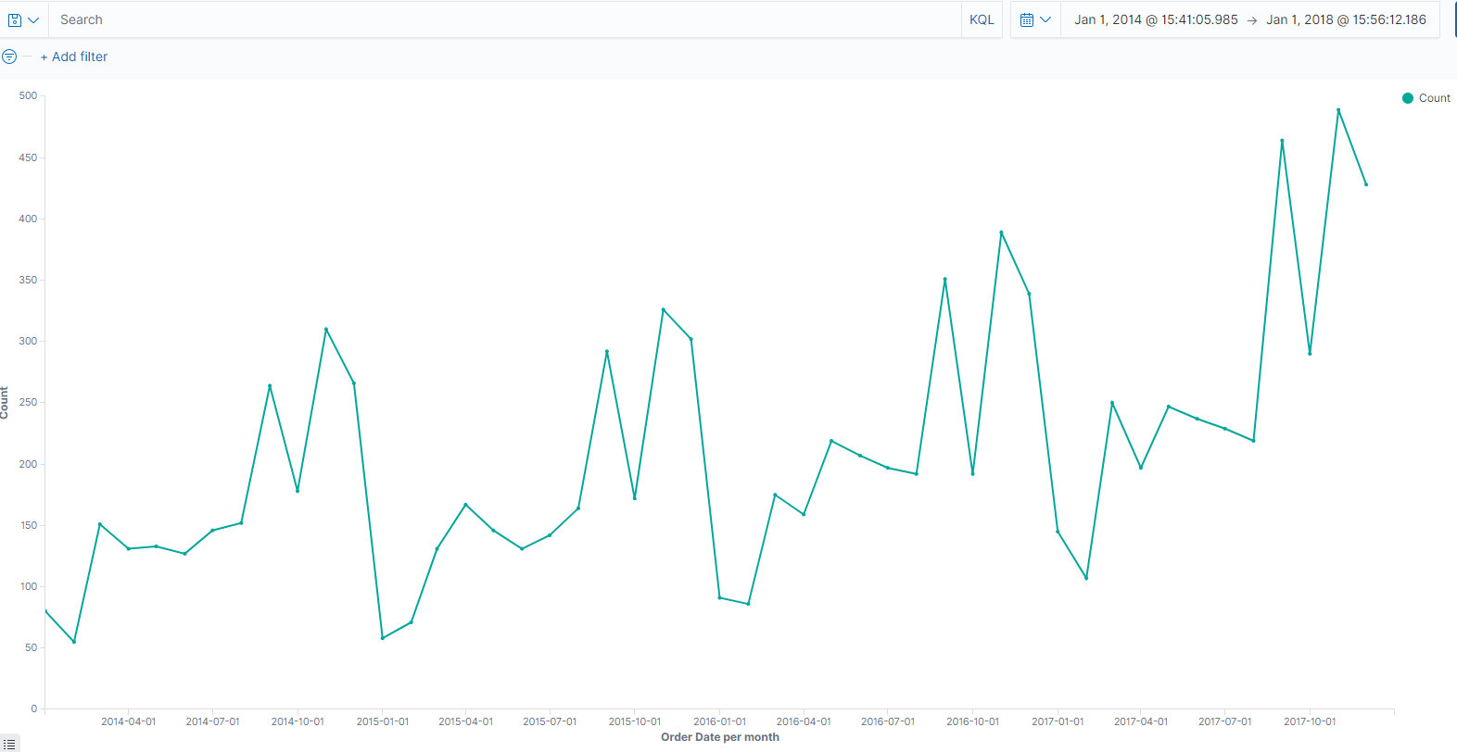
Figure 4. Quarter Sales Reports

Next, we effectively separated essential data from our superstore dataset by various states, regions, and dates, which allowed us to graph the amount of sold quantities, highest average profits earners, amount of sold office supplies, furniture, technology, and a Quarter Sales Report by using the count, average, and profits algorithm with a specified date such as a quarter system or the years 2014 - 2015 and 2016 - 2017.
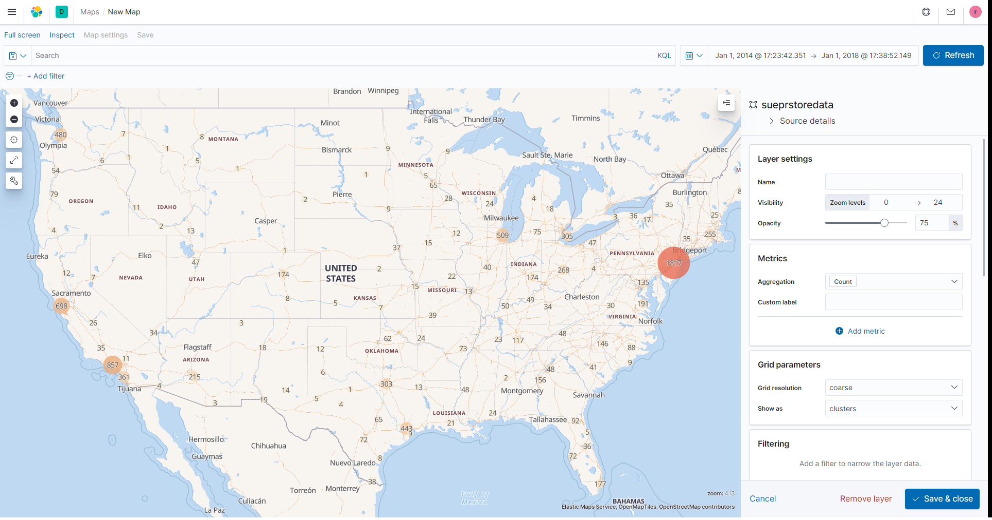
Figure 5. Geo-Spatial Map

Finally, through the use of ElasticSearch and Kibanas Geo-Point data type.we also created a Geo-Spatial map, which has a full view of all sale counts for the past four years of operation, marketing campaigns, and where we want to drill down for further analysis. We utilize the count since each unique entry is an Order Date within our database Hence, every coordinate equates to an individual product order.
5. Conclusion
In general, our group successfully downloaded the dataset, imported it into Elasticsearch, and then visualized it by creating some graphs, including bar chart, pie chart, line chart, geo-spatial map, and dashboard, which helps to enable the business to analyze and compare the results in making a better decision. Besides, we also took advantage of the Excel function by using GeoCode to import the longitude and latitude dimension into Elasticsearch. In fact, data visualization tools provide us with new methods that can significantly improve our ability to grasp and explore the information hidden in the data. It is easier to absorb and grasp information through vision and images than text and numbers.
Nonetheless, most business intelligence reports prepared for senior managers are usually filled with static tables and graphs that cannot provide vivid information to those viewing it. In contrast, data visualization enables users to receive large amounts of information about operating and business conditions. Data visualization allows decision makers to view the connections between cubes and provide new ways of interpreting data through the use of heat maps, geographic maps, and other rich graphical representations.
References

Ajah, I., &amp; Nweke, H. (2019, June 10). Big Data
and Business Analytics: Trends, Platforms,
Success Factors and Applications. Retrieved
December 19, 2020, from
https://www.mdpi.com/2504-2289/3/2/32/htm

Aliady, H. (2017, October 26). SUPERSTORE REPORT
ANALYTIC FROM SUPERSTORE
TRANSACTION DATA. Retrieved December
18, 2020, from
https://www.researchgate.net/publication/32084
2949_SuperStore_Analysis

Cox, E., & Books24x7, Inc. (2012). Retail analytics: the secret weapon. Wiley.
Elastic. “Geo-Point Field Type: Elasticsearch Reference [7.10].” Elastic, www.elastic.co/guide/en/elasticsearch/reference/current/geo-point.html
Ridge M., Johnston, K. A., O'Donovan, B. (2015). The use of big data analytics in the retail industries in South Africa. African Journal of Business Management, 9(19), 688 - 703.

Sivarajah, U., Kamal, M., Irani, Z., & Weerakkody, V. (2016, August 10). Critical analysis of Big Data challenges and analytical methods. Retrieved December 18, 2020, from https://www.sciencedirect.com/science/article/pii/S014829631630488X

