|  |  |
| --- | --- |
|  | |
|  | **Proposal to the**  **Office of Systems Integration (OSI)**  **Request for Information (RFI) #75001**  **For**  **Agile Development Pre-Qualified (ADPQ) Venfor Pool**  **Human Centered Design**  **June 3rd , 2016** |

|  |
| --- |
|  |



|  |  |
| --- | --- |
|  |  |

*Strategy! Innovation! Transformstion!*

Revision History

|  |  |  |  |
| --- | --- | --- | --- |
| Version | Date | Description of Updates | Author |
| 1 | 06/03/2016 | Created the Initial Verson | xFusion |
|  |  |  |  |
|  |  |  |  |
|  |  |  |  |

Table of Contents

Table of Contents iv

List of Tables v

LIST OF FIGURES vi

1 Introduction 1

2 Approach 2

List of Tables

No table of figures entries found.

LIST OF FIGURES

# Introduction

We have adopted various Responsive design tools and techniques to make sure that the SafeKids applicatcation provides an optimal user experience across a wide range of devices – from desktop computer to mobile devices.

We are using Twitter Bootstap framework for the frontend application in addition to AngularJS and JQuery to create a Single Page Application (SPA) that provides easy reading, navigation and great user experience.

This document describes the range of devices the application tested with and example screnshots from those testing.

# Tools and Technologies used for Responsive Design

The following tools and technologies are used for the SafeKids application for Responsive Design.

1. Twitter Bootstarp;
2. AngularJS;
3. JQuery;
4. CSS3; and
5. HTML5.

# Responsive Design Test Approach

This section dscribes the tst approach used to conduct the Responsive Design testing . The Responsive Testing is

* ***Incorporate Responsive Design Testing from the UX/UI prototype Phase to the rest of the project lifecycle phases***
  1. As described in the Human Centered Design approach (*ADPQ-SafeKids-HumanCenteredDesign.docx, Section 2*), we developed the UX/UI prototype and tested for Responsive Design on a wide range of devices.
  2. Responsive Design Testing is performed as part of every Sprint to ensure that the developed application functionality is Responsive on a wide range of devices.
  3. Responsive Design testing is performed as part of the User Acceptance Testing (UAT) of the SafeKids Application.
* ***Select wide range of devices for Responsive Design testing*** – the SafeKids application was tested on a wide range of devices from Desktop Computer/OS to Mobile devices.
* Desktop Computer Browser – MS Windows Operating System
  + Google Chrome;
  + Mozzila FireFox;
  + MS Internet Explorer/Edge;
  + Opera; and
  + Safari on Windows.
* Desktop Computer Browser – MAC
  + Safari on Mac.
* Mobile Devices – Android
  + Google Chrome on Android Mobile Phone
* Mobile Devices – iOS
  + iPhone
  + iPad
* Mobile Devices – Microsoft

# Responsive Design Testing

## Desktop Computer Browser – MS Windows Operating System

Mozilla Firefox

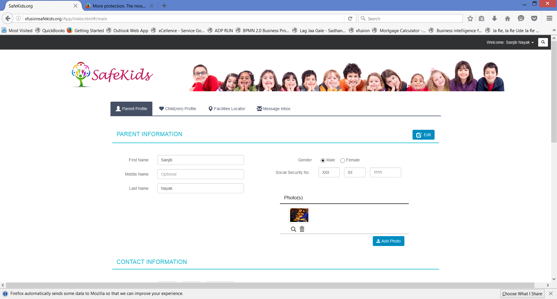

Google Chrome

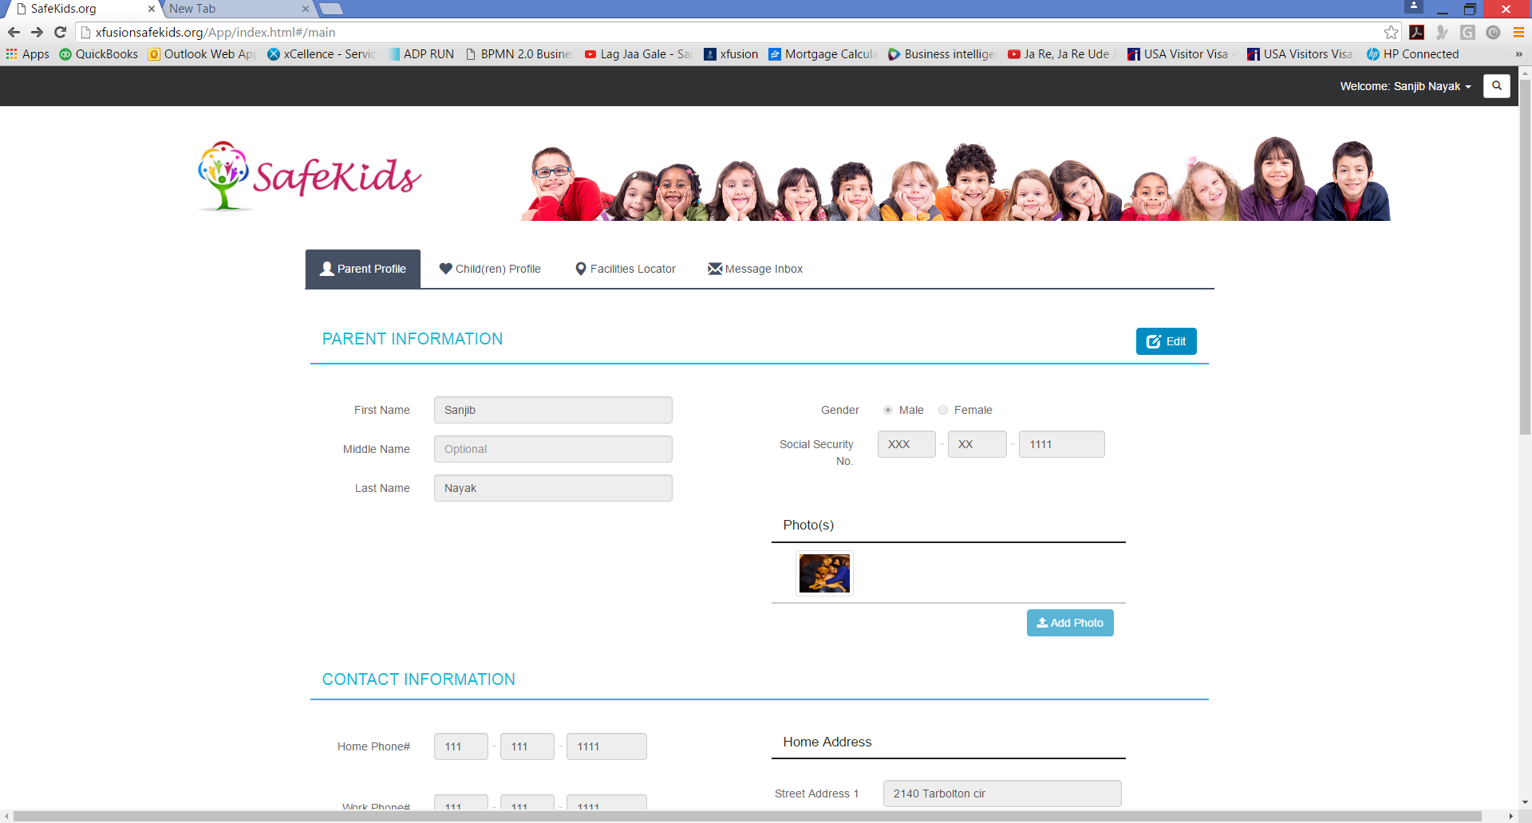

Internet Explorer/Edge

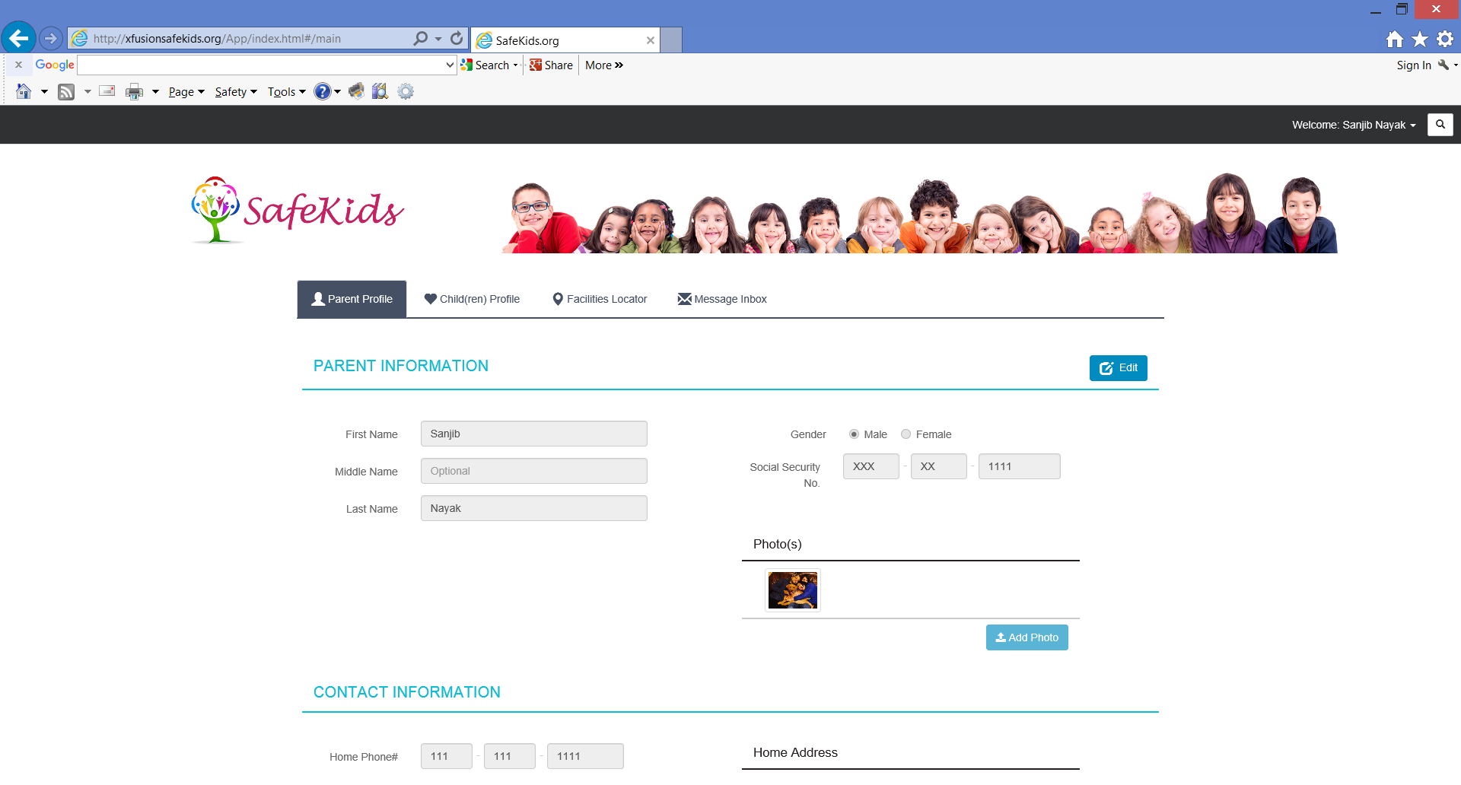

Opera

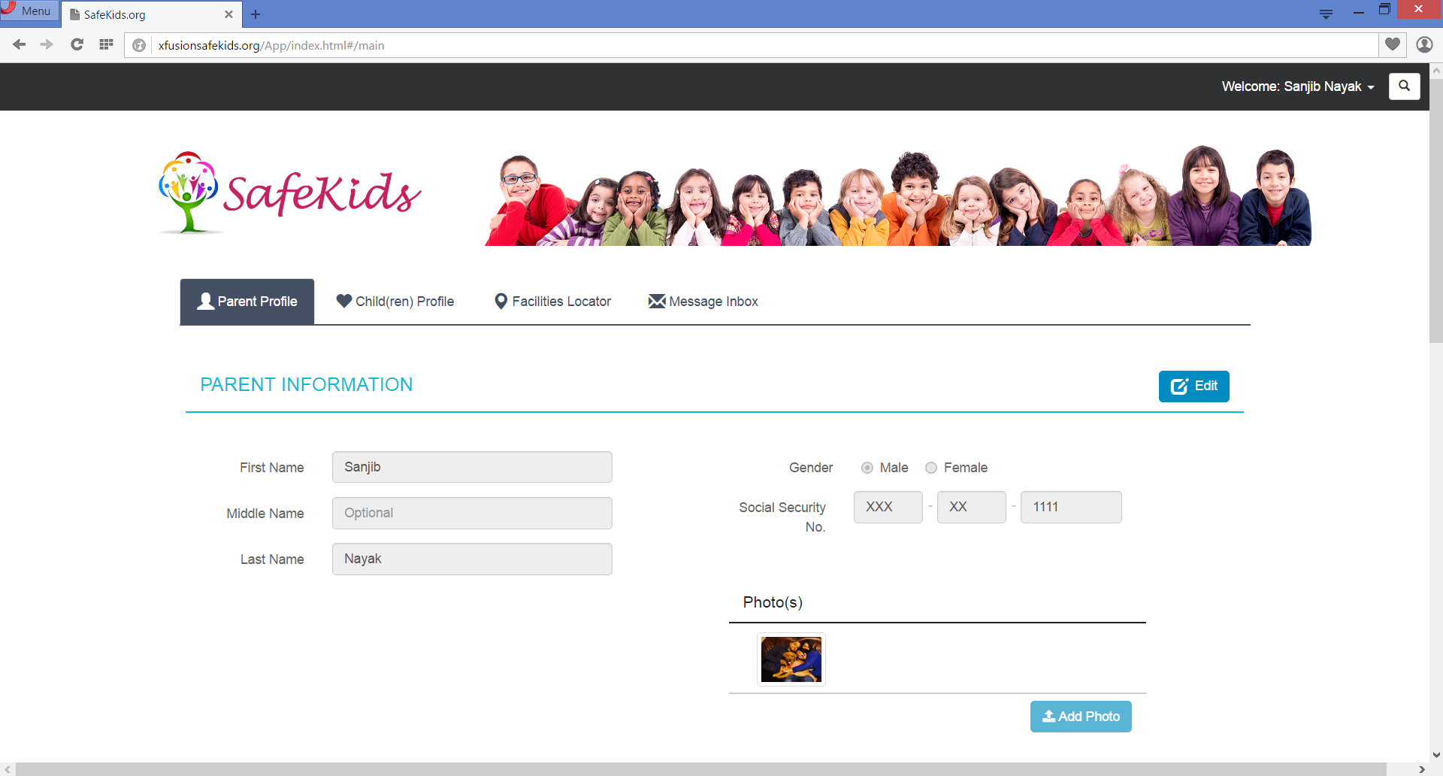

Safari on Windows OS

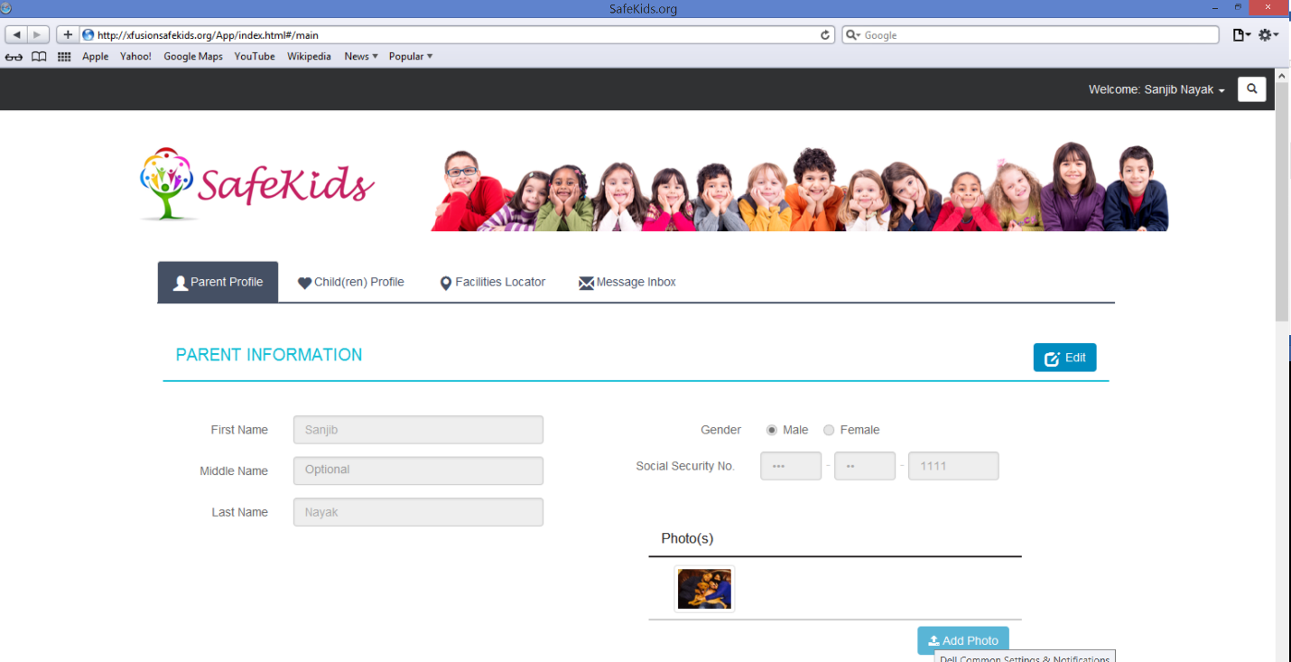

## Desktop Computer Browser – MAC

## Mobile Devices – Android OS

Google Chrome on Android Mobile Phone

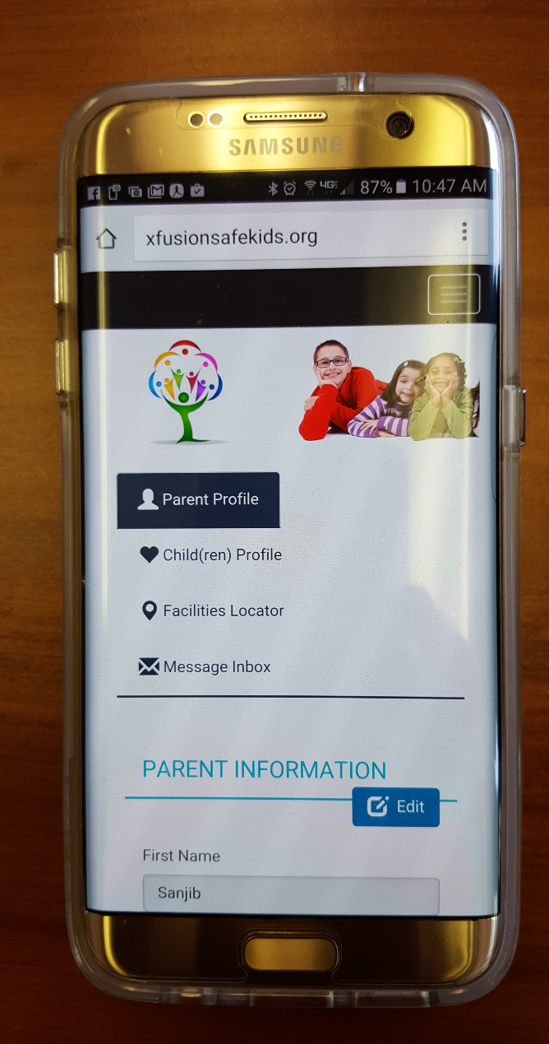

## Mobile Devices – iOS

* + iPhone
  + iPad

## Mobile Devices – Microsoft