|  |  |
| --- | --- |
|  | |
|  | **Proposal to the**  **Office of Systems Integration (OSI)**  **Request for Information (RFI) #75001**  **For**  **Agile Development Pre-Qualified (ADPQ) Venfor Pool**  **Product Roadmap and Release Plan**  **June 7th , 2016** |

|  |
| --- |
|  |



|  |  |
| --- | --- |
|  |  |

*Strategy! Innovation! Transformstion!*

Revision History

|  |  |  |  |
| --- | --- | --- | --- |
| Version | Date | Description of Updates | Author |
| 1 | 06/05/2016 | Created the Initial Verson | xFusion |
|  |  |  |  |
|  |  |  |  |
|  |  |  |  |

Table of Contents

Table of Contents 3

List of Tables 4

LIST OF FIGURES 5

1 Introduction 6

2 Test Approach and Phases 7

2.1 Usability Testing 7

2.2 Unit Testing 8

2.3 Automated Regression Testing 9

2.4 Integration Testing 9

2.5 Section 508 Testing 10

2.6 Load/Performance Testing 10

2.7 User Acceptance Testing (UAT) 11

2.8 Production Validation Testing 11

List of Tables

No table of figures entries found.

LIST OF FIGURES

***Figure 2‑1 – Test Approach Overview*** 13

# Introduction

The xFusion team understand the importance of thorough testing of an application starting from the design and conception phase to implementation and ongoing maintenance. The team follows an Agile and Joint Application Developmetn (JAD) approach where multiple iteratios of the application gets released to the stakeholders and testers. The team goes through a continuous iterative development, testing and integration cycle where the software is relased in multiple iterations and continuous testing and feedback happnes periodically. The team also practices Test Driven Development (TDD) practices where the developers are required to write test cases for their modules before they write the code.

# Test Approach and Phases

The test approach taken by xFusion includes both automated and manual testing. While the automated testing is run against pre defined test cases and also used for regression testing, the manual testing is conducted by the following:

* Focus groups using real users or persons impersonating real users
* Quality Control team
* Business Analysts
* System Analysts
* Oher product stakeholders

The manual testing is conducted to validate deep logical, functional and business area specifics. The following are the type of testing that were conducted for SafeKids:

* Usability Testing
* Unit Testing
* Automated Regression Testing
* Integration Testing
* Section 508 Testing
* Load/Performance Testing
* User Acceptance Testing (UAT)
* Production Validaton Testing

Each of these testing processes are defined below:

## Usability Testing

* **Why was it Conducted?**

The Usability testing is conducted to ensure that the Graphical Design and the User Experience meets the expectations of the real users. It also validates and confrms the UX design principle that we have adopted whch is a human-centered design. The goal is to provide a first class consumer experience to the end users that uses a responsive design.

* **Who did the Testing?**

For this testing we used a user who has impersonated being a biological parent of a foster child. Apart from that the Product Owner, Delivery Manager, Usability Tester and the GUX Designer were also a part of the testing and UX Design process.

* **What Tools were Used?**

The wireframes and sceens were tested using multiple devices and browsers to ensure a true responsive and platform agnostinc design. Those devices and browsers include:

* + **Devices**

* + - Computers running on both Windows and Mac OS
    - IPhone
    - IPad
    - Andrioid Phone
    - Android Tablet
    - Windows Mobile
    - Windows Tablet
  + **Browsers**

* + - Internet Explore and Microsoft EDGE
    - Google Chrome
    - Safari on both Mac and Windows
    - Opera
    - Firefox
* **When was this Testing Done?**

This testing was done in the conception and design phase of the project. The usability testing was conducted and the GUX was updated based on the feedback before it was released to the development team.

## Unit Testing

* **Why was it Conducted?**

The Unit Testing was conducted as a first level check by the development team to identify coding level issues that need to be resolved before the application is relased to the QA team.

* **Who did the Testing?**

This testing was done by the development team. The developers develop the code on their local machines. They are required to unit test and fix the bugs before the code is checked in to the Development environment.

* **What Tools were Used?**

The development team has used Selenium for automated unit testing

* **When was this Testing Done?**

This testing was done before checking in any code to the Development environment by the developers.

## Automated Regression Testing

* **Why was it Conducted?**

Aa a part of the Agile process, the etam follows an iterative based development practice. In that process the software is released to the Development and Test environments in multiple iterations and increments. The automated regression testing ensres that the new increment is backward compatible and has not broken anything that was working before by developing the new features.

* **Who did the Testing?**

This testing was done by the development team lead and the Quality Control Team.

* **What Tools were Used?**

Selenium was used for the automated Regression Testing

* **When was this Testing Done?**

Everytime new code was checked in to the Development and Test environments, this test was run to ensure backward compatibility

## Integration Testing

* **Why was it Conducted?**

The integration testing ensures that all the components that are a part of the specific software version are working together like an “***well oiled machine***”. It also focuses on the external interfaces (in this case the HHS API AND Google Map API) to ensure proper working of those services.

* **Who did the Testing?**

This testing was done by the development team lead, the Quality Control Team and the Business Analysts.

* **What Tools were Used?**

Selenium was used for the automated Integration Testing scenarios. On the top of that the Quality Control team and the Business Analysts conducted thorough and details testing. A set of 50~ positive and negative test cases were created for this testing which was also used by the team.

* **When was this Testing Done?**

Everytime new code was checked in to the Development and Test environments and a Regression Testing was done, this test was run by the team.

## Section 508 Testing

* **Why was it Conducted?**

This testing was conducted to ensure compatibility with the Secton 508 accessibility standards that are a mandate for this application.

**Please refer to the deliverable “ADPQ-SafeKids-Section508Compliance” for more details of the types of Section 508 testing that was conducted for SafeKids.**

* **Who did the Testing?**

This testing was done by the Quality Control Team by using both automated and manual process

* **What Tools were Used?**

We used the website <http://www.cynthiasays.com> to run an automated Section 508 testing for SafeKids

* **When was this Testing Done?**

Everytime new code was checked in to the Development and Test environments and a Regression Testing was done, the team had conducted a Section 508 testing.

## Load/Performance Testing

* **Why was it Conducted?**

This testing was conducted to make sure that the application and the hosting environment can withstand adequate load needed in a real environment and can performance in an efficient way to provide a real first-class consumer experience.

* **Who did the Testing?**

This testing was done by the Quality Control Team using automated tool

* **What Tools were Used?**

Selenium was used to create load and concurrency on the software

* **When was this Testing Done?**

This testing was done in the production environment after the code was released to production.

## User Acceptance Testing (UAT)

* **Why was it Conducted?**

The UAT was conducted as an acceptance criteria for the production ready applicaton. It was also done to ensure that the application is working against the business criteria and process that were developed in the initiation of the proect. This is also the time when a thorough end-to-end testing is conducted for production delivery.

* **Who did the Testing?**

This testing was done by the Quality Control Team, the user who impersonated a biological parent, the Business Analysts, the Delivery Manager and the Product Owner.

* **What Tools were Used?**

The UAT was conducted usig human testers and not tools

* **When was this Testing Done?**

Once the application development was completed, the code was tested end to end in the Development environment and was promoted to the Test environment, the team conducted the UAT.

## Production Validation Testing

* **Why was it Conducted?**

Once the application is released to production, a validation test is conducted. This testing is not as extensive as the UAT but is a quick validation to make sure that the application is functional in the production environment.

* **Who did the Testing?**

This testing was done by the Quality Control Team.

* **What Tools were Used?**

This testing was conducted usig human testers and not tools

* **When was this Testing Done?**

This testing was done after the application was released to the production environment and before it was reelased to the clients.

Figure 2.1 depicts the test approach that xFusion followed for SafeKids:

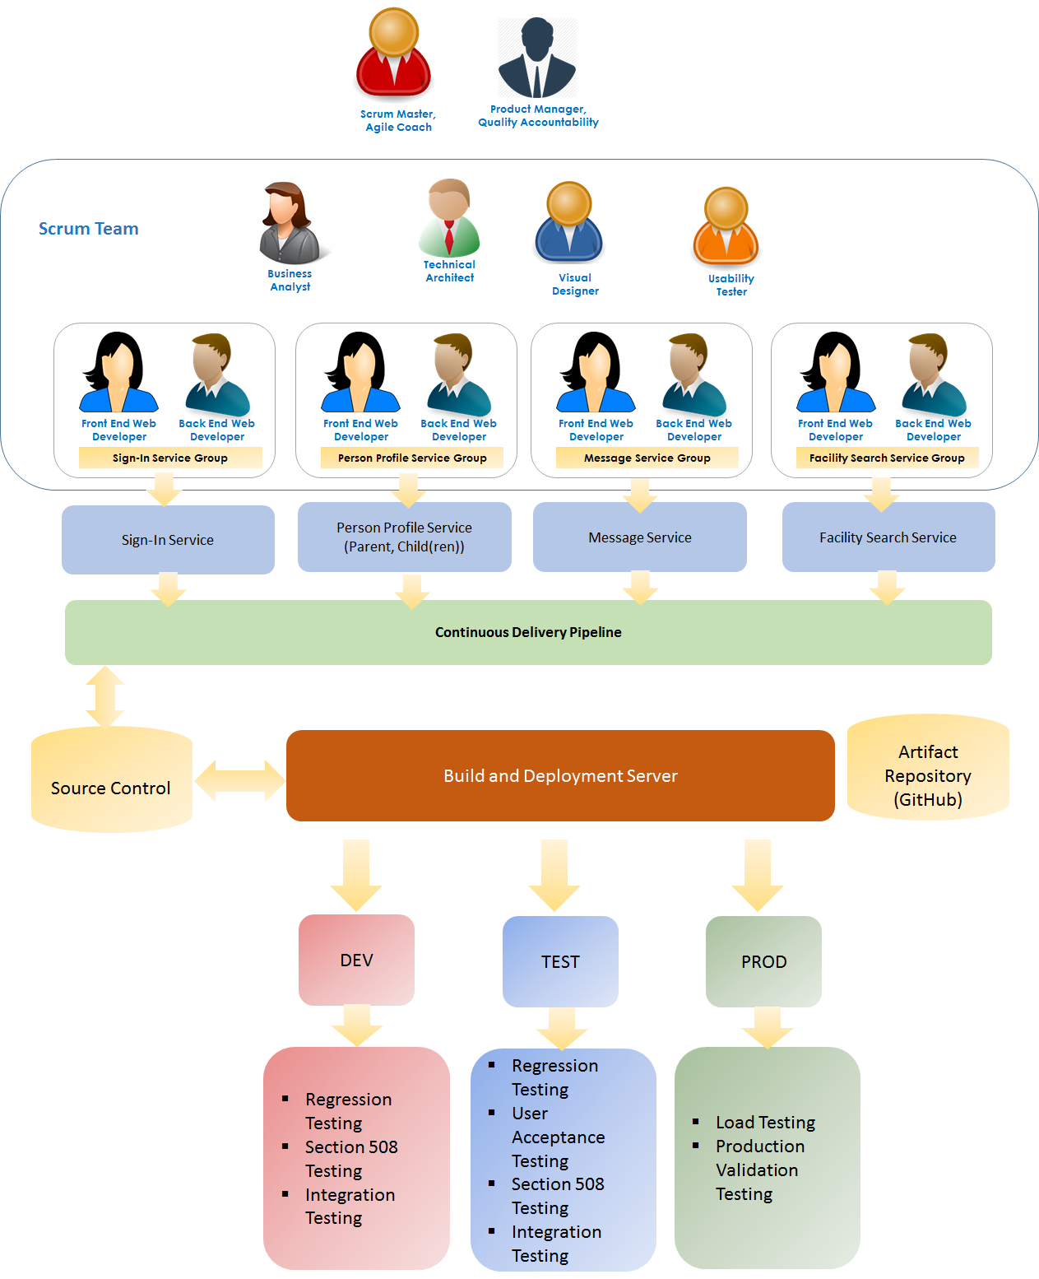

***Figure 2‑1 – Test Approach Overview***

# Automated Test Results

Summarized below are the automated test results for Unit Testing, Integration Testing, Section 508 Testing and Load/Performance Testing.

## Unit Testing

| **Test Suite** |
| --- |
| Test cases: 3 total / 2 passed / 1 failed |
| Commands: 24 total / 23 passed / 1 failed / 0 skipped |

| Index of test cases |
| --- |
| Only username |
| with wrong password |
| correct username password |

| Test case: Only username | | | |
| --- | --- | --- | --- |
| open | _blank |  |  |
| open | /App/#/ |  |  |
| pause | 5000 |  |  |
| type | name=username | test |  |
| type | name=password |  |  |
| click | //input[@value='Log In'] |  |  |
| verifyVisible | //div[@id='loginRegion']/div/div/form/div[2]/span |  |  |
| verifyText | //div[@id='loginRegion']/div/div/form/div[2]/span | Please enter a password. |  |

| Test case: with wrong password | | | |
| --- | --- | --- | --- |
| open | _blank |  |  |
| open | /App/#/ |  |  |
| pause | 5000 |  |  |
| type | name=username | test |  |
| type | name=password | wrongpassword |  |
| click | //input[@value='Log In'] |  |  |
| verifyVisible | css=div.form-group.text-warning |  | false |
| verifyText | css=div.form-group.text-warning | Incorrect username or password. | Actual value 'Incorrect username or password.' did not match 'Incorrect username or password. ' |

| Test case: correct username password | | | |
| --- | --- | --- | --- |
| open | _blank |  |  |
| open | /App/#/ |  |  |
| pause | 5000 |  |  |
| type | name=username | test |  |
| type | name=password | 123456789aA |  |
| click | //input[@value='Log In'] |  |  |
| pause | 10000 |  |  |
| verifyText | css=div.section-header.col-sm-12 | Parent Information Edit | Actual value 'Parent Information Edit' did not match '' |

|  |
| --- |
| **Test Suite: ChildTestSuite.html** |
| Test cases: 5 total / 5 passed / 0 failed |
| Commands: 94 total / 94 passed / 0 failed / 0 skipped |

|  |
| --- |
| Index of test cases |
| Child-Fname |
| Child-F-Lname |
| Child-F-L-G |
| Child-F-L-G-SSN |
| Child-F-L-G-dob-SSN |

|  |  |  |  |
| --- | --- | --- | --- |
| Test case: Child-Fname | | | |
| open | _blank |  |  |
| open | http://xfusionsafekids.org/App/index.html#/main |  |  |
| pause | 10000 |  |  |
| click | link=Child(ren) Profile |  | Element link=Child(ren) Profile not found |
| pause | 5000 |  |  |
| click | xpath=(//button[@type='button'])[5] |  | Element xpath=(//button[@type='button'])[5] not found |
| type | id=child-first-name-1 | Christin |  |
| click | css=input.btn.btn-primary |  |  |
| verifyVisible | //div[@id='childProfile']/form/div[5]/div/div/div[3]/div/span |  | false |
| verifyText | //div[@id='childProfile']/form/div[5]/div/div/div[3]/div/span | Please enter last name. |  |
| verifyVisible | css=div.col-sm-6 > span.text-danger |  | false |
| verifyText | css=div.col-sm-6 > span.text-danger | Please select Race / Ethnicity |  |
| verifyVisible | //div[@id='childProfile']/form/div[5]/div[2]/div/div[3]/div/span |  | false |
| verifyText | //div[@id='childProfile']/form/div[5]/div[2]/div/div[3]/div/span | Please select date of birth |  |
| verifyVisible | css=span.text-danger.col-sm-9 |  | false |
| verifyText | css=span.text-danger.col-sm-9 | Please enter SSN no. in XXX-XXX-XXXX format |  |

|  |  |  |  |
| --- | --- | --- | --- |
| Test case: Child-F-Lname | | | |
| open | _blank |  |  |
| open | http://xfusionsafekids.org/App/index.html#/main |  |  |
| pause | 10000 |  |  |
| click | link=Child(ren) Profile |  | Element link=Child(ren) Profile not found |
| pause | 5000 |  |  |
| click | xpath=(//button[@type='button'])[5] |  | Element xpath=(//button[@type='button'])[5] not found |
| type | id=child-first-name-1 | Christin |  |
| type | id=child-last-name-1 | Joe |  |
| click | css=input.btn.btn-primary |  |  |
| verifyNotVisible | css=span.text-danger | Please enter first name. |  |
| verifyTextNotPresent | css=span.text-danger | Please enter first name. |  |
| verifyNotVisible | //div[@id='childProfile']/form/div[5]/div/div/div[3]/div/span | Please enter last name. |  |
| verifyTextNotPresent | //div[@id='childProfile']/form/div[5]/div/div/div[3]/div/span | Please enter last name. |  |
| verifyVisible | css=div.col-sm-6 > span.text-danger | Please select Race / Ethnicity |  |
| verifyText | css=div.col-sm-6 > span.text-danger | Please select Race / Ethnicity |  |
| verifyVisible | //div[@id='childProfile']/form/div[5]/div[2]/div/div[3]/div/span | Please select date of birth |  |
| verifyText | //div[@id='childProfile']/form/div[5]/div[2]/div/div[3]/div/span | Please select date of birth |  |
| verifyVisible | css=span.text-danger.col-sm-9 | Please enter SSN no. in XXX-XXX-XXXX format |  |
| verifyText | css=span.text-danger.col-sm-9 | Please enter SSN no. in XXX-XXX-XXXX format |  |

|  |  |  |  |
| --- | --- | --- | --- |
| Test case: Child-F-L-G | | | |
| open | _blank |  |  |
| open | http://xfusionsafekids.org/App/index.html#/main |  |  |
| pause | 10000 |  |  |
| click | link=Child(ren) Profile |  | Element link=Child(ren) Profile not found |
| pause | 5000 |  |  |
| click | xpath=(//button[@type='button'])[5] |  | Element xpath=(//button[@type='button'])[5] not found |
| type | id=child-first-name-1 | Christin |  |
| type | id=child-last-name-1 | Joe |  |
| click | document.childform.getChildGender1[1] |  |  |
| click | css=input.btn.btn-primary |  |  |
| verifyNotVisible | css=span.text-danger | Please enter first name. |  |
| verifyTextNotPresent | css=span.text-danger | Please enter first name. |  |
| verifyNotVisible | //div[@id='childProfile']/form/div[5]/div/div/div[3]/div/span | Please enter last name. |  |
| verifyTextNotPresent | //div[@id='childProfile']/form/div[5]/div/div/div[3]/div/span | Please enter last name. |  |
| verifyVisible | css=div.col-sm-6 > span.text-danger | Please select Race / Ethnicity |  |
| verifyText | css=div.col-sm-6 > span.text-danger | Please select Race / Ethnicity |  |
| verifyVisible | //div[@id='childProfile']/form/div[5]/div[2]/div/div[3]/div/span | Please select date of birth |  |
| verifyText | //div[@id='childProfile']/form/div[5]/div[2]/div/div[3]/div/span | Please select date of birth |  |
| verifyVisible | css=span.text-danger.col-sm-9 | Please enter SSN no. in XXX-XXX-XXXX format |  |
| verifyText | css=span.text-danger.col-sm-9 | Please enter SSN no. in XXX-XXX-XXXX format |  |

|  |  |  |  |
| --- | --- | --- | --- |
| Test case: Child-F-L-G-SSN | | | |
| open | _blank |  |  |
| open | http://xfusionsafekids.org/App/index.html#/main |  |  |
| pause | 10000 |  |  |
| click | link=Child(ren) Profile |  | Element link=Child(ren) Profile not found |
| pause | 5000 |  |  |
| click | xpath=(//button[@type='button'])[5] |  | Element xpath=(//button[@type='button'])[5] not found |
| type | id=child-first-name-1 | Christen |  |
| type | id=child-last-name-1 | Joe |  |
| click | document.childform.getChildGender1[1] |  |  |
| type | id=first | 111 |  |
| type | id=middle | 11 |  |
| type | id=last | 1111 |  |
| click | css=input.btn.btn-primary |  |  |
| verifyNotVisible | css=span.text-danger | Please enter first name. |  |
| verifyNotVisible | //div[@id='childProfile']/form/div[5]/div/div/div[3]/div/span | Please enter last name. |  |
| verifyNotVisible | css=span.text-danger.col-sm-9 | Please enter SSN no. in XXX-XXX-XXXX format |  |
| verifyVisible | css=div.col-sm-6 > span.text-danger | Please select Race / Ethnicity |  |
| verifyText | css=div.col-sm-6 > span.text-danger | Please select Race / Ethnicity |  |
| verifyVisible | //div[@id='childProfile']/form/div[5]/div[2]/div/div[3]/div/span | Please select date of birth |  |
| verifyText | //div[@id='childProfile']/form/div[5]/div[2]/div/div[3]/div/span | Please select date of birth |  |

|  |  |  |  |
| --- | --- | --- | --- |
| Test case: Child-F-L-G-dob-SSN | | | |
| open | _blank |  |  |
| open | http://xfusionsafekids.org/App/index.html#/main |  |  |
| pause | 10000 |  |  |
| click | link=Child(ren) Profile |  | Element link=Child(ren) Profile not found |
| pause | 5000 |  |  |
| click | xpath=(//button[@type='button'])[5] |  | Element xpath=(//button[@type='button'])[5] not found |
| type | id=child-first-name-1 | Christen |  |
| type | id=child-last-name-1 | Joe |  |
| click | document.childform.getChildGender1[1] |  |  |
| select | id=ethnicity | Asian |  |
| click | id=child-birthday-1 |  |  |
| pause | 5000 | Select birth date |  |
| type | id=first | 111 |  |
| type | id=middle | 11 |  |
| type | id=last | 1111 |  |
| click | css=input.btn.btn-primary |  |  |
| verifyNotVisible | css=span.text-danger | Please enter first name. |  |
| verifyNotVisible | //div[@id='childProfile']/form/div[5]/div/div/div[3]/div/span | Please enter last name. |  |
| verifyNotVisible | css=span.text-danger.col-sm-9 | Please enter SSN no. in XXX-XXX-XXXX format |  |