|  |  |
| --- | --- |
|  | |
|  | **Proposal to the**  **Office of Systems Integration (OSI)**  **Request for Information (RFI) #75001**  **For**  **Agile Development Pre-Qualified (ADPQ) Venfor Pool**  **Scrum Team Orgnization**  **June 3rd , 2016** |

|  |
| --- |
|  |



|  |  |
| --- | --- |
|  |  |

*Strategy! Innovation! Transformstion!*

Revision History

|  |  |  |  |
| --- | --- | --- | --- |
| Version | Date | Description of Updates | Author |
| 1 | 06/03/2016 | Created the Initial Verson | xFusion |
|  |  |  |  |
|  |  |  |  |
|  |  |  |  |

Table of Contents

Table of Contents iv

List of Tables v

LIST OF FIGURES vi

1 Introduction 1

2 Micro-service Based Approach for Scrum Team Organization 2

3 Scrum Team Matrix 4

4 Playbook Scrum Team Roles 7

List of Tables

Table 3‑1 Scrum Team Role,Description and Mapping to Labor category 4

LIST OF FIGURES

Figure 2‑1 Micro-service based organization of the Scrum Team. 2

# Introduction

As a part of the Agile and Scrum development process, xFusion goes through multiple sprints for the syste development process. The sprints are managed by the sprint team that had various responsibilities aligned with the SDLC process. We also follow the U.S. Digital Services Playbook to ensure a user centric application with a human user as the cenral focus.

# Micro-service Based Approach for Scrum Team Organization

In order for the team to be able to work independently and paralley on multiple features, we took Micro-service based approach for team organization as shown in Figure 2-1. This ensures a modular approach for design, development and testing of application features independently in an iterative and incremental way.

The application features are analyzd and are divided into the following Micro-services:

1. Sign-In - User Login
2. Person Profile Service - Creating and Updating Parent and Child(ren) profile
3. Message Service – Bilogical parents communicates to the Case Worker and the Foster Parents through private mailbox
4. Facility Search - Search nearby Foster Care Facilities by ZIP code

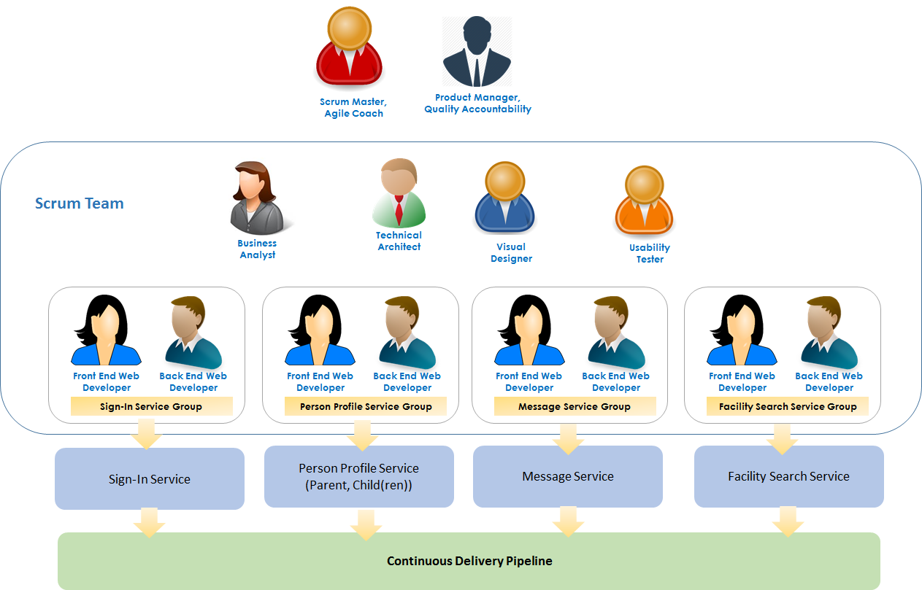

Figure ‑ Micro-service based organization of the Scrum Team.

As shown in Figure 2-1, four groups were formed to develop the front end and the back end of the services. Each group had expertise to perform the role of the Front End and Back End Web Development. Each team is responsible for one service.

Each service was developed and tesed independently. At the end all the services were integrated with the front end application together.

Other Scrum Team Roles such as Business Analyst, Technical Architect, Visual Designer and Usability Tester are global to the individual service teams.

We designated a Scrum Master for the Scrum Team and the Scrum Master also played the role of Agile Coach.

The Product Manager was responsible for Defining the product features and theor priorities, sprint and release planning.

The Product Manager is the single person who is Accountable for the Quality of the Product.

# Scrum Team Matrix

The Scrum team matrix decribes the xFusion sprint team that was responsible for the development of the SafeKids application. The Scrum Team Role, description and mapping to Labor Category are described in Table 3-1.

Table ‑ Scrum Team Role,Description and Mapping to Labor category

|  |  |  |  |
| --- | --- | --- | --- |
| **ID** | **Project Role - Agile/Scrum Role** | **Labor Category** | **Roles and Reponsibilities** |
| 1 | Product Owner | Product Quality Accountability |  |
| 1 | Product Owner | Product Manager |  |
| 2 | Scrum Master | Delivery Manager |  |
| 2 | Scrum Master | Agile Coach |  |
| 3 | Scrum Team Member | Writer/Content Designer/Content Strategist |  |
| 4 | Scrum Team Member | Technical Architect | 1. Transforming the Business Requirements (User Stories) to Technical Design 2. Logical and Physical Architecture Definition using Microservice based Architecture 3. Technology Section for various tiers in the N-Tier Architecture 4. Microservices Specification and Design 5. Technical Review and approval of implementation artifacts |
| 5 | Scrum Team Member | Visual Designer |  |
| 6 | Scrum Team Member | Interaction Designer/User Researcher/Usability Tester |  |
| 7 |  |  |  |
| 8 | Scrum Team Member | Business Analyst | 1. Develop User Stories and define Acceptance Criteria 2. Develop Teat Approach and Test Cases |
| 9 | Scrum Team Member | Front End Web Developer – Sign-In Service | 1. Creating web pages based on given design using AngularJS (for single page web application) 2. Doing form validations on all web forms 3. Making REST API calls to micro services on required events 4. Creating json objects to submit the form data to API (script development) 6. Automated Unit testing 7. Unit testing |
| 10 | Scrum Team Member | Backend Web Developer - Sign-In Service | 1. Creating controllers for REST API 2. Creating entities for tables related to person, user and data layer to get data from database 3. Writing business logic to process data as per the request 4. Managing session and using token (User login and registration) 6. Automated Unit testing 7. Unit testing |
| 11 | Scrum Team Member | Front End Web Developer - Profile Management Service | 1. Creating web pages based on given design using AngularJS (for single page web application) 2. Doing form validations on all web forms 3. Making REST API calls to micro services on required events 4. Creating json objects to submit the form data to API (script development) 5. Image upload for profile photos and displaying them 6. Automated Unit testing 7. Unit testing |
| 12 | Scrum Team Member | Backend Web Developer - Profile Service | 1. Creating controllers for REST API 2. Creating entities for tables related to person and his profile and data layer to get data from database 3. Writing business logic to process data as per the request (saving parent, updating parent, uploading profile picture of parent) 4. Intergrating CAPTCHA and validation code for registration 5. Creating entities for tables related to child profile and data layer to get data from database 6. Writing business logic to process data as per the request (saving child, updating child, getting list of children, uploading docs and pictures of child) 7. Token verification 8. Develop Email and SMS Services 9. Token verification 10. Automated Unit testing 11. Unit testing |
| 15 | Scrum Team Member | Front End Web Developer - Facility Search Service | 1. Creating web pages based on given design using AngularJS (for single page web application) 2. Integrating Angular JS Google Maps in application 3. Integrating API for facilities information in web application 4. Showing facilities as markers on Google map 5. Automated Unit testing 6. Unit testing |
| 16 | Scrum Team Member | Backend Web Developer - Facility Search Service |  |
| 17 | Scrum Team Member | Front End Web Developer - Message Service | 1. Creating web pages based on given design using AngularJS (for single page web application) 2. Doing form validations on new message form 3. Making REST API calls to send message, get list of messages and delete message 4. Creating json objects to submit the form data to API (script development) 5. Automated Unit testing 6. Unit testing |
| 18 | Scrum Team Member | Backend Web Developer - Message Service | 1. Creating controllers for REST API 2. Creating entities for tables related to messages and data layer to get data from database 3. Writing business logic to process data as per the request (new message, getting list of all messages, deleting message) 4. Token verification 6. Automated Unit testing 7. Unit testing |

# Playbook Scrum Team Roles

As descrbed above, xFusion Scrum team use the U.S. Digital Services Playbook to ensure a user centric, robust application that focuses on a human user. Below is the playbook mapping to how we incorporated those plays in to the overall development of the SafeKids application, the documents associated with each play and finally the labor categories with the primary responsibility of the development of the artifacts.

|  |  |  |
| --- | --- | --- |
| **Play Title** | **Function** | **Labor Categories** |
| Play 1  Understand what people need | Understand what people need, by including people in the prototype development and design process | Category 1 - Product Manager  Category 12 - Business Analyst  Category 5 - Visual Designer |
| Play 2  Address the whole experience, from start to  finish |  | Category 3 - Interaction Designer / User  Researcher / Usability Tester  Category 12 - Business Analyst |

|  |  |  |
| --- | --- | --- |
| Play3  Make it simple and intuitive | Used at least three "human-centered design" techniques or tools | Category 3 - Interaction Designer/User Researcher/Usability Tester |
| Play 4  Build the service using agile and iterative practices | Used an iterative approach, where feedback informed subsequent work or versions of the prototype | Category 11 - Agile Coach |
| Play 5  Structure budgets and contracts to support delivery |  | Category 1 - Product Manager |
| Play 6  Assign one leader and that person accountable | Assigned one leader, gave that person authority and responsibility, and held that person accountable for the quality of the prototype submitted | Category 1 - Product Manager |
| Play 7  Bring in experienced teams | Assembled a multidisciplinary and collaborative team including a minimum of 5 labor categories from the  Development Pool labor categories to design and develop the prototype | Category 1 - Product Manager |
| Play 8  Choose a modern technology stack | Used at least five modern and opensource technologies, regardless of | Category 2 - Technical Architect |

|  |  |  |
| --- | --- | --- |
|  | architectural layer (frontend, backend, etc.) |  |
| Play 9 Deploy in a flexible hosting environment | Deployed the prototype on an  Infrastructure as a Service (IaaS) or Platform as a Service (PaaS) provider, and indicated which provider they used | Category 7 - Backend Web Developer |
| Play 10  Automate testing and deployments | Deploy their software in a container (i.e., utilized operating-system-evel virtualization) | Category 7 - Backend Web Developer |
| Play 11  Manage security and privacy through reusable processes | Set up or used continuous monitoring | Category 8 - DevOps Engineer Category 10 - Delivery Manager |
| Play 12  Use data to drive decisions |  | Category 1 - Product Manager  Category 11 - Agile Coach  Category 12 - Business Analyst  Category 8 - DevOps Engineer |
| Play 13  Default to open | Prototype and underlying platforms used to create and run the prototype are openly licensed and free of charge | Category 2 - Technical Architect |

|  |  |  |
| --- | --- | --- |
| Play 1  Understand what people need | Created or used a design style guide and/or a pattern library | Category 12 - Business Analyst |
| Play 4  Build the service using agile and iterative practices | Performed usability tests with people | Category 3 - Interaction Designer / User  Researcher / Usability Tester |
| Play 4  Build the service using agile and iterative practices | Created a prototype that works on multiple devices, and presents a responsive design | Category 3 - Interaction Designer / User  Researcher / Usability Tester  Category 4 - Writer / Content Designer /  Content Strategist |
| Play 4  Build the service using agile and iterative practices | Wrote unit tests for their code | Category 6 - Frontend Web Developer  Category 7 - Backend Web Developer |
| Play 8  Choose a modern technology stack | Set up or used configuration management | Category 8 - DevOps Engineer |
| Play 13  Default to open | Provided sufficient documentation to install and run their prototype on another machine | Category 6 - Frontend Web Developer  Category 7 - Backend Web Developer |