|  |  |
| --- | --- |
|  | |
|  | **Proposal to the**  **Office of Systems Integration (OSI)**  **Request for Information (RFI) #75001**  **For**  **Agile Development Pre-Qualified (ADPQ) Venfor Pool**  **Product Roadmap and Release Plan**  **June 5th , 2016** |

|  |
| --- |
|  |



|  |  |
| --- | --- |
|  |  |

*Strategy! Innovation! Transformstion!*

Revision History

|  |  |  |  |
| --- | --- | --- | --- |
| Version | Date | Description of Updates | Author |
| DRAFT | 05/19/2016 | Created the DRAFT Verson | xFusion |
| 1.0 | 06/05/2016 | Upodates made for review comments | xFusion |
|  |  |  |  |
|  |  |  |  |

Table of Contents

Table of Contents iv

List of Tables v

LIST OF FIGURES vi

1 Introduction 1

2 Product Vision 2

3 Product Roadmap and Release Plan 3

4 Iterative SDLC Approach 8

List of Tables

No table of figures entries found.

LIST OF FIGURES

***Figure 3‑1 – Release Planning*** 9

***Figure 3‑2 - Sample Burndown Chart*** 10

***Figure 3‑3 - Sample Sprint Velocity Chart*** 10

***Figure 3‑4 - Product Roadmap Planning*** 11

***Figure 3‑5 - Product Roadmap and Release Plan*** 12

***Figure 4‑1 - Iterative SDLC Process*** 14

# Introduction

The purpose of this document is to create a roadmap and release plan for the SafeKids application. The Roadmap includes the vision of the application, the timeline of events, the path of the application from design to implementation as well as the high level grouping of the user stories and their iterative progression.

# Product Vision

The vision is to create a system that allows a parent of a forster child to register in the online system, create and manage his and his child(ren) profiles, search for a foster care facility within a specific zip code and comnicate with a case worker and a foster parent.

In order to achieve this goal the SafeKids application will provide:

* An online registration feature for the biological/adopted parent
* Profile namagement for the parent and the chid(ren)
* Allow the parent to search for foster care facilities within a zip cde
* Connet to the HHS API to get the results fir the specific zip code
* A Google map to visually represent the facility locations
* A secured Inbox to communicate with the case worker or the forster parent

# Product Roadmap and Release Plan

The SafeKids roadmap and release plan consists of the to-be technical and business architecture, user stories, outputs events and timeine that provides an iterative and increamental delivery of an application that has the human-user as the focus. The release of the end product has been devided into 4 iretations. Summarized below are the contents of each iteration:

* **Iteration 1 (Sprint 0)**: The first iteration includes the following:
  + Product Vision and Project Charter
  + Release planning
  + Sprint planning
  + Designing the system front end
  + Designing the system backend
  + Designing the Microservices
* **Iteration 2** **(Sprint 1):** The second iteration includes the following:
  + Development of the Graphical User Experience (GUX)
  + Development of the Minimum Viable Product (MVP)
  + Testing of the Minimally Viable Product (MVP) that includes:

|  |
| --- |
| * Parent Account Creation |
| * Create Parent Profile |
| * Upload Parent Pictures |
| * Search Facilities |
| * Send Message to Case Worker |
| * Send Message to Foster Parent |

* Sprint review and sprint retrospective.
* **Iteration 3 (Sprint 2):** The third iteration includes the following**:**
  + Development of the next product increment
  + Testing of the next increment that includes:

|  |
| --- |
| * Identity Verification |
| * CAPTCHA Validation |
| * Create Child(ren) Profile |
| * Upload Child(ren) Pictures |
| * Integrate with Google Map |
| * Receive email from Case Worker |

* Sprint review and sprint retrospective.
* **Iteration 4 (Sprint 3):** The fourth iteration includes the following**:**
  + Development of the next product increment
  + Testing of the next increment that includes:

|  |
| --- |
| * Edit Parent Profile |
| * Edit Child(ren) Profile |
| * Upload Supporting Documents |
| * Manage Inbox |
| * Change Password |

* Sprint review and sprint retrospective
* Deployment of the application to the AWS production environment
* End to end testing of the application in the AWS production environment

The following figures (Figure 3.1 – 3.5) depict the Product Roadmap and Release Planning process followed by xFusion

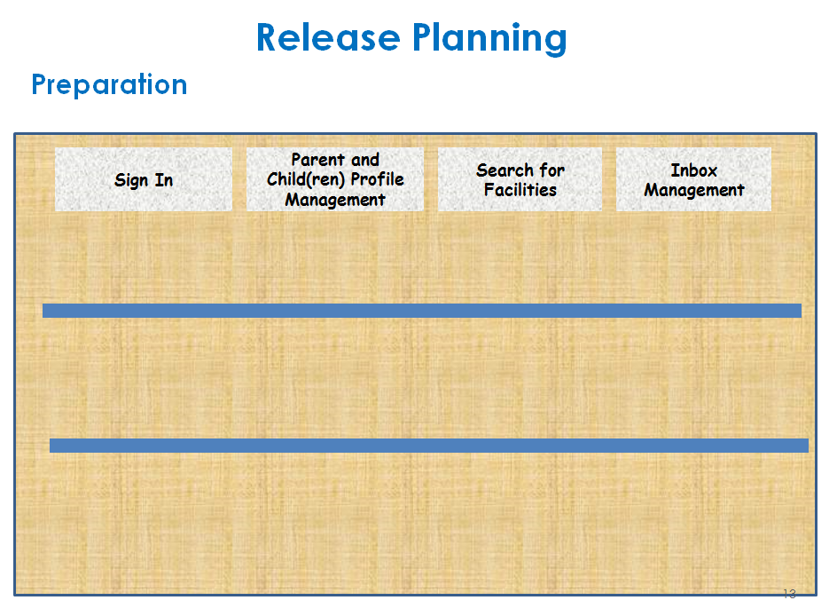

***Figure 3‑1 – Release Planning***

***Figure 3‑2 - Sample Burndown Chart***

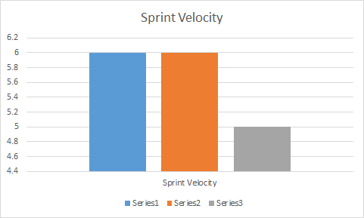

***Figure 3‑3 - Sample Sprint Velocity Chart***

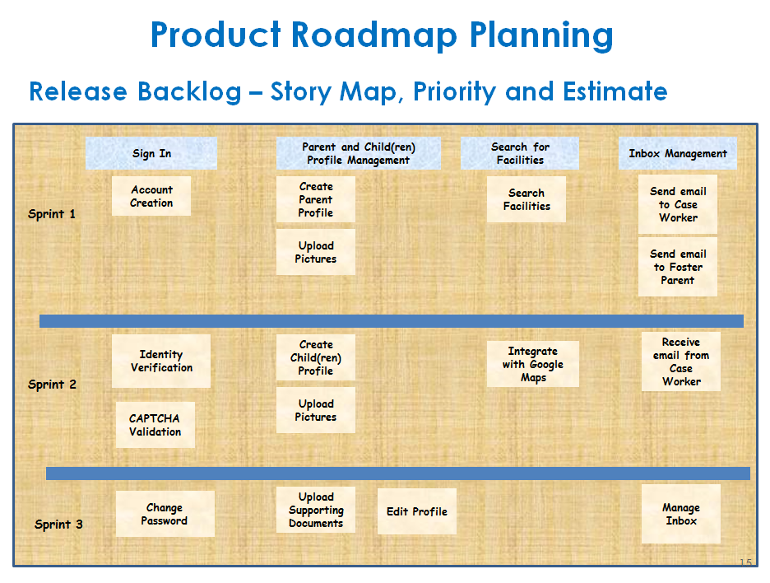

***Figure 3‑4 - Product Roadmap Planning***

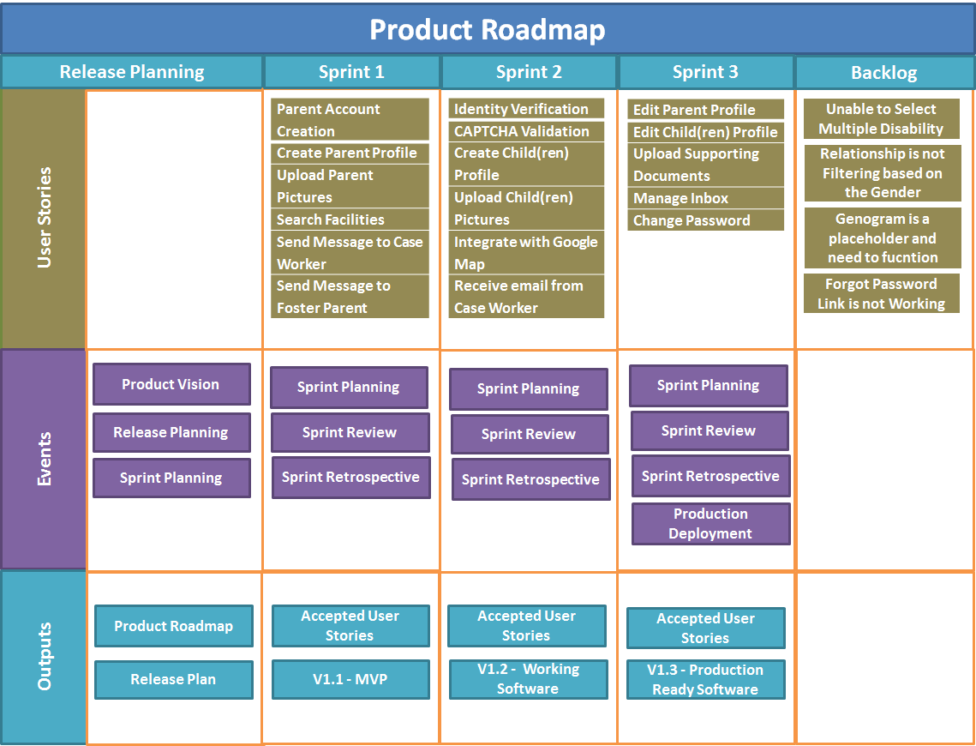

***Figure 3‑5 - Product Roadmap and Release Plan***

# Iterative SDLC Approach

At xFusion we practice Agile development approach extensively. Our approach includes the following:

* + Continuous interaction and feedback from the stakeholders
  + Working prototype based development in iterations
  + Joint Application Development (JAD) sessions with users
  + Sprint based release methodology

Summarized below are the steps that were performed for the design and development of the prototype:

* **Step 1**: Initiate kick-off meeting to iterate project plan, scope and collect requirements.
* **Step 2:** Sketch/Revise wireframes which is focusing on information structure, site skeleton, navigation flow and interface interaction.
* **Step 3:** Review and discuss wireframes.
* **Step 4:** Repeat step 2 & 3 until reaching the satisfactions.
* **Step 5:** Work on high-fidelity visual mockups which is focusing on style guides such as typography, color pallets and graphical assets.
* **Step 6:** Review and discuss mockups.
* **Step 7:** Repeat step 5 & 6 until reaching the satisfactions.
* **Step 8:** Translate graphical mockups to code-ready HTML/CSS templates.
* **Step 9:** Implement/Revise coding logics into templates and create prototype.
* **Step 10:** Test and debug.
* **Step 11:** Repeat step 9 & 10 until reaching the satisfactions.
* **Step 12:** Perform usability testing and collect feedback.
* **Step 13:** Repeat step 9 & 10 until reaching the satisfactions.

Figure 4.1 depicts the iterative SDLC process followed by xFusion

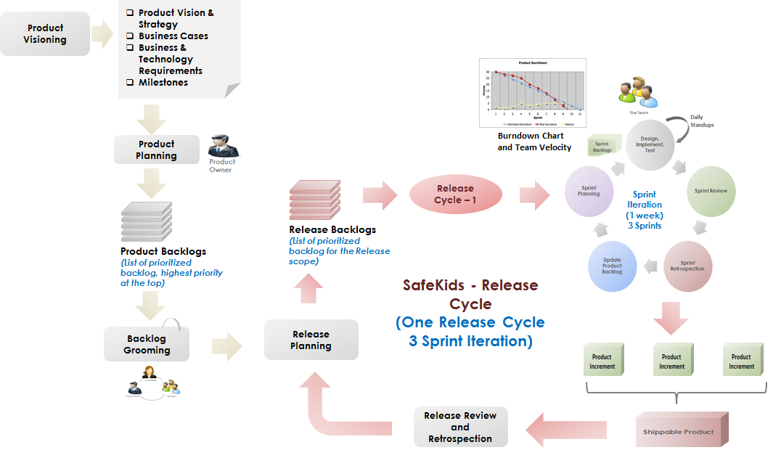

***Figure 4‑1 - Agile SDLC Process***