|  |  |
| --- | --- |
|  | |
|  | **Proposal to the**  **Office of Systems Integration (OSI)**  **Request for Information (RFI) #75001**  **For**  **Agile Development Pre-Qualified (ADPQ) Venfor Pool**  **Scrum Board and Burndown**  **June 5th , 2016** |

|  |
| --- |
|  |



|  |  |
| --- | --- |
|  |  |

*Strategy! Innovation! Transformstion!*

Revision History

|  |  |  |  |
| --- | --- | --- | --- |
| Version | Date | Description of Updates | Author |
| 1.0 | 06/05/2016 | Created the Initial Verson | xFusion |
|  |  |  |  |
|  |  |  |  |
|  |  |  |  |

Table of Contents

Table of Contents iv

List of Tables v

LIST OF FIGURES vi

1 Introduction 1

2 Scrum Board 2

3 BurnDown Charts 5

4 Resource Allocaton and Burndown Details 7

List of Tables

No table of figures entries found.

LIST OF FIGURES

***Figure 2‑1 - Scrum Board*** 2

***Figure 2‑2 – Detailed Scrum Board*** 3

***Figure 3‑1 – Sprint 1 Burndown Chart*** 5

***Figure 3‑2 – Sprint 2 Burndown Chart*** 5

***Figure 3‑3 – Sprint 3 Burndown Chart*** 6

# Introduction

As a part of the Agile and Scrum development process, xFusion goes through multiple sprints for the syste development process. The sprints are managed by the sprint team that had various responsibilities aligned with the SDLC process. We also follow the U.S. Digital Services Playbook to ensure a user centric application with a human user as the central focus.

# Scrum Board

Below are the pictures of the scrum board

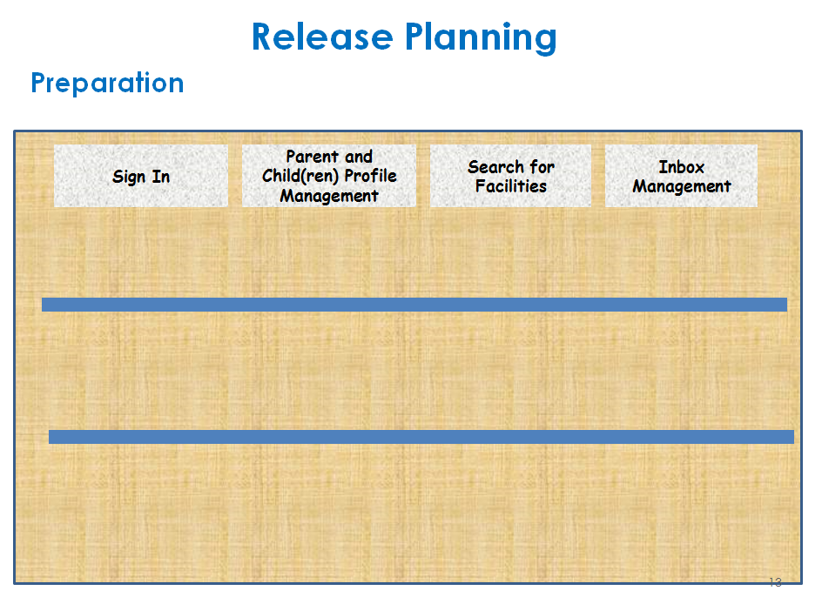

***Figure 2‑1 - Scrum Board***

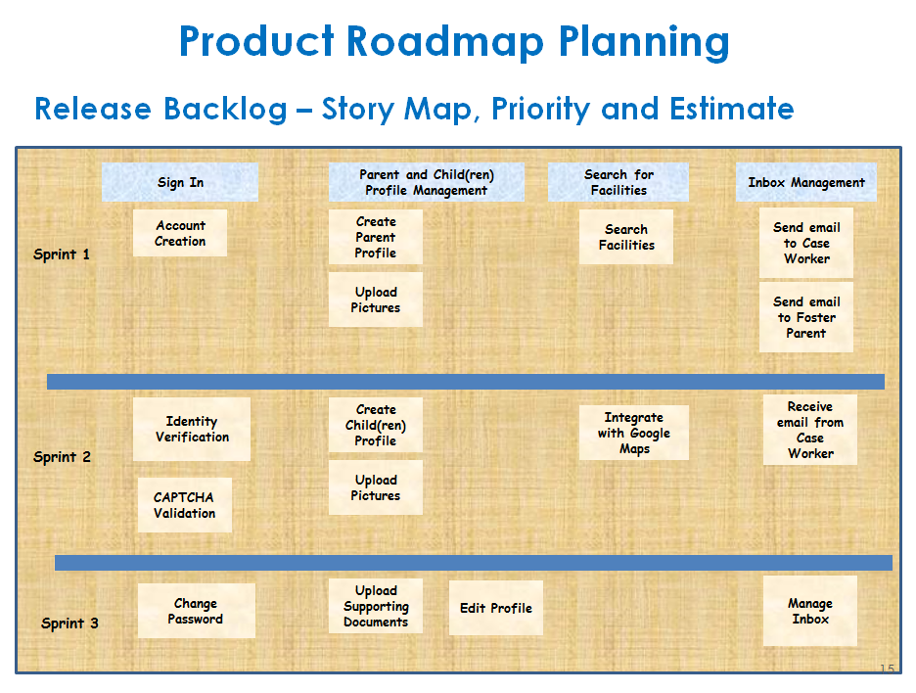

***Figure 2‑2 – Detailed Scrum Board***

# BurnDown Charts

The pictures below represent the completed Burndown chart for all 3 sprints.

***Figure 3‑1 – Sprint 1 Burndown Chart***

***Figure 3‑2 – Sprint 2 Burndown Chart***

***Figure 3‑3 – Sprint 3 Burndown Chart***

# Resource Allocaton and Burndown Details

The figure below represents the details of the resource allocation and burndwn details for the application:

