|  |  |
| --- | --- |
|  | |
|  | **Proposal to the**  **Office of Systems Integration (OSI)**  **Request for Information (RFI) #75001**  **For**  **Agile Development Pre-Qualified (ADPQ) Vendor Pool**  **Test Approach**  **June 9, 2016** |

|  |
| --- |
|  |



|  |  |
| --- | --- |
|  |  |

*Strategy! Innovation! Transformstion!*

Revision History

|  |  |  |  |
| --- | --- | --- | --- |
| Version | Date | Description of Updates | Author |
| DRFT | 05/18/2016 | Created the Initial Version | xFusion |
| 1.0 | 06/05/2016 | Updates made | xFusion |
|  |  |  |  |
|  |  |  |  |

Table of Contents

Table of Contents 3

List of Tables 4

LIST OF FIGURES 5

1 Introduction 6

2 Test Approach and Phases 7

2.1 Usability Testing 7

2.2 Unit Testing 8

2.3 Automated Regression Testing 8

2.4 Integration Testing 8

2.5 Section 508 Testing 9

2.6 Load/Performance Testing 9

2.7 User Acceptance Testing (UAT) 9

2.8 Production Validation Testing 10

3 Automated Test Results 12

3.1 Unit Testing 12

List of Tables

No table entries found.

LIST OF FIGURES

**Figure 2‑1 – Test Approach Overview** 11

# Introduction

The xFusion team understands the importance of thorough testing of an application starting from the design and conception phase, to implementation and ongoing maintenance. The team follows an Agile and Joint Application Development (JAD) approach where multiple iterations of the application are released to the stakeholders and testers. The team goes through continuous development, testing, and integration cycles where the software is released in multiple iterations, resulting in testing and feedback occuring periodically. The team also practices Test Driven Development (TDD) practices where the developers are required to write test cases for their modules before they write the code.

# Test Approach and Phases

The test approach taken by xFusion includes both automated and manual testing. While the automated testing is run against pre-defined test cases and also used for regression testing, the manual testing is conducted by the following:

* Focus groups using real users or persons impersonating real users
* Quality Control team
* Business Analysts
* Other product stakeholders

Manual testing is conducted to validate deep logical, functional, and business area specifics. The following are types of testing that were conducted for SafeKids:

* Usability Testing
* Unit Testing
* Automated Regression Testing
* Integration Testing
* Section 508 Testing
* Load/Performance Testing
* User Acceptance Testing (UAT)
* Production Validation Testing

Each of these testing processes are defined below.

## Usability Testing

* **Why was it conducted?**

The Usability testing is conducted to ensure that the Graphical Design and the User Experience meets the expectations of the real users. It also validates and confirms the UX design principle that we have adopted which is a human-centered design. The goal is to provide a first-class consumer experience to the end users that uses a responsive design.

* **Who did the testing?**

For this testing, we used a user who impersonated being a biological parent of a foster child. Additionally, the Product Owner, Delivery Manager, Usability Tester, and the GUX Designer were also part of the testing and UX Design process.

* **What tools were used?**

The wireframes and screens were tested using multiple devices and browsers to ensure a true responsive and platform-agnostic design. Those devices and browsers included:

* + **Devices**
    - Computers running on both Windows and Mac OS
    - iPhone
    - iPad
    - Android Phone
    - Android Tablet
    - Windows Mobile
    - Windows Tablet
  + **Browsers**
    - Internet Explore and Microsoft EDGE
    - Google Chrome
    - Safari on both Mac and Windows
    - Opera
    - Firefox
* **When was this testing done?**

This testing was done in the conception and design phase of the project. The usability testing was conducted and the GUX was updated based on the feedback before it was released to the development team.

## Unit Testing

* **Why was it conducted?**

The Unit Testing was conducted as a first level check by the development team to identify coding level issues that need to be resolved before the application was released to the QA team.

* **Who did the testing?**

This testing was done by the development team. The developers develop the code on their local machines. They are required to unit test and fix the bugs before the code is checked in to the development environment.

* **What tools were used?**

The development team used Selenium for automated unit testing.

* **When was this testing done?**

This testing was done before checking in any code to the development environment by the developers.

## Automated Regression Testing

* **Why was it conducted?**

As a part of the Agile process, the team followed an iterative-based development practice. In that process, the software was released to the development and test environments in multiple iterations and increments. The automated regression testing ensureed that the new increment as backward compatible and did not break anything that was working prior to developing the new features.

* **Who did the testing?**

This testing was done by the development team lead and the Quality Control Team.

* **What tools were used?**

Selenium was used for the automated Regression Testing.

* **When was this testing done?**

Every time new code was checked in to the Development and Test environments, this test was run to ensure backward compatibility.

## Integration Testing

* **Why was it conducted?**

The integration testing ensured that all components that are part of the specific software version were working together like a well-oiled machine. It also focused on the external interfaces (in this case, the HHS API and Google Map API) to ensure proper working of those services.

* **Who did the testing?**

This testing was done by the development team lead, the Quality Control Team, and the Business Analysts.

* **What tools were used?**

Selenium was used for the automated Integration Testing scenarios. Additionally, the Quality Control Team and the Business Analysts conducted thorough and detailed testing. A set of 50~ positive and negative test cases were created for this testing which was also used by the team.

* **When was this testing done?**

Every time new code was checked in to the Development and Test environments and a Regression Testing was done, this test was run by the team.

## Section 508 Testing

* **Why was it conducted?**

This testing was conducted to ensure compatibility with the Section 508 accessibility standards that are a mandate for this application.

***Please refer to the deliverable “ADPQ-SafeKids-Section508Compliance” for more details of the types of Section 508 testing that was conducted for SafeKids.***

* **Who did the testing?**

This testing was done by the Quality Control Team by using both automated and manual processes.

* **What tools were used?**

We used the website <http://www.cynthiasays.com> to run an automated Section 508 testing for SafeKids.

* **When was this testing done?**

Every time new code was checked in to the Development and Test environments and a Regression Testing was done, the team conducted a Section 508 testing.

## Load/Performance Testing

* **Why was it conducted?**

This testing was conducted to make sure that the application and hosting environment could withstand an adequate load needed in a real environment and could performance in an efficient way to provide a real first-class consumer experience.

* **Who did the testing?**

This testing was done by the Quality Control Team using automated tools.

* **What tools were used?**

Selenium was used to create load and concurrency on the software.

* **When was this testing done?**

This testing was done in the production environment after the code was released to production.

## User Acceptance Testing (UAT)

* **Why was it conducted?**

The UAT was conducted as an acceptance criteria for the production ready application. It was also done to ensure that the application is working against the business criteria and process that were developed in the initiation of the project. This is also the time when a thorough end-to-end testing is conducted for production delivery.

* **Who did the testing?**

This testing was done by the Quality Control Team, the user who impersonated a biological parent, the Business Analysts, the Delivery Manager and the Product Owner.

* **What tools were used?**

The UAT was conducted using human testers and not tools

* **When was this testing done?**

Once the application development was completed, the code was tested end to end in the Development environment and was promoted to the Test environment, the team conducted the UAT.

## Production Validation Testing

* **Why was it conducted?**

Once the application was released to production, a validation test was conducted. This testing was not as extensive as the UAT, but was a quick validation to make sure that the application was functional in the production environment.

* **Who did the testing?**

This testing was done by the Quality Control Team.

* **What tools were used?**

This testing was conducted using human testers and not tools.

* **When was this testing done?**

This testing was done after the application was released to the production environment and before it was released to the clients.

The following figure (Figure 2.1) depicts the test approach that xFusion followed for SafeKids.

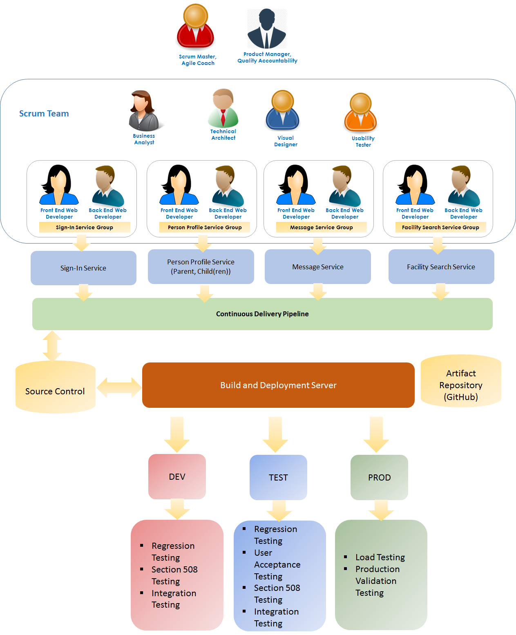

***Figure 2‑1 – Test Approach Overview***