Phishing Website Detection
PRT565 Assessment 4
Detailed report on the Assessment 3 experiment
Unit: PRT565 Machine Learning, Artificial Intelligence and Algorithms
Weighting: 40%
Due: 15 October 2026, 22:00 Sydney time
Group: Sydney Group 1
Campus: Sydney
Submission date: 9 October 2026
Member name | Student ID
Suraj Karki | S397088
Niraj Bhattarai | S396501
Dataset: UCI Phishing Websites
Methods: nine scikit-learn classifiers and two recurrent networks, plus a reduced-feature forest and majority baseline.

Contribution record
Report section allocation for Suraj Karki and Niraj Bhattarai. Both members are responsible for the accuracy of their allocated sections and for reviewing the other member’s work.
Member and student ID | Report sections
Suraj Karki  S397088 | Part 1 and Part 2
Niraj Bhattarai  S396501 | Part 3
Cross-review responsibilities: Suraj reviews Niraj’s sections; Niraj reviews Suraj’s sections.
Total main narrative words: 4855
All members receive over 1,000 words of narration; reporting is split into similar amounts. Word counts do not include headings, tables, captions, front matter, references and appendix. Suraj leads technical integration and checks for reproducibility; Niraj leads checks on metric explanations and references. Members discuss chart interpretations and final report.

Report overview
The Assessment 3 project has been uploaded which contains a reduced feature extension and majority base line, for testing purposes 11 different configurations of the classifiers are provided. The development selected Random Forest model attains 96.38% accuracy and 95.91% phishing F1 on 2,210 held out records. This report provides information on the data, model design and any remaining errors, including neural extensions, uncertainty and feature importance. The effectiveness of the current application is limited by a close limit on statements made.

Part 1 Problem data and preprocessing

Problem and motivation
In the context of comparing machine learning techniques, the classification type of phishing is interesting in both aspects because it has a meaning in practice, having both types of classification errors of interest. A missed phishing record is a lost opportunity to warn and a false alarm is a distraction to normal operations. This project is to select from a set of 11 classifiers the one, which, on a given classification set, has the lowest ratio of those errors. The objective is to design and explain a controlled experiment which could be checked by reading the code and pre-recorded predictions. The task involves not collecting live sites, creating new phishing pages or installing a browsing protection service.

Continuity with Assessment 3
Assessment 4 expands on the experiment for UCI Phishing Websites in Assessment 3. The original data, target mapping, split assignments, fitted-model parameters and test predictions recorded are stored. The existing development partition is used to create additional descriptive charts using analyse_data.py. These are explanatory analyses contained in this report, not evidence of selection of the original model design from these charts. Assessment 3 and 4 use the same data: In the lecturer's instructions about continuity of the dataset.

Dataset description and audit
The UCI dataset contains 11,055 observations and 30 integer-coded input features. UCI lists a donation date of 25 March 2015 and distributes the data under CC BY 4.0 (Mohammad & McCluskey, 2012). The experiment loads Training Dataset.arff from the original archive. Each input is a category derived from website characteristics, rather than a raw URL, timestamp or continuous measurement.
Audit measure | Observed value
Records and input features | 11,055 records; 30 inputs
Class counts | 4,898 phishing; 6,157 legitimate
Missing input values | 0
Repeated complete rows | 5,206
Repeated input rows | 5,270
Unique input patterns | 5,785
Patterns with conflicting labels | 64
Source: results/audit.json, calculated from the included ARFF. Repeated-row counts exclude the first occurrence. A repeated complete row has the same inputs and target; a repeated input row can have a different target. Identical inputs do not prove that the original websites were identical.

Inputs and target
These can be things like URL_Length, having_Sub_Domain, SSLfinal_State, URL_of_Anchor and SFH. They contain values that are historical feature rules. The URL_Length = 1 item is not a “one character” URL, it's a category. Original feature definitions are preserved with the data, and an individual indicator is not meant to be indicative of phishing.
Original target Result: -1 (phishing); +1 (legitimate). In the experiment phishing is mapped to 1 and legitimate is mapped to 0. Thus, all the binary precision, recall and F1 scores reported are phishing detection scores. The elements of the target column are removed from the input matrix prior to the training process.

Research questions
What is the best model for the development set phishing F1 grouped evaluation? What are your scores for the "other" records? If we only use 10 selected features as input to the model, is it still as successful?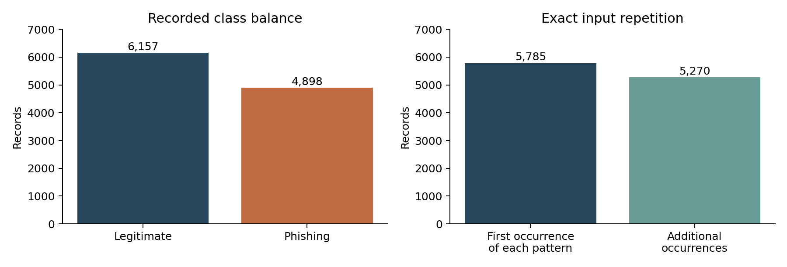Figure 1. Full-dataset class balance and exact input repetition. Source: analyse_data.py and the included ARFF.

Understanding class balance and repetition
Classes are counted and compared with the number of times the exact input is repeated in Figure 1. The percentage of legitimate records is about 55.69%, and phishing records are about 44.31% of the total data set. It represents a moderate imbalance; an always-legitimate classifier can get a seemingly useful accuracy without detecting threats. The second panel indicates that 5,785 first occurrences of input patterns were found and 5,270 additional occurrences were found. The number of rows in these bars indicate the number of unique input combinations, which is significantly higher than what is needed. If you treat each row separately you miss this! They do not prove that the extra observations are bogus or that their identities on the web are unmasked.
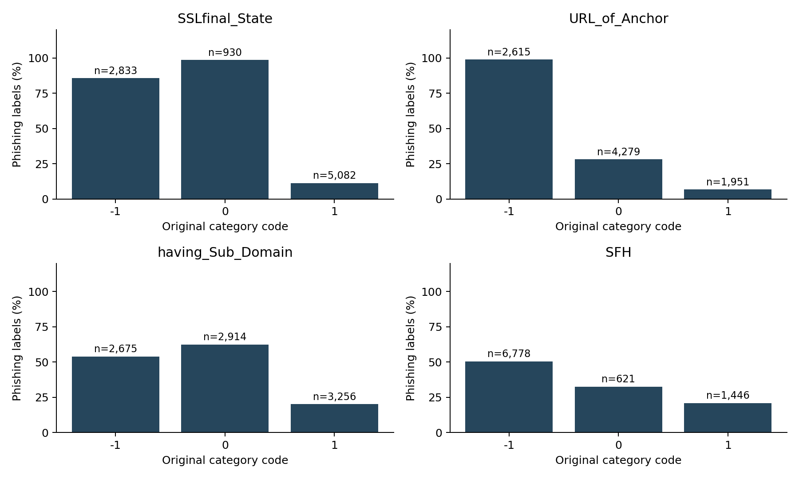Figure 2. Development-set phishing proportions by category. Counts above bars show subgroup size; repeated rows are retained. Source: development_category_rates.csv.
Interpreting category relationships
The percentage of the phishing labels from the four categories of selected features are illustrated in Figure 2, according to the development records. For SSLfinal_State, the phishing proportion is 85.63% for code -1, 98.60% for code 0 and 11.33% for code 1. So, there is no middle-observed risk, there's just the middle code. This discovery enables the codes to be of different type and not be the same numerical distance. The phishing labels in code -1 are also much higher than in code 0 (98.93% vs. 28.09%) and code 1 (98.93% vs. 6.66%). None of these marginal rates sets up a universal security rule, however.
Comparing useful and limited indicators.
The other panels provide a good contrast. The proportions of phishing with the code -1, 0 and 1 are 53.94%, 62.46% and 20.15% respectively for the domain Having_Sub_Domain in source. The first two categories are not as clear as anchor link categories. There are 6,778 development records in SFH code -1 and about half are marked phishing. A common category may thus, itself have only a moderate discriminating power. The percentage of the display categories count values is important because a percentage obtained from a smaller number of observations will not be as stable as a percentage obtained from a larger number of observations. These patterns are related to this sample and impacted by reiterative rows.
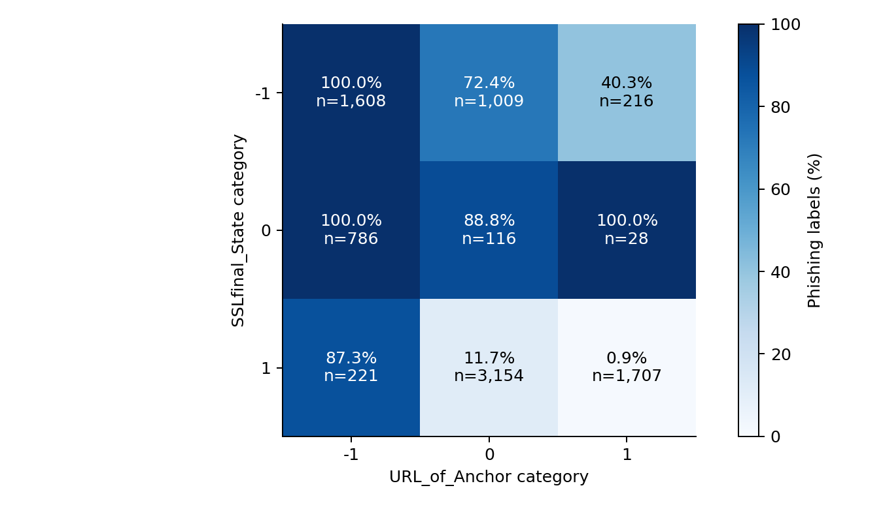Figure 3. Development-set phishing percentages and counts for two categorical inputs. Source: development_joint_rates.csv and development_joint_counts.csv.

Interpreting multiple variables together
In Figure 3, the two variables SSLfinal_State and URL_of_Anchor are analyzed together: For each cell, the percentage of phishing and the number of observations is shown. The phishing rate is reduced from 87.33% (when anchor code = -1) to 0.88% (when anchor code = 1) when SSLfinal_State is 1. It is worth noting, however, that the overall rate (marginal) of phishing, when the phishing is masked by SSLfinal_State code 1, does not show up many significant differences between anchor categories. This illustrates that two or more inputs can provide information. There are only 28 records that are observed for SSLfinal_State 0 and anchor code 1—all of which are phishing; don't give these as a sure sign of what you can expect in the future. The chart offers motivational clues to consider combinations, but it is not a causal interaction or general population probability.

Preprocessing and evaluation partition
Any observations are maintained, and even contradictory labels. The exact pattern of the input is mapped into groups. A group of data points is completely in one side of the split and not in the other, meaning that no feature vector is seen on both sides of the split. This is to overcome the concrete overlap risk and still retain the difficult cases. Statements are used to assert that no groups overlap.
Partition | Records | Phishing | Purpose
Development | 8,845 | 3,919 | Fit and tune models
Test | 2,210 | 979 | Fixed final evaluation

The first fold of StratifiedGroupKFold from shuffle with seed 565 is used for the test set. The outer fold is the only fold that is graded. Three clustered development folds (using seed 566) provide the same training, and validation sets to each candidate. Given some restrictions on each class, stratification tries to maintain the proportions of the classes (Scikit-learn developers, n.d.-g). This is not five-fold outer cross validation, but rather this is grouped holdout evaluation with internal cross validation.

The encoding and handling of features.
Decision Tree, Random Forest, and ANN have decided categories -1, 0, and 1 for each of the original features, and has used one-hot encoding for the same. This results in 90 binary inputs, with reserved categories which might not exist for a given feature. A prespecified schema. The deterministic shift X + 1 is given to Categorical Naive Bayes, which gives nonnegative codes 0, 1 and 2. No missing numbers to be completed. The binary one-hot inputs are already bounded so there is no scaling step.
Preprocessing is transferred into each of the model pipelines. The extension's pipeline also selects the features in a supervised manner for the ten-feature extension. This guarantees it's transformed with a selector that's trained on the train Half only for each validation fold following the separation principle used by the Scikit-learn developers (n.d.-a).

Selection rule
Mean binary phishing F1 is used when using GridSearchCV. This is the model family with the highest mean development CV F1 that is selected before test results are found out. There is no test-based threshold tuning - default prediction rules are kept for the classifiers. F1 is an explicit trade-off between precision and recall, but for real deployment, an operating threshold would need to be selected for the context.

Produce ready-made data and boundary of engineering problems.
For all 11,055 observations, all 30 original input columns are available in the supplementary file prepared_dataset.csv. It appends row_id, remapped phishing target and the existing split assignment for traceability. No values are deleted and there are no missing values filled in. The CSV is an export file that was prepared and can be read, however no guarantee of how much cleaning of the original data was done is provided. The inputs of the model are never the row_id and split of the metadata row – the goal is phishing. One-hot expansion is not saved as the canonical data but is done in the pipelines. Original categories are easier to audit to the source data and are less likely to be confused with data preparation vs. representation within the model.

Part 2 Algorithms and implementation

Design rationale
Modelling design is a comparison of two or more different learning assumptions in a supervised task. Conditional decision can be made using a tree, a forest is a collection of many such estimators, Naive Bayes is a special type of probabilistic factorization, and a multilayer network learns distributed nonlinear representations of the problem. These differences make the comparison a meaningful one from an educational standpoint without too many algorithms. These classifiers were taken from scikit-learn and the two PyTorch recurrent networks were provided in the Assessment 3 project. Each of the methods is provided with the same 30 feature inputs and the same development folds assignments, but the representation of the feature inputs to the estimator is different across the methods. This implies that for all methods the main test conditions stay similar; however, for each method there can be an appropriate representation.

Model settings and rationale
Model | Search settings | Selected setting
Decision Tree | Depth 5 or unrestricted; leaf minimum 1 or 5 | Unrestricted depth; leaf minimum 5
Random Forest | 150 trees; depth 10 or unrestricted; leaf minimum 1 or 3 | Unrestricted depth; leaf minimum 1
Categorical Naive Bayes | Smoothing alpha 0.1, 1 or 10 | Alpha 1
Multilayer ANN | Hidden layers 32 and 16; alpha 0.001 or 0.01 | Alpha 0.01
Source: train.py and results/cv_summary.csv. Seeds are fixed at 565 where supported. The searches are small and model-specific; they are neither exhaustive nor equal-compute comparisons.

Why these models
The Decision Tree is a series of splits that are learned from the input and is a simple nonlinear basis function. There is a tendency to decrease highly specific partitions as the leaf minimum is increased. Random Forest: 150 bootstrapped trees that are grown on a random selection of features and compared through an ensemble to the single tree. It turns out this is very good performance here and it's an empirical fact and if it's not proof that it's better than neural networks in general.
The Categorical Naive Bayes model assumes that the presence or absence of each discrete input is independent of one another. It provides a match to the encoded categories - without assuming they are Gaussian measurements. The independence assumption is limiting as indicators of websites might be correlated (Scikit-learn developers, n.d.-d).
The multilayer ANN is constructed with MLPClassifier with two hidden layers (32 ReLU units and 16 ReLU units), and maximum iterations is set to 250, optimizer is set to be Adam. The value of the L2 regularization alpha is tuned. The grouping rule would change if there was an automatic validation split, which is normally used for an internal early stopping process. Convergence warnings for the included run: there were no warnings (See results/warnings.json for details, Scikit-learn developers (n.d.-b)).

Baseline and extension
In the majority classifier, most of the instances in the training set are always legal, and the comparison is explicitly stated when it comes to the accuracy. Exploratory extension is an extension that keeps the top ten original features based on discrete mutual information in the development folds. It will be based on the full model selected by the family and the settings. This is therefore an exploratory CV estimate rather than a full-fledged selection estimate.

Decision Tree behavior
Implements the default Gini impurity criterion in the tree, and searches depth and leaf-size constraints. A split is useful if the labels of the child nodes are more distinct than those of the parent node. A deep tree might be a very particular mix of all the one-hot indicators - including the very unusual mixes - and could well end up fitting some quirks in the way it was built. This research requires the five minimum leaf size selected for this study to require more observations than a one minimum leaf size to support a terminal partition. This is complexity management, as well! It does not guarantee against overfit, and the "true" behavior of the model should be assessed from the validation result, not the name of the parameter.

Random Forest behavior
There are 150 trees in the forest and the bootstrap sampling and random feature consideration at splits follows the recorded implementation settings. Combine class scores, this can help to minimize the effect of an unstable individual tree. In the case of the one hot representation, there are 90 potential indicator columns and the default feature rule used is to select a subset of these indicator columns on each split along the tree. This experiment has a fixed number of trees and has two factors: depth and leaf size. The selected unrestricted depth and leaf minimum results in flexible constituent trees. According to the model developers (Scikit-learn developers, n.d.-f), the aggregation is an important aspect of the model behavior in this model, but the design does not require more trees or more depth to get better held-out performance with this model.

Naive Bayes behavior
Categorical Naive Bayes model assumes the likelihoods of all categories for every class and the prior of each class. It assumes naively that all the inputs are independent, given the target. The data set may also have related website indicators; so even if the classifier is also correct, the assumption is not necessarily correct. The code maps the values of the category into nonnegative integers, with the same observations in the same value still in the same category. The zero probability is avoided because the category was not included in a training sub-set by using alpha smoothing. Searching alpha thus tries out a subset of the regularization strengths. A Gaussian variant would impose model which is a continuous distribution, but not what is represented here (Scikit-learn developers, n.d.-d).

Neural network behavior
The ANN has 90 binary indicators as inputs, which then pass through two hidden layers with 32 and 16 units, respectively. The layers learn combinations with weights on the previous representation, nonlinear transformations through ReLU actives. The weights are updated by Adam, and the term α is the regularization term for L2 regularization. The two alpha values tested affect the penalty, while the other parameters of the architecture and optimization remain unchanged. The feed-forward type of multi-layered model is required as the ANN model. The data is not inherently time ordered and the separate recurrent extension is a feature-order sequence for comparison. Is formulated to fit in standard equipment. The experiment isn't an optimal architecture for this problem (Scikit-learn developers, n.d.-b).

Cross validation and refitting
Each inner fold is represented by the relative positions to the development subset. This subset is passed to GridSearchCV that has the same indices as the observations one intends to pass. Three pipelines are used for each set of parameters, and the average of the validation F1 scores are calculated. There are 4 different configurations for the tree and forest, 3 for Naive Bayes and 2 for the ANN. If refit=True, the configuration will be refitted on all development records after it wins in a family. The pipeline thus created is not one of the fold models. Its test prediction is only made once the development selection process has been completed. Another reader may check out other winning tables after the first reader has been gone and add some of his/her own to the stored candidate tables.

Preventing preprocessing leakage
All encoding and learning in a single fit-and-predict interface. For the full-feature models, the category vocabulary is explicitly given in the schema, instead of being mined from the held-out observations. The reduced model is indeed supervised in this instance because it requires labels, and importantly the model is put in the pipeline. If such a selector were applied to the whole data set before cross validation, then the cross validation would have known the answers to its questions. This implementation uses each training fold to choose their 10 features and transform their validation fold. The separation is made with the training-only fitting principle, which is explained in the implementation guidance (Scikit-learn developers, n.d.-a).

Details about how the feature extension is built.
This extension simply copies the current selected full model pipeline but does not copy the fitted state of the pipeline. The SelectKBest component is inserted in front of the encoder. The reserved category list for 'one hot' encoding is changing from thirty features to ten since a selection keeps ten original columns. Discrete mutual information gives an association score for each of input (Scikit-learn developers, n.d.-c). Empty parameter grid: Checks one tested reduced configuration. The most recent support mask (following a development refit) has been used to identify columns to keep. This leads to a certain transparency of the full and reduced inputs. Does not search for all possible combinations of features in a one-shot or estimates cost of features acquired.

Implementation and reproducibility
An experiment is executed in train.py and run_project.py takes care of dependency checks, an isolated virtual environment, and notebook launching. The new script analyse_data.py reads the split manifest saved and produces the export file with the prepared data and some sample graphics. Note the interactive view of the evidence will appear by default in the notebook, with training disabled and outputs packaged in this notebook. This is because the main splits (565) and inner splits (566) are seeds and the supported estimator randomness is fixed. The environment that recorded this includes Python 3.12.3 and scikit-learn 1.8.0. Note that even with a fixed seed, the same results may not be obtained on arbitrary systems since reproduction must still depend on some extent, on the version of the source file, the package versions, and the numerical environment.

The following features are acceptable for a successful implementation:
Assertions verify source dimension, codes and group separation. No convergences are seen with any warnings on this run, and this is a Warning capture run to capture problems in the primary searches. The prediction output is temporarily written to a file and later overwritten, which helps to reduce the chance of showing a partial CSV. These deployment checks help auditability but do not check or certify the original labels or safety of deployment. Fitted estimators will not be serialized in package. In this case a new model will have to be retrained, or the numbers and forecasts can be considered without the need to retrain a model. It's good to keep this side of the demonstration going but not make a false promise that it's a live detection service.

Further classical comparisons of models.

The Assessment 3 experiment expands on the 4 mandatory families, by adding Logistic Regression, k-Nearest Neighbors, an RBF SVM and histogram Gradient Boosting. Logistic Regression is searching for C values of 0.1, 1 and 10, and requires one-hot input; C value used is 10, which creates a more flexible linear decision boundary. It is just a way to determine whether a relatively simple additive model will suffice. The number of neighbors used for a NN search is set as nearest neighbors searches 3, 7 and 15 neighbors with uniform or distance weighting, and 15 neighbors and distance weighting are chosen. The similarity is computed using bounded one-hot inputs, which cannot guarantee, that nearest neighbors are semantically similar websites. This RBF SVM looks for the C value as 1 and 10 and finally it decides to take C value 10 which is a nonlinear level of comparison of margin. Hard predictions are based on the estimator's classification rule, and the ROC AUC is supportable by the probability estimation. All 30 inputs are explicitly specified as categorical with shifted category codes being passed to Histogram Gradient Boosting. It returns learning rates of 0.05 and 0.1, and max leaf counts of 15 and 31 — in the order that they were passed to it, so it returns 0.1 and 31 in that order. In the boosting the trees are added to improve the ensemble, while the Random Forest adds trees which average all the parallel bootstrapped trees. These small searches have differing computational cost and cannot determine the best performance for each family.

Build deeper and recurrent network implementation
In the hidden layers depth of the ANN in scikit-learn, the numbers are 128- 64 - 32 ReLU units, the optimizer is Adam, and alpha is 0.001 or 0.01 (the latter value is used), the iteration number is set to a maximum of 300. It looks at a higher capacity feedforward alternative to the necessities (32, 16) ANN. Each PyTorch script is used separately, with feature i and category c being combined to form the token 3i + (c + 1), yielding ninety different tokens and thirty steps per record. Each token is mapped to 16 learnt values by an embedding layer. Then, a bidirectional LSTM or simple RNN are applied with 32 hidden units per direction, with the output of the 30 steps averaged and fed into a dropout layer (at 0.2) and linear output layer. BCEWithLogitsLoss can be used to train the binary output, while sigmoid can be used to convert logits to scores that can be evaluated. This is not a time series, but rather a column ordering that has been imposed. PyTorch documentation mentions bidirectional recurrent modules, but if you use a bidirectional module, it does not necessarily mean that you have sequential meaning in the order of the tabular features (PyTorch contributors, n.d.).

Recurrent model validation and refitting.
The recurrent models are trained using learning rate 0.002, weight decay of 0.00001 and batch size of 128. A patience of eight based on the validation F1 metric, and a maximum of sixty epochs per fold are used to train all grouped folds. For each-fold the best epoch is stored. The final refit length of the development set is the median of the three folds for both LSTM: 23 epochs and RNN: 14 epochs. The scores of the validation results are 94.09% and 93.63% F1 respectively. Both estimation of the performance as well as selection of the epoch can lead to such optimistic scores. They are not to be seen as unmodified external estimates. In the main train.py, we choose the random forest of the 9 scikit-learn options before testing it; however, we test the recurrent extension separately. It thus makes additions with comparisons without changing that basic choice retroactively. The scripts do not achieve this level of uniformity in future nested selections and there are 11 different settings.

Part 3 Evaluation results and understanding

Evaluation measures and their purpose

The number of correct labels/total number of test labels. Precision is the measure of the number of phishing alerts to phishing labels; recall is the measure of the proportion of phishing labels that is found to be phishing. But their denominators differ: False alarms decrease precision and missed threats decrease recall. Their harmonic mean is F1 and it provides lower rating in case one of the quantities is weak. The objective is clearly stated if a phishing F1 is selected for development selection. Does not penalize the two errors, and an alternative operating criterion might be needed for a production system. As an additional complementary-ranking measure, AUCROC is added (based on scores (not on hard predictions)). Don't consider it as the percentage of correctly classified websites.

Validation and held-out comparison
Model | CV F1 | Fold SD
Decision Tree | 91.69% | 0.85 pp
Random Forest | 94.58% | 0.62 pp
Categorical NB | 91.76% | 0.55 pp
Multilayer ANN | 93.62% | 0.66 pp
Source: results/cv_summary.csv. Random Forest has the largest mean CV F1, 94.58%, and is the primary model. Fold standard deviations describe variation across the three folds; they are not confidence intervals or significance tests. Tuning can make selection estimates optimistic.
Model | Accuracy | Precision | Recall | F1 | AUC
Random Forest | 96.38 | 96.10 | 95.71 | 95.91 | 0.9931
SVM (RBF) | 95.38 | 96.11 | 93.36 | 94.72 | 0.9917
Deep ANN | 95.07 | 97.18 | 91.52 | 94.27 | 0.9928
Gradient Boosting | 94.89 | 94.46 | 93.97 | 94.21 | 0.9933
Multilayer ANN | 94.39 | 95.05 | 92.13 | 93.57 | 0.9915
Reduced RF | 94.16 | 92.25 | 94.79 | 93.50 | 0.9845
k-NN | 93.98 | 94.43 | 91.83 | 93.11 | 0.9853
LSTM | 93.89 | 94.05 | 92.03 | 93.03 | 0.9889
RNN | 93.67 | 93.20 | 92.44 | 92.82 | 0.9880
Logistic Regression | 93.35 | 93.06 | 91.83 | 92.44 | 0.9861
Decision Tree | 93.03 | 93.38 | 90.70 | 92.02 | 0.9582
Categorical NB | 92.94 | 93.09 | 90.81 | 91.93 | 0.9811
Majority baseline | 55.70 | 0.00 | 0.00 | 0.00 | 0.5000
Source: results/metrics.csv and deep_learning_metrics.csv from the Assessment 3 project. Accuracy, precision, recall and F1 are percentages; AUC is on a 0–1 scale. All thirteen rows use the same 2,210 held-out records. Eleven classifier configurations are compared, alongside the ten-feature extension and majority baseline. Phishing is the positive class.Interpretation
Random Forest is the best among the four required models in terms of held out F1 (95.91%), followed by the ANN (93.57%), Decision Tree (92.02%) and Categorical Naive Bayes (91.93%). The forest is trained with a 98.81% mean training-fold F1 which is larger than the validation F1 of 94.58%, suggesting that even with these test results there is a gap in the generalization. The ANN also has a training–validation gap; no single cause can be identified as to why this difference in the test score is.
The majority baseline is correct 55.70% of the time and fails to successfully spot all the phishing records. Phishing precision and explicitly set F1 (zero_division=0) are said to be true. This shows that an accuracy-based measure wouldn't adequately assess this task. ROC AUC is not a calibrated probability, rather it is a ranking over thresholds.
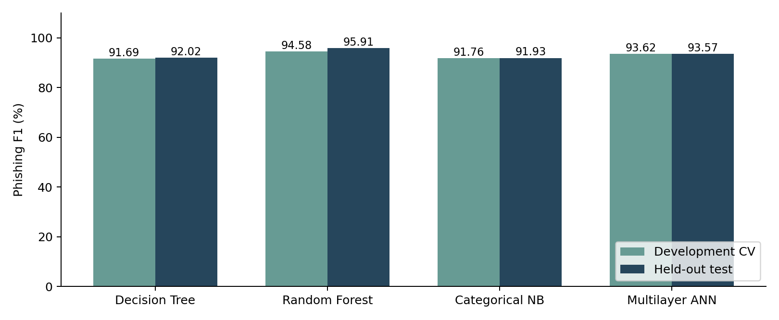Figure 4. Mean development CV F1 and held-out F1 for the four required models. The vertical scale starts at zero. Source: cv_summary.csv and metrics.csv.

Interpreting the comparison chart

The mean development CV F1 and test F1 value are presented for each of the necessary models in Fig. 4. Random Forest and the ANN remain the best two models in both comparisons while the tree and Naive Bayes are close and alternate in the test set. This mini turnaround would be a sign that it isn't worth a strong prioritization of those two methods. All values of F1 are higher than the CV means. This is because the difficulty level of the test can be different than the dev observations and all dev observations are used during training. There is no dominance of one explanation over the other in the chart. Don't think higher test scores mean there is no overfitting.

Understanding the expanded comparison

The full Results table retains the Assessment 3 evidence and doesn't consider the project as being just 4 classifiers. Random Forest is the model with the best held-out phishing F1 (95.91%). The RBF SVM is also able to achieve the nearest accuracy to the deeper ANN with 94.72% while Gradient Boosting achieves 94.21%. These are F1 scores, not accuracies: their respective accuracies are: 95.38%, 95.07% and 94.89%. The measures are corrected by distinguishing. Based on CV rank alone, there is no clear evidence from the developments of Gradient Boosting being significantly better than Random Forest as it has a development F1 value of some 94.57% versus 94.58% for RF. When tested, the recall rate for this is 91.52% with only 83 phishing records missed, but still with 26 false alarms, ANN is 97.18% precise. The greater precision however, results in a lower sensitivity than the forest (95.71%). Instead of the highest one of the individual scores, the joint error-pattern is used for model choice.

Interpreting the recurrent extension

The LSTM test F1 score is 93.03% and RNN test F1 is 92.82%, and 78 and 74 phishing records were missed. Both of their F1 are below the target feedforward ANN's (93.57%). This run is performed with deeper feedforward, and scores 94.27 % - there is no reason to believe that any additional neural complexity was detrimental. It corroborates the truer conclusion that there was no significant difference between the two Recurrent configurations selected, and that the deeper ANN achieved lower recall and higher precision. The curves of training loss recorded are examples of progress in training (development records). They don't show that either architecture is at their optimum solution, or that with more training they could not get better. This experiment does not exclude if the missing natural feature sequence is due to an architecture–data mismatch; the only thing it excludes are tunings, regularization and/or optimization effects.

Understanding generalization gaps

The selected configurations have mean training-fold F1 scores of 96.08% for the tree, 98.81% for the forest, 92.06% for Naive Bayes and 98.29% for the ANN. Their corresponding gap after subtraction of their validation means is around 4.39, 4.23, 0.30 and 4.67 percentage points. However, the absolute numerical better results of the naive Bayes validation performance match the expected values of a more limited fit, and the small Naive Bayes gap is commensurate with this. On the other hand, the forest size is quite large, which means that care should be taken, though the validation and test performance is relatively good. To assess a model, the level and generalization should be considered, not just one statistic.

Errors and reduced feature comparison
Actual class | Predicted legitimate | Predicted phishing
Legitimate | 1,193 true negatives | 38 false positives
Phishing | 42 false negatives | 937 true positives

Random Forest confusion matrix, from results/metrics.csv. The total number of errors is 80. Precision is 937 / (937 + 38) = 96.10%. Recall is 937 / (937 + 42) = 95.71%. Accuracy is (1,193 + 937) / 2,210 = 96.38%. Phishing F1 is 2 × 937 / (2 × 937 + 38 + 42) = 95.91%.

So a false negative is a record that was supposed to be marked as phishing that was not in reality and a false positive is when something was marked legitimate that actually is not. The forest loses 4.29% of the phishing test records and it raises 3.09% of ALL test records. These are the class specific rates in relation to this benchmark and not current browsing traffic. The saved examples show results, are not representative samples, nor causal explanations of the errors.

Ten feature extension
The final development-fitted selector retains Prefix_Suffix, having_Sub_Domain, SSLfinal_State, Domain_registeration_length, Request_URL, URL_of_Anchor, Links_in_tags, SFH, age_of_domain and web_traffic. The spelling follows the original ARFF. Mutual information measures association with the target; it gives neither causal direction nor proof that a feature is independently necessary.
Random Forest inputs | Test F1 | False alarms | Missed phishing
All 30 features | 95.91% | 38 | 42
Selected 10 features | 93.50% | 78 | 51
Source: results/selection.json and metrics.csv. Using unrounded scores, test F1 falls by 2.40 percentage points. The reduction increases both error types in this run. Keeping all 30 inputs is supported for the fixed benchmark comparison. Feature extraction cost and prediction latency were not measured, so the reduced input count is not evidence of a quantified cost or speed saving.

Bootstrap uncertainty and paired comparisons

The group_bootstrap_f1 function provided takes one thousand resamples of the complete exact-input groups from the test partition with all the rows in each resampled group intact. It returns the numbers of true-positive, false-positive and false-negative, and computes F1 based on this; it returns the 2.5th percentile and 97.5th percentile. Random Forest’s recorded interval is approximately 94.32%–97.26%, compared with 92.83%–96.53% for the SVM and 92.30%–96.12% for the deeper ANN. These intervals reflect the resampling variability based on this data set, this grouping rule and a fixed fitted model and not the variability due to model selection, change in distribution of that model over time or the label uncertainty. Interval overlap is a test of a model difference but not paired. The project also contains exact row level McNemar tests for correctness discordant. In the case of the SVM, it is correct on 43 records and the SVM is correct on 21 records. With repetitive input patterns, however, this assumption of independence of the rows is not valid. The classical script receives nine p-values (Holm) adjusts; the recurrent script saves two additional p-values which are not adjusted. The different files themselves do not provide one correction (per Holm) of the 11 comparisons. So, the tests are rather to be regarded as preliminary diagnostics and it is not stated that all tests are significant with all rivals, for the group.

Permutation importance and its limits
Random Forest permutation analysis shuffles each of the input columns in turn on the held-out rows, and ten times for each column shuffling, calculates the F1 decrease. The recorded mean decrease of SSLfinal_State and URL_of_Anchor is about 13.6 and 11.8 percentage point. This provides for good dependence of the score of this fitted model with respect to those inputs. It is different from that of mutual information which measures the feature-label association before training the classifiers. The permutation results are explanatory and were not used for feature selection, further tuning. Related features can be swapped in and out for each other; an individual importance of low magnitude does not constitute a lack of importance; combinations of inputs can differ from real records when these inputs are shuffled. Permutation importance is model specific and depends on the evaluation context (Scikit-learn developers, n.d.-e). In addition to the 10-feature comparison, the evidence indicates that all thirty features should be kept for this benchmark, but not all have the same level of importance, nor can the value of their deployment be quantified.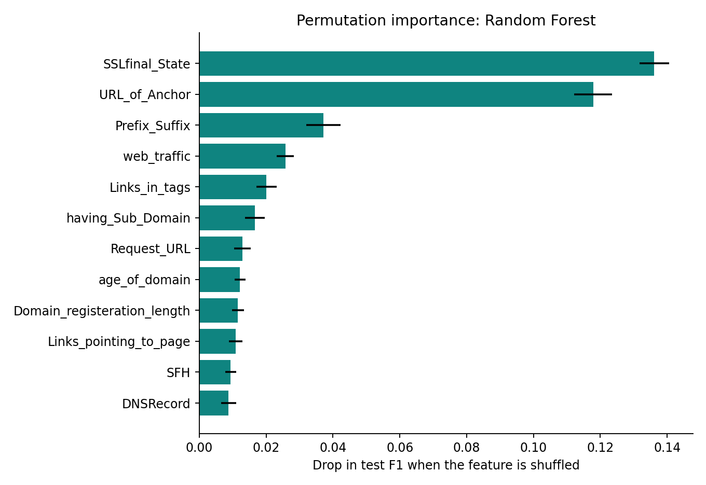
Figure 5. Uploaded Assessment 3 Random Forest permutation importance. Values measure test-F1 decrease after shuffling; repeated ten times. Source: permutation_importance.csv.

Discussion and conclusion

What the evidence supports
The experiment provides a reproducible comparison of the four required model types, with identical evaluation partitions, explicit treatment of repeated inputs and interpretable error counts. Within this design, the CV-selected Random Forest gives the strongest held-out F1. The feature-subset experiment adds a testable question and shows that reducing inputs can sacrifice predictive performance.

Limits of the conclusion

The data is historical and has been pre-extracted indicators, such as reputation-related features. The patterns of phishing and availability of those indicators may differ from current patterns. The ARFF does not contain raw domains or raw timestamps, so it cannot be checked that the testing has been done disjointly in domains and/or times. The removal of collection bias and all dependence between websites by exact-pattern grouping is not guaranteed. In row level evaluation, repeated patterns are still given repeated weight.

64 feature patterns are labeled differently than recorded. They are held and not solved/removed without proof. This restricts the classification of a deterministic classifier with these inputs only. Provenance and original feature building continues to be a theoretical cause for concerns.

Evaluation of a single outer partition and a few hyperparameters. These scores are not statistically significant, generally not the best model, are not adversarial proof, or ready for deployment. Probability calibration, live feature extraction, real world prevalence, error costs and runtime performance were not assessed. Checking saved error cases is good for explanation purposes, but not necessarily as a proof of the internal model's reason for the individual decision.

Conclusion and continuation

Random Forest has an accuracy of 96.38%, a phishing F1 value of 95.91% on the held-out benchmark and 42 missed threats and 38 false alarms. The best conclusion will include these remaining error items, along with the shortcomings of the data, and the good comparative performance. In this experiment, the performance of the tested multilayer ANN was inferior to with respect to phishing F1 in comparison to Random Forest.

Uncertainty and further evaluation
The standard deviation of the three-fold scores is not a confidence interval for future websites and only provides limited information about variation. Group-bootstrap intervals have already been incorporated into the project and are addressed in the uncertainty analysis. These windows are a helpful way to honor exact-pattern repetitions, but they do not eliminate collection bias or the doubt about a website's identity. A more rigorous follow-on investigation would study a variety of prespecified outer grouped partitions or would investigate an independent collection. The following are still suggested enhancements. However, since this test set has now been explored further tuning should not be done as if this test was not seen.

Overall understanding
It is not that the forest has the highest percentage – that is the most useful result. The experiment illustrates how a defensible result is affected by the choice of positive class definition, use of repeated inputs, the selection of errors to develop, and the interpretation of the remaining errors. The new multivariable analysis also demonstrates that seemingly comforting levels of one feature can co-occur with high rates of phishing in another category of features. This helps to validate options instead of relying on one indicator to decide. Meanwhile, the properties of this recorded benchmark stay descriptive associations and model performance. They do not provide evidence of what is happening at sites today, label quality or operational consequences.

References
Mohammad, R., & McCluskey, L. (2012). Phishing websites [Data set]. UCI Machine Learning Repository. https://doi.org/10.24432/C51W2X
PyTorch contributors. (n.d.). LSTM. PyTorch 2.14 documentation. https://docs.pytorch.org/docs/stable/generated/torch.nn.modules.rnn.LSTM.html
Scikit-learn developers. (n.d.-a). Common pitfalls and recommended practices. Scikit-learn 1.8 documentation. https://scikit-learn.org/1.8/common_pitfalls.html
Scikit-learn developers. (n.d.-b). MLPClassifier. Scikit-learn 1.8 documentation. https://scikit-learn.org/1.8/modules/generated/sklearn.neural_network.MLPClassifier.html
Scikit-learn developers. (n.d.-c). mutual_info_classif. Scikit-learn 1.8 documentation. https://scikit-learn.org/1.8/modules/generated/sklearn.feature_selection.mutual_info_classif.html
Scikit-learn developers. (n.d.-d). Naive Bayes. Scikit-learn 1.8 documentation. https://scikit-learn.org/1.8/modules/naive_bayes.html
Scikit-learn developers. (n.d.-e). Permutation feature importance. Scikit-learn 1.8 documentation. https://scikit-learn.org/1.8/modules/permutation_importance.html
Scikit-learn developers. (n.d.-f). RandomForestClassifier. Scikit-learn 1.8 documentation. https://scikit-learn.org/1.8/modules/generated/sklearn.ensemble.RandomForestClassifier.html
Scikit-learn developers. (n.d.-g). StratifiedGroupKFold. Scikit-learn 1.8 documentation. https://scikit-learn.org/1.8/modules/generated/sklearn.model_selection.StratifiedGroupKFold.html

Appendix Reproduction record
The project/ folder contains the supplied Assessment 3 scripts, original data and saved outputs. Run train.py for the nine scikit-learn classifiers, then deep_learning_extension.py for the LSTM and RNN. Run analyse_data.py for the added Assessment 4 charts and prepared CSV, and verify_results.py to check saved evidence without retraining. Recurrent training requires the optional PyTorch dependencies. Original data and feature definitions are attributed to Mohammad and McCluskey (2012), under CC BY 4.0.
Original environment: Python 3.12.3, NumPy 2.3.5, pandas 2.2.3, SciPy 1.17.0 and scikit-learn 1.8.0. The recurrent run records PyTorch 2.14.0+cu130 and seed 565; computation uses CPU tensors. See the bundled environment and recurrent metadata files.

