- GIT base actions:
  - Clone remote repository using SSH keys:
- Create new SSH key
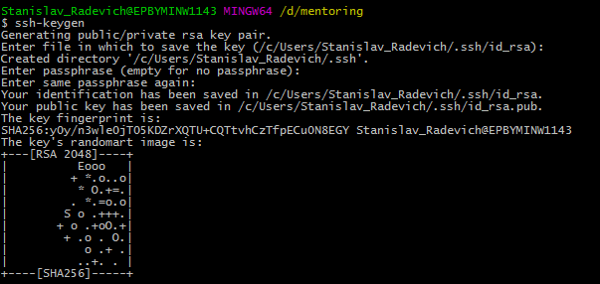
- Add SSH key on github
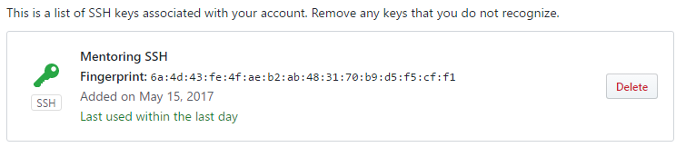
- Clone GIT repository using SSH
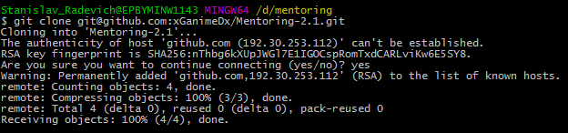
  - Create 3 commits in “master” branch:
- First commit in “master”
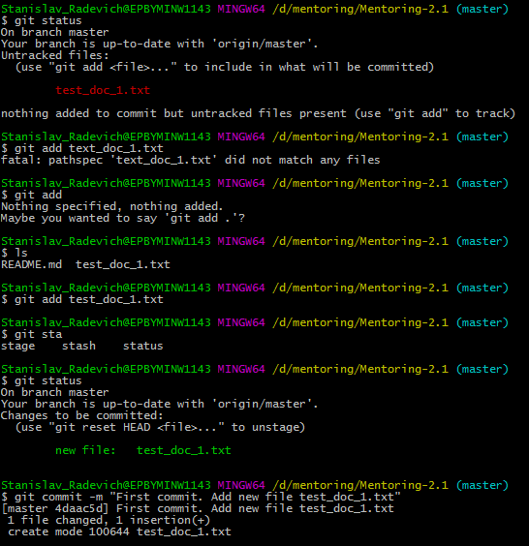
- Second commit in “master”
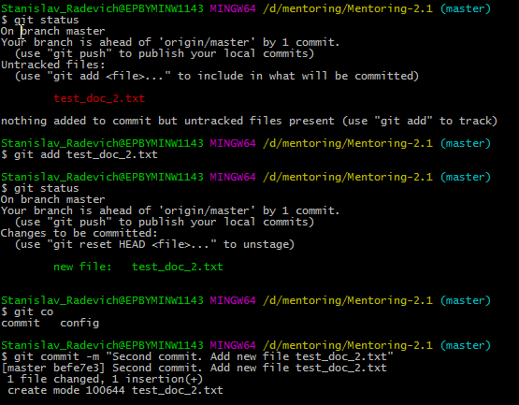
- Third commit in “master”
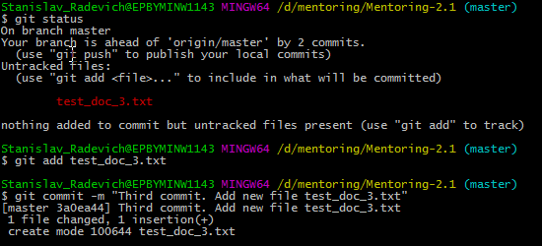
- Push all 3 commits in “master”
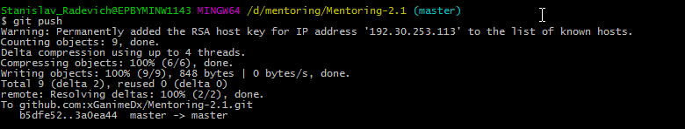
  - Create new “develop” branch and push 2 commits to it
- For creating new branch “develop” and switch to this branch I used:
git checkout –b develop
- First commit in “develop”
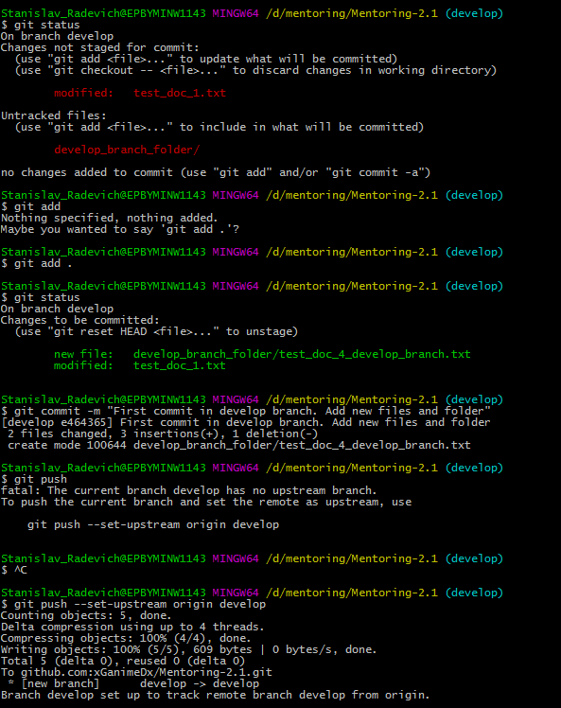
As I don’t have “develop” branch on server I should use “git push --set-upstream origin develop”

- Second commit in “develop”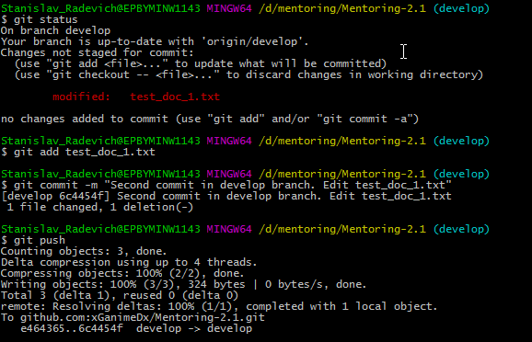
  - Merge “develop” branch to “master” branch:
- Merge
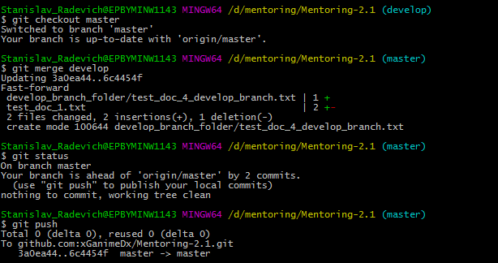

- GIT advanced actions:
  - Add 2 additional commits to “develop” branch and 1 additional commit to “master”. Rebase “develop” with new commits from “master”
- First additional commit in “develop”
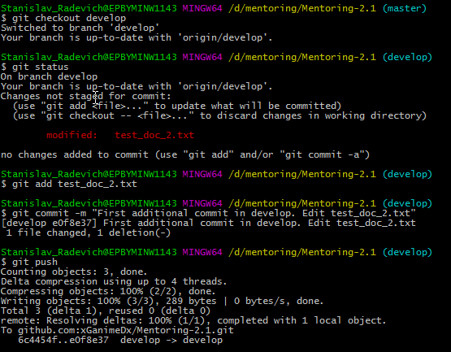
- Second additional commit in “develop”
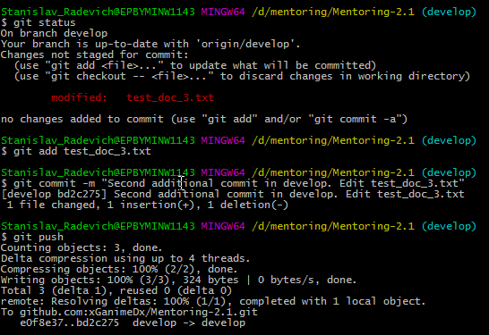
- First additional commit in “master”
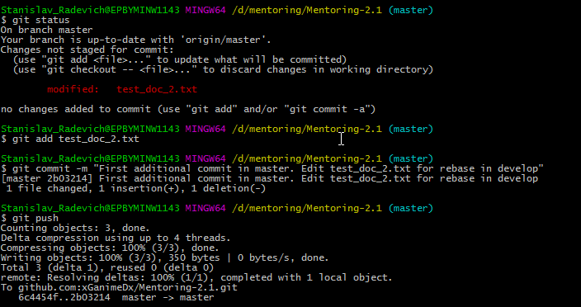
- Rebase “develop” with new commit from “master” and fix rebase issue
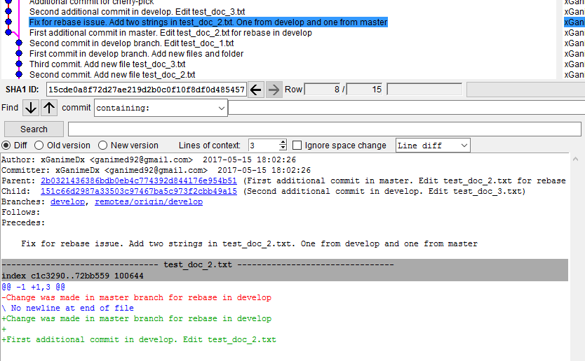
I made changes it one file “test_doc_2.txt”, so when I tried to rebase develop from master I had rebase conflicts.
Commit in develop contains string in test_doc_2.txt:
First additional commit in develop. Edit test_doc_2.txt
Commit in master contains string in test_doc_2.txt:
Change was made in master branch for rebase in develop
For resolving this issue I made additional commit in which I leave both string in the file test_doc_2.txt and then continued rebasing.
  - Add 2 additional commits in “develop” branch. Cherry-pick the first commit to “master”. Revert the second commit
- For reverting I used “git revert <commit>”, in my case it was “889b23f3c41f9e792feba5cb6123aec6807e0c08”
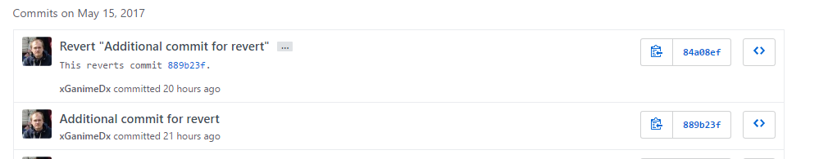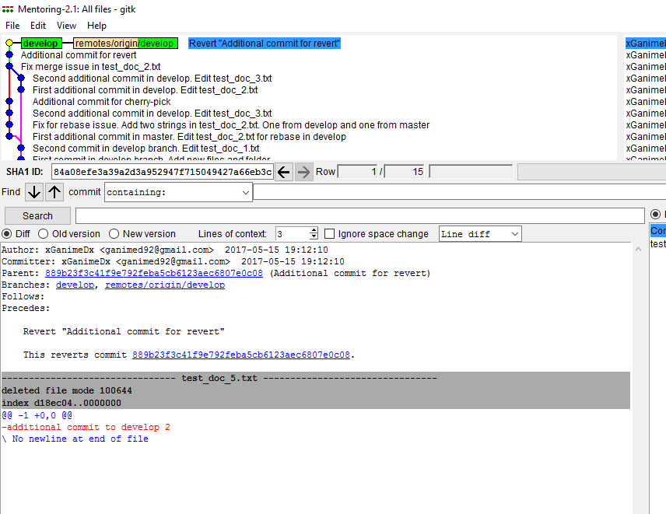
- When I tried to cherry-pick first commit in “develop” I switched to master and tried to pull changes from server, but again received merge issues and again fix them. Then I used “git cherry-pick <commit>” in my case it was “e4a65fd22642f4f8a7687aae4bb7fed88de9963a”
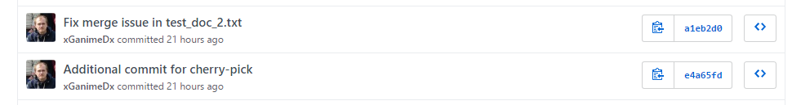
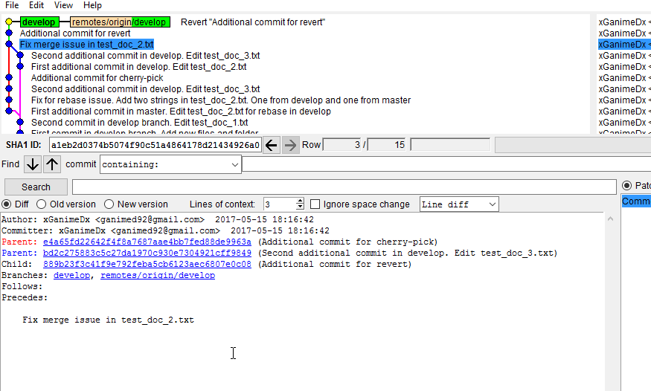
  - Together with your mentor emulate “merge conflict” situation and resolve this
- Mentor made some changes in repository and pushed they to server, I made some changes locally and tried to push these changes to server, but I got merge conflict
