- Jenkins Installation
- Install Jenkins server on local or remote machine:
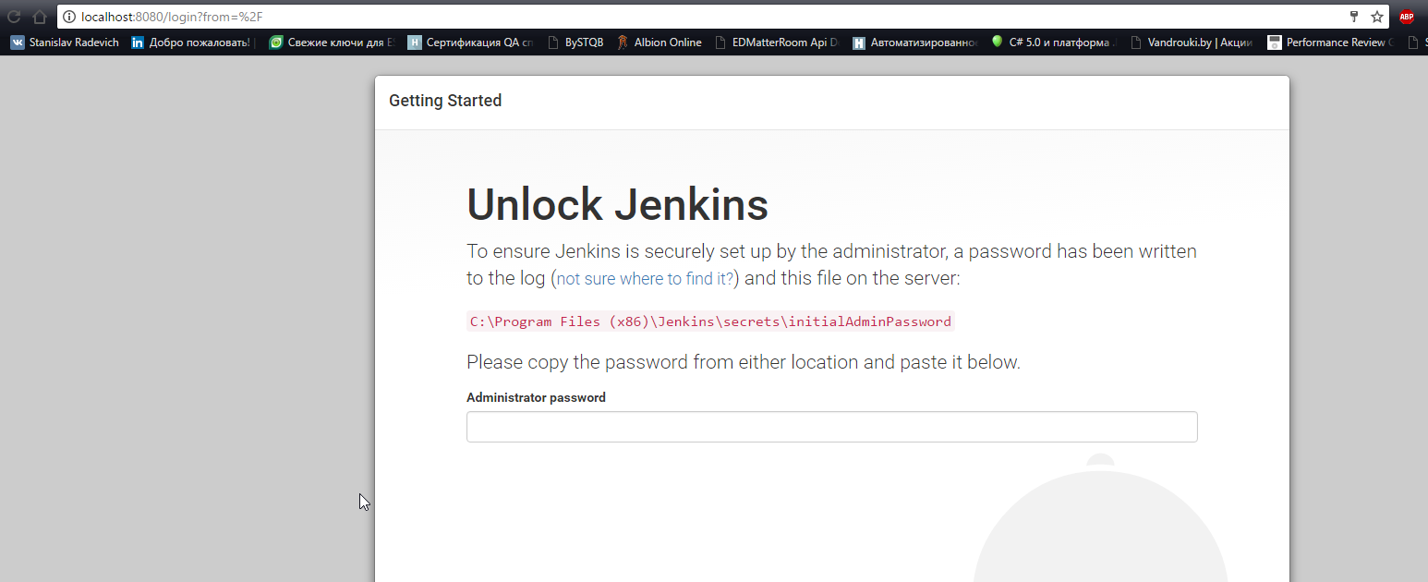
Right after installation Jenkins opens on 8080 port and ask for administrator password. Then Jenkins asks us for plugins, select needed and install them.

- Change Jenkins default port to 8081:
To change the default port we need to find jenkins.xml file in c:\Program Files (x86)\Jenkins\ directory. In this file we have following string:
After changes:
After that we should restart Jenkins:
After that Jenkins will be available on port 8081:
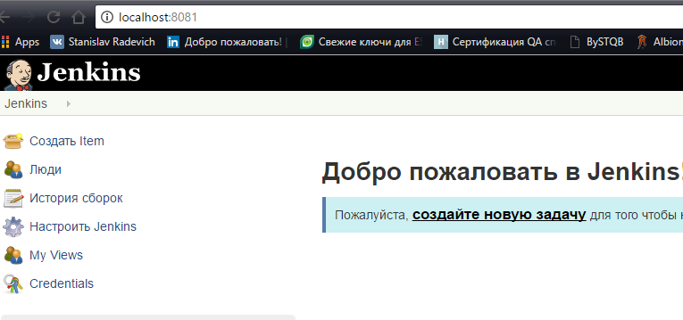

- Create slave node on remote or local machine (you may use the same (one) machine for master and slave)
To create new node select Manage Jenkins -> Manage Nodes -> New Node
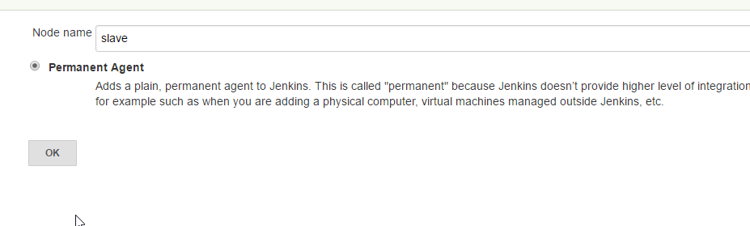Then we fill all needed parameters for new node
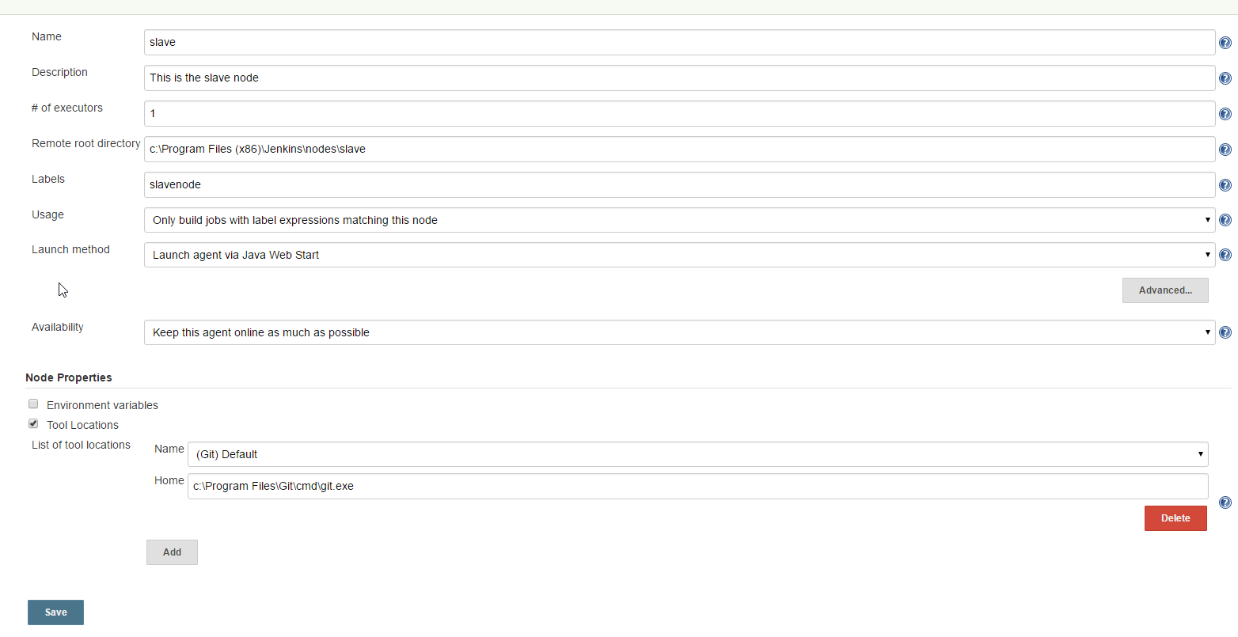
After that we can see our new node in list
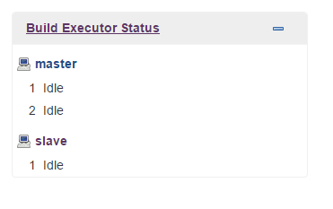
- Job configuration
- Get code from git repository
To get the we need to create new project in Jenkins
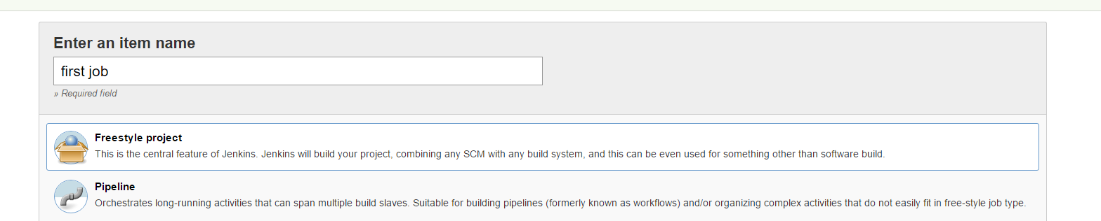
Then in Global Tool Configuration we should tell to Jenkins where is Git installed on our local machine
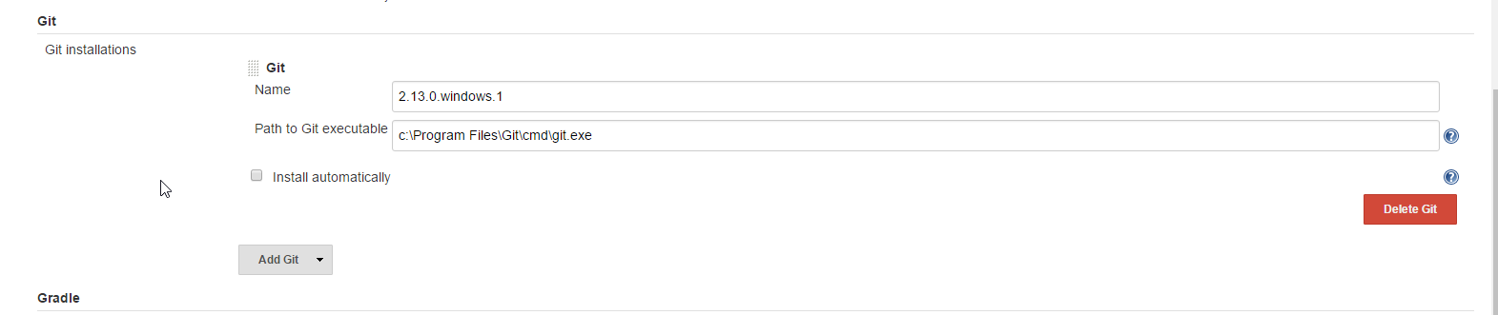

Then we should show where is git repository for our job. Just go to Source Code Management section in configuration for our job
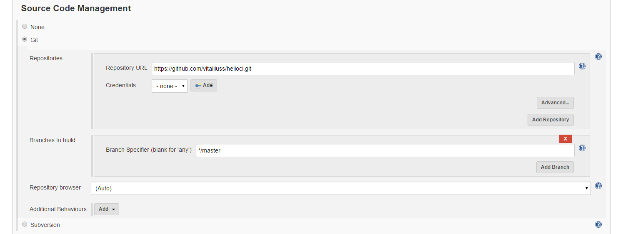
For now to get the code we just need to run this job
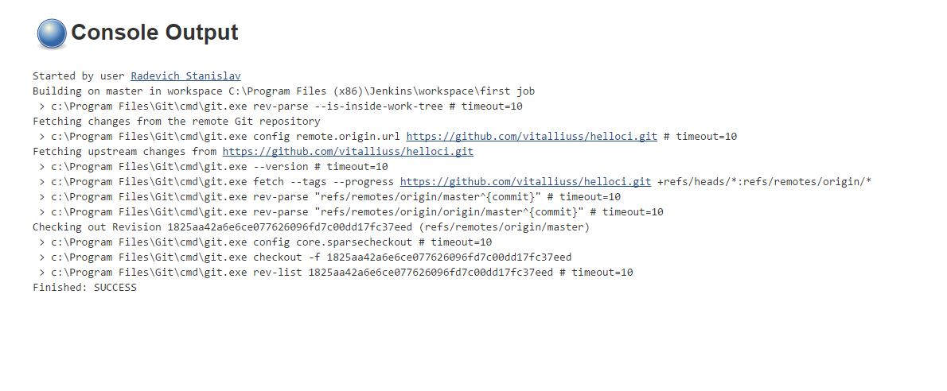
- Build solution using MSBuild
Firstly we need to add MSBuild to Jenkins
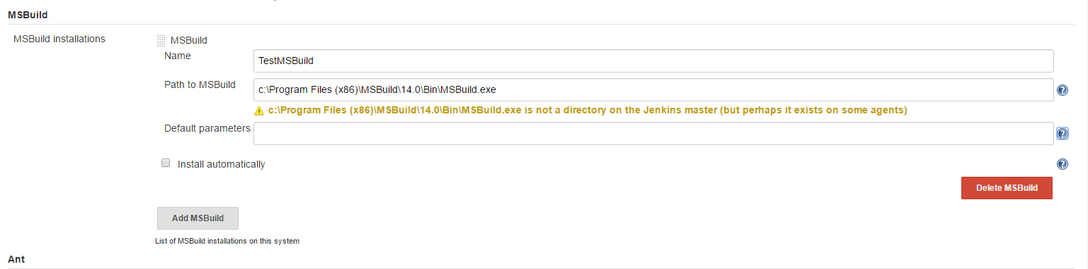
Then we should add build parameters to our job
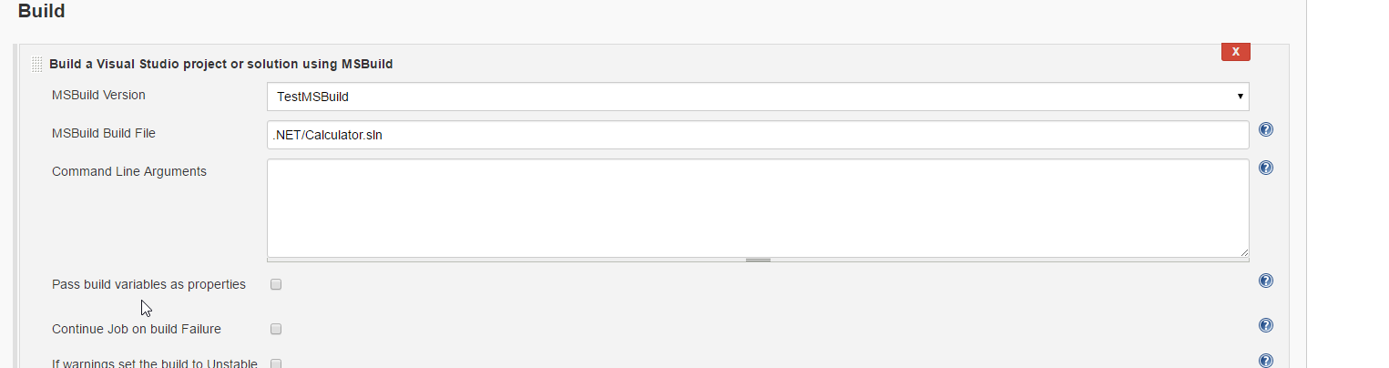
And the result of running our job
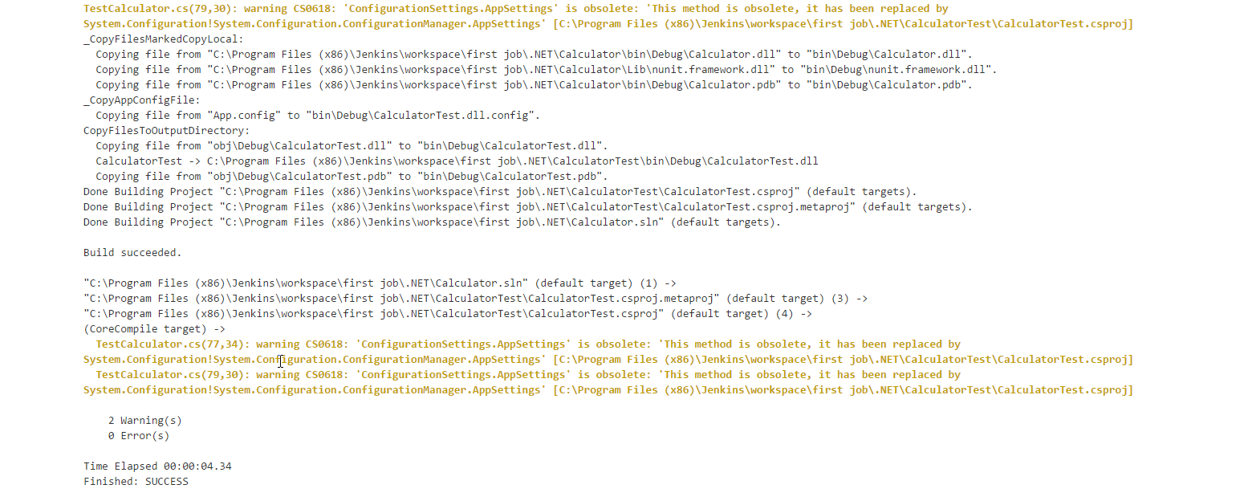

- Set build triggers
To create build triggers we need to change parameters for our job in “Build Triggers” section.
After commit in VCS no longer that in 5 minutes
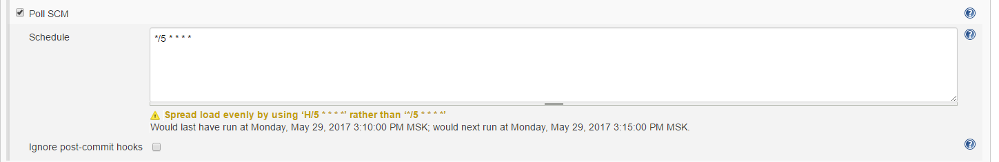
At midnight every day

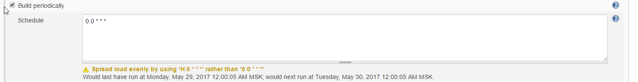

- Job should run on slave only
To run our job only on slave node we just need to add one parameter in job configuration

And result

