**Question 4 2025 Math Major**

Q1. Apply Leibniz test to alternating harmonic series

Code:

1. clc; clear; close all;

2.

3. % Use qt graphics toolkit for proper labels/legends

4. graphics_toolkit("qt");

5.

6. N = 100; % number of terms

7. n = 1:N;

8. terms = (-1).^n ./ n; % series terms

9. partial_sums = cumsum(terms);

10.

11. % Limit value

12. limit_val = -log(2);

13.

14. % Plot partial sums

15. figure;

16. plot(n, partial_sums, 'b-o', 'LineWidth', 1.5, 'MarkerSize', 4); hold on;

17.

18. % Replacement for yline in Octave:

19. plot([1 N], [limit_val limit_val], 'r--', 'LineWidth', 2);

20.

21. xlabel('Number of terms (n)', 'FontSize', 14);

22. ylabel('Partial Sum', 'FontSize', 14);

23. title('Alternating Harmonic Series: Leibniz Test', 'FontSize', 16);

24. legend('Partial Sums', 'Limit (-ln(2))', 'Location', 'best', 'FontSize', 12);

25. grid on;

26. drawnow; % force figure update

27.

Graph:

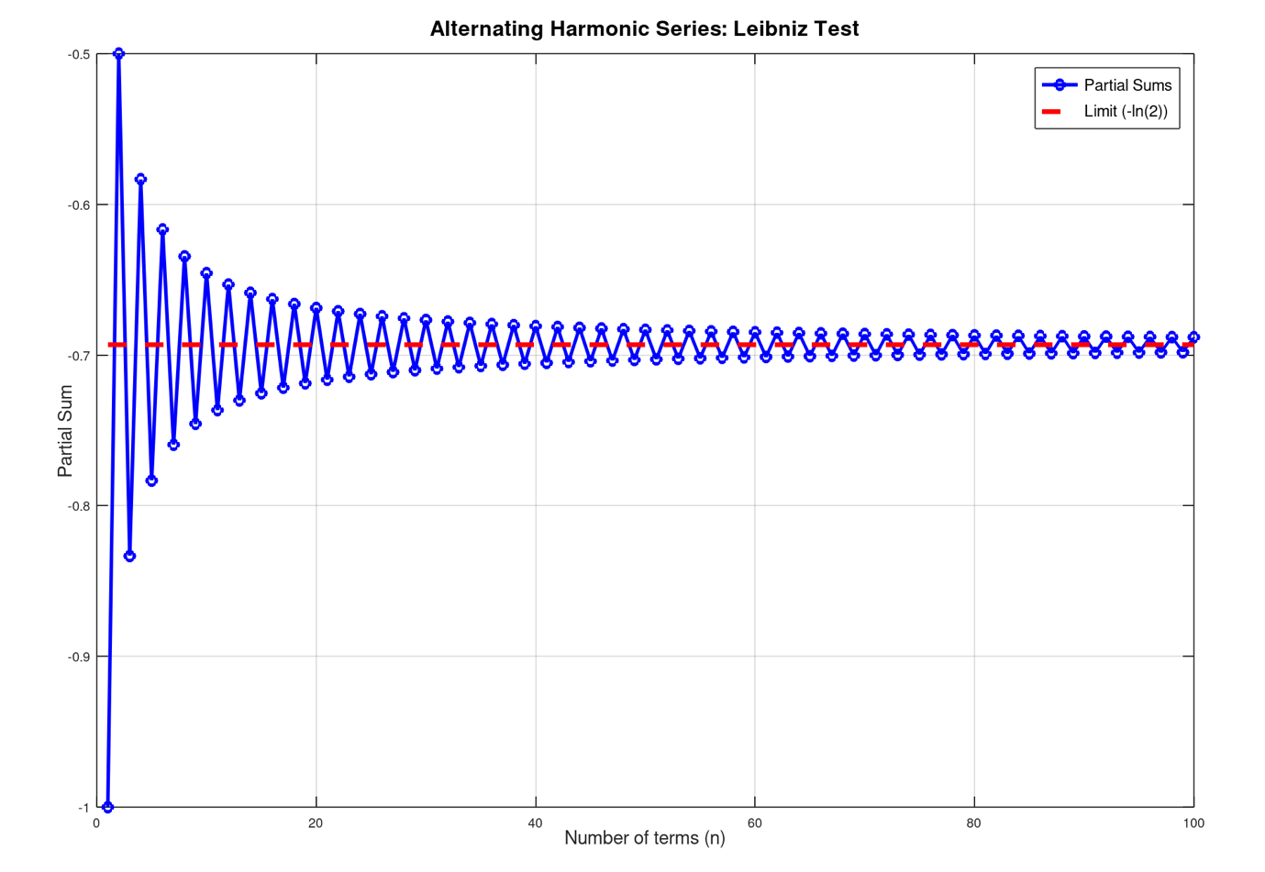

Q2. Partial sums of geometric and harmonic series

Code:

1. clc; clear; close all;

2.

3. % Use qt graphics toolkit for proper labels/legends

4. graphics_toolkit("qt");

5.

6. N = 50; % number of terms

7. n = 1:N;

8.

9. % Geometric series with r = 0.5

10. r = 0.5;

11. geo_terms = r.^(n-1); % start with n=0 term = 1

12. geo_partial = cumsum(geo_terms);

13.

14. % Harmonic series

15. harm_terms = 1 ./ n;

16. harm_partial = cumsum(harm_terms);

17.

18. %% Plot geometric series

19. figure;

20. plot(n, geo_partial, 'm-o', 'LineWidth', 1.5, 'MarkerSize', 4); hold on;

21. plot([1 N], [1/(1-r) 1/(1-r)], 'r--', 'LineWidth', 2); % replacement for yline

22.

23. xlabel('Number of terms (n)', 'FontSize', 14);

24. ylabel('Partial Sum', 'FontSize', 14);

25. title('Convergence of Geometric Series (r = 0.5)', 'FontSize', 16);

26. legend('Partial Sums', 'Limit (1/(1-r))', 'Location', 'best');

27. grid on;

28.

29. %% Plot harmonic series

30. figure;

31. plot(n, harm_partial, 'g-o', 'LineWidth', 1.5, 'MarkerSize', 4);

32.

33. xlabel('Number of terms (n)', 'FontSize', 14);

34. ylabel('Partial Sum', 'FontSize', 14);

35. title('Divergence of Harmonic Series', 'FontSize', 16);

36. legend('Partial Sums', 'Location', 'best');

37. grid on;

38.

39. drawnow; % force update of figures

40.

Graphs:

Graph1:

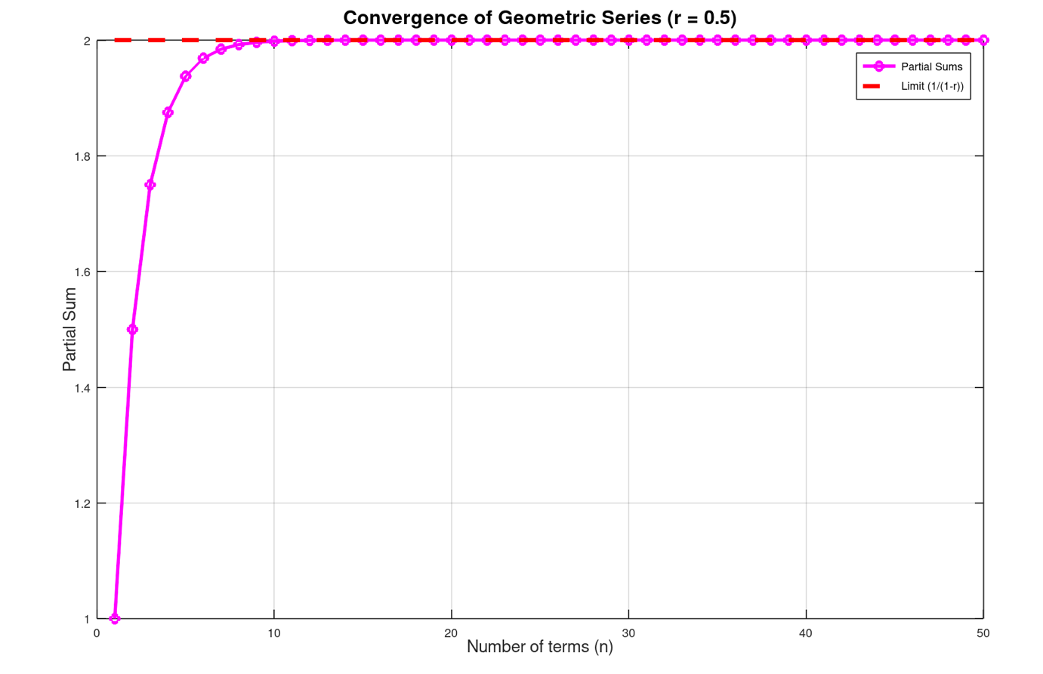

Graph2:

