**Question 2025 Math Minor**

Q1: Plot a 4th-degree polynomial and its derivatives

Code:

1. clc; clear; close all;

2.

3. % Define function and derivatives

4. f = @(x) x.^4 - 3*x.^3 + 2*x.^2 - x + 5; % Original function

5. f1 = @(x) 4*x.^3 - 9*x.^2 + 4*x - 1; % First derivative

6. f2 = @(x) 12*x.^2 - 18*x + 4; % Second derivative

7.

8. % Define x range

9. x = linspace(-10, 10, 500);

10.

11. % Evaluate functions

12. y = f(x);

13. y1 = f1(x);

14. y2 = f2(x);

15.

16. % Plot

17. figure;

18. plot(x, y, 'b', 'LineWidth', 2); hold on;

19. plot(x, y1, 'r--', 'LineWidth', 2);

20. plot(x, y2, 'g-.', 'LineWidth', 2);

21.

22. % Labels and formatting

23. xlabel('x', 'FontSize', 12);

24. ylabel('y', 'FontSize', 12);

25. title('Polynomial Function and its Derivatives', 'FontSize', 16);

26. legend('f(x)', 'f''(x)', 'f''''(x)', 'Location', 'best', 'FontSize', 12);

27. grid on;

28.

Graph:

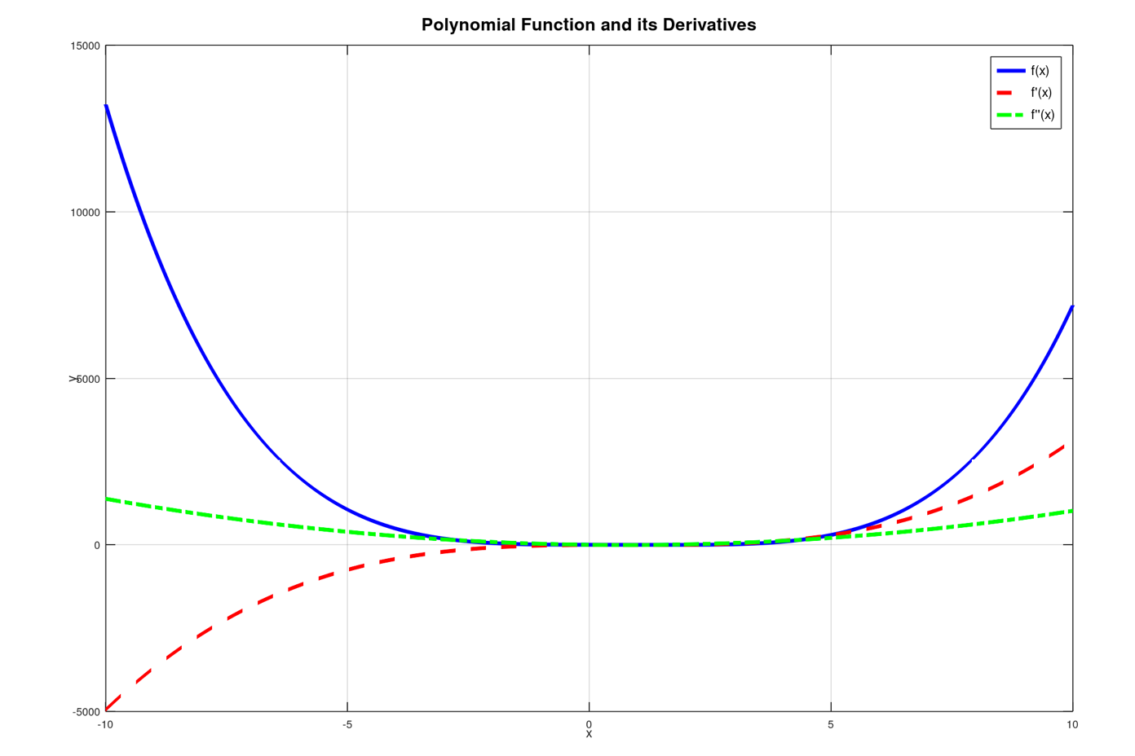

Q2. Plot cardioid in Cartesian coordinates

Code:

1. % Q2: Plot cardioid r(theta) = a(1 + cos(theta)), a = 1

2.

3. clc; clear; close all;

4.

5. % Parameters

6. a = 1;

7. theta = linspace(0, 2*pi, 500);

8.

9. % Polar equation

10. r = a * (1 + cos(theta));

11.

12. % Convert to Cartesian

13. x = r .* cos(theta);

14. y = r .* sin(theta);

15.

16. % Plot

17. figure;

18. plot(x, y, 'm', 'LineWidth', 2);

19.

20. % Labels and formatting

21. xlabel('x', 'FontSize', 14);

22. ylabel('y', 'FontSize', 14);

23. title('Cardioid: r(\theta) = 1 + cos(\theta)', 'FontSize', 16);

24. axis equal; % Keep aspect ratio equal

25. grid on;

26.

Graph:

