EcoSand Cleaner: Automated Beach Debris Cleaner

Submitted by:

Balimbingan, Shaina F.
Dacatimban, Kristine Jewel M.
Dado, Kenneth S.
Fajutagana, Kimberly A.
Fernandez, Robyn Kristoffer P.

May 2026
Table of Contents

Project Overview 3
Problem Statement 3
Scope of the Study 4
System Architecture 5
Architecture Description 5
Data Flow 6
Hardware Components 8
Database Design 11
System Operation Procedure 13
Gantt Chart 16
Expected Output 20

Project Overview
Beaches in the Philippines, are super dirty because of plastic waste and trash washing in from the sea think bottles, bags, fishing nets, and tiny microplastics. The Department of Environment and Natural Resources (DENR, 2023) reports a whopping 1.5 million tons of marine debris hitting Philippine shores yearly, mostly plastics that don't break down. This hurts fish and animals they eat it or get tangled, kills off sea turtles and corals, and makes tourism worse since no one wants to visit trashy beaches. In areas near Quezon City like Manila Bay or nearby coastal spots in Cavite and Bataan, pollution is extra bad from urban runoff and rivers dumping city waste straight into the sea (Jambeck et al., 2015). Cleaning by hand takes forever workers spend hours raking sand, it's really tiring (leading to back pain and injuries, as shown in Villanueva et al., 2021), and it misses small pieces of trash buried 5-10 cm deep in the sand. Big industrial machines like tractors with rakes exist but cost hundreds of thousands of pesos and damage beach dunes (Earthwatch, 2019). To address this, the EcoSand Cleaner: Automated Beach Debris Cleaner was developed as a low-cost and semi-mechanized solution. The system is operated using a 2.4GHz RC transmitter and receiver for manual control. An ESP32 microcontroller processes control signals and manages system operations. The system uses DC motors for movement and a vibration motor with a wire mesh to separate sand from debris. Collected waste is stored in an onboard collection bin, while sensors such as IR and soil moisture sensors assist in obstacle detection and environmental monitoring. The system is powered by a 12V battery with solar charging support and is designed to help barangays clean beaches more efficiently and sustainably.

Problem Statement
Coastal areas are increasingly affected by improper waste disposal and environmental pollution, resulting in the continuous accumulation of debris along shorelines. Existing beach cleaning practices are primarily manual, making them labor-intensive, time-consuming, and often ineffective in addressing small and partially buried waste. These challenges highlight the need for an efficient, safe, and sustainable automated solution for coastal waste management.
Specifically, this study seeks to answer the following problems:
- How can beach cleaning be made more efficient and less labor-intensive?
Manual cleaning requires significant time and effort, especially in large coastal areas, creating a need for an automated cleaning system.
- How can small and partially buried debris be effectively collected?
Traditional cleaning methods often fail to remove small to medium-sized waste materials such as plastics, bottle caps, and cigarette butts, which remain embedded in the sand.
- How can health and safety risks to cleaners be minimized?
Manual cleaning exposes individuals to hazardous waste, sharp objects, and prolonged environmental exposure, necessitating a safer, automated approach.
- How can coastal pollution be reduced through continuous and efficient cleaning?
Waste accumulation caused by improper disposal and ocean currents requires a system capable of maintaining cleaner shorelines over time.
- How can operational costs in beach cleaning be reduced?
Frequent clean-up operations involve recurring expenses in labor, equipment, and transportation, highlighting the need for a cost-effective solution.
- How can continuous and automated cleaning be implemented in coastal areas?
Most current efforts rely on scheduled clean-up drives rather than a system capable of regular or ongoing operation.
- How can automation and smart technologies be integrated into beach cleaning systems?
There is limited use of automated technologies in coastal waste management, indicating the need for an innovative system with monitoring and control capabilities.
General Objective
Generally, this study aims to design and develop the EcoSand Cleaner, an automated beach debris cleaning system that improves efficiency, enhances safety, and promotes sustainability in coastal waste management through the use of automation technology.
Specifically, it aims to
- To design and develop a semi-autonomous beach debris cleaning prototype that improves efficiency and reduces manual labor in shoreline cleaning.
- To develop a mechanical filtration and collection system capable of separating sand from small to medium solid waste materials.
- To implement an automated debris collection mechanism that minimizes direct human contact with hazardous and contaminated waste.
- To incorporate a dual-mode charging system using solar panels and Type-C input to ensure continuous and flexible power supply.
- To create a local web-based interface for monitoring system performance and viewing real-time cleaning data.
- To deploy a cost-effective and reusable prototype intended to support local beach cleaning operations within defined environmental and operational limits.

Scope and Delimitations
This study shows the design and development of the EcoSand Cleaner, an automated beach debris cleaning system. The automation of the collection process is designed to enhance the efficiency of cleaning in shorelines by mechanically separating the sand from solid waste. It focuses on gathering small to medium-sized waste like plastics, bottle caps, cigarette buttds, and partially buried wastes. The unit is designed to operate at a slow but controlled speed of up to 4 km/h for sufficient filtration and safe semi-autonomous navigation of the designated beach areas while mainly targeting to minimize human labor and human contact with hazardous materials. The development of the system is thus primarily aimed at cleaning beach areas from debris without direct human interaction. The system also features a dual-mode charging feature that enables the battery to be replenished using the integrated solar panels for a more field-sustainable mode of charging or through a Type-C charging feature for a faster charging cycle. A local web-based administrative interface is also included to enable users to manage the associated records and monitor real-time cleaning records through a web-based browser in the same network as the unit.
There are several limitations to this study, and the design limitations are apparent as a result of the research purpose. First, the system is only capable of operating under proper weather conditions, for example sun-drenched, in order to maximise solar charging and allow the vehicle to move at optimal efficiency across dry sand. As such, the vehicle’s functionality may dwindle greatly upon contact with very wet and damp sand or under water. Additionally, the vehicle’s size limits its efficiency in collecting large amounts or especially sized solid waste with large and/or massive solid debris such as heavy metallic objects and driftwood. It is not capable of collecting liquid forms of pollution or oil spills. The vehicle requires a stable input of 12V DC, thus its operational time is limited by the 20000mAh battery capacity and required charge time. On a larger scale, remote access is only limited by the local Wi-Fi network range created by the ESP32 or router. Finally, the system was built and designed for a semi-autonomously navitated in a flat beach terrain and manual intervention may be required in response when navigating across steep slopes and/or uneven terrain.

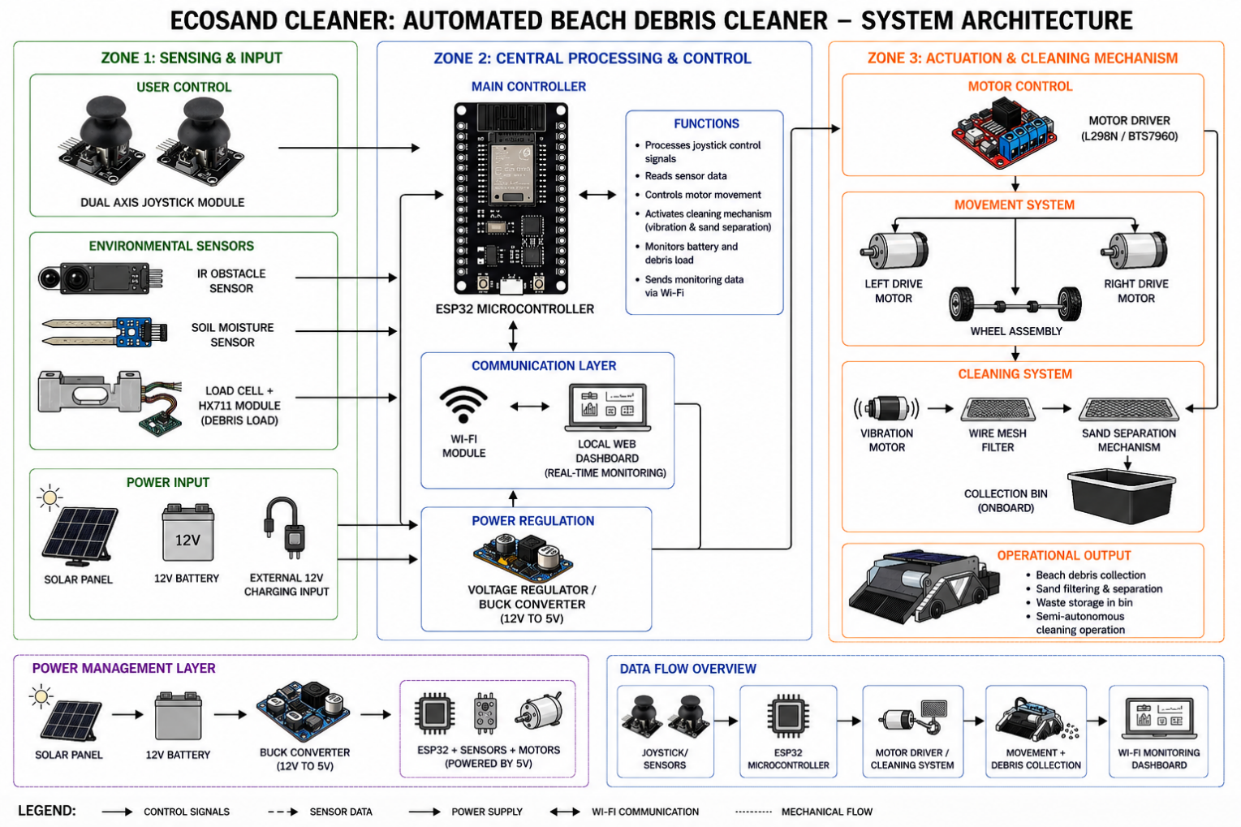
System Architecture

Figure 1. System Architecture

Architecture Description

Figure 1 shows the system architecture of the EcoSand Cleaner: Automated Beach Debris Cleaner is designed using a multi-zone structure composed of sensing and input, central processing and control, and actuation and cleaning mechanisms to ensure efficient and semi-automated beach cleaning operations. In the sensing and input zone, a dual-axis joystick module allows the user to manually control the system, while sensors such as the IR obstacle sensor, soil moisture sensor, and load cell with HX711 module collect environmental and operational data including obstacle detection, sand condition, and debris load measurement. These inputs are transmitted to the ESP32 microcontroller located in the central processing and control zone, which serves as the main controller responsible for processing sensor data, managing motor movement, activating the cleaning mechanism, monitoring battery and debris status, and transmitting real-time information through the built-in Wi-Fi module to a local web dashboard for monitoring purposes. The system is powered by a 12V battery supported by a solar panel and external charging input, while a voltage regulator or buck converter ensures stable power distribution to all components. In the actuation and cleaning mechanism zone, the ESP32 sends control signals to the motor driver, which controls the left and right drive motors for movement, while the vibration motor activates the wire mesh filtering mechanism that separates sand from collected debris and transfers waste materials into the onboard collection bin. Overall, the system operates through a continuous flow of sensing, processing, movement, cleaning, and monitoring to provide an efficient, cost-effective, and environmentally sustainable solution for automated beach debris collection.

Data Flow
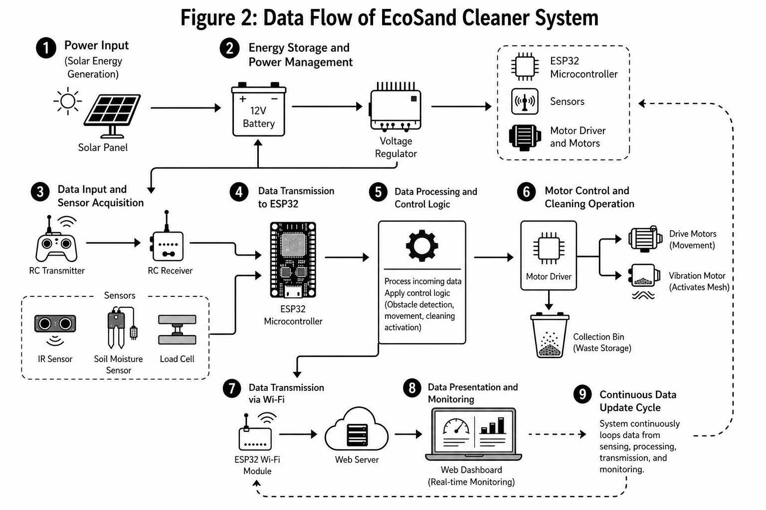

Figure 2: Data Flow

Figure 2 show the data flow of the EcoSand Cleaner System follows a structured path: power input → energy storage and management → data input and sensing → data transmission to ESP32 → data processing and control → motor operation and cleaning → data transmission via Wi-Fi → web-based monitoring. This flow helps the system operate smoothly, manage power properly, and provide accurate and real-time updates, as explained below:
- Power Input
The system starts with the solar panel. It collects sunlight and turns it into electrical energy that will be used to run the whole system.
- Energy Storage and Power Management
The energy from the solar panel is stored in a 12V battery. A voltage regulator makes sure the power is steady and safe before it is sent to the other parts.
- Data Input and Sensor Acquisition
The user can control the system using RC transmitter, and the signal is received by the RC receiver.
At the same time, sensors gather information from the environment.
- The IR sensor checks for obstacles
- The soil moisture sensor checks if the sand is wet or dry
- The load cell measures how much waste is collected
- Data Transmission to ESP32
All the signals from the controller and sensors are sent to the ESP32 micro-controller, which acts as the main brain of the system
- Data Processing and Control Logic
The ESP32 reads and understands the data. It decides what the system should do like avoiding obstacles, moving in a direction, or starting the cleaning process
- Motor Control and Cleaning
After deciding what to do, the system sends signals to the motor driver.
- The drive motors move the cleaner
- The vibration motor shakes the mesh to separate waste from sand
- The waste is collected in the bin
- Data Transmission via Wi-Fi
The ESP32 sends data through its Wi-Fi module to a web server so it can be viewed online
- Data Presenting and Monitoring
The data is shown on a web dashboard where users can see the system status, sensor readings, and cleaning activity in real time

Hardware Components
Component | Description | Minimum Requirements | Recommended Requirements
Microcontroller | Main control unit with WiFi/Bluetooth | ESP8266 | ESP32
Motor Driver | Controls DC motors | L298N | BTS7960 (High Power)
RC Transmitter & Receiver | Wireless control system | 2.4GHz RC system | 2.4GHz long-range RC
Drive Motor | Powers the RC car wheels | 6V DC Motor | High torque 12V DC Motor
DC Motor | For sand pag-aag-ag mechanism | 6V DC motor | 12V DC motor with offset weight
Solar Panel | To charge the battery and continuous use | 100W | 200W
HX711 Module | Load cell amplifier | HX711 | HX711
Power Supply | Main battery source | 24V 20Ah | 24V 30Ah
Buck Converter | Steps down voltage to 5V and 12v | LM7805 | Buck Converter Module
Collection Bin | Stores debris | Plastic container | Removable reinforced bin
Wire Mesh Screen | Sand sifting | 5mm mesh | 3–4mm stainless mesh
Jumper Wires | Circuit connections | Male-Male | Male-Male & Male-Female

Table 1. Hardware Components

Software | Purpose |  | Minimum Requirements | Recommended Requirements
Arduino IDE | Write and upload code to ESP32/ Arduibo |  | Arduino IDE | Arduino IDE/ PlatformIO
Programming Language (C/C++) | Develop system logic and control |  | Basic C/C++ knowledge | Advanced C/C++ with libraries
ESP32 Board Package | Enables ESP32 support in IDE |  | ESP32 core installed | Latest ESP32 core version
Esp32Servo | Controls steering |  | Esp32servo | Updated & optimized version
ESP32Now | Connection between two esp32 |  | ESP32now | Esp32now library
Motor Driver Library | Controls DC motors |  | Basic PWM code | Advanced motor control library
Serial Monitor | Debugging and data monitoring | Arduino Serial Monitor |  | Serial Plotter/ External Debug Tool
Wi-Fi/Bluetooth Library | Enables wireless communication | Basic Wi-Fi setup |  | Web server/ Mobile app integration

Table 2: Software Components

Functional Requirements
This section discusses the core functional requirements of the EcoSand Cleaner: Automated Beach Debris Cleaner system. Each requirement defines a specific behavior that the system must perform to ensure efficient, safe, and practical beach cleaning within the defined scope of the prototype.

1. The system shall detect small to medium beach debris
The system is required to detect nearby obstacles using the integrated IR obstacle sensor. The detection mechanism shall identify objects located on the sand surface within short range to assist in navigation and prevent collisions during cleaning. The soil moisture sensor shall additionally monitor sand conditions to determine suitability for cleaning operations. The system is not required to detect deeply buried waste, metallic materials, or very large debris. This function enables basic environmental awareness during operation.
2. The system shall mechanically collect and filter debris
After reaching a debris area, the system must activate its DC motor with offset weight and wire mesh filtering mechanism. The offset-weight DC motor shall generate vibration that agitates sand through the 3–4mm stainless steel wire mesh screen, allowing fine sand particles to pass through while retaining small to medium solid debris such as plastics, bottle caps, and cigarette butts. The system is designed to operate efficiently in dry sand conditions only.
3. The system shall store collected waste in an onboard container
The system must store collected debris in a removable, reinforced collection bin attached to the chassis. The bin shall securely hold filtered waste materials and prevent spillage during movement. The load cell with HX711 amplifier module shall monitor the weight of collected debris in real time and alert the operator when the bin approaches its maximum capacity, prompting waste disposal.
4. The system shall support wireless remote-controlled operation
The EcoSand Cleaner must support real-time manual control using a 2.4GHz RC transmitter and receiver. The operator shall be able to control movement directions (forward, backward, left, right) and cleaning activation. The system is not fully autonomous and depends on user control for navigation.
5. The system shall control motor movement and cleaning operations
The ESP32 microcontroller shall process RC control signals received via the 2.4GHz receiver and manage all system operations. The motor driver (BTS7960 recommended, L298N minimum) shall regulate the speed and direction of the high-torque 12V DC drive motors for movement, and control the 12V DC offset-weight motor for the vibration-based filtering mechanism. This ensures synchronized movement and cleaning functionality.
6. The system shall detect unsuitable cleaning conditions (wet sand)
The system shall use the onboard soil moisture sensor to continuously read moisture levels in sand during operation. If excessive moisture is detected, the ESP32 shall signal the operator and prevent or limit activation of the DC offset-weight motor and filtering mechanism to avoid clogging the wire mesh and causing mechanical damage. This ensures optimal filtration performance within the defined dry-sand operating conditions.

7. The system shall provide dual-mode battery charging
The system shall support dual-mode battery charging using a 100W solar panel (200W recommended) for continuous outdoor operation and through a Type-C input for faster recharging. The buck converter module shall regulate and step down the battery voltage to stable 12V and 5V outputs required by the drive motors, ESP32, and other components. The system shall operate based on available battery capacity (12V, 20Ah minimum, 20000mAh recommended).

8. The system shall transmit real-time data to a local web-based monitoring dashboard
The ESP32’s built-in Wi-Fi module shall host a local web server accessible via any browser on the same network. The dashboard shall display real-time sensor readings including IR obstacle status, soil moisture level, load cell weight (via HX711), battery level, and system operation status. This allows operators to monitor cleaning activity and system health without direct physical interaction with the unit.

Non-Functional Requirements
This section discusses the non-functional requirements of the EcoSand Cleaner system. These requirements define the quality attributes and operational constraints of the prototype.
1. Performance
The system must respond to 2.4GHz RC control inputs within one (1) second during operation. The BTS7960 motor driver shall maintain smooth PWM-based speed control of the 12V DC drive motors, keeping travel speed at or below 4 km/h to ensure effective debris filtration through the wire mesh. The DC offset-weight motor for the vibration mechanism shall activate continuously while the system is in motion over a designated cleaning area.
2. Safety
The system must include obstacle detection using the IR obstacle sensor to prevent collisions during operation. The ESP32 shall process IR sensor signals and stop or redirect the drive motors via the motor driver when an obstacle is detected within the sensor’s predefined range. The buck converter module shall regulate and step down battery voltage to safe and stable 12V and 5V outputs to protect all electronic components from overvoltage damage.
3. Reliability
The system must operate continuously within the limits of its 12V, 20000mAh battery capacity and maintain stable performance under normal outdoor conditions including heat, dust, and dry sand exposure. The ESP32 microcontroller and motor driver shall maintain consistent communication and motor control throughout a cleaning session. Performance may decrease in wet sand or on uneven terrain, as defined in the system delimitations.
4. Usability
The system shall provide simple and intuitive control using a standard RC controller. The collection bin shall be removable to allow easy disposal of collected waste. The system shall be easy to operate without requiring advanced technical knowledge.

5. Power Efficiency
The system must efficiently manage power consumption through the buck converter module, which steps down the 12V battery supply to regulated 12V and 5V outputs for the drive motors, ESP32, and sensors respectively. The 100W solar panel (200W recommended) shall provide supplementary charging via the solar charge controller to extend operational time outdoors and reduce dependency on Type-C manual charging.
6. Maintainability
The system shall allow easy replacement of modular hardware components including the DC drive motors, offset-weight DC motor, IR sensor, soil moisture sensor, HX711 load cell module, and the removable reinforced collection bin. Jumper wires (male-to-male and male-to-female) shall support quick circuit assembly, reconfiguration, and troubleshooting. The design shall support future hardware upgrades such as switching from the L298N to the BTS7960 motor driver or expanding the solar panel capacity.
7. Durability
All system components, including the 3–4mm stainless steel wire mesh screen and the chassis frame, must withstand continuous vibration generated by the offset-weight DC motor, prolonged sand and dust exposure, and general outdoor operating conditions. Stainless steel mesh is specified to prevent corrosion and wire deformation over repeated use. The ESP32 and motor driver shall be mounted securely within an enclosure to minimize exposure to sand ingress and moisture during operation.
These eight (8) functional and seven (7) non-functional requirements define the expected behavior, performance, safety, and operational limits of the EcoSand Cleaner prototype. Each requirement is directly grounded in the actual hardware components of the system — including the ESP32 microcontroller, BTS7960 motor driver, 2.4GHz RC transmitter and receiver, 12V DC drive motors, offset-weight DC motor, IR obstacle sensor, soil moisture sensor, HX711 load cell module, solar panel, buck converter, stainless steel wire mesh, and reinforced collection bin — ensuring that the system remains efficient, practical, and fully aligned with its hardware capabilities.

Database Design
1. Users Table- Stores administrator login credentials for the local web dashboard.
Table: users
Field Name | Data Type | Description
user_id (PK) | INT (Auto Increment) | Unique ID of the admin
username | VARCHAR(50) | Admin username
password_hash | VARCHAR(255) | Encrypted password
role | VARCHAR(20) | Role (Admin / Operator)
created_at | DATETIME | Account creation date

2. Cleaning Sessions Table- Stores each cleaning operation instance.
Table: cleaning_sessions
Field Name | Data Type | Description
session_id (PK) | INT (Auto Increment) | Unique cleaning session ID
start_time | DATETIME | Cleaning start
end_time | DATETIME | Cleaning end
area_covered | FLOAT | Estimated area cleaned (sqm)
total_debris_collected | INT | Total debris pieces collected
status | VARCHAR(20) | Completed / Interrupted
operator_id (FK) | INT | References users(user_id)

3. Debris Collection Logs Table
Stores detailed logs of collected debris during sessions.
Table: debris_logs
Field Name | Data Type | Description
debris_id (PK) | INT (Auto Increment) | Unique debris record
session_id (FK) | INT | References cleaning_sessions(session_id)
debris_type | VARCHAR(50) | Plastic / Bottle Cap / Cigarette Butt
quantity | INT | Number collected
timestamp | DATETIME | Time detected

4. System Status Logs Table
Stores periodic system health updates.
Table: system_status_logs
Field Name | Data Type | Description
status_id (PK) | INT (Auto Increment)
session_id (FK) | INT | References cleaning_sessions(session_id)
battery_level | INT | Battery percentage
speed | FLOAT | Current speed (km/h)
obstacle_detected | BOOLEAN | Yes / No
log_time | DATETIME | Time recorded

5. Charging Logs Table
Tracks charging activity (Solar / Type-C).
Table: charging_logs
Field Name | Data Type | Description
charge_id (PK) | INT (Auto Increment)
charge_mode | VARCHAR(20) | Solar / Type-C
start_time | DATETIME | Charging started
end_time | DATETIME | Charging ended
energy_level_before | INT | Battery % before
energy_level_after | INT | Battery % after

System Operation Procedure
This section describes the step-by-step procedure for operating the EcoSand Cleaner: Automated Beach Debris Cleaner system. The procedure outlines the normal sequence of actions required to ensure proper system functionality from startup to cleaning session monitoring.
Step 1: Power On the EcoSand Cleaner
Power On the EcoSand Cleaner

Ensure that the 24V battery is sufficiently charged either through the solar panel or external charging source. Turn on the main power switch to supply power to the system. Upon startup, the microcontroller (ESP8266 or ESP32) initializes all connected components including the motor driver, sensors (IR sensor, soil moisture sensor, load cell), and communication modules.
Step 2: Initialize Wireless Control System
Initialize Wireless Control System

After initialization, the RC transmitter and receiver establish a wireless connection. The operator uses the 2.4GHz remote controller to send movement and operation commands. The system is controlled manually and does not require Wi-Fi or a web-based interface for operation.
Step 3: Begin Cleaning Operation
Begin Cleaning Operation

The operator navigates the EcoSand Cleaner across the target beach area using the RC controller. The drive motors, controlled by the motor driver (L298N or BTS7960), enable movement in all directions (forward, backward, left, right). The system operates at a controlled speed suitable for effective cleaning.
.
Step 4: Activate Sand Filtering Mechanism
Activate Sand Filtering Mechanism

When debris such as plastics, bottle caps, or cigarette butts is detected, the mechanical filtration mechanism activates automatically. The rotating brush or conveyor collects sand and debris, separates the waste materials from the sand, and returns filtered sand back to the beach surface. The collected debris is directed into the onboard storage compartment.

Step 5: Environmental and Obstacle Monitoring
Environmental and Obstacle Monitoring

During operation, the system continuously monitors environmental conditions:
- The IR obstacle sensor detects nearby objects and helps the operator avoid collisions.
Step 6: Debris Collection and Load Monitoring
Debris Collection and Load Monitoring

Collected waste is stored in the onboard collection bin. The load cell with HX711 module measures the weight of the debris in real time. When the bin approaches its maximum capacity, the system alerts the operator (via indicator or monitoring system), prompting disposal.

Step 7: Power Management During Operation
Power Management During Operation

The system operates using a 24V battery supply. The solar panel provides supplementary charging during operation to extend usage time. The voltage regulator ensures that sensitive components receive stable 5V power.

Step 8: Session Completion and Shutdown
Session Completion and Shutdown

Once the cleaning session is complete or the collection bin is full, the operator stops the system using the RC controller. The collected debris is removed from the bin for proper disposal. The system is then powered off and the battery is recharged if necessary.
The system operation procedure ensures a structured and controlled beach cleaning process. By following these steps, debris is efficiently collected, hardware components function within their limits, and the system maintains safe and reliable operation based on its design.

Gantt Chart
Task / Phase | 1 | 2 | 3 | 4 | 5 | 6 | 7 | 8 | 9
Project Planning & Proposal | ███ | ███ | ███ | ███ | ███ | ███ | ███ | ███
Requirements Analysis | ███
System Architecture Design |  |  |  |  |  |  | ███
Documentation Writing | ███ | ███ | ███ | ███ | ███ | ███ | ███ | ███
Hardware Setup & Wiring
System Integration (Hardware + Software)
Mechanical Fabrication (Filtration System)
Firmware Development (ESP32)
Obstacle Detection & Motor Control Integration
Web Server & Dashboard Development
Testing & Debugging (In Dry Sand Conditions)
Final Evaluation & Submission
Task / Phase | 1 | 2 | 3 | 4 | 5 | 6 | 7 | 8 | 9
Project Planning & Proposal | ███ | ███ | ███ | ███ | ███ | ███ | ███ | ███
Requirements Analysis | ███
System Architecture Design
Documentation Writing | ███ | ███ | ███ | ███ | ███ | ███ | ███ | ███
Hardware Setup & Wiring
System Integration (Hardware + Software)
Mechanical Fabrication (Filtration System)
Firmware Development (ESP32)
Obstacle Detection & Motor Control Integration
Web Server & Dashboard Development
Testing & Debugging (In Dry Sand Conditions)
Final Evaluation & Submission
Balimbingan, Shaina

Dacatimban, Kristine Jewel M.

Task / Phase | 1 | 2 | 3 | 4 | 5 | 6 | 7 | 8 | 9
Project Planning & Proposal
Requirements Analysis
System Architecture Design
Documentation Writing
Hardware Setup & Wiring
System Integration (Hardware + Software)
Mechanical Fabrication (Filtration System)
Firmware Development (ESP32)
Obstacle Detection & Motor Control Integration
Web Server & Dashboard Development
Testing & Debugging (In Dry Sand Conditions)
Final Evaluation & Submission
Dado, Kenneth S.

Task / Phase | 1 | 2 | 3 | 4 | 5 | 6 | 7 | 8 | 9
Project Planning & Proposal | ███ | ███ | ███ | ███ | ███ | ███ | ███ | ███
Requirements Analysis | ███ | ███ | ███ | ███ | ███ | ███ | ███ | ███
System Architecture Design
Documentation Writing | ███ | ███ | ███ | ███ | ███ | ███ | ███ | ███
Hardware Setup & Wiring |  |  |  |  |  |  | ███ | ███
System Integration (Hardware + Software)
Mechanical Fabrication (Filtration System)
Firmware Development (ESP32)
Obstacle Detection & Motor Control Integration
Web Server & Dashboard Development
Testing & Debugging (In Dry Sand Conditions)
Final Evaluation & Submission
Task / Phase | 1 | 2 | 3 | 4 | 5 | 6 | 7 | 8 | 9
Project Planning & Proposal | ███ | ███ | ███ | ███ | ███ | ███ | ███ | ███
Requirements Analysis | ███ | ███ |  |  |  |  | ███ | ███
System Architecture Design |  |  |  |  |  |  |  | ███
Documentation Writing | ███ | ███ | ███ | ███ | ███ | ███ | ███ | ███
Hardware Setup & Wiring
System Integration (Hardware + Software)
Mechanical Fabrication (Filtration System)
Firmware Development (ESP32)
Obstacle Detection & Motor Control Integration
Web Server & Dashboard Development
Testing & Debugging (In Dry Sand Conditions)
Final Evaluation & Submission
Fajutagana, Kimberly A.

Fernandez, Robyn Kristoffer P.

Task / Phase | 1 | 2 | 3 | 4 | 5 | 6 | 7 | 8 | 9
Project Planning & Proposal | ███ | ███ | ███ | ███ | ███ | ███ | ███ | ███
Requirements Analysis | ███ | ███ |  | ███ |  | ███
System Architecture Design | ███ | ███ | ███ |  |  |  | ███ | ███
Documentation Writing | ███ | ███ | ███ | ███ | ███ | ███ | ███ | ███
Hardware Setup & Wiring
System Integration (Hardware + Software)
Mechanical Fabrication (Filtration System)
Firmware Development (ESP32)
Obstacle Detection & Motor Control Integration
Web Server & Dashboard Development
Testing & Debugging (In Dry Sand Conditions)
Final Evaluation & Submission

Expected Output
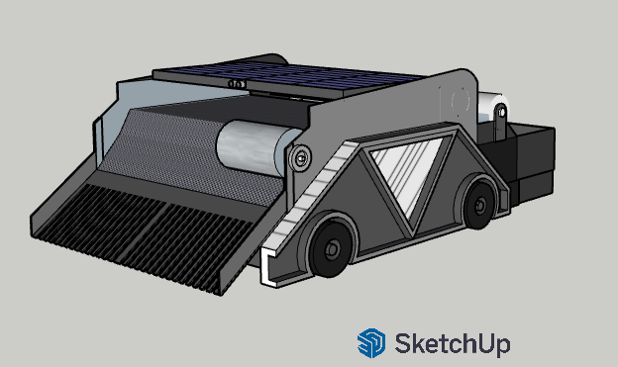
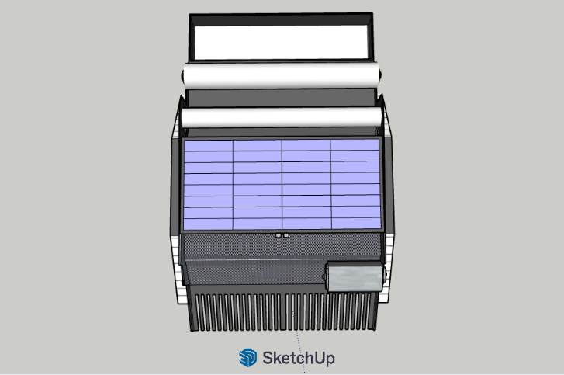

Figure 3. ISO View Figure 4. Top View
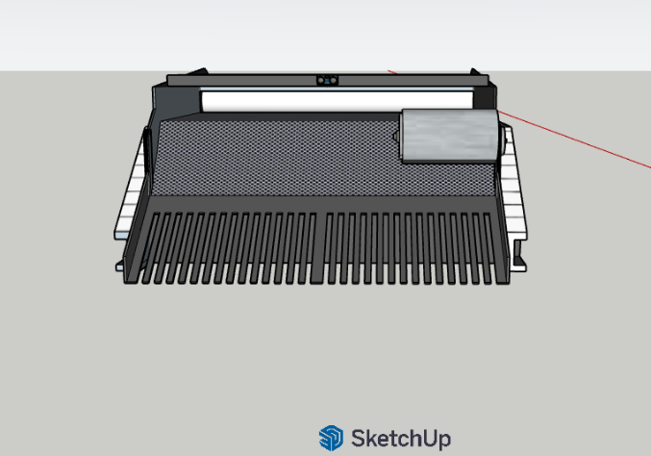
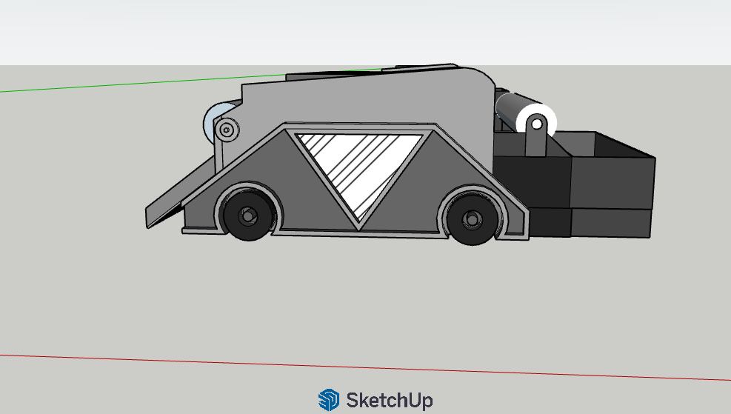

Figure 5. Front View Figure 6. Right View
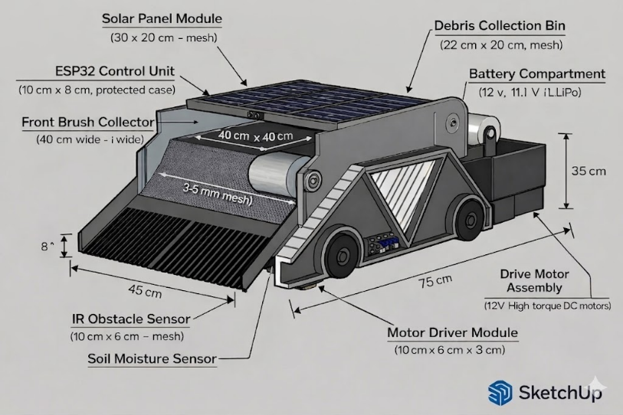
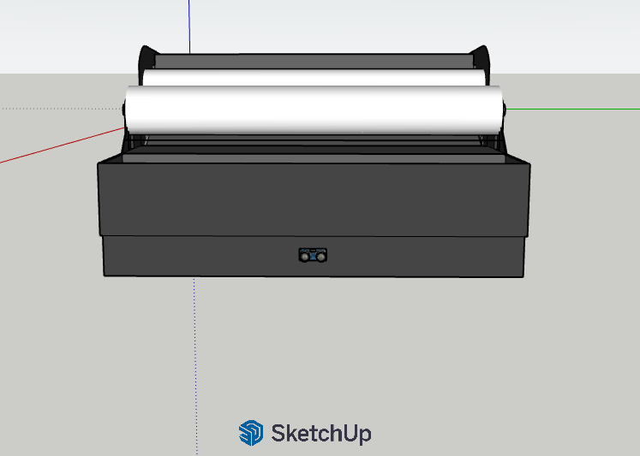

Figure 7. Left View Figure 8. ISO View with Components

