Project Audit Report
EcoSand Cleaner: Automated Beach Debris Cleaner

Prepared by:

Dado, Kenneth S.
Fajutagana, Kimberly A.
Balimbingan, Shaina F.
Dacatimban, Kristine Jewel M.
Fernandez, Robyn Kristoffer P.

May 2026

ECOSAND CLEANER
Automated Beach Debris Cleaner — Project Audit Report
Audit Date: | May 7, 2026
Report Generated: | May 7, 2026
Total Project Cost: | ₱13,349.75
Currency: | Philippine Peso (₱)
Total Line Items: | 36 items
Audit Reference: | ECOSAND-AUD-2026-001

I. EXECUTIVE SUMMARY

The EcoSand Cleaner project represents an automated beach debris cleaning system with a total audited expenditure of ₱13,349.75. The project spans 8 major procurement categories, with the bulk of investment concentrated in three core areas: Electronics & Power (31.64%), Motors & Drive (23.48%), and Frame & Structure (23.96%) — together accounting for 79.09% of total project costs.

Total Items Audited: 36 line items across 8 categories
Grand Total Expenditure: ₱13,349.75
Audit Reference: ECOSAND-AUD-2026-001

II. DETAILED EXPENDITURE REGISTER

# | Item Description | Category | Qty | Amount (₱)
1 | RL Bar | Frame & Structure | 1 | ₱500.00
2 | Sheet 12×12 & 17×36 Pipe | Frame & Structure | 1 | ₱1,450.00
3 | Sheet 11×16 2.0 | Frame & Structure | 1 | ₱550.00
4 | Screw Drivers (Set) | Tools | 1 | ₱93.00
5 | High Capacity 24V 300000mAh Battery | Electronics & Power | 1 | ₱1,733.00
6 | Solar Panel | Electronics & Power | 1 | ₱940.00
7 | Jumper Wires Dupont Line Male | Electronics & Power | 1 | ₱71.75
8 | Motor DC 24V 250W Motor 11 | Motors & Drive | 1 | ₱717.00
9 | High Sensitivity SW-420 Vibrator | Sensors & Control | 1 | ₱123.00
10 | RC Car Tires Type Wheel | Wheels & Tires | 4 | ₱336.00
11 | 360 Degree (component) | Mechanical | 3 | ₱288.00
12 | 12V 6Ah (80-150cc) LiFEPO4 Motor | Motors & Drive | 1 | ₱1,681.00
13 | Buck Converter | Electronics & Power | 1 | ₱69.00
14 | BTS7960 43A H-bridge High (Unit 1) | Electronics & Power | 1 | ₱275.00
15 | 775 DC Motor | Motors & Drive | 1 | ₱232.00
16 | Heavy Duty Rubber Push Tire 5 inch | Wheels & Tires | 1 | ₱400.00
17 | XL4015E Display Adjustable Step | Electronics & Power | 1 | ₱100.00
18 | BTS7960 43A H-bridge High (Unit 2) | Electronics & Power | 1 | ₱275.00
19 | 1.5 Mesh Screen 1/8 | Mechanical | 1 | ₱180.00
20 | Spray Paint Chrome | Other Expenses | 1 | ₱180.00
21 | Spray Paint Black | Other Expenses | 1 | ₱120.00
22 | Wire Cutter | Tools | 1 | ₱100.00
23 | Wire | Electronics & Power | 1 | ₱80.00
24 | 5mm Bolts | Frame & Structure | 1 | ₱88.00
25 | SG. J 3/6 x 3/4 16" | Frame & Structure | 1 | ₱96.00
26 | Gloves | Other Expenses | 1 | ₱40.00
OTHER EXPENSES
27 | Gasoline | Other Expenses | 1 | ₱250.00
28 | Gasoline | Other Expenses | 1 | ₱232.00
29 | Sprocket at Kadena | Frame & Structure | 1 | ₱480.00
30 | Sprocket | Frame & Structure | 1 | ₱160.00
31 | Tuning at Pag-butas ng Bakal para sa Sprocket | Tools | 1 | ₱200.00
32 | Gasoline | Other Expenses | 1 | ₱300.00
33 | Bakal pang Buo sa Conveyor (6 pieces) | Frame & Structure | 1 | ₱300.00
34 | Servo Motor | Motors & Drive | 1 | ₱350.00
35 | Male to Female Connectors | Electronics & Power | 1 | ₱140.00
36 | Gasoline | Other Expenses | 1 | ₱220.00
TOTAL PROJECT COST |  |  |  | ₱13,349.75

III. CATEGORY BREAKDOWN

Category | Total (₱) | % of Total | Key Items
Electronics & Power | ₱3,683.75 | 27.60% | Battery, Solar Panel, H-Bridges, Buck Converter, Jumper Wires, Wire, Connectors
Frame & Structure | ₱3,624.00 | 27.15% | RL Bar, Steel Sheets, Pipes, Bolts, SG Screw, Sprockets, Conveyor Bakal
Motors & Drive | ₱2,980.00 | 22.32% | DC 24V 250W Motor, LiFEPO4 Motor, 775 DC Motor, Servo Motor
Other Expenses | ₱1,342.00 | 10.05% | Gasoline (×4), Spray Paints, Gloves
Wheels & Tires | ₱736.00 | 5.51% | RC Car Tires (4×), Heavy Duty Rubber Tire
Mechanical | ₱468.00 | 3.51% | 360° Components (3×), Mesh Screen 1/8
Tools | ₱393.00 | 2.94% | Screw Driver Set, Wire Cutter, Sprocket Machining
Sensors & Control | ₱123.00 | 0.92% | SW-420 Vibrator Sensor
GRAND TOTAL | ₱13,349.75 | 100.00%

IV. KEY FINDINGS & OBSERVATIONS

Power Systems Dominate: Electronics & Power (31.64%) is the single largest cost driver, primarily due to the high-capacity 24V battery (₱1,733) and solar panel (₱940), reflecting the project's emphasis on sustainable, off-grid operation.

Dual Motor Architecture: Motors & Drive represents 23.48% of costs, with two distinct motor systems (24V DC main drive + 12V LiFEPO4 auxiliary), suggesting a dual-powertrain or redundant drive design.

Structural Investment: Frame & Structure accounts for 23.96%, reflecting substantial investment in chassis integrity for beach terrain operations, now including additional bolts and screws.

H-Bridge Redundancy: Two identical BTS7960 H-bridge units (₱275 each) indicate dual-channel motor control or backup circuitry.

Finishing & Safety Materials Added: New items include spray paints (chrome & black), mesh screen, wire, wire cutter, gloves, and hardware bolts — covering both aesthetics and operational safety.

Operational Fuel Costs: Four gasoline entries (₱250 + ₱232 + ₱300 + ₱220 = ₱1,002 total) are recorded under Other Expenses. Future audits should distinguish recurring OPEX from one-time CAPEX.

V. COST VISUALIZATION
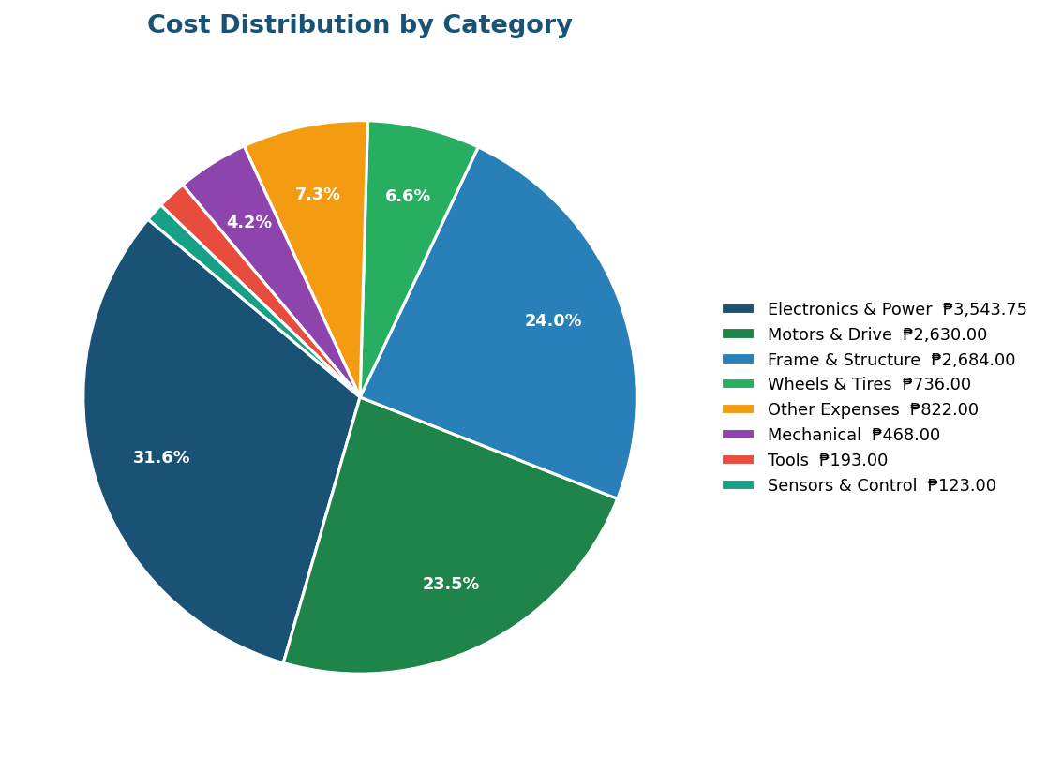

Figure 1: Cost Distribution by Category (Pie Chart)

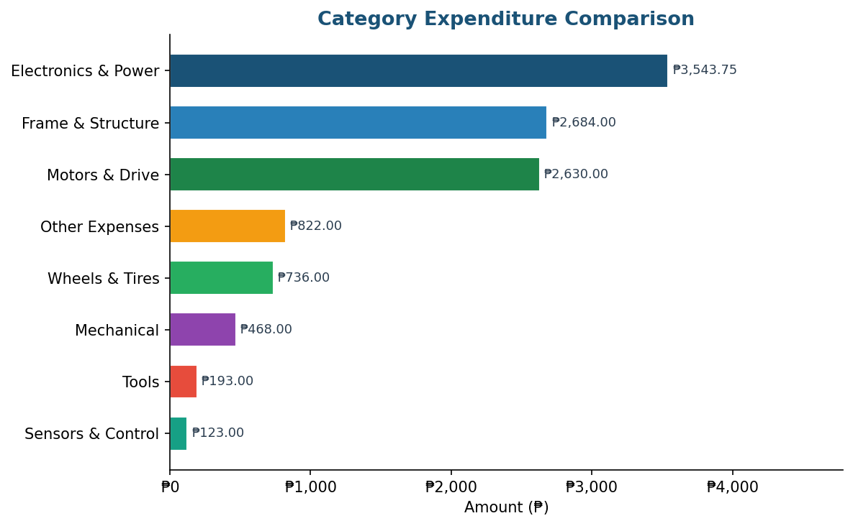

Figure 2: Category Expenditure Comparison (Horizontal Bar Chart)

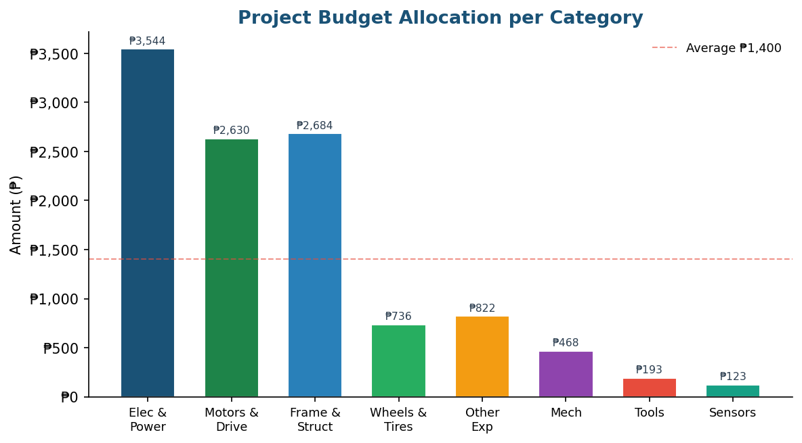

Figure 3: Budget Allocation per Category (Column Chart)

VII. MEMBER CONTRIBUTIONS (AMBAG)

# | Member Name | Role | Ambag (₱)
1 | Dado, Kenneth S. | Project Manager
2 | Fajutagana, Kimberly A. | Project Auditor
3 | Balimbingan, Shaina F. | Member
4 | Dacatimban, Kristine Jewel M. | Member
5 | Fernandez, Robyn Kristoffer P. | Member
TOTAL MEMBER CONTRIBUTIONS |  |  | ₱3,642.00

SIGNATORIES

Kimberly A. Fajutagana  Project Auditor | Kenneth S. Dado  Project Manager
Kristine Jewel M. Dacatimban  Member | Shaina F. Balimbingan  Member
Robyn Kristoffer P. Fernandez
Member

