System Manual
EcoSand Cleaner: Automated Beach Debris Cleaner

Prepared by:

Dado, Kenneth S.
Fajutagana, Kimberly A.
Balimbingan, Shaina F.
Dacatimban, Kristine Jewel M.
Fernandez, Robyn Kristoffer P.

May 2026

TABLE OF CONTENTS
PRELIMINARY PAGES
1.DOCUMENT INFORMATION
Document Information Table 4

2. PURPOSE AND SCOPE
2.1 Purpose 4
2.2 Scope 4
2.3 Intended Users 4

3. SYSTEM OVERVIEW
3.1 General Description 5
3.2 Key Features 5
3.3 System Specifications 5

4. HARDWARE COMPONENTS
4.1 Component List and Specifications 6
4.2 Component Descriptions 6
4.2.1 ESP32 Microcontroller 6
4.2.2 BTS7960 Motor Driver 6
4.2.3 Vibration Motor & Wire Mesh Filtration 6
4.2.4 Power System 7

5. SOFTWARE AND WEB DASHBOARD
5.1 Software Components 7
5.2 Web Dashboard 7
5.2.1 Accessing the Dashboard 7
5.2.2 Dashboard Features 7

6. SYSTEM OPERATION PROCEDURE
A. Powering On 11
B. Driving and Cleaning 11

7. CHARGING PROCEDURE
7.1 Solar Charging 12
7.2 Type-C Charging 12

8. MAINTENANCE SCHEDULE
8.1 After Every Use 12
8.2 Weekly Maintenance 12
8.3 Monthly Maintenance 12

9. SAFETY GUIDELINES
9.1 Operator Safety 13
9.2 Electrical Safety 13
9.3 Environmental Guidelines 13

10. SYSTEM LIMITATIONS
Known Limitations Overview 13

1.DOCUMENT INFORMATION

Document Title | EcoSand Cleaner — System Manual
Document Version | v1.0
Date Issued | May 2026
Document Reference | ECOSAND-SYS-MAN-2026-001
Applicable System | EcoSand Cleaner: Automated Beach Debris Cleaner
Prepared By | Balimbingan, Dacatimban, Dado, Fajutagana, Fernandez
Audience | Operators, Technicians, System Administrators

2.PURPOSE AND SCOPE
2.1 Purpose
This System Manual provides comprehensive guidance for the installation, operation, maintenance, and troubleshooting of the EcoSand Cleaner — an automated beach debris cleaning prototype developed by the EcoSand Project Team. It is intended to serve as the primary reference document for all personnel involved in the deployment and use of the system.

2.2 Scope
This manual covers all aspects of the EcoSand Cleaner system, including:
- Hardware components, wiring, and physical setup
- System startup, shutdown, and normal operation procedures
- RC transmitter control and navigation guidelines
- Sand filtering and debris collection operations
- Web dashboard monitoring and database overview
- Charging procedures (Solar and Type-C)
- Maintenance schedules and component care
- Troubleshooting common faults and error conditions

2.3 Intended Users
User Role | Responsibilities
Operator | Controls the cleaner via RC transmitter; monitors the web dashboard
Technician | Performs hardware maintenance, wiring checks, and component replacements
System Administrator | Manages web dashboard accounts, cleaning session records, and database
Project Supervisor | Reviews audit reports and approves operational procedures

- SYSTEM OVERVIEW
3.1 General Description
The EcoSand Cleaner is a semi-autonomous, RC-controlled beach debris cleaning robot designed for coastal areas in the Philippines. It is engineered to collect small-to-medium solid waste (plastics, bottle caps, cigarette butts, and partially buried debris) using a vibration-motor-driven wire mesh filtration mechanism. The system is powered by a 12V rechargeable battery, supplemented by a solar panel, and is controlled wirelessly via a 2.4GHz RC transmitter.

3.2 Key Features
- Semi-autonomous operation via 2.4GHz RC wireless control
- Mechanical sand filtration using vibration motor and wire mesh screen
- Dual-mode charging: Solar Panel and Type-C input
- Real-time monitoring via ESP32-hosted local web dashboard
- Compact, low-cost design suitable for barangay-level deployment

3.3 System Specifications
Specification | Value / Description
Microcontroller | ESP32 (Wi-Fi + Bluetooth enabled)
Operating Voltage | 24V DC (regulated to 5V and 12V via Buck Converter)
Battery Capacity | 24V / 30,000mAh minimum
Charging Modes | Solar Panel (up to 200W) and Type-C input
Control System | 2.4GHz RC Transmitter & Receiver
Maximum Speed | Up to 4 km/h (controlled for effective filtration)
Filtration Mechanism | 775 DC Motor + 1.5 mesh wire screen (1/8 aperture)
Debris Target Size | Small to medium: plastics, bottle caps, cigarette butts
Terrain Compatibility | Flat, dry sand surfaces
Communication | Local Wi-Fi (ESP32 Access Point or router-connected)
Operating Conditions | Dry outdoor environment; avoid wet sand and heavy rain

- HARDWARE COMPONENTS
4.1 Component List and Specifications
Component | Model / Spec | Minimum Req. | Recommended
Microcontroller | ESP32 | ESP8266 | ESP32 (latest)
Motor Driver | BTS7960 43A | L298N | BTS7960 High Power
RC System | 2.4GHz TX/RX | 2.4GHz standard | 2.4GHz long-range
Drive Motor | 24V DC High Torque | 12V DC Motor | High Torque 24V DC
Solar Panel | Up to 200W | 100W panel | 200W panel
Battery | 12V / 30,000mAh | 12V 20Ah | 12V 30Ah
Buck Converter | XL4015E Step-Down | LM7805 regulator | XL4015E Display Module
DC Motor | 12V DC High Torque | 12V DC Motor | 24V DC Motor
Wire Mesh Screen | 1.5 mesh, 1/8 aperture | 5mm mesh | 3–4mm stainless mesh
Collection Bin | Removable reinforced | Plastic container | Removable reinforced bin
Jumper Wires | Female-Female/ Male-Female | Male-Male | Both types

4.2 Component Descriptions
4.2.1 ESP32 Microcontroller
The ESP32 serves as the central processing unit of the EcoSand Cleaner. It processes all incoming control signals from the RC receiver, reads sensor data, controls motor operations via the BTS7960 motor driver, and hosts a local Wi-Fi web server for real-time dashboard monitoring.

4.2.2 BTS7960 Motor Driver
Two BTS7960 43A H-bridge motor driver units are installed to control the forward and reverse and the conveyor of the drive motors independently. This dual-channel configuration allows precise directional control (forward, backward, left, right) and variable speed adjustment through PWM signals from the ESP32.

4.2.3 Conveyor & Wire Mesh Filtration
The conveyor filtration mechanism when enabled, the motor agitates the wire mesh screen (1.5 mesh, 1/8 aperture), allowing fine sand particles to fall through while retaining solid waste materials. Collected debris is then channeled into the onboard collection bin.

4.2.4 Power System
The system operates on a 24V DC supply from the onboard LiFEPO4 battery. The XL4015E buck converter steps down voltage to 5V for powering the ESP32 and servomotor. Solar panels provide supplementary charging during outdoor operation, while a Type-C port allows faster indoor recharging.

- SOFTWARE AND WEB DASHBOARD
5.1 Software Components
Software | Purpose | Recommended Version
Arduino IDE | Write and upload firmware to ESP32 | Latest stable release
Programming Language (C/C++) | System logic, motor control, sensor reading | Advanced C/C++ with libraries
.ESP32 Board Package | Enables ESP32 support in Arduino IDE | Latest ESP32 core version
Wi-Fi / Web Server Library | Hosts local web dashboard via ESP32 | ESP32 WebServer library
Motor Driver Library | PWM-based motor speed and direction control | Advanced motor control library
Serial Monitor | Debugging and real-time data observation | Arduino Serial Plotter / external tool
ESP32Servo | Controlling the servomotor for the steering. | Latest Release
ESPNOW | Connection of two ESP32 for transmitter and receiver for the remote | Latest Release

5.2 Web Dashboard
The EcoSand Cleaner includes a local web-based monitoring dashboard (DAZZZBOARD v1.0) hosted by the ESP32 microcontroller. The dashboard is accessible from any browser on the same Wi-Fi network and provides full real-time visibility and remote control of the machine.

5.2.1 Accessing the Dashboard
- Ensure the EcoSand Cleaner is powered on and the ESP32 has fully initialized.
- Connect your device (phone, tablet, or laptop) to the same Wi-Fi network as the ESP32.
- Open a web browser and enter the ESP32's IP address (e.g., http://192.168.1.107). The IP address is displayed under Settings → Connection Info → ESP32 IP.
- On first setup, click 🔥 Reconfigure Firebase under Settings → Connection Info and provide the following:
  - API Key – from your Firebase project settings
  - Project Name – your Firebase project ID
  - Project Path – Firestore collection path used for data storage
  - Firestore Address – your regional Firestore endpoint
- Once connected, the top-right corner will display ● ONLINE, confirming live synchronization.

5.2.2 Dashboard Pages
The dashboard is organized into six navigation tabs:
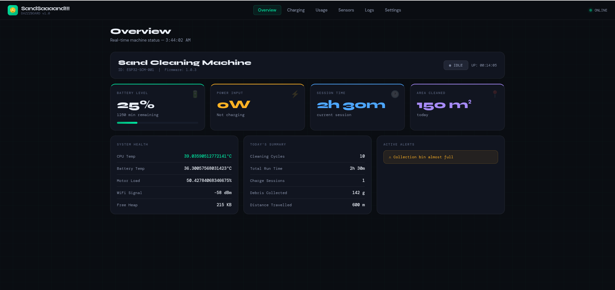

Figure 1. Overview
The main status page displaying real-time machine state:
- Battery Level – current charge percentage and estimated remaining runtime
- Power Input – live wattage (Solar / Type-C / Not Charging)
- Session Time – elapsed time for the current cleaning session
- Area Cleaned – square meters covered today
- System Health – CPU temperature, battery temperature, motor load, WiFi signal strength (dBm), and free heap memory
- Today's Summary – cleaning cycles, total run time, charge sessions, debris collected (grams), and distance travelled (meters)
- Active Alerts – real-time notifications (e.g., Collection bin almost full)
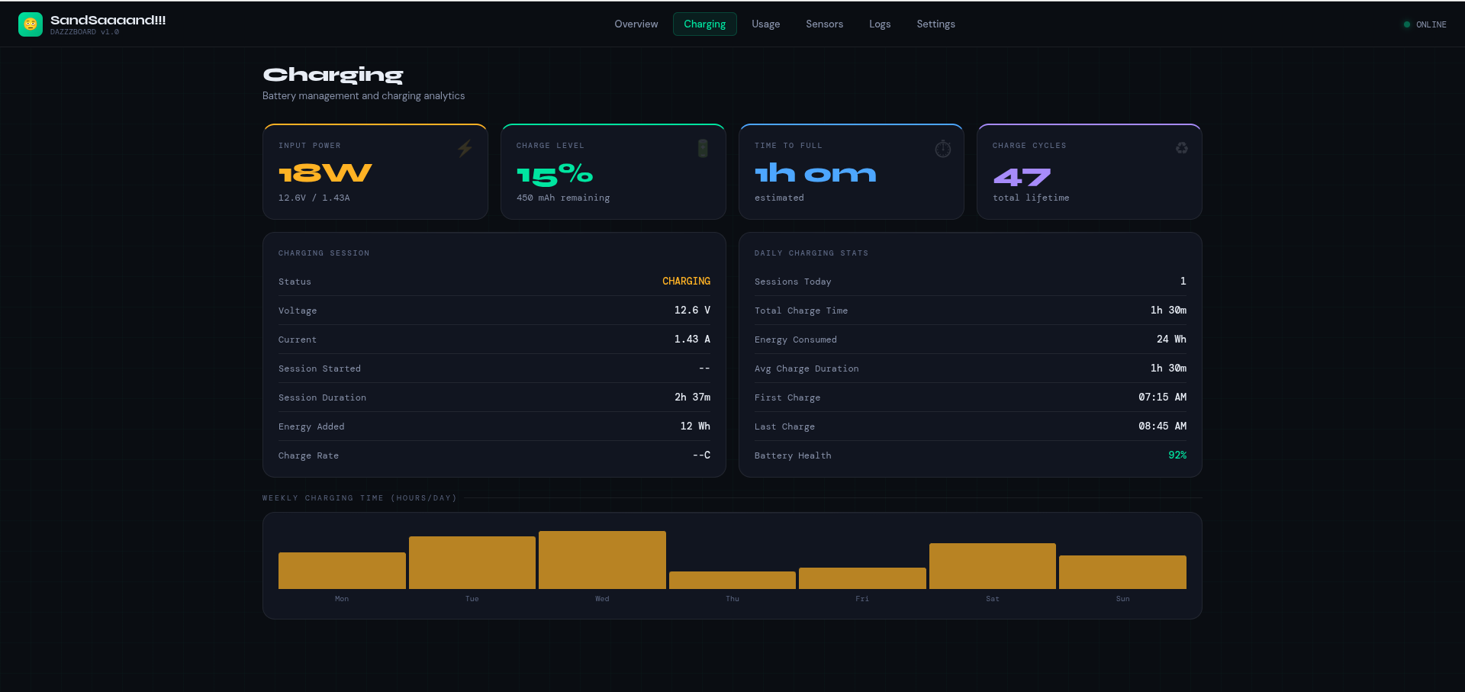

Figure 2. Charging
Battery management and charging analytics:
- Input Power – live wattage, voltage, and current (e.g., 18W / 12.6V / 1.43A)
- Charge Level – battery percentage and remaining mAh
- Time to Full – estimated time to complete charge
- Charge Cycles – total lifetime charge cycles
- Charging Session Details – status, voltage, current, session start time, duration, energy added (Wh), and charge rate
- Daily Charging Stats – sessions today, total charge time, energy consumed, average charge duration, first/last charge times, and battery health percentage
- Weekly Charging Time Chart – bar graph showing hours charged per day over the last 7 days
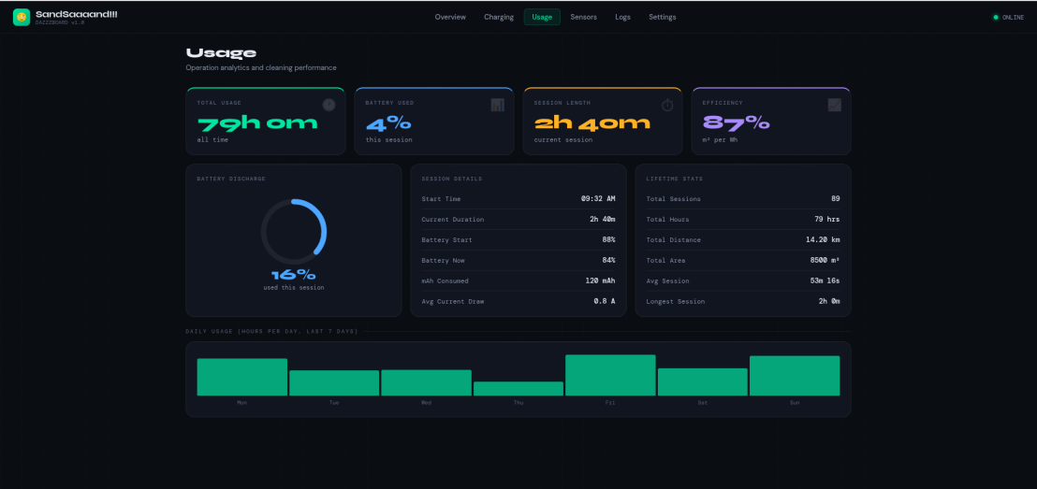

Figure 3. Usage
Operation analytics and cleaning performance:
- Total Usage – cumulative all-time operating hours
- Battery Used – percentage consumed this session
- Session Length – current session duration
- Efficiency – m² cleaned per Wh consumed
- Battery Discharge Gauge – circular indicator showing percentage used this session
- Session Details – start time, duration, battery start/current percentage, mAh consumed, and average current draw
- Lifetime Stats – total sessions, total hours, total distance (km), total area (m²), average session length, and longest session
- Daily Usage Chart – bar graph showing hours of operation per day over the last 7 days
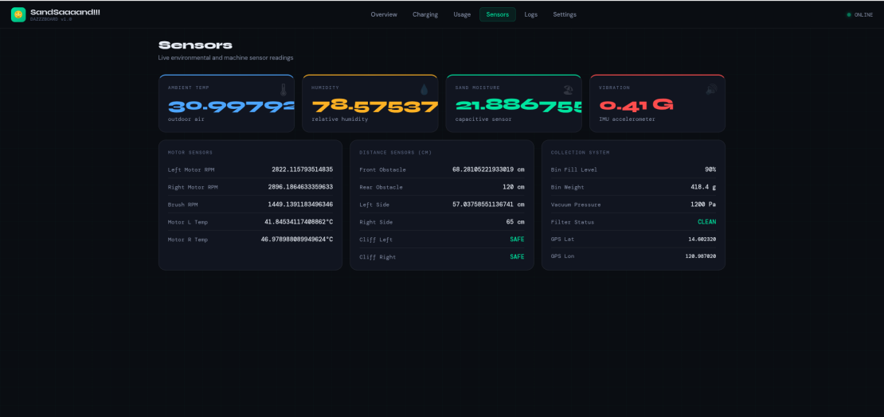

Figure 4. Sensors
Live environmental and machine sensor readings:
- Ambient Temperature – outdoor air temperature (°C)
- Humidity – relative humidity (%)
- Sand Moisture – capacitive sensor reading (%)
- Vibration – IMU accelerometer reading (G-force)
- Motor Sensors – Left Motor RPM, Right Motor RPM, Brush RPM, Motor L Temp (°C), Motor R Temp (°C)
- Distance Sensors – Front Obstacle, Rear Obstacle, Left Side, Right Side (all in cm); Cliff Left and Cliff Right safety status
- Collection System – Bin Fill Level (%), Bin Weight (g), Vacuum Pressure (Pa), Filter Status, GPS Latitude, GPS Longitude
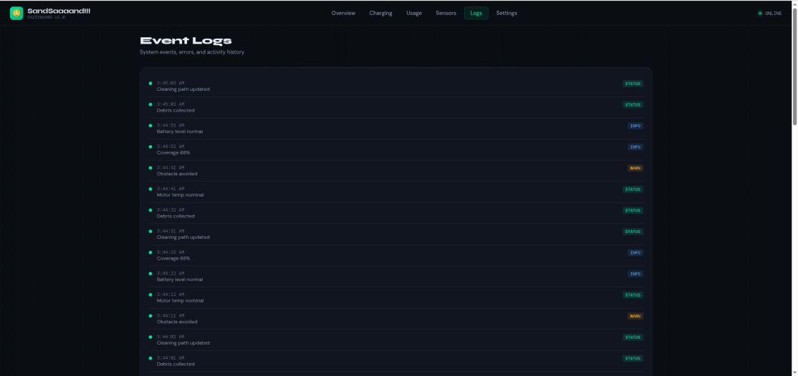

Figure 5. Logs
System event history and activity records:
- Timestamped log entries showing all system events in chronological order
- Each entry includes a severity badge: STATUS (normal operations), INFO (informational updates), or WARN (warnings such as obstacle avoidance)
- Typical logged events include: Cleaning path updated, Debris collected, Battery level normal, Coverage percentage, Obstacle avoided, Motor temp nominal

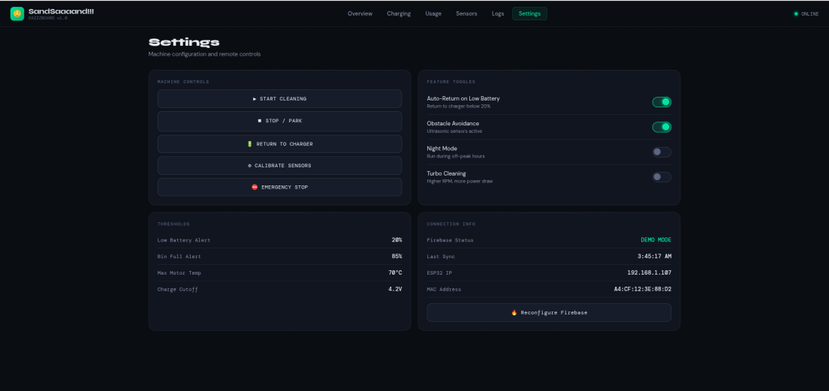

Figure 6. Settings
Machine configuration and remote controls:
Machine Controls:
- ▶ Start Cleaning – initiates an autonomous cleaning session
- ■ Stop / Park – halts the machine and parks it in place
- 🔋 Return to Charger – sends the machine back to the charging dock
- ⊙ Calibrate Sensors – runs the sensor calibration routine
- 🚫 Emergency Stop – immediately cuts all motor operation

Feature Toggles:
- Auto-Return on Low Battery – automatically returns to charger when battery drops below 20%
- Obstacle Avoidance – enables ultrasonic sensors for real-time obstacle detection
- Night Mode – schedules cleaning during off-peak hours
- Turbo Cleaning – enables higher RPM mode (increases power consumption)
Thresholds:
- Low Battery Alert: 20%
- Bin Full Alert: 85%
- Max Motor Temp: 70°C
- Charge Cutoff: 4.2V
Connection Info:
- Firebase Status, Last Sync timestamp, ESP32 IP address, MAC Address
- 🔥 Reconfigure Firebase button for re-entering cloud credentials

- SYSTEM OPERATION PROCEDURE
⚠️ PRE-OPERATION SAFETY CHECK: Always inspect the system before powering on. Verify battery charge level, check for loose wiring, and confirm the mesh screen is properly seated. Do not operate on wet sand or during rain.

A. Powering On
Step 1:
Toggle the main isolation switch from the battery to the Buck Converters.
Step 2:
Wait for the ESP32 to initialize (usually 2–3 seconds).
Step 3:
Test the Servo Motor by moving the joystick left and right to ensure the steering linkage is responsive.

B. Driving and Cleaning
Step 1: Forward/Reverse Movement
Push the joystick on the Y-axis.
The ESP32 sends a PWM signal to the first BTS7960 to drive the MY1016 motor.
Step 2: Steering Control
Move the joystick on the X-axis.
The Servo Motor will pivot the front wheels or rudder mechanism for steering.
Step 3: Conveyor Activation
Depending on the programmed code, the 775 Motor is activated through the second BTS7960 motor driver.
- CHARGING PROCEDURE
7.1 Solar Charging
The EcoSand Cleaner supports passive solar charging during outdoor operation. The solar panel is connected directly to the charging circuit of the 24V battery via the power management module.
- Place the unit in direct sunlight for maximum charging efficiency.
- Solar charging is supplementary — it extends operational time but may not fully recharge a depleted battery in a single day.
- Recommended solar panel: 200W for faster charge rates.

7.2 Type-C Charging
For faster recharging, connect the unit to a compatible Type-C power source.
- Connect the Type-C cable to the charging port located on the chassis.
- The charging indicator LED will activate when charging begins.
- Full charge time varies based on battery depletion level and charger wattage.
- Disconnect the charger before operating the unit.

⚠️ Safety Warning: Never charge the unit near water or in wet conditions. Ensure the charging port is dry before connecting. Do not leave the unit unattended during Type-C charging.

8. MAINTENANCE SCHEDULE
8.1 After Every Use
- Remove and empty the collection bin; rinse if needed.
- Inspect the wire mesh screen for clogs, tears, or deformation.
- Wipe sand and debris from the chassis and motor areas.
- Check all exposed wiring for abrasion or loose connections.
- Recharge the battery if level is below 50%.

8.2 Weekly Maintenance
- Inspect the motor driver units (BTS7960) for heat damage or discoloration.
- Check the solar panel surface for dirt or obstruction; clean with a dry cloth.
- Test the IR obstacle sensor range by placing an object at 10–20 cm distance.
- Verify the soil moisture sensor calibration with a dry sand sample.
- Lubricate drive axles and wheel bearings lightly with appropriate lubricant.

8.3 Monthly Maintenance
- Perform a full firmware verification — re-upload firmware if sensor readings are erratic.
- Inspect and tighten all chassis bolts and screws (5mm bolts, SG J 3/6 x 3/4 hardware).
- Replace wire mesh screen if apertures are enlarged or screen is torn.
- Test load cell accuracy with a known weight; re-calibrate HX711 if reading error exceeds 5%.
- Full battery charge-discharge cycle test to verify battery health.

9. SAFETY GUIDELINES
⛔ IMPORTANT: Read all safety guidelines before operating the EcoSand Cleaner. Failure to follow these guidelines may result in damage to the system, injury, or voiding of the project warranty.
9.1 Operator Safety
- Always wear gloves when handling the collection bin and debris.
- Do not reach into the filtration mechanism while the system is powered on.
- Keep hands and feet clear of the drive wheels and the conveyor during operation.
- Operate the unit at a safe distance — minimum 1 meter from the operator at all times.
9.2 Electrical Safety
- Never expose the system to rain or submerge any component in water.
- Ensure all wiring connections are secure before powering on.
- Do not short-circuit the battery terminals — risk of fire or explosion.
- Use the correct charging cables — Type-C only for the designated charging port.
- If the battery becomes swollen, discolored, or emits heat, do not use it — replace immediately.
9.3 Environmental Guidelines
- Do not operate on steep slopes or uneven terrain without manual supervision.
- Avoid operating in water-logged areas — wet sand can damage motors and the mesh screen.
- Collect and dispose of beach debris responsibly at designated waste collection points.
- Do not operate near wildlife habitats, nesting areas, or protected coastal zones without permission.

- SYSTEM LIMITATIONS
Users should be aware of the following known limitations of the EcoSand Cleaner prototype:

Limitation Area | Description
Terrain | Designed for flat, dry sandy beaches only. Performance degrades significantly on wet sand, steep slopes, or rocky terrain.
Debris Size | Capable of collecting small-to-medium debris only. Cannot collect large objects (driftwood, heavy metal), liquid pollution, or oil spills.
Power Supply | Operational time is limited by the 12V / 20,000mAh battery. Solar charging is supplementary and weather-dependent.
Wireless Range | RC control and web dashboard are limited to the range of the 2.4GHz RC system and the ESP32 local Wi-Fi network.
Autonomy | The system is semi-autonomous — RC operator guidance is required for navigation. It does not support fully autonomous path planning.
Water Exposure | Electronic components are not waterproof. The system must not be used in rain or near breaking waves.
Scale | The prototype is designed for localized barangay-scale cleaning, not large-scale industrial beach cleaning operations.

