[Read Me]

The link to the repository: <https://github.com/xHerox9/project.git>

1. The first thing you want to do is copy the above link.

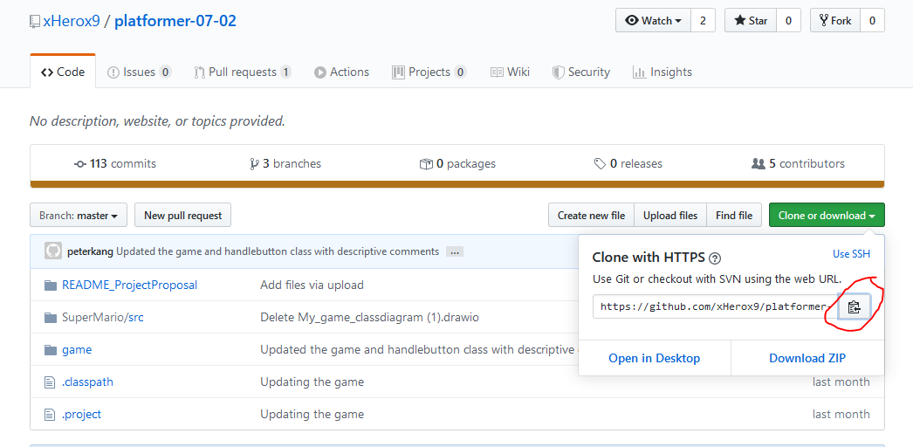

1. Proceed to open eclipse into a setup eclipse workspace and then click import project.

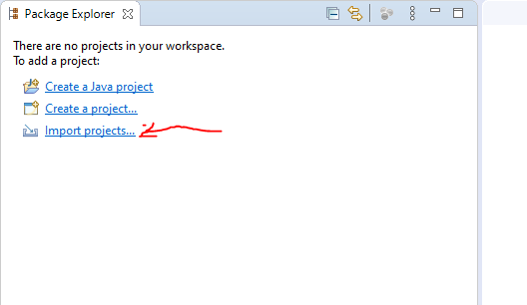

1. Click “Projects from Git” and then “Next”.

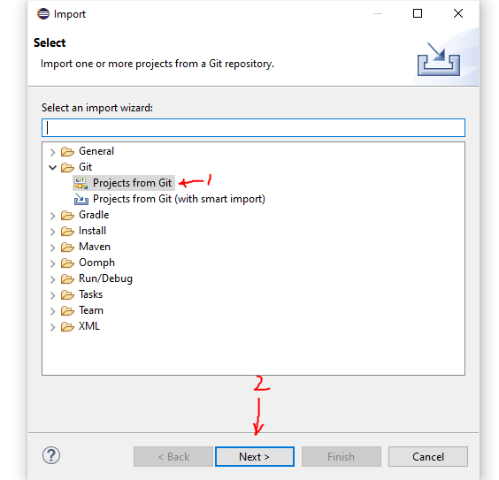

1. Click “Clone URI” then “Next”.

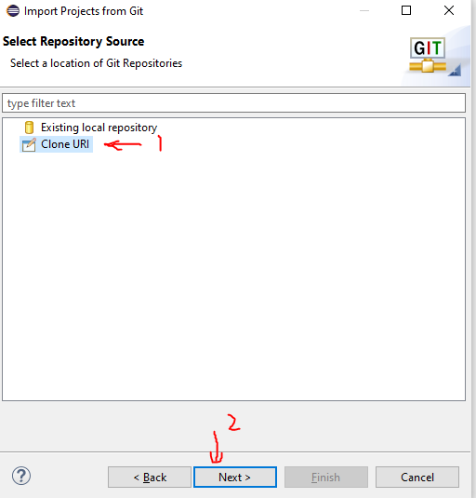

1. Paste in the link then click “Next”.

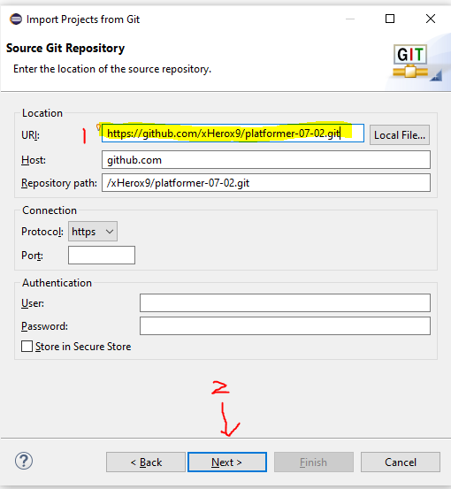

1. Make sure only “Master” is checked then click “Next”.

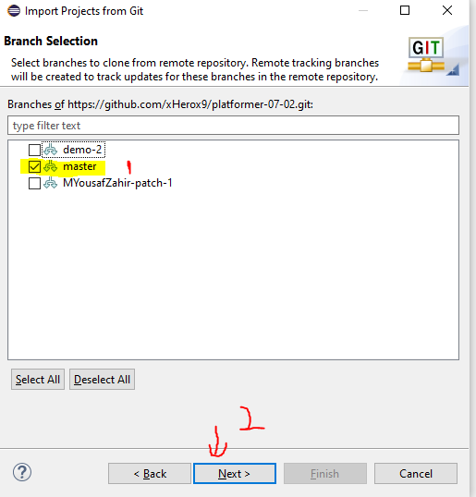

1. Choose where you want the files save on your hard drive and then click “Next”.

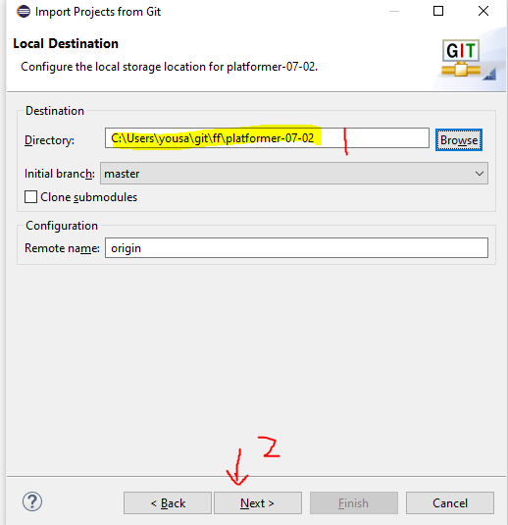

1. Click “Next”.

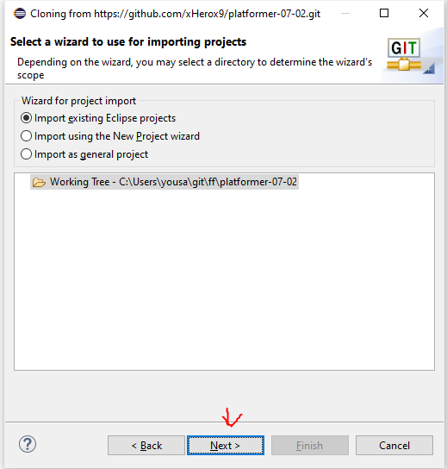

1. Make sure only “game” is checked then click “Finish”.

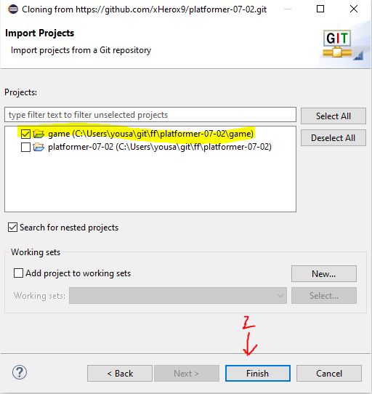

1. Open “game” from the package explorer and run for the game to launch.

