HQ-R

1)nano /etc/hostname 🡪 HQ-R

nano /etc/network/interfaces 🡪

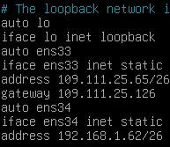

systemctl restart networking

ip add

ping 109.111.25.126

ping 8.8.8.8

nano /etc/resolv.conf 🡪 nameserver 8.8.8.8

ping ya.ru

nano /etc/apt/sources.list 🡪

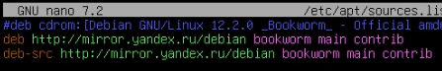

apt update

nano /etc/sysctl.conf 🡪



sysctl -p

apt install iptables-persistent -y

iptables -t nat -A POSTROUTING -o ens33 -j MASQUERADE

iptables-save > /etc/iptables/rules.v4

reboot

BR-R

2)nano /etc/hostname 🡪 BR-R

nano /etc/network/interfaces 🡪

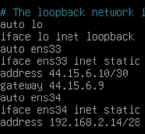

systemctl restart networking

ping 8.8.8.8

nano /etc/resolv.conf 🡪 nameserver 8.8.8.8

ping ya.ru

nano /etc/apt/sources.list 🡪



apt update

apt install iptables-persistent -y

iptables -t nat -A POSTROUTING -o ens33 -j MASQUERADE

iptables-save > /etc/iptables/rules.v4

nano /etc/sysctl.conf 🡪



reboot

HQ-SRV

3)nano /etc/hostname 🡪 HQ-SRV

nano /etc/network/interfaces 🡪

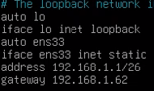

systemctl restart networking

ping 8.8.8.8

nano /etc/apt/sources.list 🡪



nano /etc/resolv.conf 🡪 nameserver 8.8.8.8

apt update

ping ya.ru

BR-SRV

4)nano /etc/hostname 🡪 BR-SRV

nano /etc/network/interfaces 🡪

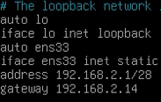

systemctl restart networking

ping 8.8.8.8

nano /etc/resolv.conf 🡪 nameserver 8.8.8.8

ping ya.ru

nano /etc/apt/sources.list 🡪



apt-update

HQ-R

5)nano gre-up.sh 🡪

{ip tunnel add gre1 mode gre remote 44.15.6.10 local 109.111.25.65 ttl 255}

{ip link set gre1 up}

{ip add add 10.10.10.1/30 dev gre1}

chmod +x gre-up.sh

nano /etc/crontab 🡪

{#}

{@reboot root /root/gre-up.sh}

./gre-up.sh

BR-R

6)nano gre-up.sh 🡪

{ip tunnel add gre1 mode gre remote 109.111.25.65 local 44.15.6.10 ttl 255}

{ip link set gre1 up}

{ip add add 10.10.10.2/30 dev gre1}

chmod +x gre-up.sh

nano /etc/crontab 🡪

{#}

{@reboot root /root/gre-up.sh}

./gre-up.sh

ping 10.10.10.1

apt install frr -y

HQ-R

7)apt install frr -y

nano /etc/frr/daemons (=>) ospfd=yes

systemctl restart frr

vtysh

HQ-R# {conf t}

HQ-R# (config)# {router ospf}

HQ-R# (config-router)# {network 10.10.10.0/30 area 0.0.0.0}

HQ-R# (config-router)# {network 192.168.1.0/26 area 0.0.0.0}

HQ-R# (config-router)# {exit}

HQ-R# (config)# {exit}

HQ-R# {wr}

HQ-R# {exit}

systemctl restart frr

BR-R

8)nano /etc/frr/daemons 🡪 ospfd=yes

systemctl restart frr

vtysh

BR-R# {conf t}

BR-R# (config)# {router ospf}

BR-R# (config-router)# {network 10.10.10.0/30 area 0.0.0.0}

BR-R# (config-router)# {network 192.168.2.0/28 area 0.0.0.0}

BR-R# (config-router)# {exit}

BR-R# (config)# {exit}

BR-R# {wr}

BR-R# {exit}

systemctl restart frr

ip ro

nano gre-up.sh 🡪

{sysctl -p}

{systemctl restart frr}

reboot

HQ-R

9)nano gre-up.sh 🡪

{sysctl -p}

{systemctl restart frr}

reboot

ip ro

HQ-SRV

10)apt install bind9 -y

ping 192.168.2.1

nano /etc/bind/named.conf.options 🡪

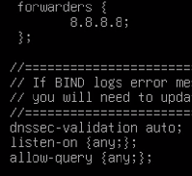

cp /etc/bind/db.local /etc/bind/hq.work

nano /etc/bind/hq.work 🡪



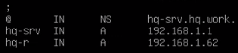

cp /etc/bind/hq.work /etc/bind/branch.work

nano /etc/bind/branch.work 🡪



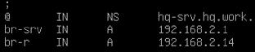

cp /etc/bind/db.127 /etc/bind/rev1

nano /etc/bind/rev1 🡪



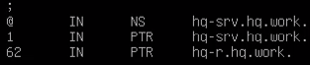

cp /etc/bind/ rev1 /etc/bind/rev2

nano /etc/bind/rev2 🡪



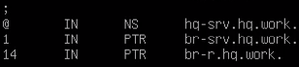

nano /etc/bind/branch.work 🡪 

nano /etc/bind/named.conf.default-zones🡪

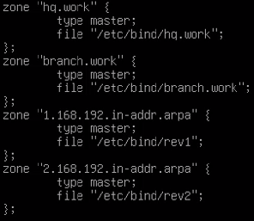

systemctl restart bind9

nano /etc/resolv.conf 🡪



ping hq-srv.hq.work

ping hq-r.hq.work

ping br-srv.branch.work

ping edu.branch.work

apt install bind9utils -y

reboot

HQ-R

11) nano /etc/resolv.conf 🡪

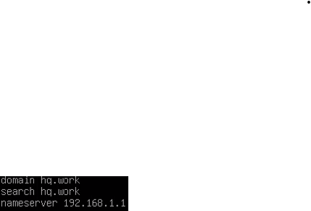

ping ya.ru

BR-R

12) nano /etc/resolv.conf 🡪



ping hq-srv.hq.work

BR-SRV

13) nano /etc/resolv.conf 🡪



ping edu.branch.work

reboot

HQ-R

14) apt install isc-dhcp-server -y

nano /etc/default/isc-dhcp-server 🡪



nano /etc/dhcp/dhcpd.conf

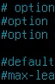----закоментировать 4 строки

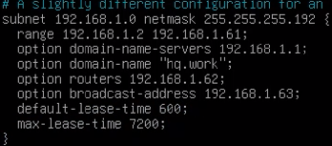

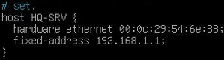----маска подсети HQ-SRV

systemctl restart isc-dhcp-server

HQ-SRV

15) nano /etc/network/interfaces

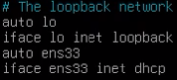

systemctl restart networking

ip add

apt install ca-certificates curl gnupg git lsb-release -y

mkdir -m 0755 -p /etc/apt/keyrings/

apt install curl -y

[curl -fsSL <https://download.docker.com/linux/debian/gpg> | gpg --dearmor -o /etc/apt/keyrings/docker.gpg]

nano /etc/apt/sources.list.d/docker.list 🡪

{deb [arch=amd64 signed-by=/etc/apt/keyrings/docker.gpg] <https://download.docker.com/linux/debian> bookworm stable}

dpkg --print-architecture 🡪 amd64

apt update

CLI

Ip add

su -

nano /etc/hostname 🡪HQ-CLI

reboot