**Daily Accomplishment Report**

**Student Intern: Lynel D. Nicdao**

**Company :** **Concepcion Vocational School (CVS)**

**Designation : Admin**

**DAILY WORK ACTIVITIES**

**WEEK # 7**

|  |  |  |  |
| --- | --- | --- | --- |
| **DAY** | **DATE** | **DAILY ACCOMPLISHMENTS** | **NO. OF WORKING HOURS** |
| 29 | March 11, 2024 | * Attended the Flag Raising Ceremony * Encoded the fund 01 report of checks and ADA issued 2023 | 8 |
| 30 | March 12, 2024 | * Encoded the fund 01 report of checks issued 2023 | 8 |
| 31 | March 13, 2024 | * Encoded the fund 01 report of checks issued 2023 | 8 |
|  | March 14, 2024 | * Absent | 0 |
| 33 | March 15, 2024 | * Updated the e 201 Cament CVS | 8 |

**TOTAL NO. OF HOURS: 32**

Accomplished by: **LYNEL D. NICDAO**

Student Intern

Certified by : **MR.** **CARLOS D. MOLA. LPT**

Trainer/Immediate Supervisor

Enclosures : Scanned copy of Daily Time Record, Narrative Report

Scanned Copy:

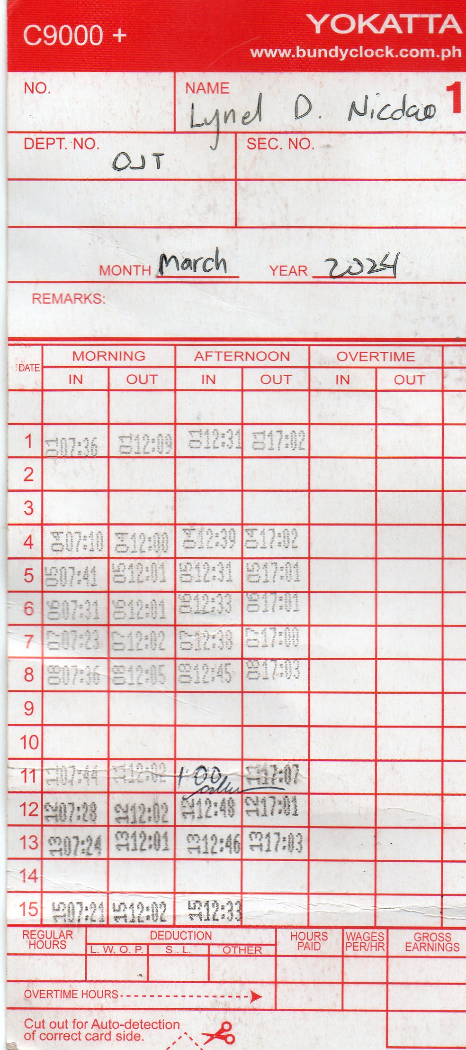

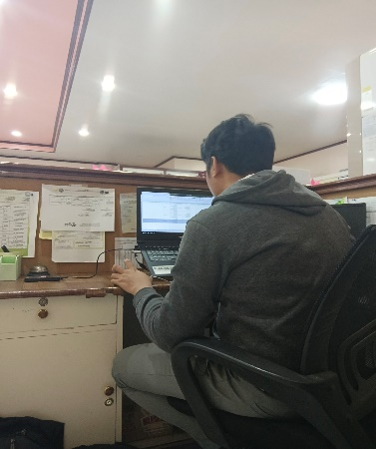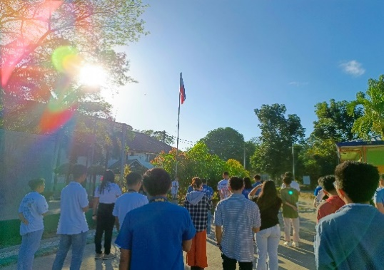

Day 29

Attended the Flag Raising Ceremony and Encoded the fund 01

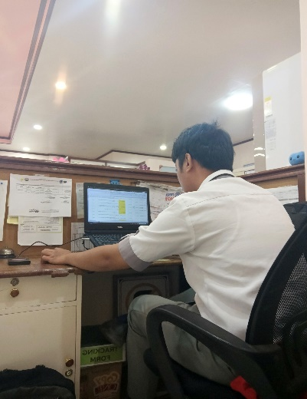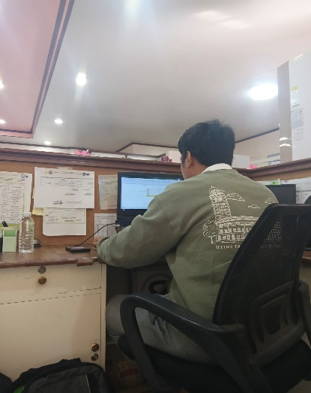

Day 30 Day 31

Encoded the fund 01 Encoded the fund 01

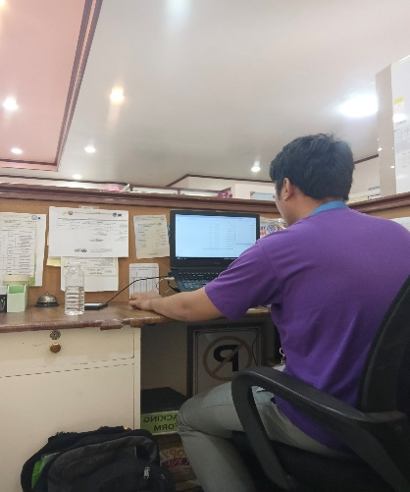

Day 32

Updated the e cament CVS

**Weekly Narrative Report**

DAY 29: March 11, 2024

Attended and Led the Flag Raising Ceremony and BAMB Activities and encoded the Fund 01 report of checks and ADA issued 2023.

* Fund 01 report of checks and ADA issued 2023

DAY 30: March 12, 2024

Encoded the Fund 01 report of checks issued 2023.

* Fund 01 report of checks issued 2023

DAY 31: March 13, 2024

Encoded the Fund 01 report of checks issued 2023

* Fund 01 report of checks issued 2023

March 14, 2024

* Absent

DAY 32: March 15, 2024

Transferred and updated the e cament CVS file.

* E 201 Cament CVS

Accomplished by:

**LYNEL D. NICDAO**

Student Intern Certified by: **MR. CARLOS D. MOLA. LPT**

Trainer/Immediate Supervisor