Student ID: 103669129

Name: Jaesa Maxwell

# Setup Screenshot

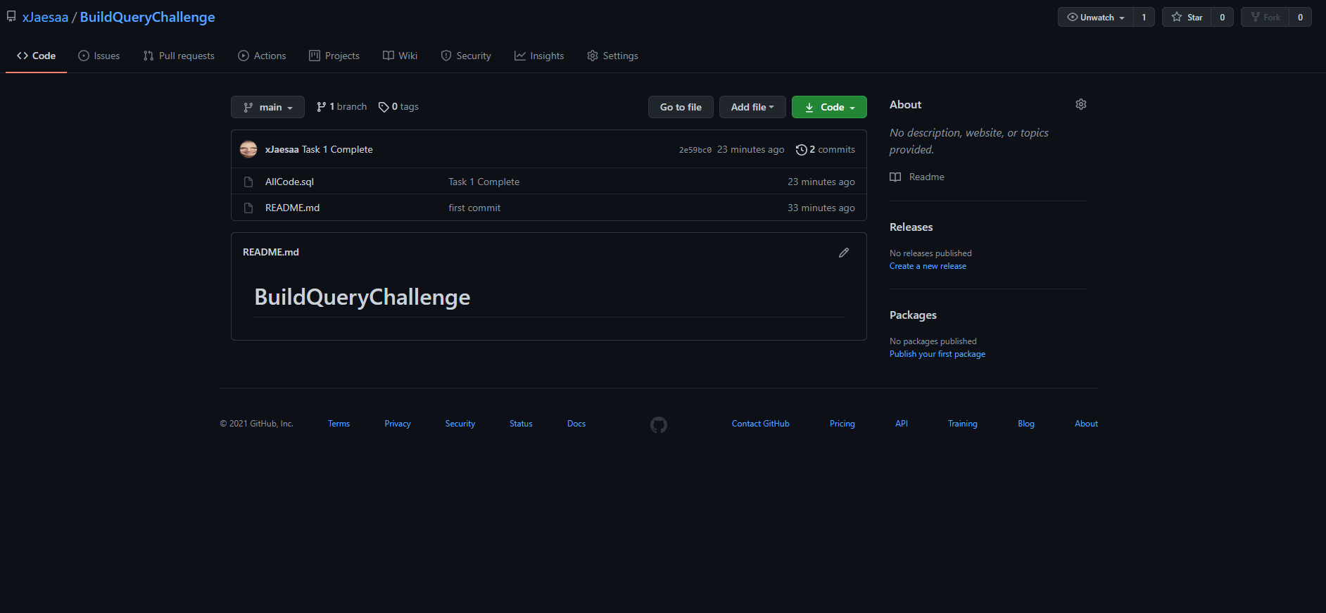

# Task 2 Screenshot

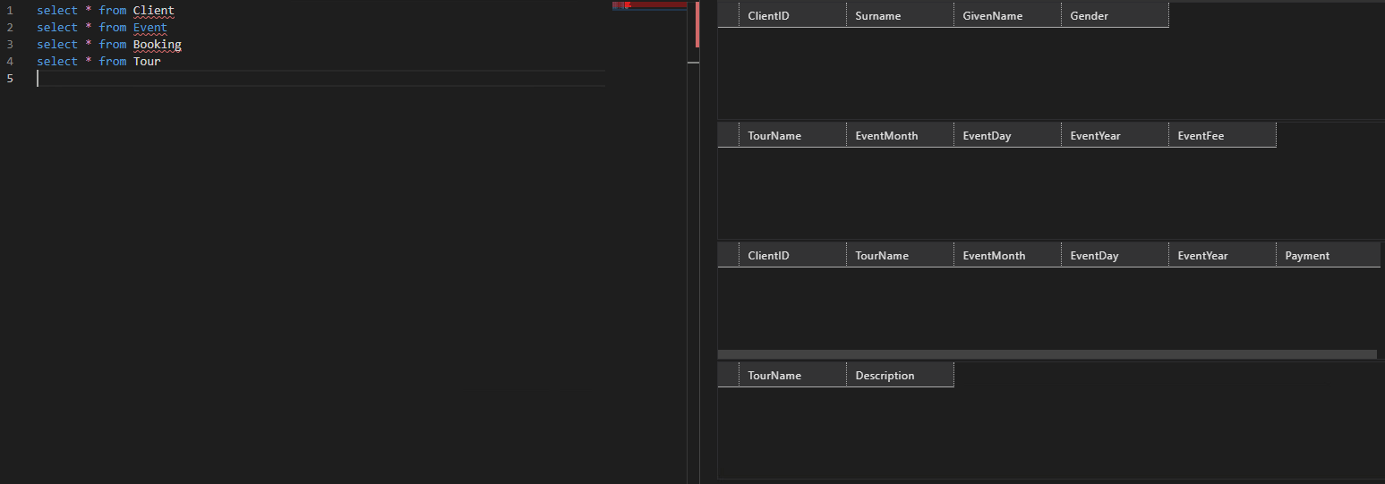

# Task 3 Screenshot

