Video tutorial：

1. add CurveTextureCreater component to the gameobject which used StylizedHilight shader

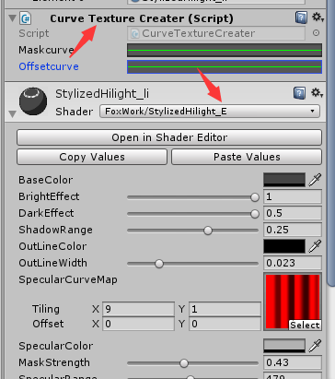

### Click Curve to add a Curve

### There are two curves here.，The curve above is the mask curve，1 is full display, 0 is completely blocked，So the curve is adjusted from 1 to 0。

**Maskcurve Example**

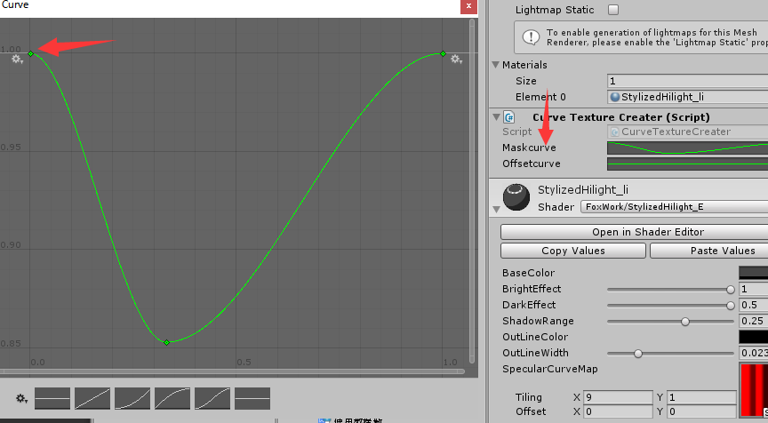

Below is the offset curve，This curve is to adjust the highlight offset，0 and 0 below are completely non-offset，0 or more is offset。So the curve is adjusted from 0 up。

**OffsetCurve example**

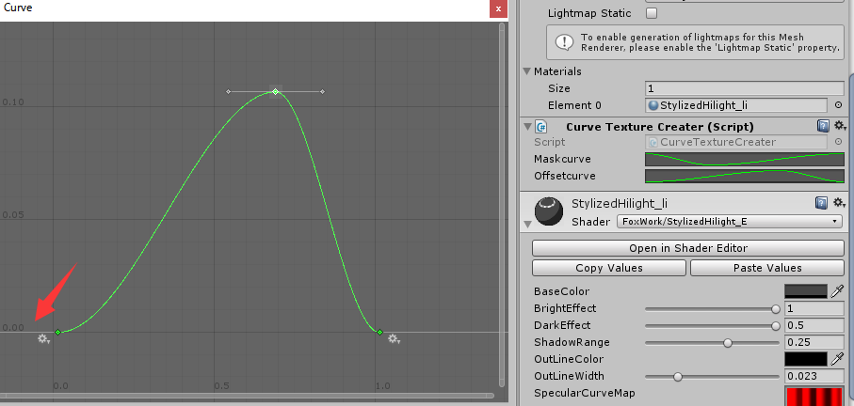

### 3.Right Click CurveTextureCreater ，Select PreviewCurveMap can make a curve preview

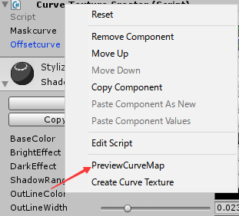

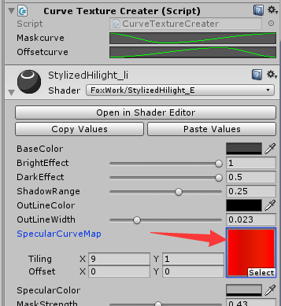

### 4. Right Click On CurveTextureCreater and select CreateCurveTexture, it will create the curve texture in CreateCurve folder。

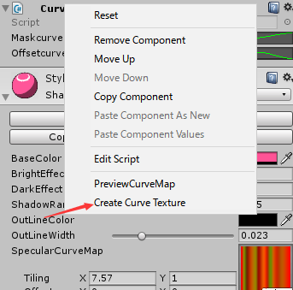

### Use the curve texture to the Shader，and delete CurveTextureCreater component.

