

Liz (Android Virtual Assistant)

Final Design document

John Herrera | CSE480HA (SU-18) | 8/01/2018

# REQUIREMENTS

* **Project Description: Liz (WIP) is an android virtual assistant that will answer the user’s questions or commands when inputted. This android application will open and present a chat box where the user will converse with Liz (WIP).**
* **Purpose: This program is meant to fulfill the commands of a user which can range from calculating, settings an alarm, and noting information. These tasks will be completed using the user’s phone software.**
* **End Users of Application: Students, workers, and people who use their phones daily.**
* **Scope:**
* **Functionality:**
* **Technology Stack:**
* **Architecture Diagram:**
* **Class Diagram/Component Level Diagram/Modules:**
* **Use Cases:**

## PAttern orgnizing table

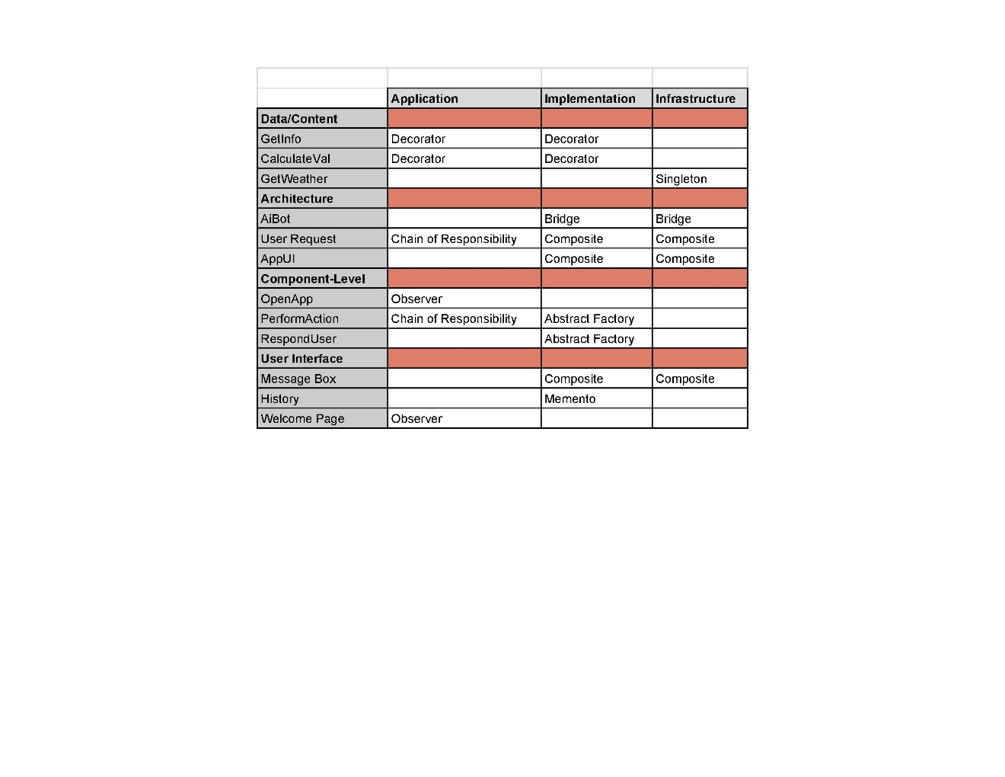

## Project planning board

## critical path

## test cases