Locke (Virtual Lock Assistant)

Final Design document

Phase 1

John Herrera | CSE480HA (SU-18) | 8/01/2018

# REQUIREMENTS

* **Project Description:** Locke is a virtual assistant which will generate and store passwords for the users based on their input. The application will have multiple pages ranging from the chat box to the passwords page.
* **Purpose:** This program is meant to generate a password for the user to use on a website then store it in a password page located in the application. Afterwards, the user can ask for the password for a certain site and Locke will tell you it. This is an easy way for people to generate, retrieve, and update their passwords while not being connected online so that all your passwords are safe.

**Example:**

User: Generate password for BestBuy

Locke: A&CKADGF@15461 generated for BestBuy and stored

* **End Users of Application:** Students, workers, and people who forget their passwords in general.
* **Scope:** Will be a bot that responds to user input but return an error when non-supported request are inputted. Will only responds to greetings, generating requests, and already created passwords requests. Will have multiple pages that will have a chat box, passwords, and about page.
* **Functionality:** Will be created in Eclipse using java as the programming language.
* **Technology Stack:**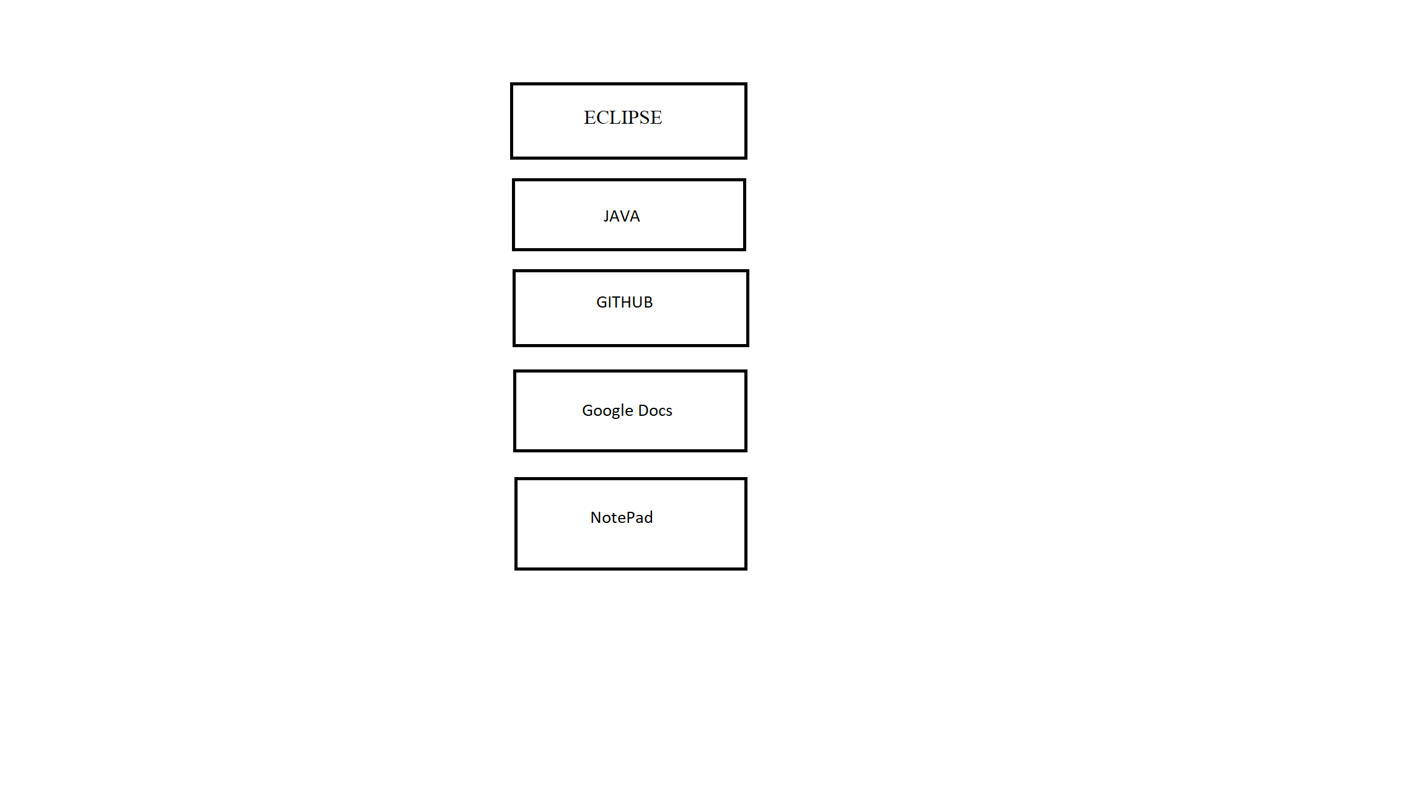
* **Architecture Diagram:**

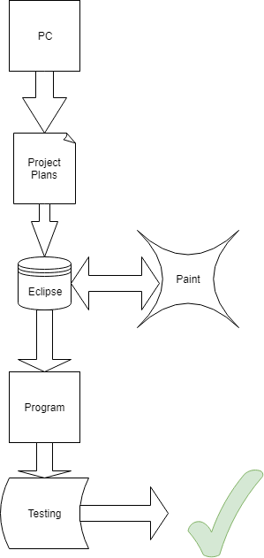

* **Class Diagram/Component Level Diagram/Modules:**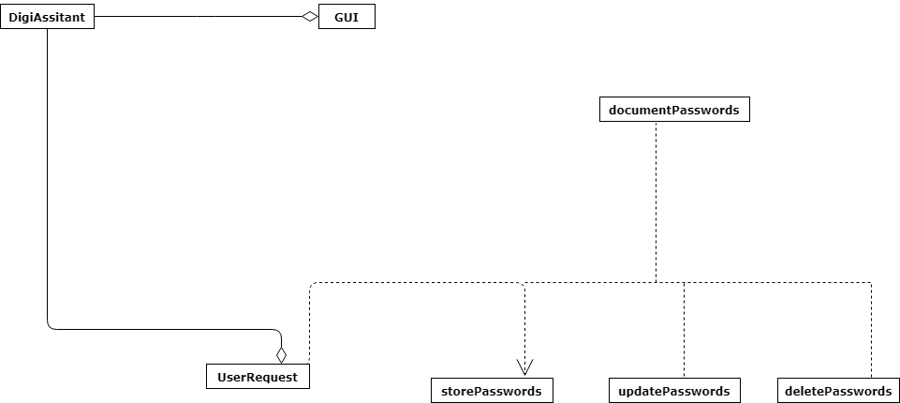
* **Use Cases:**

Primarily used to generate passwords for the user to use.

Will also save passwords and provide to user when asked.

The passwords can be saved in a document by request.

The passwords can be destroyed by request.

The passwords can be updated by request.

## Pattern organizing table

## Project planning board

## critical path

## test cases