Week 11: Data exploration, split and preprocessing
Dataset: Wine (178 wines, 13 numeric features, 3 classes). Notebook: ai_week11.ipynb

1. Data exploration
- All 13 features are float64 and the target is int64.
- There are 0 missing values.
- The features have very different ranges (proline goes up to 1680, hue is around 1), so we will normalize.
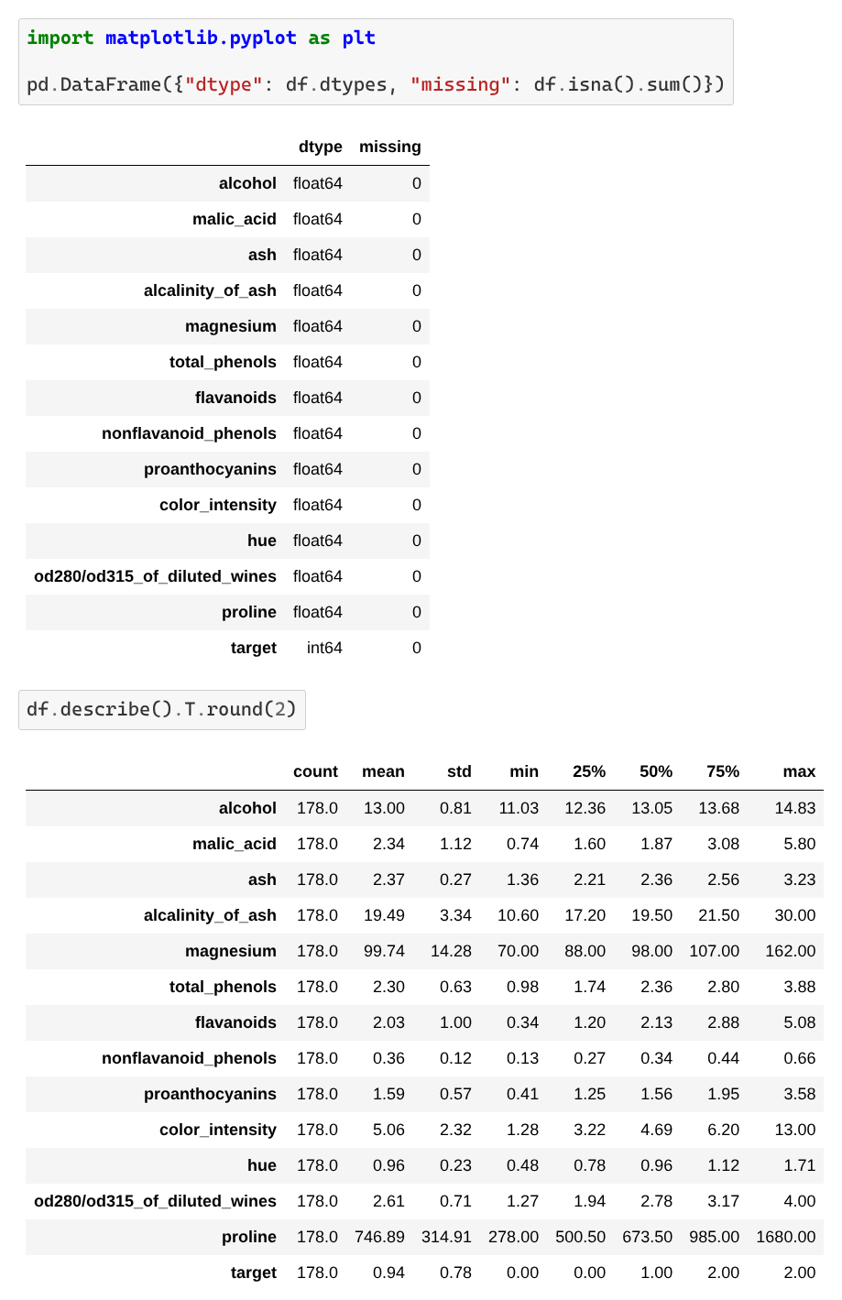
Data types, missing values and describe()
Target distribution: class_0 = 59 (33%), class_1 = 71 (40%), class_2 = 48 (27%). It is a bit imbalanced but no class is rare.
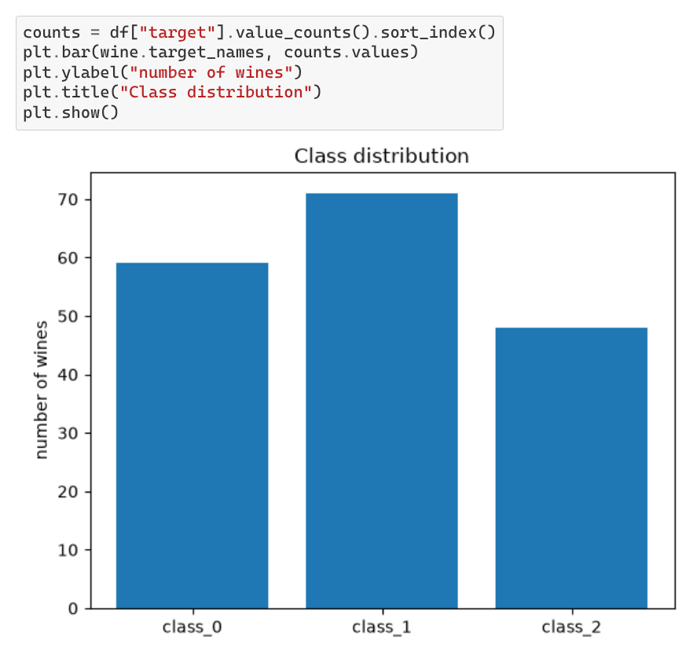
Graph 1: class distribution
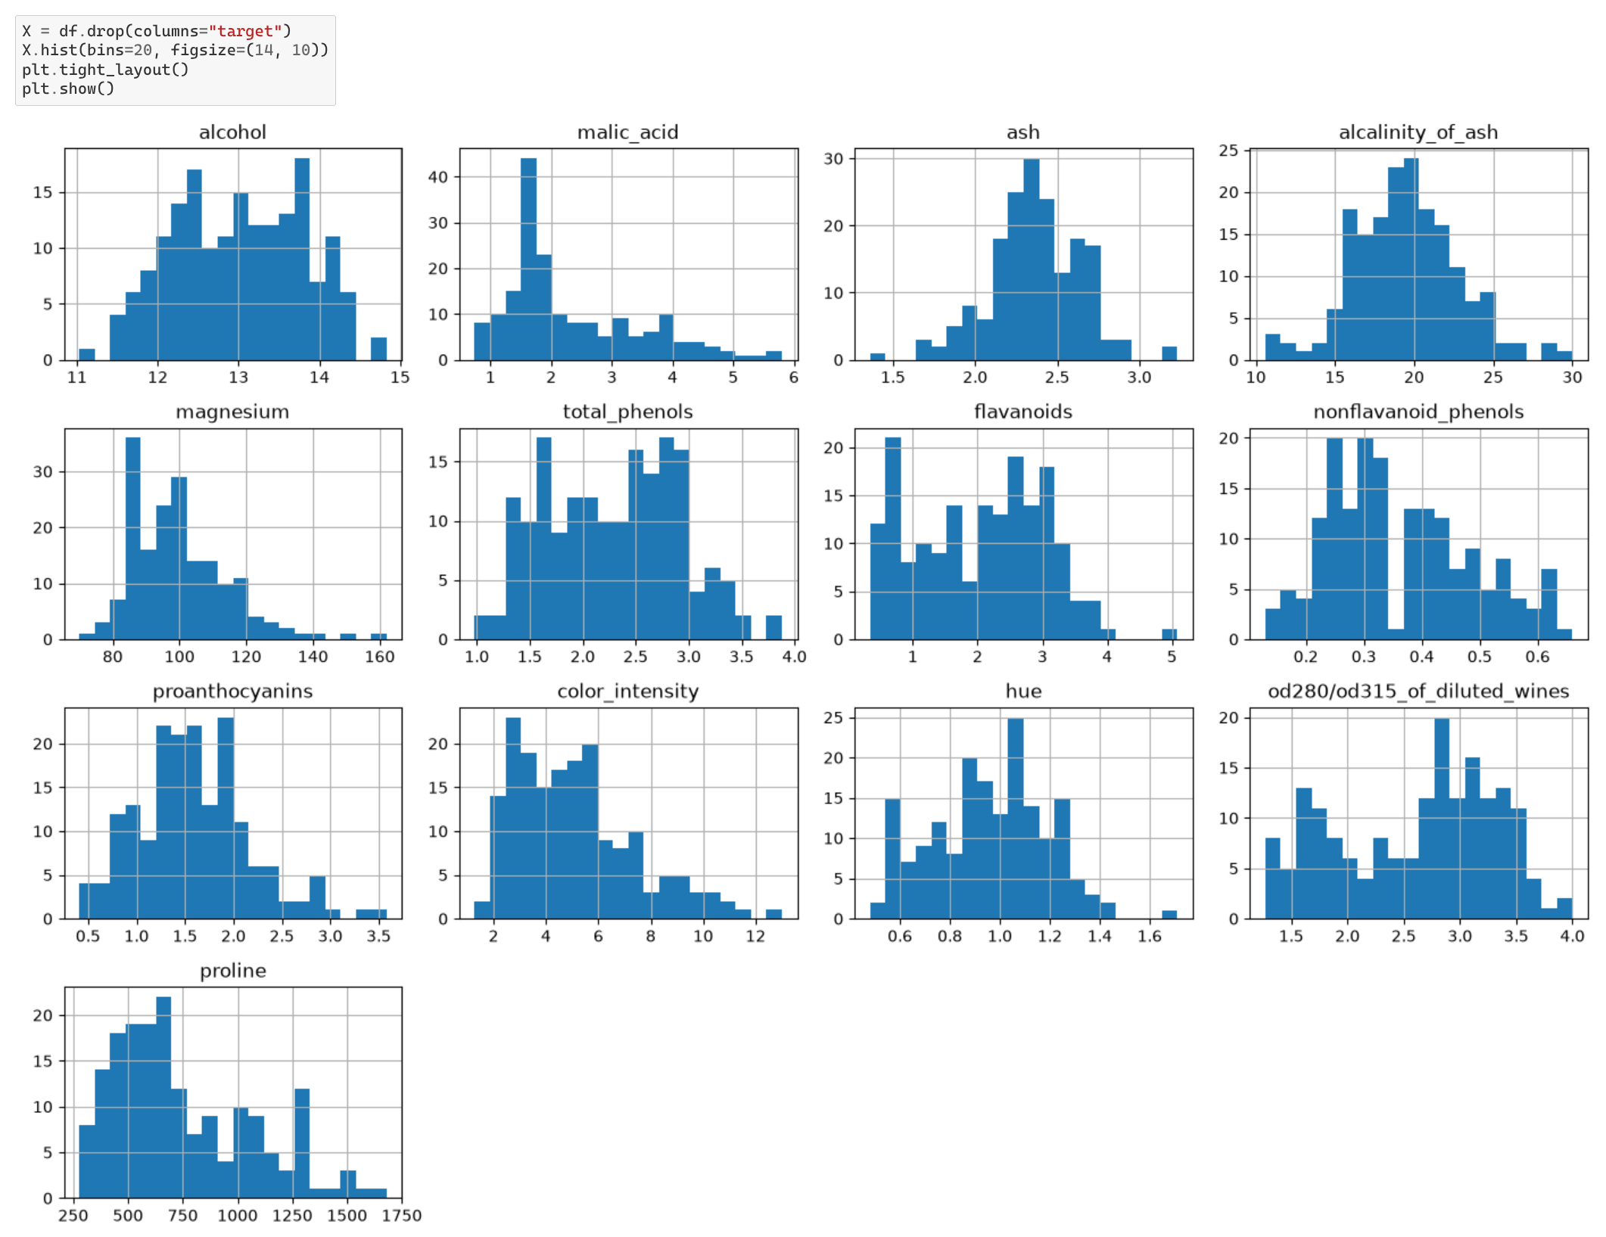
Graph 2: histograms of the 13 features
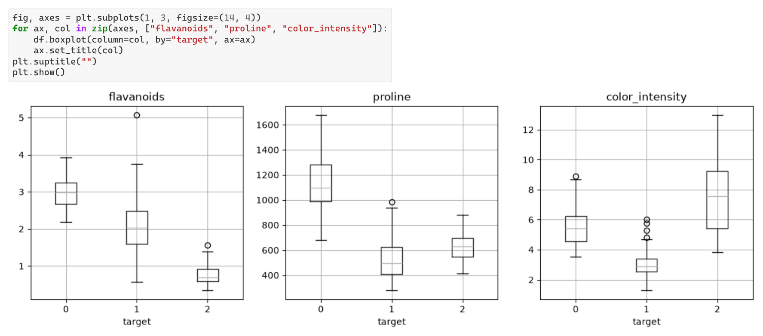
Graph 3: flavanoids, proline and color_intensity by class
- Most features look like a bell curve, with a few outliers (magnesium, malic_acid). Proline is skewed to the right.
- These three features are clearly different between the classes, so the problem should be easy to learn.
- The rows are sorted by class, so we shuffle before splitting.

2. Data split
We use 80% training (142 wines) and 20% final test (36 wines). With less than 1,000 samples we can skip the check-up test set. With only 178 wines, a check-up set (about 27 wines) would be too small and we would lose training data. We will choose our models with cross-validation instead. The split is stratified (same class ratio in each set) and shuffled.
The final test set is saved in data/final_test.csv and the training set in data/train.csv. From now on the notebook only loads train.csv.
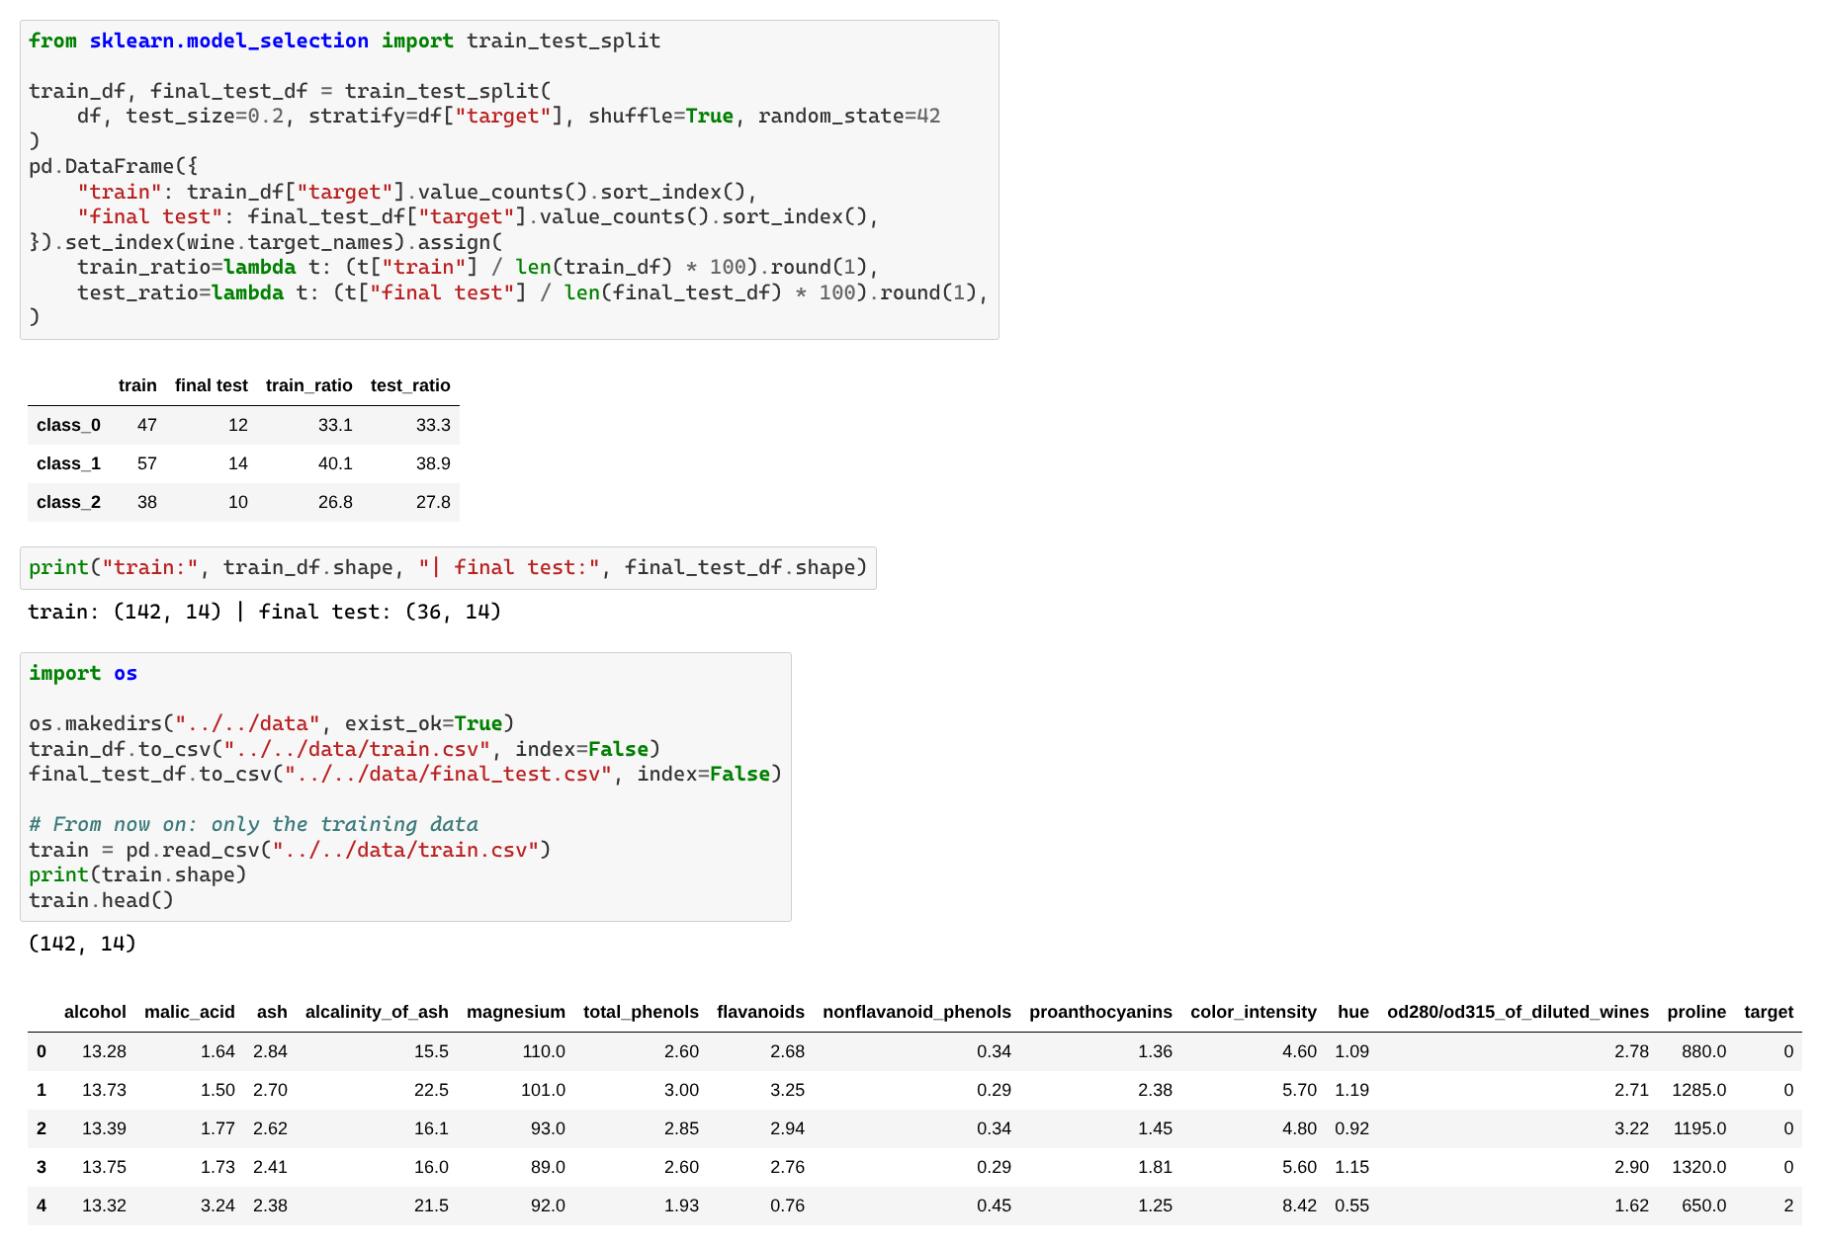
Split, class ratios and saved files

3. K-fold cross-validation
We chose K = 5. The training set has 142 wines, so each validation fold has about 28 wines. With K = 10 a fold would only have 14 wines and the scores would be too noisy. With K = 3 the models would be trained on only 2/3 of the data. The K-fold is stratified and shuffled. From Week 12, all models will be compared with the average accuracy over the 5 folds.
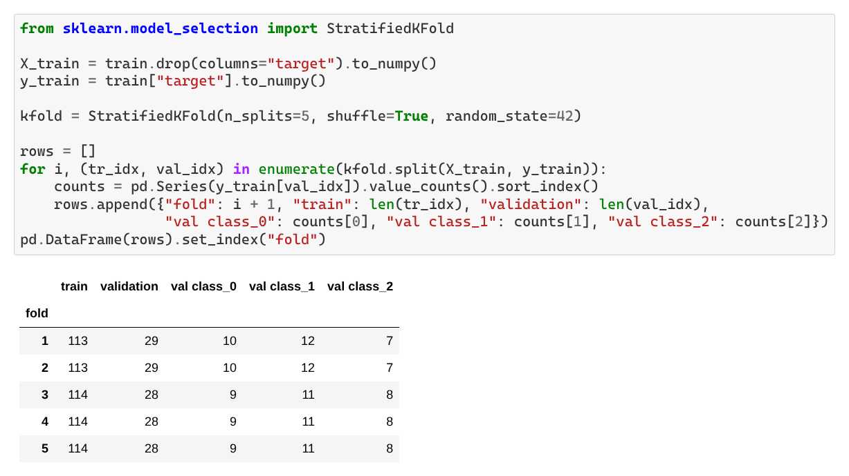
The 5 folds (size and class counts)

4. Preprocessing
- Missing values: there are none, so nothing to fill. (If there were, we would use the median of the training data because outliers do not change it.)
- Categorical features: there are none, so no one-hot encoding is needed. The target is already an integer (0, 1, 2) and can be used with sparse_categorical_crossentropy in Keras.
- Normalization: each feature is scaled to mean 0 and standard deviation 1, as in the course. The features have very different scales and a neural network trains badly with this. The mean and std are computed on the training data only. The final test set is not modified and will be scaled later with the same values.
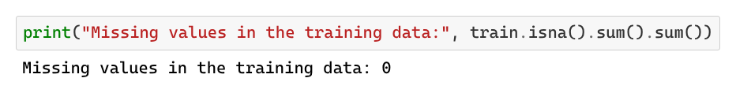
Missing values check
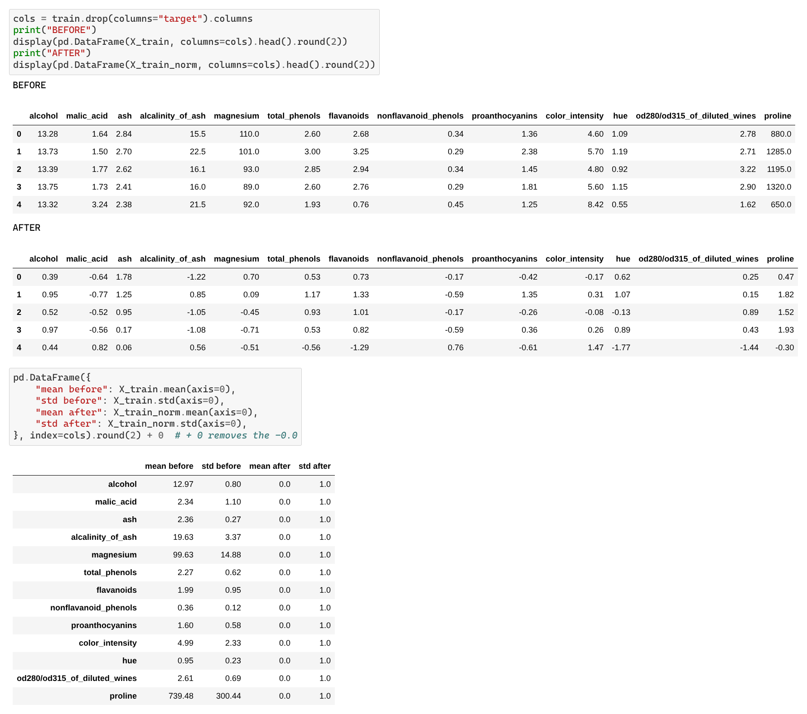
Training data before and after normalization

5. Data leakage check
- Feature known only after the target? No. The 13 features are chemical measurements of the wine, so we have them for any new wine.
- Feature that is a copy of the target? No, the highest correlation is 0.87 (flavanoids).
- Duplicated wines that could be in both train and test? No duplicates.
- Split before preprocessing? Yes, and the final test set is saved and not opened.
- Mean and std from the training data only? Yes.
- Rows sorted by class? Yes, but the split and the K-fold shuffle the data.
- One small point: we normalize the whole training set once, so each validation fold has a tiny influence on the mean and std. With 142 samples it is negligible. To be strict we could compute them inside each fold in Week 12.
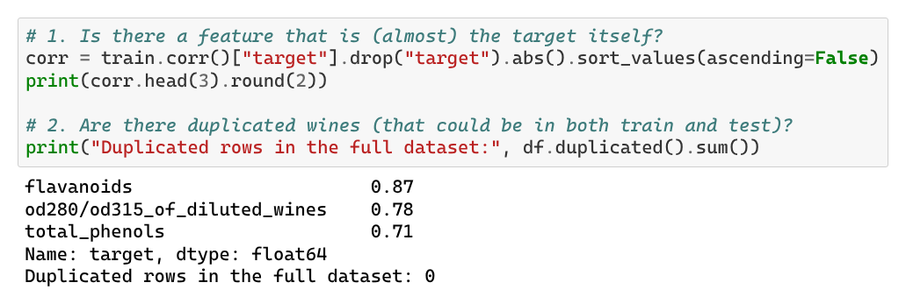
Leakage checks

