**Stance and Swing Phase Marker**

Two new functions are added to the pipeline called “ContactR” and “ContactL”. These two functions will create a table called “Contact” and save it in the main segmented structure in the directory for both left and right sides.

In the Contact table, first column is

HSIdx = the index of heel strike (beginning of stance phase) in the stride (each stride begins with index 1)

TOIdx = the index of toe off (beginning of swing phase) in the stride (each stride begins with index 1)

TotalHSIdx = the index of heel stride relative to the whole recorded walk signal

TotalTOIdx = the index of toe off relative to the whole recorded walk signal

**How to work with the function: It plots the vertical position of toe (red signal) and vertical velocity of foot (blue signal). You should adjust the contact points (heel strike and toe off) by *holding and dragging* the line. The toe off contact point is set at the minimum vertical position of toe (the last moment toe contacts the ground) and heel strike is the point where velocity signal for the first time crosses zero speed from negative side to the positive side (foot strikes the ground). 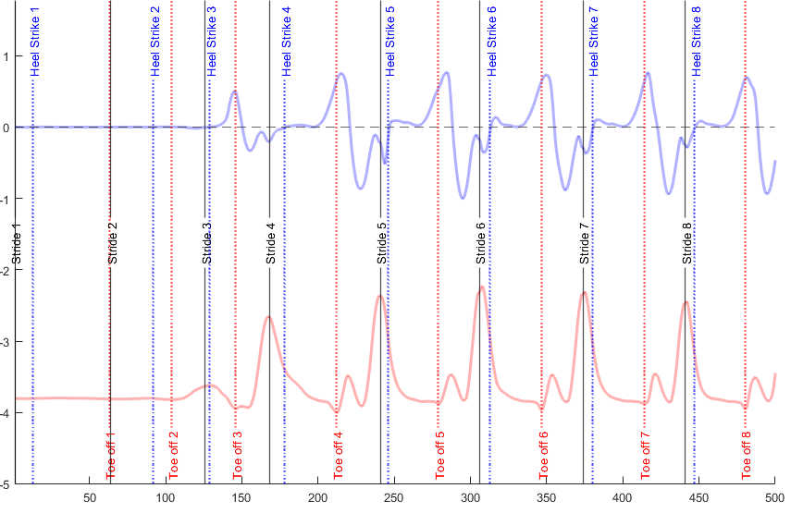 The plot above shows you some strides (black lines are the beginning of each stride). Heel strike and toe off lines. You can hold and drag red and blue lines.**

**You may find some bad strides, if you believe they are bad, just move the toe off contact before the heel strike contact line. In the later functions, the code will remove the strides with odd contact times.**

**For more information contact “S Daneshgar”**