EFICIENCIA

ALGORÍTMICA 2016

Práctica 1

Alejandro Campoy Nieves

David Criado Ramón

Luis Gallego Quero

Nour Eddine El Alaoui

Álvaro Marín Pérez

Contenido

Especificaciones iniciales

Algoritmos $O(n^{2}$)

Burbuja

Inserción

Selección

Tabla comparativa

Algoritmos $O(n\log{n)}$

Mergesort

Quicksort

Heapsort

Tabla comparativa

Algoritmo Floyd $O(n^{3})$

Algoritmo Hanoi $O(2^{n})$

Comparativa de todas los algoritmicos

Pruebas empíricas en otro ordenador

# Especificaciones iniciales

Las tomas de datos han sido realizadas en un ordenador con las siguientes características:

Procesador: Intel® Core™ i7-3630QM CPU @ 2.40GHz

Memoria RAM: 4Gb DDR3

Sistema Operativo y procesador de 64 bits

Hemos utilizado un tamaño de 99000 entradas tomando datos de 1000 en 1000

Hemos utilizado g++ como compilador y gnuplot como herramienta para realizar las gráficas. La compilación ha sido realizada con optimización -O2 y utilizando la librería chrono (-std=c++11) para medir el tiempo.

Para ajustar las funciones en gnuplot y obtener las constantes ocultas definimos una función parametrizada:

**Gnuplot > f(x)=a0\*x\*log(x)**

**Gnuplot > fit f(x) ‘entrada.dat’ via a0**

# Algoritmos $O(n^{2})$

## **BURBUJA**C:\Users\xKuZz\AppData\Local\Microsoft\Windows\INetCache\Content.Word\burbuja_emp.png

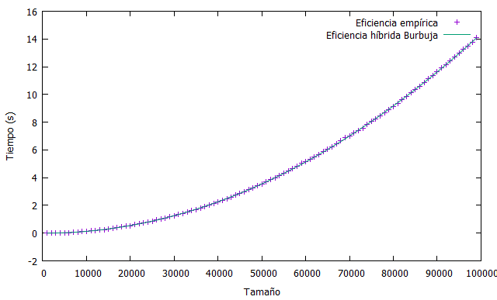

Aplicando la función $f\left(x\right)={a_{0}∙x}^{2}+ a_{1}∙x+ a_{2}$ obtenemos la muestra híbrida

Final set of parameters Asymptotic Standard Error

======================= ==========================

a0 = 3.04014e-010 +/- 1.163e-012 (0.3826%)

a1 = 7.60142e-007 +/- 1.201e-007 (15.79%)

a2 = -0.00307741 +/- 0.002601 (84.52%)

correlation matrix of the fit parameters:

a0 a1 a2

a0 1.000

a1 -0.969 1.000

a2 0.753 -0.871 1.000

## **INSERCIÓN**

**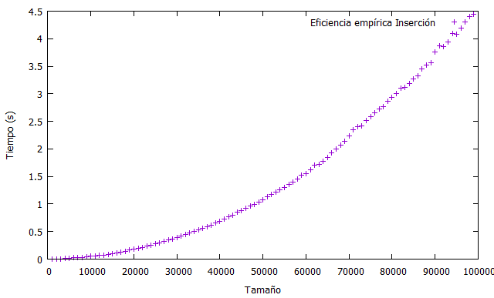**

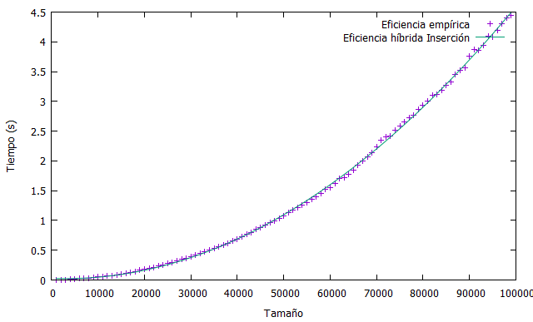

Aplicando la función $f\left(x\right)={a_{0}∙x}^{2}+ a_{1}∙x+ a_{2}$ obtenemos la muestra híbrida

Final set of parameters Asymptotic Standard Error

======================= ==========================

a0 = 4.85472e-010 +/- 3.93e-012 (0.8096%)

a1 = -2.89494e-006 +/- 4.057e-007 (14.01%)

a2 = 0.0272895 +/- 0.008789 (32.21%)

correlation matrix of the fit parameters:

a0 a1 a2

a0 1.000

a1 -0.969 1.000

a2 0.753 -0.871 1.000

## **SELECCIÓN**

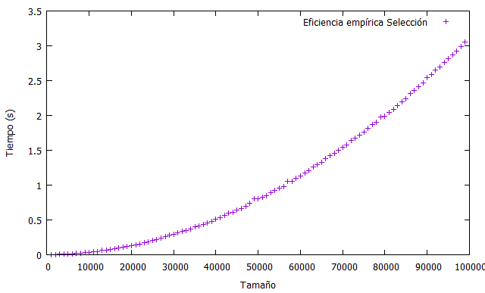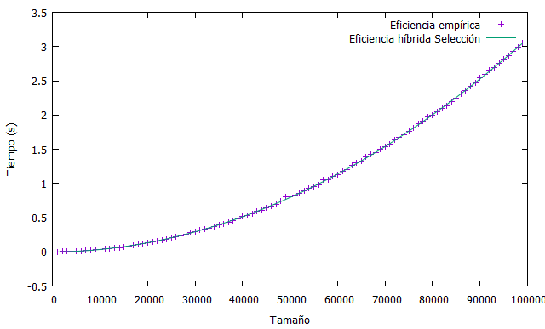

Aplicando la función $f\left(x\right)={a_{0}∙x}^{2}+ a_{1}∙x+ a_{2}$ obtenemos la muestra híbrida

Final set of parameters Asymptotic Standard Error

======================= ==========================

a0 = 4.85472e-010 +/- 3.93e-012 (0.8096%)

a1 = -2.89494e-006 +/- 4.057e-007 (14.01%)

a2 = 0.0272895 +/- 0.008789 (32.21%)

correlation matrix of the fit parameters:

a0 a1 a2

a0 1.000

a1 -0.969 1.000

a2 0.753 -0.871 1.000

## **tabla comparativa**

El más rápido de entre los cuadráticos es la selección y el más lento la burbuja.

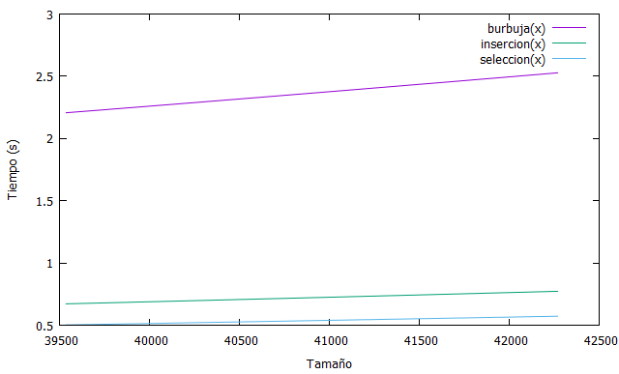

|  |  |  |  |
| --- | --- | --- | --- |
| TAMAÑO ENTRADA | BURBUJA | INSERCIÓN | SELECCIÓN |
| 1000 | 0.00193278 | 0.00119073 | 0.00106583 |
| 2000 | 0.00574371 | 0.00483048 | 0.00421014 |
| 3000 | 0.0147419 | 0.00634113 | 0.00611563 |
| 4000 | 0.0160938 | 0.00977951 | 0.00923968 |
| 5000 | 0.0241518 | 0.0110149 | 0.0107127 |
| 6000 | 0.0370208 | 0.0213544 | 0.0141393 |
| 7000 | 0.0559488 | 0.027549 | 0.0164859 |
| 8000 | 0.077394 | 0.0325693 | 0.0213593 |
| 9000 | 0.0996316 | 0.0383736 | 0.0307084 |
| 10000 | 0.12504 | 0.0504274 | 0.0365495 |
| 11000 | 0.155465 | 0.0560958 | 0.0436521 |
| 12000 | 0.185994 | 0.0643708 | 0.0460723 |
| 13000 | 0.221542 | 0.0743196 | 0.0617761 |
| 14000 | 0.262355 | 0.0829463 | 0.0638702 |
| 15000 | 0.313742 | 0.0993409 | 0.0763433 |
| 16000 | 0.344767 | 0.112805 | 0.0862639 |
| 17000 | 0.393989 | 0.127465 | 0.0977184 |
| 18000 | 0.443831 | 0.142312 | 0.104901 |
| 19000 | 0.494928 | 0.16262 | 0.117594 |
| 20000 | 0.541784 | 0.177866 | 0.128693 |
| 21000 | 0.601821 | 0.192111 | 0.144611 |
| 22000 | 0.670945 | 0.212365 | 0.156386 |
| 23000 | 0.730936 | 0.233384 | 0.169816 |
| 24000 | 0.798589 | 0.256854 | 0.187769 |
| 25000 | 0.86433 | 0.272494 | 0.203976 |
| 26000 | 0.950313 | 0.295784 | 0.22049 |
| 27000 | 1.01267 | 0.315448 | 0.233975 |
| 28000 | 1.08518 | 0.345475 | 0.259682 |
| 29000 | 1.17615 | 0.369731 | 0.285635 |
| 30000 | 1.23924 | 0.392813 | 0.296659 |
| 31000 | 1.33951 | 0.417925 | 0.316248 |
| 32000 | 1.43123 | 0.441373 | 0.333616 |
| 33000 | 1.54881 | 0.471313 | 0.349971 |
| 34000 | 1.61507 | 0.49981 | 0.370014 |
| 35000 | 1.71919 | 0.533378 | 0.397472 |
| 36000 | 1.81089 | 0.556018 | 0.411494 |
| 37000 | 1.92128 | 0.582914 | 0.435042 |
| 38000 | 2.02508 | 0.621715 | 0.459433 |
| 39000 | 2.13626 | 0.658378 | 0.479043 |
| 40000 | 2.2682 | 0.682856 | 0.515993 |
| 41000 | 2.37281 | 0.725555 | 0.532668 |
| 42000 | 2.47002 | 0.764756 | 0.560259 |
| 43000 | 2.60563 | 0.799758 | 0.593797 |
| 44000 | 2.72683 | 0.848523 | 0.606935 |
| 45000 | 2.86289 | 0.880025 | 0.641518 |
| 46000 | 3.00222 | 0.915282 | 0.665768 |
| 47000 | 3.13006 | 0.957817 | 0.692255 |
| 48000 | 3.27237 | 0.988046 | 0.740195 |
| 49000 | 3.42226 | 1.03093 | 0.79884 |
| 50000 | 3.53413 | 1.0817 | 0.809775 |
| 51000 | 3.6858 | 1.12911 | 0.829542 |
| 52000 | 3.8553 | 1.1728 | 0.849437 |
| 53000 | 4.00511 | 1.21558 | 0.895926 |
| 54000 | 4.15512 | 1.25415 | 0.929031 |
| 55000 | 4.31624 | 1.29537 | 0.954373 |
| 56000 | 4.45669 | 1.36229 | 0.980938 |
| 57000 | 4.66444 | 1.39928 | 1.05764 |
| 58000 | 4.79954 | 1.45267 | 1.05679 |
| 59000 | 5.0191 | 1.52366 | 1.09782 |
| 60000 | 5.16054 | 1.5578 | 1.13266 |
| 61000 | 5.33829 | 1.62587 | 1.17763 |
| 62000 | 5.48741 | 1.70439 | 1.20597 |
| 63000 | 5.65385 | 1.72413 | 1.26676 |
| 64000 | 5.9007 | 1.77687 | 1.29673 |
| 65000 | 6.04788 | 1.85069 | 1.33161 |
| 66000 | 6.22091 | 1.92659 | 1.38406 |
| 67000 | 6.42717 | 1.99636 | 1.42367 |
| 68000 | 6.64442 | 2.06643 | 1.45304 |
| 69000 | 6.87195 | 2.13365 | 1.50347 |
| 70000 | 7.01997 | 2.23995 | 1.53951 |
| 71000 | 7.20483 | 2.348 | 1.57591 |
| 72000 | 7.38953 | 2.39959 | 1.63793 |
| 73000 | 7.58491 | 2.4238 | 1.66935 |
| 74000 | 7.83766 | 2.51599 | 1.71531 |
| 75000 | 8.07336 | 2.58915 | 1.75942 |
| 76000 | 8.25566 | 2.65624 | 1.81272 |
| 77000 | 8.45629 | 2.72939 | 1.86745 |
| 78000 | 8.69371 | 2.7645 | 1.90706 |
| 79000 | 8.90351 | 2.86533 | 1.97499 |
| 80000 | 9.14048 | 2.9343 | 1.99295 |
| 81000 | 9.37395 | 3.00243 | 2.04312 |
| 82000 | 9.60246 | 3.1008 | 2.09096 |
| 83000 | 9.84795 | 3.11186 | 2.13797 |
| 84000 | 10.1159 | 3.19076 | 2.19098 |
| 85000 | 10.3665 | 3.27571 | 2.24229 |
| 86000 | 10.5664 | 3.33002 | 2.31197 |
| 87000 | 10.8511 | 3.45721 | 2.36011 |
| 88000 | 11.1552 | 3.52815 | 2.4147 |
| 89000 | 11.3849 | 3.5606 | 2.4702 |
| 90000 | 11.6295 | 3.75412 | 2.54254 |
| 91000 | 11.9129 | 3.87514 | 2.59302 |
| 92000 | 12.1546 | 3.86056 | 2.65245 |
| 93000 | 12.4473 | 3.93597 | 2.69702 |
| 94000 | 12.6998 | 4.09445 | 2.7567 |
| 95000 | 12.9788 | 4.08602 | 2.81217 |
| 96000 | 13.2653 | 4.19012 | 2.87102 |
| 97000 | 13.4892 | 4.29806 | 2.92952 |
| 98000 | 13.7606 | 4.40432 | 2.98787 |
| 99000 | 14.1295 | 4.43804 | 3.04999 |

# Algoritmos $O(n\log{n)}$

## **MERGESORT**

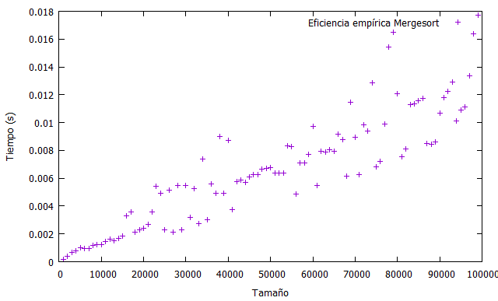

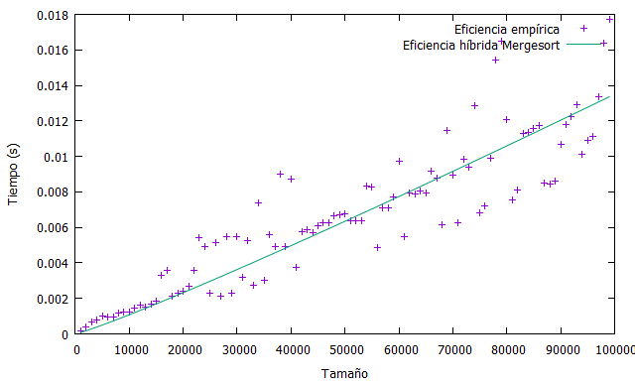

Aplicando la función $f\left(x\right)=a_{0} ∙ x∙log⁡(x)$ obtenemos la muestra híbrida

Final set of parameters Asymptotic Standard Error

======================= ==========================

a0 = 1.17285e-008 +/- 2.805e-010 (2.391%)

## **QUICKSORT**

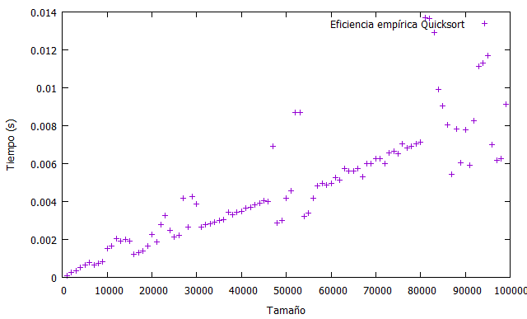

Aplicando la función $f\left(x\right)=a_{0} ∙ x∙log⁡(x)$ obtenemos la muestra híbrida

Final set of parameters Asymptotic Standard Error

======================= ==========================

a0 = 8.43252e-009 +/- 2.422e-010 (2.872%)

## **HEAPSORT**

La muestra empírica obtenida es la siguiente:

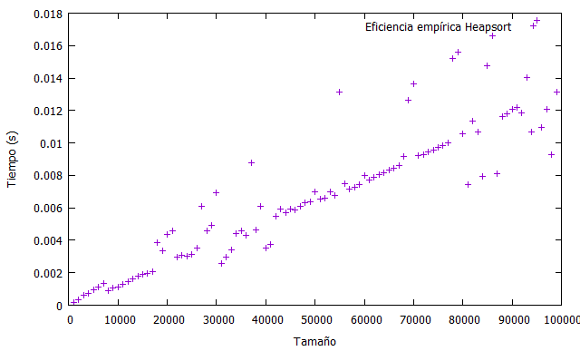

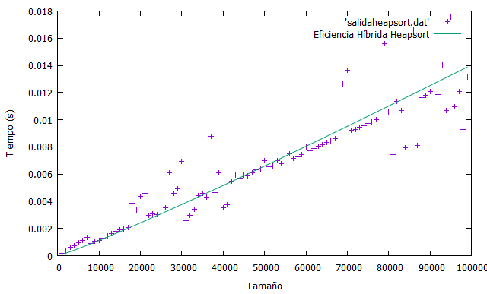

Aplicando la función $f\left(x\right)=a_{0} ∙ x∙log⁡(x)$ obtenemos la muestra híbrida

Final set of parameters Asymptotic Standard Error

======================= ==========================

a0 = 1.21862e-008 +/- 2.73e-010 (2.24%)

## **TABLA COMPARATIVA**

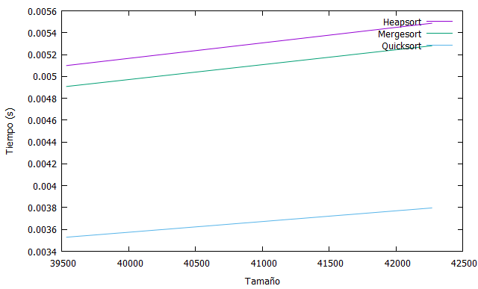

El algoritmo más rápido es el quicksort y el más lento es el heapsort

|  |  |  |  |
| --- | --- | --- | --- |
| TAMAÑO ENTRADA | HEAPSORT | MERGESORT | QUICKSORT |
| 1000 | 0.000151173 | 0.000160207 | 0.000107103 |
| 2000 | 0.000334822 | 0.000391972 | 0.000267754 |
| 3000 | 0.000640338 | 0.000671014 | 0.000367727 |
| 4000 | 0.000732223 | 0.000789439 | 0.000499528 |
| 5000 | 0.000935871 | 0.00103305 | 0.000670934 |
| 6000 | 0.0011413 | 0.000946087 | 0.000790946 |
| 7000 | 0.00135429 | 0.000972073 | 0.000639736 |
| 8000 | 0.000904135 | 0.00115533 | 0.000733028 |
| 9000 | 0.00106421 | 0.00123021 | 0.00082077 |
| 10000 | 0.00114524 | 0.00125683 | 0.00152238 |
| 11000 | 0.00128548 | 0.0014263 | 0.00165355 |
| 12000 | 0.00147887 | 0.00163923 | 0.002049 |
| 13000 | 0.00163276 | 0.00152397 | 0.00191535 |
| 14000 | 0.00178882 | 0.0016616 | 0.00201306 |
| 15000 | 0.00192613 | 0.00184074 | 0.00191354 |
| 16000 | 0.00194023 | 0.0033187 | 0.0012307 |
| 17000 | 0.00208832 | 0.00360712 | 0.00130669 |
| 18000 | 0.00387202 | 0.00211597 | 0.00140313 |
| 19000 | 0.00337592 | 0.00228484 | 0.00166245 |
| 20000 | 0.00436502 | 0.00242274 | 0.00223926 |
| 21000 | 0.00455621 | 0.00271153 | 0.00188535 |
| 22000 | 0.0029595 | 0.0035679 | 0.00277177 |
| 23000 | 0.00307198 | 0.0054465 | 0.00326143 |
| 24000 | 0.00302008 | 0.00490295 | 0.00249325 |
| 25000 | 0.00314577 | 0.00230293 | 0.00211182 |
| 26000 | 0.00354199 | 0.00513691 | 0.00222129 |
| 27000 | 0.00610992 | 0.00211546 | 0.00417443 |
| 28000 | 0.0045748 | 0.00549614 | 0.00266261 |
| 29000 | 0.00494706 | 0.00231032 | 0.00425466 |
| 30000 | 0.00693464 | 0.00547337 | 0.00389012 |
| 31000 | 0.00255637 | 0.00320499 | 0.00265303 |
| 32000 | 0.00298216 | 0.00524964 | 0.00277496 |
| 33000 | 0.00340037 | 0.00273903 | 0.00283326 |
| 34000 | 0.00442783 | 0.00736225 | 0.00290305 |
| 35000 | 0.00457668 | 0.00302218 | 0.0029907 |
| 36000 | 0.00429643 | 0.00559118 | 0.0030662 |
| 37000 | 0.00877498 | 0.0049115 | 0.00342034 |
| 38000 | 0.00466036 | 0.00897527 | 0.00328642 |
| 39000 | 0.00607675 | 0.00491191 | 0.0034239 |
| 40000 | 0.0035082 | 0.00871179 | 0.00346134 |
| 41000 | 0.00376867 | 0.00375363 | 0.00366509 |
| 42000 | 0.00548462 | 0.00573394 | 0.00368592 |
| 43000 | 0.00591583 | 0.00588839 | 0.00384056 |
| 44000 | 0.00572484 | 0.00567407 | 0.00392845 |
| 45000 | 0.00594272 | 0.00609346 | 0.0040353 |
| 46000 | 0.00586186 | 0.00625056 | 0.00399197 |
| 47000 | 0.00609537 | 0.00628693 | 0.00692451 |
| 48000 | 0.00632192 | 0.0066467 | 0.0028817 |
| 49000 | 0.00638911 | 0.00672504 | 0.00298908 |
| 50000 | 0.00697849 | 0.0067456 | 0.00418185 |
| 51000 | 0.00652921 | 0.00639481 | 0.00457435 |
| 52000 | 0.00660708 | 0.00639711 | 0.00868707 |
| 53000 | 0.00701069 | 0.00636191 | 0.00870088 |
| 54000 | 0.00675589 | 0.00835094 | 0.00323543 |
| 55000 | 0.0131643 | 0.00825398 | 0.00340335 |
| 56000 | 0.00750173 | 0.00485352 | 0.00415681 |
| 57000 | 0.00715528 | 0.00710545 | 0.00482236 |
| 58000 | 0.00729358 | 0.0070955 | 0.00497333 |
| 59000 | 0.00741934 | 0.00772749 | 0.00486803 |
| 60000 | 0.0079723 | 0.00972585 | 0.00497758 |
| 61000 | 0.00773402 | 0.00545149 | 0.00526912 |
| 62000 | 0.00789123 | 0.00792095 | 0.00513951 |
| 63000 | 0.00803787 | 0.00787285 | 0.00573998 |
| 64000 | 0.00815668 | 0.0080629 | 0.00559355 |
| 65000 | 0.00831842 | 0.00796297 | 0.00559362 |
| 66000 | 0.00845498 | 0.00918895 | 0.00574281 |
| 67000 | 0.00859644 | 0.0087979 | 0.00529156 |
| 68000 | 0.00914172 | 0.00614429 | 0.00600232 |
| 69000 | 0.0126269 | 0.011465 | 0.00600089 |
| 70000 | 0.0136269 | 0.00893282 | 0.0062612 |
| 71000 | 0.00923813 | 0.00625879 | 0.00627331 |
| 72000 | 0.00929113 | 0.0098244 | 0.00601773 |
| 73000 | 0.00944039 | 0.00938754 | 0.00656667 |
| 74000 | 0.00957822 | 0.0128581 | 0.0066675 |
| 75000 | 0.00972702 | 0.00684251 | 0.00650286 |
| 76000 | 0.00985298 | 0.00719798 | 0.00704573 |
| 77000 | 0.0100213 | 0.00989137 | 0.00682924 |
| 78000 | 0.0152271 | 0.0154591 | 0.00689972 |
| 79000 | 0.0155984 | 0.0164962 | 0.00704073 |
| 80000 | 0.010583 | 0.0120512 | 0.00713459 |
| 81000 | 0.00743785 | 0.00752384 | 0.0136777 |
| 82000 | 0.0113414 | 0.00810747 | 0.0136346 |
| 83000 | 0.0107026 | 0.0112661 | 0.0129179 |
| 84000 | 0.00795548 | 0.0113339 | 0.00993469 |
| 85000 | 0.0147314 | 0.0115892 | 0.00904529 |
| 86000 | 0.0166075 | 0.0117131 | 0.00806075 |
| 87000 | 0.00812198 | 0.00851443 | 0.0054259 |
| 88000 | 0.0116 | 0.00843193 | 0.00784248 |
| 89000 | 0.0118031 | 0.00863068 | 0.00604101 |
| 90000 | 0.0120579 | 0.0106994 | 0.00776619 |
| 91000 | 0.0121696 | 0.011771 | 0.00589269 |
| 92000 | 0.0118518 | 0.0122238 | 0.0082774 |
| 93000 | 0.0140275 | 0.0128904 | 0.0111204 |
| 94000 | 0.0106661 | 0.0100977 | 0.0113069 |
| 95000 | 0.0175575 | 0.0109127 | 0.0116835 |
| 96000 | 0.0109676 | 0.0111199 | 0.0069914 |
| 97000 | 0.0120897 | 0.0133593 | 0.00618103 |
| 98000 | 0.00929047 | 0.016363 | 0.00628194 |
| 99000 | 0.0131529 | 0.017722 | 0.00914352 |

# Algoritmo Floyd $[O\left(n^{3}\right)]$

|  |  |
| --- | --- |
| TAMAÑO ENTRADA | TIEMPO (SEG) |
| 500 | 0.12076 |
| 1000 | 0.958451 |
| 1500 | 3.55072 |
| 2000 | 8.28796 |
| 2500 | 15.7234 |
| 3000 | 26.8504 |
| 3500 | 42.8598 |
| 4000 | 63.5461 |
| 4500 | 93.339 |
| 5000 | 127.906 |
| 5500 | 190.035 |
| 6000 | 244.767 |
| 6500 | 311.748 |
| 7000 | 340.212 |
| 7500 | 430.018 |
| 8000 | 567.336 |
| 8500 | 602.636 |
| 9000 | 711.541 |
| 9500 | 988.618 |

# Algoritmo Hanoi $\left[O\left(2^{n}\right)\right]$

|  |  |
| --- | --- |
| TAMAÑO ENTRADA | TIEMPO (SEG) |
| 1 | 3.75E-07 |
| 2 | 4.27E-07 |
| 3 | 6.18E-07 |
| 4 | 8.18E-07 |
| 5 | 7.39E-07 |
| 6 | 9.60E-07 |
| 7 | 1.48E-06 |
| 8 | 2.29E-06 |
| 9 | 3.68E-06 |
| 10 | 6.27E-06 |
| 11 | 1.17E-05 |
| 12 | 2.27E-05 |
| 13 | 4.46E-05 |
| 14 | 8.77E-05 |
| 15 | 0.00017443 |
| 16 | 0.00034764 |
| 17 | 0.00069648 |
| 18 | 0.00131433 |
| 19 | 0.00402453 |
| 20 | 0.00710707 |
| 21 | 0.0102376 |
| 22 | 0.0164459 |
| 23 | 0.022695 |
| 24 | 0.0485116 |
| 25 | 0.0917417 |
| 26 | 0.175646 |
| 27 | 0.354592 |
| 28 | 0.707532 |
| 29 | 1.40671 |
| 30 | 2.81724 |
| 31 | 5.63279 |
| 32 | 11.3072 |
| 33 | 22.4701 |
| 34 | 45.9655 |
| 35 | 92.5853 |
| 36 | 181.291 |
| 37 | 359.786 |
| 38 | 753.337 |
| 39 | 1557.24 |

# COMPARATIVA DE TODOS LOS ALGORITMOS

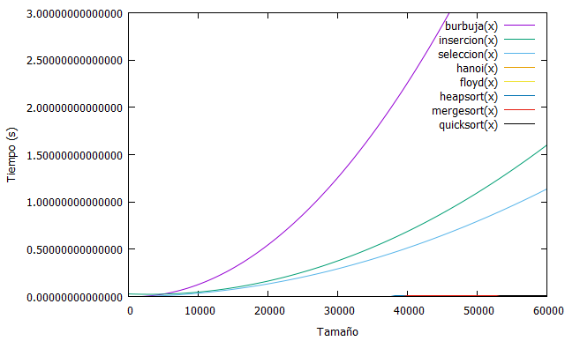

# PRUEBAS EMPÍRICAS EN OTRO ORDENADOR

**Ordenador 2 : Nourdine**

**Especificaciones iniciales :**

- Las tomas de datos han sido realizadas en un ordenador con las siguientes características:

**HP Pavilion g6 Notebook**

**Memoria : 3.3 GIB**

**Procesador : AMD A4-3300M APU with Radeon(tm) HD Graphics × 2**

**Graficos : Gallium 0.4 on AMD SUMO (DRM 2.43.0, LLVM 3.6.2)**

**Tipo de SO : 64 bits**

**Disco : 470,6 GB**

- Hemos utilizado un tamaño de 99000 entradas tomando datos de 1000 en 1000

- Hemos utilizado g++ como compilador y gnuplot como herramienta para realizar las gráficas.

- La compilación ha sido realizada con optimización -O2 y utilizando la librería chrono (-std=c++11) para medir el tiempo.

QUICKSORT :

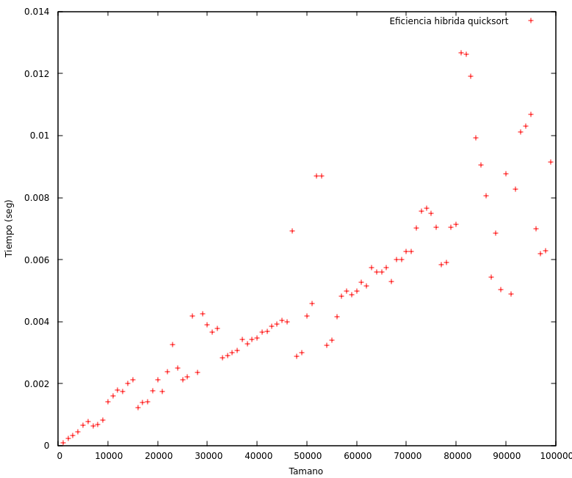

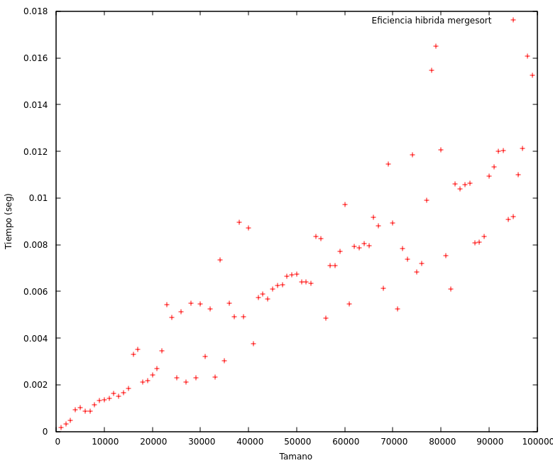MERGESORT :

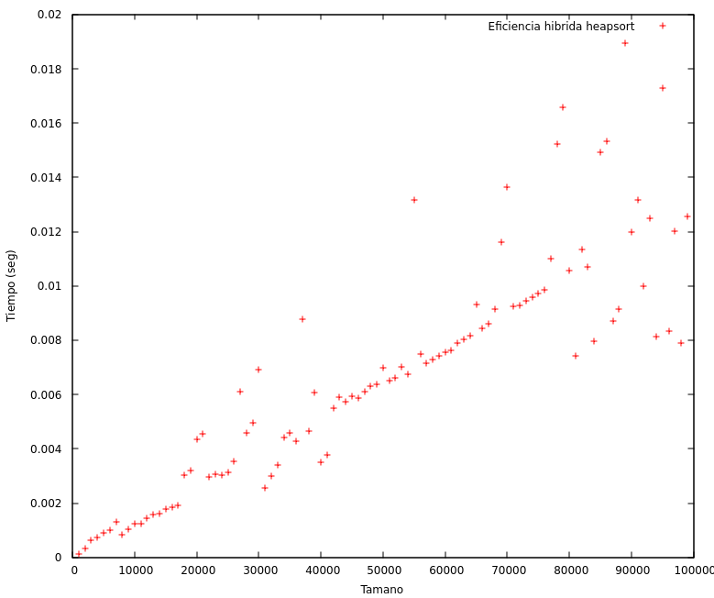HEAPSORT :