**Heist to the museum**

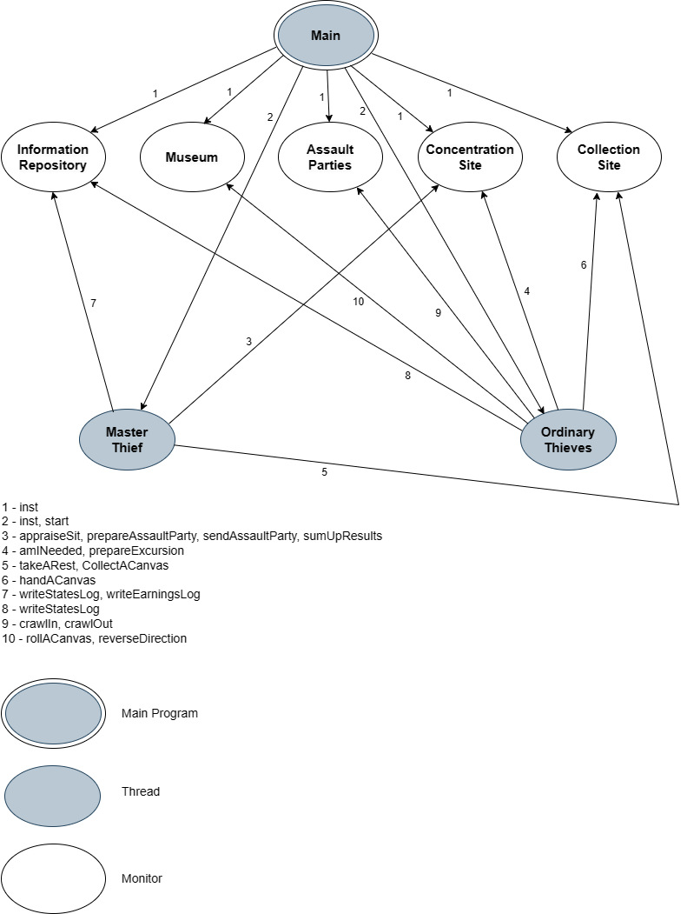**Interaction Diagram**