**Heist to the museum (Assignment 2)**

**Interaction Diagrams**

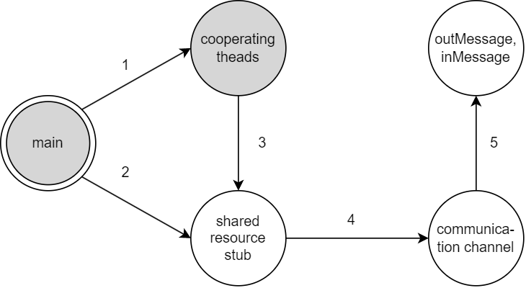**Master Thief Client**

1 – instantiate, start, join

2 – instantiate, shutdown

collection site, concentration site, information repository

3 – already defined methods

collection site stub: takeARest, collectACanvas, shutdown

concentration site stub: appraiseSit, prepareAssaultParty, sendAssaultParty, sumUpResults, shutdown

information repository stub: writeHeaderLog, writeStatesLog, writeEarningsLog, shutdown

4 – instantiate, open, close, writeObject, readObject

5 – instantiate, get field values

**Ordinary Thief Client**

1 – instantiate, start, join

2 – instantiate, shutdown

assault party, collection site, concentration site, information repository, museum

3 – already defined methods

assault party stub: crawlIn, crawlOut, shutdown

collection site stub: handACanvas, shutdown

concentration site stub: amINeeded, prepareExcursion, thiefLeaving, shutdown

information repository stub: writeStatesLog, fillMuseum, shutdown

museum stub: rollACanvas, reverseDirection, fillMuseum, shutdown

4 – instantiate, open, close, writeObject, readObject

5 – instantiate, get field values

**Information Repository Server**

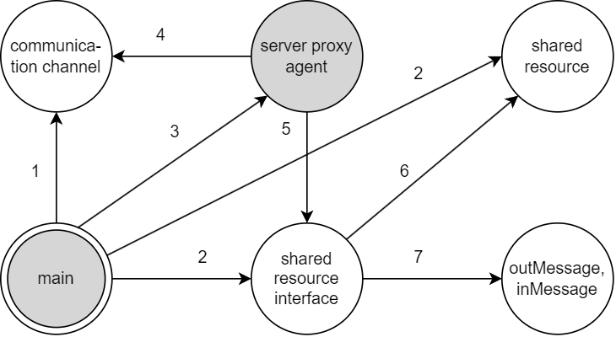

1 – instantiate, start, end, accept

2 – instantiate

3 – instantiate, start

4 – readObject, writeObject, close

5 – processAndReply

6 – already defined methods

writeHeaderLog, writeStatesLog, writeEarningsLog, fillMuseum, shutdown

7 – instantiate, get field values

**Concentration Site Server**

1 – instantiate, start, end, accept

2 – instantiate

3 – instantiate, start

4 – readObject, writeObject, close

5 – processAndReply

6 – already defined methods

appraiseSit, prepareAssaultParty, sendAssaultParty, sumUpResults, amINeeded, prepareExcursion, thiefLeaving, shutdown

7 – instantiate, get field values

**Collection Site Server**

1 – instantiate, start, end, accept

2 – instantiate

3 – instantiate, start

4 – readObject, writeObject, close

5 – processAndReply

6 – already defined methods

takeARest, collectACanvas, handACanvas, shutdown

7 – instantiate, get field values

**Assault Party Servers (two processes, running in two distinct machines)**

1 – instantiate, start, end, accept

2 – instantiate

3 – instantiate, start

4 – readObject, writeObject, close

5 – processAndReply

6 – already defined methods

crawlIn, crawlOut, shutdown

7 – instantiate, get field values

**Museum Server**

1 – instantiate, start, end, accept

2 – instantiate

3 – instantiate, start

4 – readObject, writeObject, close

5 – processAndReply

6 – already defined methods

rollACanvas, reverseDirection, fillMuseum, shutdown

7 – instantiate, get field values