**Heist to the museum (Assignment 3)**

**Interaction Diagrams**

**Master Thief Client**

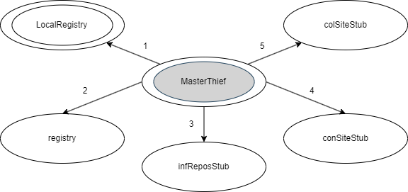

1 – getRegistry

2 – instantiate, lookup

3 – instantiate, writeHeaderLog, writeStatesLog, writeEarningsLog, shutdown

4 – instantiate, appraiseSit, prepareAssaultParty, sendAssaultParty, sumUpResults, shutdown

5 – instantiate, takeARest, colACanvas, shutdown

**Ordinary Thief Client**

1 – getRegistry

2 – instantiate, lookup

3 – instantiate, writeStatesLog, fillMuseum, shutdown

4 – instantiate, amINeeded, prepareExcursion, thiefLeaving, shutdown

5 – instantiate, handACanvas, shutdown

6 – instantiate, crawlIn, crawlOut, shutdown

7 – instantiate, rollACanvas, reverseDirection, fillMuseum, shutdown

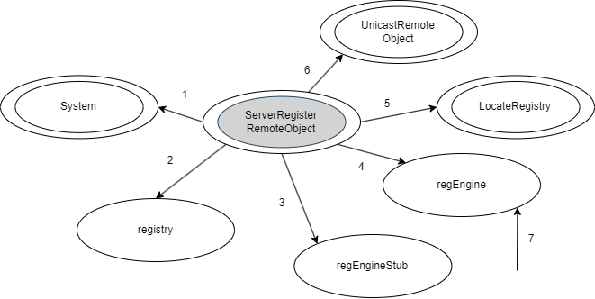**Register Remote Object Server**

1 – getSecurityManager, setSecurityManager

2 – instantiate, rebind

3 – instantiate

4 – instantiate

5 – getRegistry

6 – exportObject

7 – bind, unbind, rebind

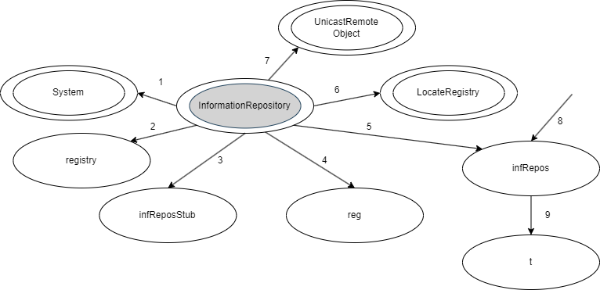**Information Repository Server**

1 – getSecurityManager, setSecurityManager

2 – instantiate, locate

3 – instantiate

4 – instantiate, bind

5 – instantiate

6 – getRegistry

7 – exportObject

8 – writeHeaderLog, writeStatesLog, writeEarningsLog, shutdown

9 – execute

**Concentration Site Server**

1 – getSecurityManager, setSecurityManager

2 – instantiate, locate

3 – instantiate

4 – instantiate, bind

5 – instantiate

6 – getRegistry

7 – exportObject

8 – appraiseSit, prepareAssaultParty, sendAssaultParty, sumUpResults, amINeeded, prepareExcursion, thiefLeaving, shutdown

9 – execute

**Collection Site Server**

1 – getSecurityManager, setSecurityManager

2 – instantiate, locate

3 – instantiate

4 – instantiate, bind

5 – instantiate

6 – getRegistry

7 – exportObject

8 – takeARest, colACanvas, handACanvas, shutdown

9 – execute

**Assault Party Server (two processes, running in two distinct machines)**

1 – getSecurityManager, setSecurityManager

2 – instantiate, locate

3 – instantiate

4 – instantiate, bind

5 – instantiate

6 – getRegistry

7 – exportObject

8 – crawlIn, crawlOut, shutdown

9 – execute

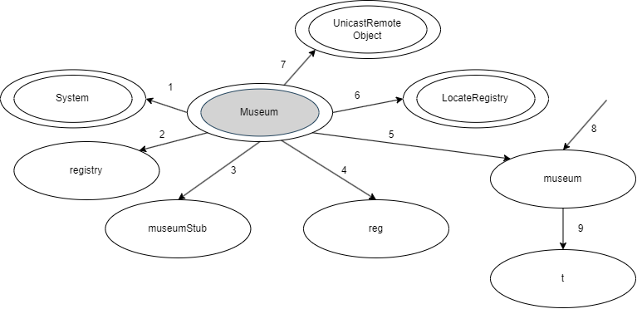**Museum Server**

1 – getSecurityManager, setSecurityManager

2 – instantiate, locate

3 – instantiate

4 – instantiate, bind

5 – instantiate

6 – getRegistry

7 – exportObject

8 – rollACanvas, reverseDirection, fillMuseum, shutdown

9 – execute