**Formative Assignment 2**

**Task 1**: Expand lab activity to physically turn on device’s flashlight.

Permissions for camera and flashlight use in manifest.

<uses-permission android:name="android.permission.CAMERA" />  
<uses-feature android:name="android.hardware.camera" />  
  
<uses-permission android:name="android.permission.FLASHLIGHT"/>  
<uses-feature android:name="android.hardware.camera.flash" android:required="false" />

MainActivity.Java

package com.example.lesgo.a2t1;  
  
import android.hardware.Camera;  
import android.support.v7.app.AppCompatActivity;  
import android.os.Bundle;  
import android.view.MotionEvent;  
import android.view.View;  
import android.widget.ImageView;  
  
public class MainActivity extends AppCompatActivity {  
  
 boolean bulb = false;  
 Camera mCam ;  
  
 @Override  
 protected void onCreate(Bundle savedInstanceState) {  
 super.onCreate(savedInstanceState);  
 setContentView(R.layout.*activity_main*);  
  
 final ImageView bulbImageView = (ImageView)findViewById(R.id.*bulbview*);  
 restoreState(savedInstanceState);  
  
  
 mCam = Camera.*open*();  
  
  
 if(bulb == false)  
 {  
 bulbImageView.setImageResource(R.drawable.*off*);  
 }  
 else  
 {  
 bulbImageView.setImageResource(R.drawable.*on*);  
  
 Camera.Parameters p = mCam.getParameters();  
 p.setFlashMode(Camera.Parameters.*FLASH_MODE_TORCH*);  
 mCam.setParameters(p);  
 mCam.startPreview();  
 }  
  
  
 bulbImageView.setOnTouchListener(new View.OnTouchListener() {  
 @Override  
 public boolean onTouch(View v, MotionEvent event) {  
  
 switch(event.getAction()){  
 case MotionEvent.*ACTION_UP*:  
 if(bulb==false)  
 {  
 bulbImageView.setImageResource(R.drawable.*on*);  
 bulb = true;  
  
 Camera.Parameters p = mCam.getParameters();  
 p.setFlashMode(Camera.Parameters.*FLASH_MODE_TORCH*);  
 mCam.setParameters(p);  
 mCam.startPreview();  
  
 }  
 else  
 {  
 bulbImageView.setImageResource(R.drawable.*off*);  
 bulb = false;  
  
 Camera.Parameters p = mCam.getParameters();  
 p.setFlashMode(Camera.Parameters.*FLASH_MODE_OFF*);  
 mCam.setParameters(p);  
  
  
 }  
 }  
 return true;  
 }  
 });  
 }  
  
 @Override  
 protected void onSaveInstanceState(Bundle outState) {  
  
 outState.putBoolean("BULB",bulb);  
  
 mCam.stopPreview();  
 mCam.release();  
  
 super.onSaveInstanceState(outState);  
 }  
  
 private void restoreState(Bundle bundle){  
 if(bundle==null)  
 return;  
  
 bulb = bundle.getBoolean("BULB");  
 }  
}

**Task 2**: Describe concept of string externalization and how it assist localization.

String externalization is the process of separating messages from programming codes to enable translation to another language which has been defined by the programmer. As smartphones are available all over the globe, there are people who would prefer to have their phone’s languages (locale setting) to be a native language although English is the international language for communication. Thus, it is important to cater for different locales if the application has a lot of users from a country where English is a native language. It is impossible to support all languages, thus targeting major regional languages as a start for a successful worldwide launch.

When strings are externalized in an android project (strings coded in strings.xml), strings of different languages can be coded for different locales, and translations for each string can be clearly seen from inside the studio. When a phone with a different locale loads the application, if the application has support for that locale, android will gracefully handle and automatically load the string.xml of that locale and the rest is history.



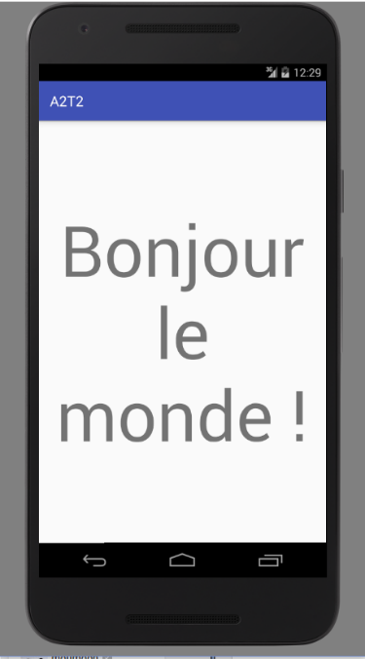

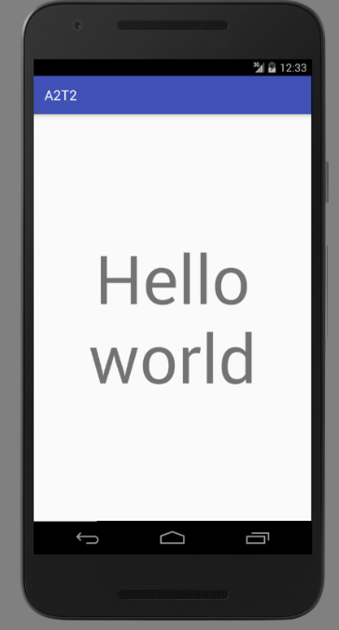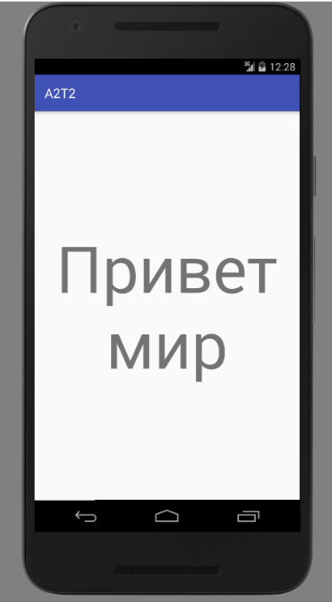

**Task 3**: Create app to convert volumetric measurement

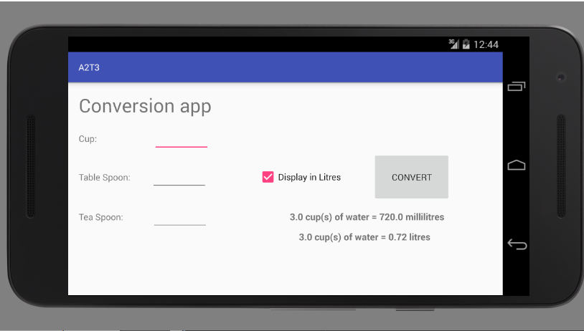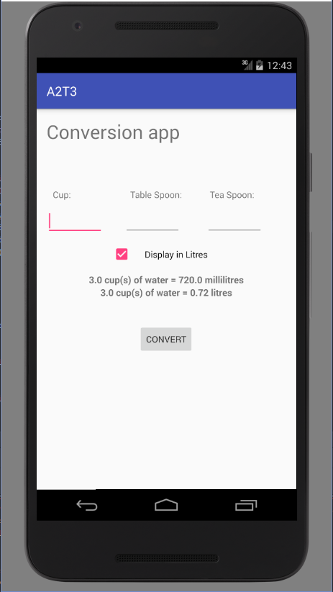

MainActivity.Java

package com.example.lesgo.redoa2t3;  
  
import android.content.res.Configuration;  
import android.support.v7.app.AppCompatActivity;  
import android.os.Bundle;  
import android.view.MotionEvent;  
import android.view.View;  
import android.widget.Button;  
import android.widget.CheckBox;  
import android.widget.CompoundButton;  
import android.widget.EditText;  
import android.widget.TextView;  
  
  
public class MainActivity extends AppCompatActivity {  
  
 EditText cup ;  
 EditText tables;  
 EditText teas;  
 TextView ml;  
 Double answer=0.0;  
 Double total =0.0;  
 String a1="";  
 String a2="";  
 CheckBox cb;  
 TextView l;  
  
  
 @Override  
 protected void onCreate(Bundle savedInstanceState) {  
 super.onCreate(savedInstanceState);  
 setContentView(R.layout.*activity_main*);  
 restoreState(savedInstanceState);  
  
  
 Button convert = (Button)findViewById(R.id.*convert*);  
 cup = (EditText)findViewById(R.id.*cups*);  
 tables = (EditText)findViewById(R.id.*tablespoon*);  
 teas = (EditText)findViewById(R.id.*teaspoon*);  
 ml = (TextView)findViewById(R.id.*milli*);  
 cb = (CheckBox)findViewById(R.id.*convert1*);  
 l = (TextView)findViewById(R.id.*litres*);  
  
  
 ml.setText(a1);  
 l.setText(a2);  
  
 cb.setOnCheckedChangeListener(new CompoundButton.OnCheckedChangeListener() {  
 @Override  
 public void onCheckedChanged(CompoundButton buttonView, boolean isChecked) {  
 if(isChecked==true)  
 {  
 l.setVisibility(View.*VISIBLE*);  
 }  
 else{  
 l.setVisibility(View.*INVISIBLE*);  
 }  
 }  
 });  
  
  
 cup.setOnFocusChangeListener(new View.OnFocusChangeListener() {  
 @Override  
 public void onFocusChange(View v, boolean hasFocus) {  
 if(hasFocus)  
 {  
 tables.setText("");  
 teas.setText("");  
 }  
 }  
 });  
  
 tables.setOnFocusChangeListener(new View.OnFocusChangeListener() {  
 @Override  
 public void onFocusChange(View v, boolean hasFocus) {  
 if(hasFocus)  
 {  
 cup.setText("");  
 teas.setText("");  
 }  
 }  
 });  
  
  
 teas.setOnFocusChangeListener(new View.OnFocusChangeListener() {  
 @Override  
 public void onFocusChange(View v, boolean hasFocus) {  
 if(hasFocus)  
 {  
 cup.setText("");  
 tables.setText("");  
 }  
 }  
 });  
  
  
  
 convert.setOnTouchListener(new View.OnTouchListener() {  
 @Override  
 public boolean onTouch(View v, MotionEvent event) {  
  
 String cupinput = cup.getText().toString();  
 String tableinput = tables.getText().toString();  
 String teainput = teas.getText().toString();  
  
 if(!cupinput.matches(""))  
 {  
 total = Double.*parseDouble*(cupinput);  
 answer = total *240;  
 a1 = total+ " cup(s) of water = "+ answer + " millilitres";  
 a2 = total+ " cup(s) of water = "+ answer/1000 + " litres";  
  
 ml.setText(a1);  
 l.setText(a2 );  
  
 cup.setText("");  
 answer =0.0;  
  
 }  
  
 if(!tableinput.matches(""))  
 {  
 total = Double.*parseDouble*(tableinput);  
 answer = total *15;  
 a1 = total+ " tablespoon(s) of water = "+ answer + " millilitres" ;  
 a2 = total+ " tablespoon(s) of water = "+ answer/1000 + " litres" ;  
  
 ml.setText(a1);  
 l.setText(a2);  
  
 tables.setText("");  
 answer =0.0;  
 }  
  
 if(!teainput.matches(""))  
 {  
 total = Double.*parseDouble*(teainput);  
 answer = total *5;  
 a1 = total+ " teaspoon(s) of water = "+ answer + " millilitres" ;  
 a2 = total+ " teaspoon(s) of water = "+ answer/1000 + " litres" ;  
  
 ml.setText(a1);  
 l.setText(a2);  
  
 teas.setText("");  
 answer =0.0;  
 }  
 return true;  
 }  
 });  
 }  
  
  
 @Override  
 protected void onSaveInstanceState(Bundle outState) {  
  
 outState.putString("a1", a1);  
 outState.putString("a2", a2);  
  
 super.onSaveInstanceState(outState);  
 }  
  
  
 private void restoreState(Bundle bundle){  
 if(bundle== null)  
 return ;  
  
 if(bundle.getInt("field")==1)  
 {  
 String x = String.*valueOf*(bundle.getDouble("input"));  
 cup.setText("abc");  
 }  
  
 a1 =(bundle.getString("a1"));  
 a2 =(bundle.getString("a2"));  
  
 }  
}

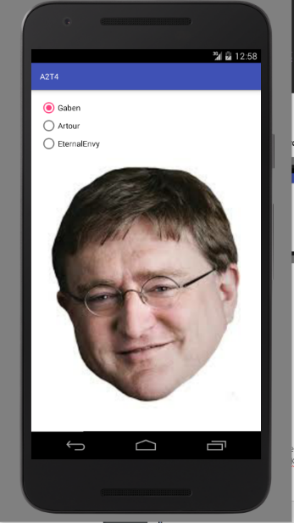**Task 4**: Create android activity with radio group and image view

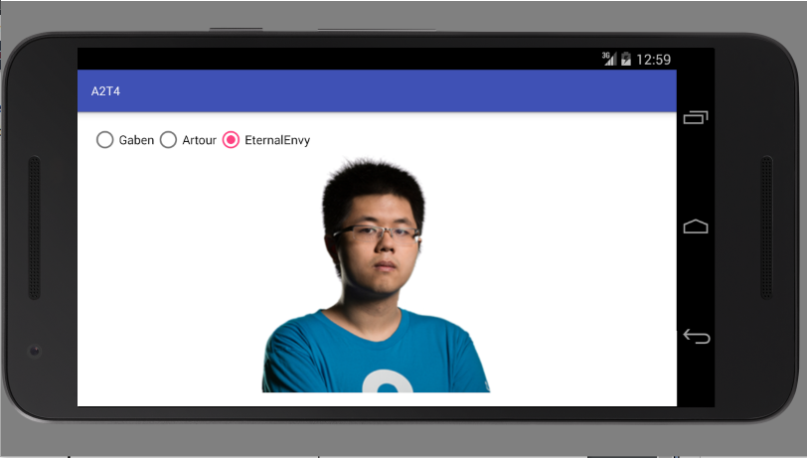

MainActivity.Java

package com.example.lesgo.a2t4;  
  
import android.content.res.Configuration;  
import android.provider.MediaStore;  
import android.support.v7.app.AppCompatActivity;  
import android.os.Bundle;  
import android.util.Log;  
import android.view.View;  
import android.widget.ImageView;  
import android.widget.LinearLayout;  
import android.widget.RadioButton;  
import android.widget.RadioGroup;  
  
public class MainActivity extends AppCompatActivity {  
 RadioGroup radiog;  
 ImageView imgv;  
  
  
 @Override  
 protected void onCreate(Bundle savedInstanceState) {  
  
  
 super.onCreate(savedInstanceState);  
 setContentView(R.layout.*activity_main*);  
 radiog = (RadioGroup)findViewById(R.id.*radiogroup*);  
 imgv = (ImageView)findViewById(R.id.*imgview*);  
  
  
 radiog.setOnCheckedChangeListener(new RadioGroup.OnCheckedChangeListener() {  
 @Override  
 public void onCheckedChanged(RadioGroup group, int checkedId) {  
 View radioButton = radiog.findViewById(checkedId);  
 int index = radiog.indexOfChild(radioButton);  
  
 switch(index){  
 case 0:  
 imgv.setImageResource(R.drawable.*gabe*);  
 break;  
  
 case 1:  
 imgv.setImageResource(R.drawable.*rtz*);  
 break;  
  
 case 2:  
 imgv.setImageResource(R.drawable.*ee*);  
 break;  
 }  
 }  
 });  
  
  
 }  
  
 @Override  
 public void onConfigurationChanged(Configuration newConfig) {  
 super.onConfigurationChanged(newConfig);  
 RadioGroup radiog = (RadioGroup)findViewById(R.id.*radiogroup*);  
  
 switch(getResources().getConfiguration().orientation)  
 {  
  
 case Configuration.*ORIENTATION_PORTRAIT*:  
 radiog.setOrientation(LinearLayout.*VERTICAL*);  
 break;  
 case Configuration.*ORIENTATION_LANDSCAPE*:  
 radiog.setOrientation(LinearLayout.*HORIZONTAL*);  
 break;  
 }  
  
 }  
}