**Formative Assignment 3**

**Task 1**: Creating custom dialog box

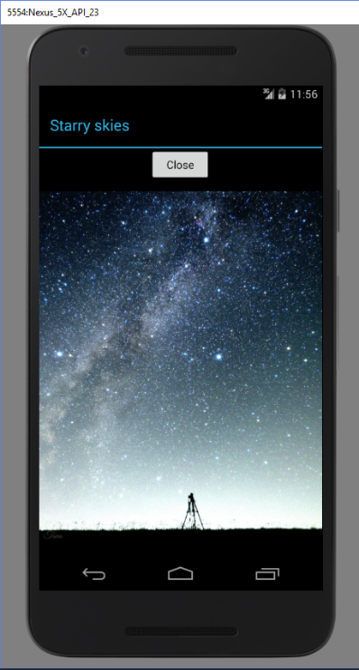Screenshots

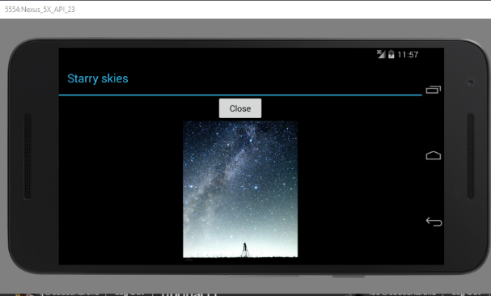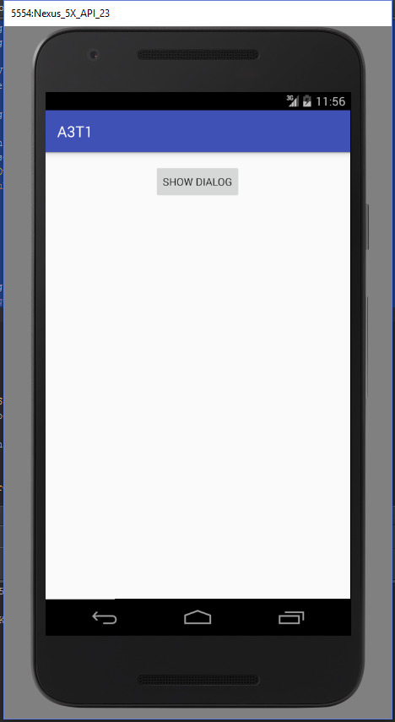

Code Snippets

**Listener to load the dialog box**

1. btn1.setOnClickListener(new View.OnClickListener() {
2. @Override
3. public void onClick(View v) {
5. final Dialog dialog = new Dialog(context);
6. dialog.setContentView(R.layout.custom);
7. dialog.setTitle(R.string.starry);
9. ImageView img = (ImageView) dialog.findViewById(R.id.ImageView);
10. img.setImageResource(R.drawable.sky);
12. dialog.getWindow().setBackgroundDrawableResource(R.color.black);
14. Button btn2 = (Button)dialog.findViewById(R.id.dialogBtn);
15. btn2.setOnClickListener(new View.OnClickListener() {
16. @Override
17. public void onClick(View v) {
18. dialog.dismiss();
19. dialogOpen = false;
21. }
22. });
24. dialog.show();
25. dialogOpen = true;
26. }
27. });

**Handling the open dialog once screen is rotated and state is restored.**

1. if(dialogOpen == true)
2. {
3. final Dialog dialog = new Dialog(context);
4. dialog.setContentView(R.layout.custom);
5. dialog.setTitle(R.string.starry);
7. ImageView img = (ImageView) dialog.findViewById(R.id.ImageView);
8. img.setImageResource(R.drawable.sky);
10. dialog.getWindow().setBackgroundDrawableResource(R.color.black);
12. Button btn2 = (Button)dialog.findViewById(R.id.dialogBtn);
13. btn2.setOnClickListener(new View.OnClickListener() {
14. @Override
15. public void onClick(View v) {
16. dialog.dismiss();
17. dialogOpen = false;
19. }
20. });
21. dialog.show();
23. }

**Task 2**: Data transfer between activities using explicit intents

Screenshots

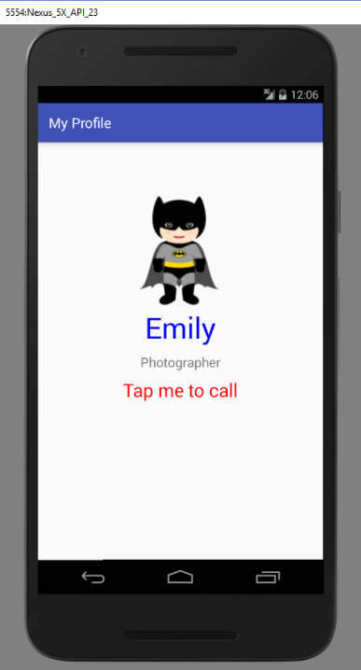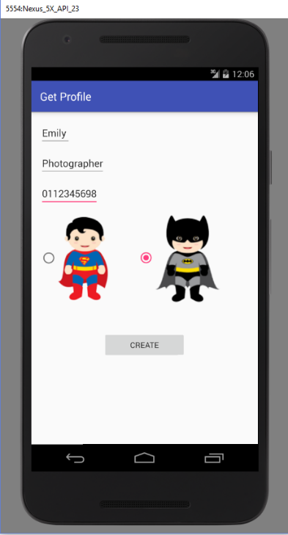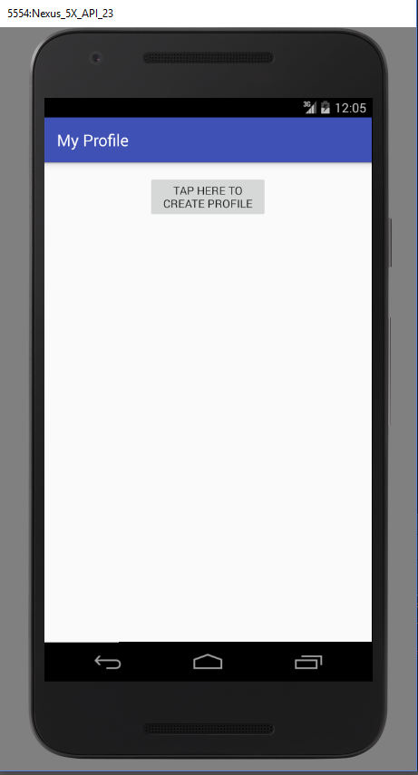

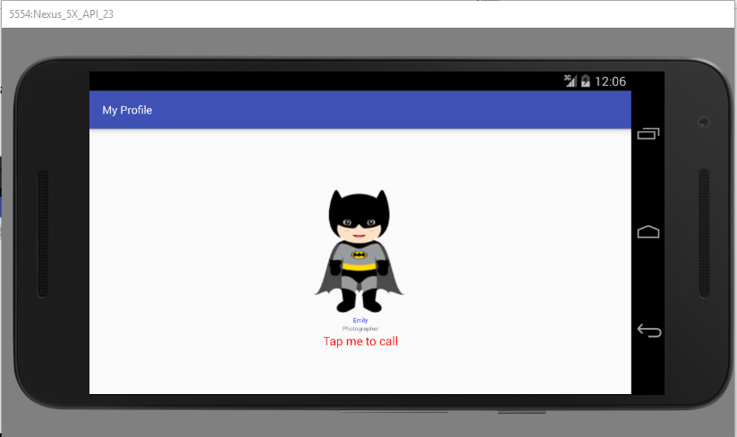

Additional permission

<uses-permission android:name="android.permission.CALL_PHONE" />

Codes

MainActivity

1. package com.example.lesgo.myprofile;
3. import android.app.Activity;
4. import android.content.Intent;
5. import android.content.res.Configuration;
6. import android.graphics.Color;
7. import android.net.Uri;
8. import android.support.v7.app.AppCompatActivity;
9. import android.os.Bundle;
10. import android.util.Log;
11. import android.util.TypedValue;
12. import android.view.Gravity;
13. import android.view.MotionEvent;
14. import android.view.View;
15. import android.widget.Button;
16. import android.widget.ImageView;
17. import android.widget.LinearLayout;
18. import android.widget.TextView;
20. import java.util.ArrayList;
22. public class MainActivity extends AppCompatActivity {
23. Button btn;
24. Profile profile = new Profile();
25. Boolean created = false;
27. @Override
28. protected void onCreate(Bundle savedInstanceState) {
29. super.onCreate(savedInstanceState);
30. setContentView(R.layout.activity_main);
31. btn = (Button)findViewById(R.id.button);

34. restoreState(savedInstanceState);
36. if(created)
37. {
38. TextView tV1 = new TextView(this);
39. TextView tV2 = new TextView(this);
40. TextView tV3 = new TextView(this);

43. btn.setVisibility(View.INVISIBLE);
45. LinearLayout linearLayout = (LinearLayout)findViewById(R.id.mainlayout);
46. ImageView iV = new ImageView(this);
47. if(profile.getBat())
48. {
49. iV.setImageResource(R.drawable.batman);
50. }
51. else
52. {
53. iV.setImageResource(R.drawable.superman);
54. }

57. tV1.setText(profile.getName());
58. tV1.setTextColor(Color.BLUE);

61. tV2.setText(profile.getProfession());

64. tV3.setText("Tap me to call");
65. tV3.setTextColor(Color.RED);

68. tV1.setGravity(Gravity.CENTER);
69. tV2.setGravity(Gravity.CENTER);
70. tV3.setGravity(Gravity.CENTER);

73. int orientation=this.getResources().getConfiguration().orientation;
74. if(orientation== Configuration.ORIENTATION_PORTRAIT){

77. tV1.setTextSize(TypedValue.COMPLEX_UNIT_PX,110);
78. tV2.setTextSize(TypedValue.COMPLEX_UNIT_PX,50);
79. tV3.setTextSize(TypedValue.COMPLEX_UNIT_PX,70);
81. tV1.setPadding(0,0,0,25);
82. tV2.setPadding(0,0,0,25);
84. }
85. else{
86. //code for landscape mode

89. tV1.setTextSize(TypedValue.COMPLEX_UNIT_PX,20);
90. tV2.setTextSize(TypedValue.COMPLEX_UNIT_PX,20);
91. tV3.setTextSize(TypedValue.COMPLEX_UNIT_PX,40);
92. }

95. linearLayout.addView(iV);
96. linearLayout.addView(tV1);
97. linearLayout.addView(tV2);


101. tV3.setOnClickListener(new View.OnClickListener() {
102. @Override
103. public void onClick(View v) {
104. Intent intent = new Intent(Intent.ACTION_CALL, Uri.parse("tel:" + Integer.parseInt( profile.getContact())));
105. startActivity(intent);
106. }
107. });
109. linearLayout.addView(tV3);
111. }
113. setTitle("My Profile");

116. btn.setOnClickListener(new View.OnClickListener() {
117. @Override
118. public void onClick(View v) {
119. Intent intent = new Intent();
120. intent.setClass(getApplicationContext(),GetProfile.class);
121. startActivityForResult(intent,0);
123. }
124. });
125. }
127. @Override
128. protected void onActivityResult(int requestCode, int resultCode, Intent data) {
129. super.onActivityResult(requestCode, resultCode, data);

132. if(data==null)
133. Log.d("NO RESULT", " no result");
134. else
135. {
136. created=true;
137. ArrayList<Profile> profileData = data.getParcelableArrayListExtra("profile");
138. profile = profileData.get(0);
140. TextView tV1 = new TextView(this);
141. TextView tV2 = new TextView(this);
142. TextView tV3 = new TextView(this);

145. btn.setVisibility(View.INVISIBLE);
147. LinearLayout linearLayout = (LinearLayout)findViewById(R.id.mainlayout);
148. ImageView iV = new ImageView(this);
149. if(profile.getBat())
150. {
151. iV.setImageResource(R.drawable.batman);
152. }
153. else
154. {
155. iV.setImageResource(R.drawable.superman);
156. }

159. tV1.setText(profile.getName());
160. tV1.setTextColor(Color.BLUE);

163. tV2.setText(profile.getProfession());

166. tV3.setText("Tap me to call");
167. tV3.setTextColor(Color.RED);

170. tV1.setGravity(Gravity.CENTER);
171. tV2.setGravity(Gravity.CENTER);
172. tV3.setGravity(Gravity.CENTER);

175. int orientation=this.getResources().getConfiguration().orientation;
176. if(orientation== Configuration.ORIENTATION_PORTRAIT){

179. tV1.setTextSize(TypedValue.COMPLEX_UNIT_PX,110);
180. tV2.setTextSize(TypedValue.COMPLEX_UNIT_PX,50);
181. tV3.setTextSize(TypedValue.COMPLEX_UNIT_PX,70);
183. tV1.setPadding(0,0,0,25);
184. tV2.setPadding(0,0,0,25);
186. }
187. else{
188. //code for landscape mode

191. tV1.setTextSize(TypedValue.COMPLEX_UNIT_PX,20);
192. tV2.setTextSize(TypedValue.COMPLEX_UNIT_PX,20);
193. tV3.setTextSize(TypedValue.COMPLEX_UNIT_PX,40);
194. }

197. linearLayout.addView(iV);
198. linearLayout.addView(tV1);
199. linearLayout.addView(tV2);


203. tV3.setOnClickListener(new View.OnClickListener() {
204. @Override
205. public void onClick(View v) {
206. Intent intent = new Intent(Intent.ACTION_CALL, Uri.parse("tel:" + Integer.parseInt( profile.getContact())));
207. startActivity(intent);
208. }
209. });
211. linearLayout.addView(tV3);
212. }
213. }

216. @Override
217. protected void onSaveInstanceState(Bundle outState) {
219. if(created)
220. {
221. outState.putBoolean("bat",profile.getBat());
222. outState.putString("contact",profile.getContact());
223. outState.putString("profession",profile.getProfession());
224. outState.putString("name",profile.getName());
225. outState.putBoolean("created",created);
226. }
228. super.onSaveInstanceState(outState);
229. }
231. public void restoreState(Bundle bundle){
232. if(bundle== null)
233. return ;
235. profile.setBat(bundle.getBoolean("bat"));
236. profile.setContact(bundle.getString("contact"));
237. profile.setProfession(bundle.getString("profession"));
238. profile.setName(bundle.getString("name"));
240. created  = bundle.getBoolean("created") ;
242. }
243. }

GetProfile.java

1. package com.example.lesgo.myprofile;
3. import android.content.Intent;
4. import android.provider.ContactsContract;
5. import android.provider.MediaStore;
6. import android.support.v7.app.AppCompatActivity;
7. import android.os.Bundle;
8. import android.util.Log;
9. import android.view.View;
10. import android.widget.Button;
11. import android.widget.EditText;
12. import android.widget.RadioGroup;
13. import android.widget.Toast;
15. import java.util.ArrayList;
17. public class GetProfile extends AppCompatActivity {
19. EditText eText1;
20. EditText eText2;
21. EditText eText3;
22. RadioGroup rg;
23. Boolean bat=false;
24. Button create;
26. @Override
27. protected void onCreate(Bundle savedInstanceState) {
28. super.onCreate(savedInstanceState);
29. setContentView(R.layout.activity_get_profile);
30. setTitle("Get Profile");
32. eText1 = (EditText)findViewById(R.id.editText1);
33. eText2 = (EditText)findViewById(R.id.editText2);
34. eText3 = (EditText)findViewById(R.id.editText3);
35. rg = (RadioGroup)findViewById(R.id.radiogroup);
36. create = (Button)findViewById(R.id.createButton);
38. rg.setOnCheckedChangeListener(new RadioGroup.OnCheckedChangeListener() {
39. @Override
40. public void onCheckedChanged(RadioGroup group, int checkedId) {
41. View radioBtn = rg.findViewById(checkedId);
42. int index = rg.indexOfChild(radioBtn);
44. switch(index){
45. case 0:
46. bat = false;
47. break;
48. case 1:
49. bat = true;
50. break;
51. }
53. }
54. });
56. create.setOnClickListener(new View.OnClickListener() {
57. @Override
58. public void onClick(View v) {
59. Toast t =  Toast.makeText(getApplicationContext(), "Please fill in all your details", Toast.LENGTH_SHORT);
60. String name = eText1.getText().toString();
61. String profession = eText2.getText().toString();
62. String contact = eText3.getText().toString();
64. if(name.matches("") || profession.matches("")|| contact.matches(""))
65. {
66. t.cancel();
67. t =  Toast.makeText(getApplicationContext(), "Please fill in all your details", Toast.LENGTH_SHORT);
68. t.show();
69. }
70. else
71. {
72. t.cancel();
74. t = Toast.makeText(getApplicationContext(), "Profile created", Toast.LENGTH_SHORT);
75. t.show();
77. Profile profile = new Profile(name,profession,contact,bat);
79. Log.d("LOG",profile.getBat().toString());
81. Intent intent = new Intent();
82. ArrayList<Profile> profileList = new ArrayList<Profile>();
83. profileList.add(profile);
85. intent.putParcelableArrayListExtra("profile",profileList); // needs extend parcelrable
86. setResult(RESULT_OK,intent);
87. }
89. }
90. });
92. }
94. }

Profile.java

1. package com.example.lesgo.myprofile;
3. import android.os.Parcel;
4. import android.os.Parcelable;
5. import android.util.Log;
7. /**
8. * Created by lesgo on 9/29/2016.
9. */
10. public class Profile implements Parcelable{
12. String name;
13. String profession;
14. String contact;
15. Boolean bat=false;
17. public Profile(String name, String profession, String contact, Boolean bate) {
18. this.name = name;
19. this.profession = profession;
20. this.contact = contact;
21. this.bat = bate;
23. Log.d("LOG111",bate.toString());

26. }
28. public Profile() {
29. this.name = "";
30. this.profession = "";
31. this.contact = "";
32. this.bat = false;
33. }
35. public String getName() {
36. return name;
37. }
39. public void setName(String name) {
40. this.name = name;
41. }
43. public String getProfession() {
44. return profession;
45. }
47. public void setProfession(String profession) {
48. this.profession = profession;
49. }
51. public String getContact() {
52. return contact;
53. }
55. public void setContact(String contact) {
56. this.contact = contact;
57. }
59. public Boolean getBat() {
60. return bat;
61. }
63. public void setBat(Boolean bat) {
64. this.bat = bat;
65. }
67. @Override
68. public int describeContents() {
69. return 0;
70. }
72. @Override
73. public void writeToParcel(Parcel parcel, int flags) {
75. parcel.writeString(this.name);
76. parcel.writeString(this.profession);
77. parcel.writeString(this.contact);
78. parcel.writeByte((byte) (bat ? 1 : 0));
80. }
82. public Profile(Parcel in)
83. {
84. this.name= in.readString();
85. this.profession = in.readString();
86. this.contact = in.readString();
87. this.bat = in.readByte() != 0;
88. }
90. public static final Creator<Profile> CREATOR = new Creator<Profile>(){
91. @Override
92. public Profile createFromParcel(Parcel parcel) {
93. return new Profile(parcel);
94. }
96. @Override
97. public Profile[] newArray(int i) {
98. return new Profile[i];
99. }

102. };
103. }

**Task 3**: Communicating between fragments

Codes

MainActivity

1. package com.example.a4329619.lab5task2;
3. import android.graphics.Color;
4. import android.net.Uri;
5. import android.support.v4.app.FragmentManager;
6. import android.support.v4.app.FragmentTransaction;
7. import android.support.v7.app.AppCompatActivity;
8. import android.os.Bundle;
9. import android.util.Log;
10. import android.view.View;
11. import android.widget.AdapterView;
12. import android.widget.ArrayAdapter;
13. import android.widget.ListView;
14. import android.widget.TextView;
16. import org.w3c.dom.Text;
18. import java.io.BufferedReader;
19. import java.io.IOException;
20. import java.io.InputStream;
21. import java.io.InputStreamReader;
22. import java.util.ArrayList;
23. import java.util.HashSet;
24. import java.util.List;
25. import java.util.Set;
27. public class MainActivity extends AppCompatActivity implements FragmentOne.OnFragmentInteractionListener,FragmentTwo.OnFragmentInteractionListener{
29. @Override
30. protected void onCreate(Bundle savedInstanceState) {
31. super.onCreate(savedInstanceState);
32. setContentView(R.layout.activity_main);
34. FragmentOne frag1 = new FragmentOne();
35. FragmentManager fragManager = getSupportFragmentManager();
36. FragmentTransaction fragTrans = fragManager.beginTransaction();
37. fragTrans.add(R.id.linearlayout,frag1);
38. fragTrans.commit();
39. }

42. @Override
43. public void onFragmentClick(String clicked) {
44. // Log.d("value",clicked);
46. FragmentTwo frag2 = new FragmentTwo();
47. Bundle bundle = new Bundle();
48. bundle.putString("cValue",clicked);
49. frag2.setArguments(bundle);
50. FragmentTransaction transaction = getSupportFragmentManager().beginTransaction();
51. transaction.replace(R.id.linearlayout,frag2); // replace frag container with new frag
52. transaction.addToBackStack(null); //allow back
54. transaction.commit();
56. }
58. @Override
59. public void OnLoad(String msg) {
60. Log.d("MESSAGE", msg);
61. }
62. }

FragmentOne.java

1. package com.example.a4329619.lab5task2;
3. import android.content.Context;
4. import android.graphics.Color;
5. import android.net.Uri;
6. import android.os.Bundle;
7. import android.support.v4.app.Fragment;
8. import android.view.LayoutInflater;
9. import android.view.View;
10. import android.view.ViewGroup;
11. import android.widget.AdapterView;
12. import android.widget.ArrayAdapter;
13. import android.widget.ListView;
14. import android.widget.TextView;
16. import java.io.BufferedReader;
17. import java.io.IOException;
18. import java.io.InputStream;
19. import java.io.InputStreamReader;
20. import java.util.ArrayList;
21. import java.util.HashSet;
22. import java.util.Set;

25. /**
26. * A simple {@link Fragment} subclass.
27. * Activities that contain this fragment must implement the
28. * {@link FragmentOne.OnFragmentInteractionListener} interface
29. * to handle interaction events.
30. */
31. public class FragmentOne extends Fragment {
33. private OnFragmentInteractionListener mListener;
35. public interface OnFragmentInteractionListener {
36. // TODO: Update argument type and name
37. void onFragmentClick(String clicked);
38. }
40. public FragmentOne() {
41. // Required empty public constructor
42. }

45. @Override
46. public View onCreateView(LayoutInflater inflater, ViewGroup container,
47. Bundle savedInstanceState) {
48. // Inflate the layout for this fragment
49. View view = inflater.inflate(R.layout.fragment_one,container,false);
50. ListView lv = (ListView)view.findViewById(R.id.listview);
52. InputStream inputStream = getResources().openRawResource(R.raw.android_dev_agreement);
53. Set<String> words = getWords(inputStream);

56. ArrayList<String> newA = new ArrayList<String>();
58. for (String s : words) {
59. newA.add(s);
60. }
62. ArrayAdapter<String>adapter= new ArrayAdapter<String>(getContext(),android.R.layout.simple_list_item_1,newA);
63. lv.setAdapter(adapter);
65. lv.setOnItemClickListener(new AdapterView.OnItemClickListener() {
66. @Override
67. public void onItemClick(AdapterView<?> adapterView, View view, int i, long l) {
69. String input = (String)adapterView.getItemAtPosition(i);
70. mListener.onFragmentClick(input); // pass to listener
72. }
73. });

76. return view;
77. }
79. // TODO: Rename method, update argument and hook method into UI event
80. /* public void onButtonPressed(Uri uri) {
81. if (mListener != null) {
82. mListener.onFragmentInteraction(uri);
83. }
84. }*/
86. @Override
87. public void onAttach(Context context) {
88. super.onAttach(context);
89. if (context instanceof OnFragmentInteractionListener) {
90. mListener = (OnFragmentInteractionListener) context;
91. } else {
92. throw new RuntimeException(context.toString()
93. + " must implement OnFragmentInteractionListener");
94. }
95. }
97. @Override
98. public void onDetach() {
99. super.onDetach();
100. mListener = null;
101. }
103. /**
104. * This interface must be implemented by activities that contain this
105. * fragment to allow an interaction in this fragment to be communicated
106. * to the activity and potentially other fragments contained in that
107. * activity.
108. * <p/>
109. * See the Android Training lesson <a href=
110. * "http://developer.android.com/training/basics/fragments/communicating.html"
111. * >Communicating with Other Fragments</a> for more information.
112. */

115. private Set<String> getWords(InputStream res)
116. {
117. BufferedReader br=new BufferedReader(new InputStreamReader(res));
118. String line;
119. Set<String> words = new HashSet<String>(2000); // to store unique words
120. try
121. {
122. while ((line = br.readLine()) != null)
123. {
124. String[] wordsOnLine = line.split("[\\p{Punct}\\s}]");
125. for (String w : wordsOnLine)
126. {
127. if (w.trim().length() < 2)
128. continue; // ignore empty and single char
129. words.add(w.toLowerCase());
130. }
131. }
132. } catch (IOException iox)
133. {
134. words = null; // this is evil
135. }
136. return words;
137. }
138. }

FragmentTwo.java

1. package com.example.a4329619.lab5task2;
3. import android.content.Context;
4. import android.graphics.Color;
5. import android.net.Uri;
6. import android.os.Bundle;
7. import android.renderscript.ScriptGroup;
8. import android.support.v4.app.Fragment;
9. import android.text.Spannable;
10. import android.text.SpannableStringBuilder;
11. import android.text.style.ForegroundColorSpan;
12. import android.util.Log;
13. import android.view.LayoutInflater;
14. import android.view.View;
15. import android.view.ViewGroup;
16. import android.widget.TextView;
18. import org.w3c.dom.Text;
20. import java.io.BufferedReader;
21. import java.io.File;
22. import java.io.FileNotFoundException;
23. import java.io.FileReader;
24. import java.io.InputStream;
25. import java.io.InputStreamReader;
26. import java.util.Scanner;
27. import java.util.regex.Matcher;
28. import java.util.regex.Pattern;

31. /**
32. * A simple {@link Fragment} subclass.
33. * Activities that contain this fragment must implement the
34. * {@link FragmentTwo.OnFragmentInteractionListener} interface
35. * to handle interaction events.
36. */
37. public class FragmentTwo extends Fragment {
39. private OnFragmentInteractionListener mListener;
41. public interface OnFragmentInteractionListener {
42. // TODO: Update argument type and name
43. void OnLoad(String msg);
44. }
46. public FragmentTwo() {
47. // Required empty public constructor
48. }

51. @Override
52. public View onCreateView(LayoutInflater inflater, ViewGroup container,
53. Bundle savedInstanceState) {
54. // Inflate the layout for this fragment
56. String textfile="";
57. String abc ="aaaaa";
58. Integer count = 0;
59. Bundle bundle = getArguments();
60. String word = bundle.getString("cValue");
61. Log.d("at create view 2",word);
63. View view = inflater.inflate(R.layout.fragment_two, container, false);
65. TextView tvWord = (TextView)view.findViewById(R.id.tvWord);
66. TextView tvFound1 = (TextView)view.findViewById(R.id.tvFound1);


70. InputStream inputStream = getResources().openRawResource(R.raw.android_dev_agreement);
72. Scanner in = null;
73. try {
74. in = new Scanner(inputStream);
75. while(in.hasNext())
76. {
77. String line=in.nextLine().toLowerCase();
78. if(line.contains(word))
79. {
80. count+=1;
82. SpannableStringBuilder sb = new SpannableStringBuilder(line); // for coloring text
83. Pattern p = Pattern.compile(word, Pattern.CASE_INSENSITIVE);
84. Matcher m = p.matcher(line);
85. while (m.find()){
86. sb.setSpan(new ForegroundColorSpan(Color.rgb(0, 0, 255)), m.start(), m.end(), Spannable.SPAN_INCLUSIVE_INCLUSIVE);
87. }
89. tvFound1.setText(sb);
90. }
91. }
92. } catch (Exception e) {
93. // TODO Auto-generated catch block
94. e.printStackTrace();
95. }
97. if(count>5)
98. tvWord.setTextColor(Color.parseColor("#FF0000"));
99. else
100. tvWord.setTextColor(Color.parseColor("#00FF00"));




106. tvWord.setText(word);
108. return view;
109. }
111. // TODO: Rename method, update argument and hook method into UI event
112. /* public void onButtonPressed(Uri uri) {
113. if (mListener != null) {
114. mListener.onFragmentInteraction(uri);
115. }
116. }*/
118. @Override
119. public void onAttach(Context context) {
120. super.onAttach(context);
121. if (context instanceof OnFragmentInteractionListener) {
122. mListener = (OnFragmentInteractionListener) context;
123. } else {
124. throw new RuntimeException(context.toString()
125. + " must implement OnFragmentInteractionListener");
126. }
127. }
129. @Override
130. public void onDetach() {
131. super.onDetach();
132. mListener = null;
133. }
135. /**
136. * This interface must be implemented by activities that contain this
137. * fragment to allow an interaction in this fragment to be communicated
138. * to the activity and potentially other fragments contained in that
139. * activity.
140. * <p>
141. * See the Android Training lesson <a href=
142. * "http://developer.android.com/training/basics/fragments/communicating.html"
143. * >Communicating with Other Fragments</a> for more information.
144. */
146. }

Screenshots

