**Formative Assignment 4**

**Task 1**: Establish http connection to remote server and insert records into database

**Additional permissions**

<uses-permission android:name="android.permission.INTERNET" />

<uses-permission android:name="android.permission.ACCESS_NETWORK_STATE" />

MainActivity.Java

1. package com.example.lesgo.a4t1;
3. import android.content.Context;
4. import android.net.ConnectivityManager;
5. import android.net.NetworkInfo;
6. import android.os.StrictMode;
7. import android.support.v7.app.AppCompatActivity;
8. import android.os.Bundle;
9. import android.util.Log;
10. import android.view.View;
11. import android.view.inputmethod.InputMethodManager;
12. import android.widget.Button;
13. import android.widget.EditText;
14. import android.widget.TextView;
15. import android.widget.Toast;
17. import java.io.IOException;
18. import java.io.InputStream;
19. import java.io.InputStreamReader;
20. import java.io.Reader;
21. import java.net.HttpURLConnection;
22. import java.net.URL;
23. import java.net.URLEncoder;
25. public class MainActivity extends AppCompatActivity {
27. EditText nameTxt;
28. EditText naTxt ;
29. EditText eTxt ;
30. TextView msgView;
31. Button sBtn;

34. @Override
35. protected void onCreate(Bundle savedInstanceState) {
36. super.onCreate(savedInstanceState);
37. setContentView(R.layout.activity_main);
39. StrictMode.ThreadPolicy policy = new StrictMode.ThreadPolicy.Builder().permitAll().build();
40. StrictMode.setThreadPolicy(policy);
42. nameTxt = (EditText)findViewById(R.id.eName);
43. naTxt = (EditText)findViewById(R.id.eNationality);
44. eTxt = (EditText)findViewById(R.id.eEmail);
45. msgView = (TextView)findViewById(R.id.message);
46. sBtn = (Button)findViewById(R.id.sButton);

49. sBtn.setOnClickListener(new View.OnClickListener() {
50. @Override
51. public void onClick(View v) {
52. String name = nameTxt.getText().toString();
53. String nationality = naTxt.getText().toString();
54. String email = eTxt.getText().toString();
55. Toast t =  Toast.makeText(getApplicationContext(), "Please fill in all your details", Toast.LENGTH_SHORT);
56. String message= "";
58. if(name.matches("")||nationality.matches("")|| email.matches(""))
59. {
60. t.show();
61. }
62. else
63. {
64. ConnectivityManager connMgr = (ConnectivityManager)getSystemService(Context.CONNECTIVITY_SERVICE);
65. NetworkInfo networkInfo = connMgr.getActiveNetworkInfo();
67. if (networkInfo != null && networkInfo.isConnected()) {
68. try
69. {
70. message = postToDB(name,nationality,email);
71. } catch(Exception e){
72. e.printStackTrace();
73. }
74. InputMethodManager inputManager = (InputMethodManager)
75. getSystemService(Context.INPUT_METHOD_SERVICE);
77. inputManager.hideSoftInputFromWindow(getCurrentFocus().getWindowToken(),
78. InputMethodManager.HIDE_NOT_ALWAYS);
80. } else {
81. // display error
82. msgView.setText("Either you have bad connection or you have no internet");
83. }
84. msgView.setText(message);
86. }
88. }
89. });
91. }
93. private String postToDB(String name,String nationality, String email) throws IOException {
94. InputStream is = null;
96. String name1 = name.replace(" ","+");
98. nationality = URLEncoder.encode(nationality);
99. email = URLEncoder.encode(email);
101. String link = "https://cos30017-server1-tootsie.c9users.io/upload/?nm=" + name1 + "&national=" +nationality + "&email=" + email + "&author=" + "NotLester";
102. try{
103. URL url = new URL(link);
104. HttpURLConnection conn = (HttpURLConnection) url.openConnection();
105. conn.setReadTimeout(10000 /* milliseconds */);
106. conn.setConnectTimeout(15000 /* milliseconds */);
107. conn.setRequestMethod("GET");
108. conn.setDoInput(true);
109. // Starts the query
110. conn.connect();
111. int response = conn.getResponseCode();
112. Log.d("RESPONSE", "The response is: " + response);
113. is = conn.getInputStream();
115. // Convert the InputStream into a string
116. String contentAsString = readIt(is, 24);
117. return contentAsString;
119. } finally {
120. if (is != null) {
121. is.close();
122. }
123. }
125. }
127. public String readIt(InputStream stream, int len) throws IOException{
128. Reader reader = null;
129. reader = new InputStreamReader(stream, "UTF-8");
130. char[] buffer = new char[len];
131. reader.read(buffer);
132. return new String(buffer);
133. }
134. }

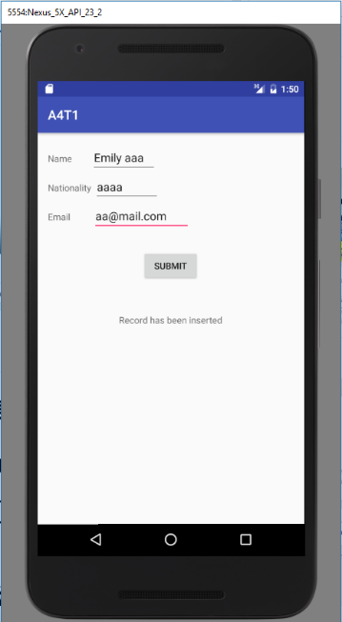**Screenshot**

**Task 2**: Material theme and animations

**Material theme**: The material theme when implemented correctly is able to produce an image representing the developer’s or company’s color scheme or something similar. In addition, it provides a uniform color scheme to the entire app, ensuring there is contrast between the different parts of the application.On this attempt, I am trying to produce a view which is low light friendly by changing the application’s color scheme to darker colors, which are soothing to the eyes of the user when under low to no light conditions.

**Custom Animations:** Custom animations on activity change tells the user that that they are going to a different part of application. When directional transition animations are used, it creates an imaginary breadcrumb inside the user’s mind, where the left to right animation shows positive progress whereas left to right shows negative progress (going back to previous activity).

Codes for animations

In mainactivity

1. btn.setOnClickListener(new View.OnClickListener() {
2. @Override
3. public void onClick(View v) {
4. Intent intent = new Intent();
5. intent.setClass(getApplicationContext(),GetProfile.class);
6. intent.addFlags(Intent.FLAG_ACTIVITY_NO_ANIMATION);
7. startActivityForResult(intent,1);
8. overridePendingTransition(R.anim.fadein, R.anim.fadeout);


12. }
13. });
15. btn1.setOnClickListener(new View.OnClickListener() {
16. @Override
17. public void onClick(View v) {
18. Intent intent = new Intent();
19. intent.setClass(getApplicationContext(),GetNationality.class);
20. //intent.addFlags(Intent.FLAG_ACTIVITY_NO_ANIMATION);
21. startActivityForResult(intent,2);
22. overridePendingTransition(R.anim.slidein, R.anim.slideout);
24. }
25. });

In other activities , returning from activity animations are defined as

@Override

public void onBackPressed() {

super.onBackPressed();

overridePendingTransition(R.anim.enter, R.anim.leave);

}

Defining animations in /res/ani

Slidein.xml

1. <?xml version="1.0" encoding="utf-8"?>
2. <translate
3. xmlns:android="http://schemas.android.com/apk/res/android"
4. android:duration="@android:integer/config_longAnimTime"
5. android:fromXDelta="100%p"
6. android:toXDelta="0%p">
7. </translate>

Slideout.xml

1. <?xml version="1.0" encoding="utf-8"?>
2. <translate
3. xmlns:android="http://schemas.android.com/apk/res/android"
4. android:duration="@android:integer/config_longAnimTime"
5. android:fromXDelta="0%p"
6. android:toXDelta="-100%p">
7. </translate>

Fadein.xml

1. <?xml version="1.0" encoding="utf-8"?>
2. <alpha xmlns:android="http://schemas.android.com/apk/res/android"
3. android:interpolator="@android:anim/accelerate_interpolator"
4. android:fromAlpha="0.0" android:toAlpha="1.0"
5. android:duration="500" />

Fadeout.xml

1. <?xml version="1.0" encoding="utf-8"?>
2. <alpha xmlns:android="http://schemas.android.com/apk/res/android"
3. android:interpolator="@android:anim/accelerate_interpolator"
4. android:fromAlpha="1.0" android:toAlpha="0.0"
5. android:fillAfter="true"
6. android:duration="500" />

Enter.xml

1. <set xmlns:android="http://schemas.android.com/apk/res/android"
2. android:shareInterpolator="false">
3. <translate android:fromXDelta="-100%" android:toXDelta="0%"
4. android:fromYDelta="0%" android:toYDelta="0%"
5. android:duration="700"/>
6. </set>

Leave.xml

1. <set xmlns:android="http://schemas.android.com/apk/res/android"
2. android:shareInterpolator="false">
3. <translate
4. android:fromXDelta="0%" android:toXDelta="100%"
5. android:fromYDelta="0%" android:toYDelta="0%"
6. android:duration="700" />
7. </set>

Screenshot

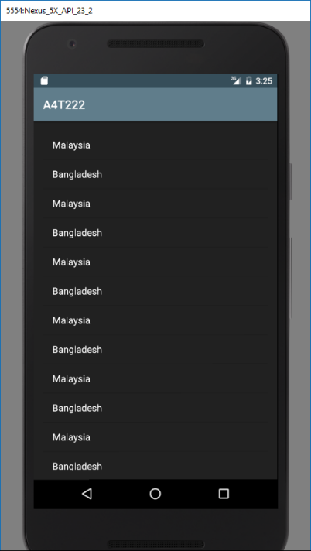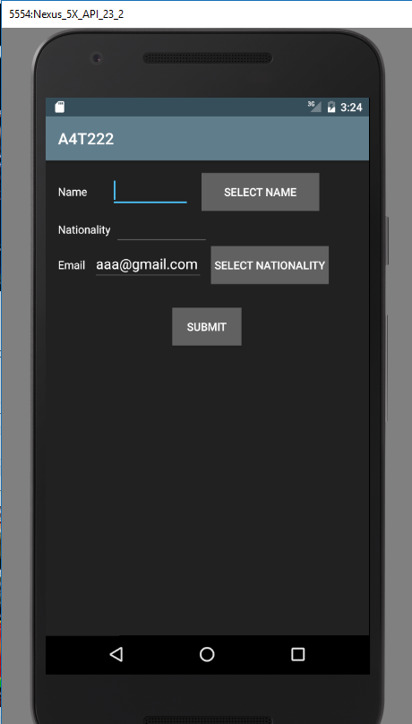

**Task 3**: Implicit intent to open browser and search.

MainActivity.java

1. package com.example.a4329619.a4t3;
3. import android.content.Intent;
4. import android.net.Uri;
5. import android.support.v7.app.AppCompatActivity;
6. import android.os.Bundle;
7. import android.view.View;
8. import android.widget.Button;
9. import android.widget.EditText;
11. import java.net.URLEncoder;
13. public class MainActivity extends AppCompatActivity {
15. Button btn;
16. EditText ed;
18. @Override
19. protected void onCreate(Bundle savedInstanceState) {
20. super.onCreate(savedInstanceState);
21. setContentView(R.layout.activity_main);

24. btn = (Button)findViewById(R.id.btn);
25. ed = (EditText)findViewById(R.id.ed);
27. btn.setOnClickListener(new View.OnClickListener() {
28. @Override
29. public void onClick(View view) {
30. String query = ed.getText().toString();
31. query = URLEncoder.encode(query);
32. String url = "http://www.google.com/search?q="+ query;
33. Intent i = new Intent(Intent.ACTION_VIEW);
34. i.setData(Uri.parse(url));
35. startActivity(i);
36. }
37. });
39. }
40. }

Screenshots

