**Formative Assignment 5**

**Task 1**: Create app utilizing SQLite to add, view, update and delete records.

Added permission for phone call in manifest.

<**uses-permission android:name="android.permission.CALL_PHONE"** />

Contact.java

**package** com.example.lesgo.a5t1;  
  
**import** android.os.Parcel;  
**import** android.os.Parcelable;  
  
*/**  
 * Created by lesgo on 10/31/2016.  
 */***public class** Contact **implements** Parcelable{  
 **int id**;  
 String **name**;  
 String **contact**;  
 String **email**;  
  
 **public** Contact(**int** id, String name, String contact, String email) {  
 **this**.**id** = id;  
 **this**.**name** = name;  
 **this**.**contact** = contact;  
 **this**.**email** = email;  
 }  
  
 **public** Contact(String name, String contact, String email) {  
 **this**.**name** = name;  
 **this**.**contact** = contact;  
 **this**.**email** = email;  
 }  
  
 **public** Contact() {  
 }  
  
 **public** Contact(**int** id) {  
 **this**.**id** = id;  
 }  
  
 **public int** getId() {  
 **return id**;  
 }  
  
 **public void** setId(**int** id) {  
 **this**.**id** = id;  
 }  
  
 **public** String getName() {  
 **return name**;  
 }  
  
 **public void** setName(String name) {  
 **this**.**name** = name;  
 }  
  
 **public** String getContact() {  
 **return contact**;  
 }  
  
 **public void** setContact(String contact) {  
 **this**.**contact** = contact;  
 }  
  
 **public** String getEmail() {  
 **return email**;  
 }  
  
 **public void** setEmail(String email) {  
 **this**.**email** = email;  
 }  
  
  
 @Override  
 **public int** describeContents() {  
 **return** 0;  
 }  
  
 @Override  
 **public void** writeToParcel(Parcel parcel, **int** flags) {  
 parcel.writeInt(**this**.**id**);  
 parcel.writeString(**this**.**name**);  
 parcel.writeString(**this**.**contact**);  
 parcel.writeString(**this**.**email**);  
  
 }  
  
 **public** Contact(Parcel in){  
 **this**.**id**= in.readInt();  
 **this**.**name** = in.readString();  
 **this**.**contact** = in.readString();  
 **this**.**email** = in.readString();  
 }  
  
 **public static final** Creator<Contact> ***CREATOR*** = **new** Creator<Contact>(){  
 @Override  
 **public** Contact createFromParcel(Parcel parcel) {  
 **return new** Contact(parcel);  
 }  
  
 @Override  
 **public** Contact[] newArray(**int** i) {  
 **return new** Contact[i];  
 }  
  
 };  
}

AddContact.java

**package** com.example.lesgo.a5t1;  
  
**import** android.content.Intent;  
**import** android.support.v7.app.AppCompatActivity;  
**import** android.os.Bundle;  
**import** android.util.Log;  
**import** android.view.View;  
**import** android.widget.EditText;  
**import** android.widget.ImageView;  
**import** android.widget.Toast;  
  
**import** java.util.ArrayList;  
**import** java.util.List;  
  
**public class** AddContact **extends** AppCompatActivity {  
  
 EditText **txtName**;  
 EditText **txtNum**;  
 EditText **txtEmail**;  
 ImageView **btnSubmit**;  
  
 DbHandler **db**;  
  
  
 @Override  
 **protected void** onCreate(Bundle savedInstanceState) {  
 **super**.onCreate(savedInstanceState);  
 setContentView(R.layout.***activity_add_contact***);  
  
 **db** = **new** DbHandler(**this**);  
  
 List<Contact> contacts= **db**.getAllContacts();  
 **if** (contacts!=**null**){  
 **for**(Contact c:contacts){  
 Log.*d*(**"record in add"**,Integer.*toString*(c.getId())+ **","** + c.getName()+ **","** + c.getContact()+**","** + c.getEmail() );  
 }  
 }  
 **else**{  
 Log.*d*(**"null"**,**"null"**);  
 }  
  
  
 **txtName** = (EditText)findViewById(R.id.***nAme***);  
 **txtNum** = (EditText)findViewById(R.id.***nUmber***);  
 **txtEmail** = (EditText)findViewById(R.id.***eMail***);  
  
 **btnSubmit** = (ImageView)findViewById(R.id.***addBtn***);  
  
 **btnSubmit**.setOnClickListener(**new** View.OnClickListener() {  
 @Override  
 **public void** onClick(View v) {  
 Toast t = Toast.*makeText*(getApplicationContext(), **"Please fill in all your details"**, Toast.***LENGTH_SHORT***);  
  
 String name = **txtName**.getText().toString();  
 String number = **txtNum**.getText().toString();  
 String email = **txtEmail**.getText().toString();  
  
 **if**(name.matches(**""**)||number.matches(**""**)||email.matches(**""**))  
 {  
 t.cancel();  
 t = Toast.*makeText*(getApplicationContext(), **"Please fill in all your details"**, Toast.***LENGTH_SHORT***);  
 t.show();  
 }  
 **else** {  
 t.cancel();  
  
 t = Toast.*makeText*(getApplicationContext(), **"Contact created"**, Toast.***LENGTH_SHORT***);  
 t.show();  
  
 Contact c = **new** Contact(name,number,email);  
  
 Intent intent = **new** Intent();  
 ArrayList<Contact> contactList = **new** ArrayList<>();  
 contactList.add(c);  
  
 intent.putParcelableArrayListExtra(**"contact"**,contactList);  
 setResult(***RESULT_OK***,intent);  
 finish();  
 }  
 }  
 });  
  
 }  
}

MainActivity.java

**package** com.example.lesgo.a5t1;  
  
**import** android.app.AlertDialog;  
**import** android.content.DialogInterface;  
**import** android.content.Intent;  
**import** android.os.Bundle;  
**import** android.support.design.widget.FloatingActionButton;  
**import** android.support.v7.app.AppCompatActivity;  
**import** android.support.v7.widget.DefaultItemAnimator;  
**import** android.support.v7.widget.LinearLayoutManager;  
**import** android.support.v7.widget.RecyclerView;  
**import** android.support.v7.widget.Toolbar;  
**import** android.util.Log;  
**import** android.view.View;  
**import** android.widget.Toast;  
  
**import** java.util.ArrayList;  
**import** java.util.List;  
  
**public class** MainActivity **extends** AppCompatActivity {  
  
 DbHandler **db**;  
 List<Contact> **contacts**;  
 RecyclerViewAdapter **adapter** ;  
 RecyclerView **recycle_view**;  
 AlertDialog.Builder **builder1**;  
  
 @Override  
 **protected void** onCreate(Bundle savedInstanceState) {  
 **super**.onCreate(savedInstanceState);  
 setContentView(R.layout.***activity_main***);  
  
 **builder1** = **new** AlertDialog.Builder(**this**);  
 **db** = **new** DbHandler(**this**);  
  
  
 Toolbar toolbar = (Toolbar) findViewById(R.id.***toolbar***);  
 setSupportActionBar(toolbar);  
  
 FloatingActionButton fab = (FloatingActionButton) findViewById(R.id.***fab***);  
 fab.setOnClickListener(**new** View.OnClickListener() {  
 @Override  
 **public void** onClick(View view) {  
 Intent intent = **new** Intent();  
 intent.setClass(getApplicationContext(),AddContact.**class**);  
 startActivityForResult(intent,0);  
 }  
 });  
  
 **contacts**= **db**.getAllContacts();  
  
 **adapter** = **new** RecyclerViewAdapter(**contacts**);  
 **adapter**.setOnItemClickListener(**new** RecyclerViewAdapter.OnItemClickListener() {  
 @Override  
 **public void** onItemClick(String name, String contact,String id) {  
 Log.*d*(**"ON ITEM CLICK"**, name + contact);  
  
 Intent intent = **new** Intent();  
 intent.setClass(getApplicationContext(), DisplayContact.**class**);  
 intent.putExtra(**"id"**,id);  
  
 startActivityForResult(intent,2);  
 }  
 });  
  
  
 **adapter**.setOnLongClickListener(**new** RecyclerViewAdapter.OnLongClickListener() {  
 @Override  
 **public void** OnLongItemClick(String id) {  
 Log.*d*(**"ON LONG PRESS"** , id);  
  
 **final** Contact c = **new** Contact(Integer.*parseInt*(id));  
  
 **builder1**.setTitle(**"Confirm deletion"**);  
 **builder1**.setMessage(**"Are you sure you want to delete this contact"**);  
 **builder1**.setCancelable(**true**);  
  
 **builder1**.setPositiveButton(  
 **"Yes"**,  
 **new** DialogInterface.OnClickListener() {  
 **public void** onClick(DialogInterface dialog, **int** ida) {  
 **db**.deleteContact(c);  
  
 finish();  
 startActivity(getIntent());  
  
 dialog.cancel();  
  
 Toast t = Toast.*makeText*(getApplicationContext(), **"Contact Deleted"**, Toast.***LENGTH_SHORT***);  
 t.show();  
 }  
 });  
  
 **builder1**.setNegativeButton(  
 **"No"**,  
 **new** DialogInterface.OnClickListener() {  
 **public void** onClick(DialogInterface dialog, **int** id) {  
 dialog.cancel();  
 }  
 });  
  
 AlertDialog alert11 = **builder1**.create();  
 alert11.show();  
  
 }  
 });  
  
 **recycle_view** = (RecyclerView)findViewById(R.id.***recyclerview***);  
 RecyclerView.LayoutManager layoutManager = **new** LinearLayoutManager(getApplicationContext());  
 **recycle_view**.setLayoutManager(layoutManager);  
 **recycle_view**.setItemAnimator(**new** DefaultItemAnimator());  
 **recycle_view**.setAdapter(**adapter**);  
  
 }  
  
 @Override  
 **protected void** onActivityResult(**int** requestCode, **int** resultCode, Intent data) {  
 **super**.onActivityResult(requestCode, resultCode, data);  
  
 **if**(data == **null**)  
 {  
 Log.*d*(**"onactivityresult"**,**"is null"**);  
 **if**(requestCode == 2)  
 {  
 finish();  
 startActivity(getIntent());  
  
 }  
 }  
 **else** {  
 **if**(requestCode == 0)  
 {  
 ArrayList<Contact> contactdata = data.getParcelableArrayListExtra(**"contact"**);  
 Contact d;  
 d = contactdata.get(0);  
  
 Log.*d*(**"here"**, d.getName() +**","**+ d.getContact() +**","**+ d.getEmail());  
 **db**.addContact(d);  
  
 finish();  
 startActivity(getIntent());  
  
 }  
 }  
 }  
  
}

RecyclerViewAdapter.java

**package** com.example.lesgo.a5t1;  
  
**import** android.content.Context;  
**import** android.support.v7.widget.RecyclerView;  
**import** android.util.Log;  
**import** android.view.LayoutInflater;  
**import** android.view.View;  
**import** android.view.ViewGroup;  
**import** android.widget.AdapterView;  
**import** android.widget.TextView;  
  
**import** java.util.List;  
  
*/**  
 * Created by lesgo on 11/1/2016.  
 */***public class** RecyclerViewAdapter **extends** RecyclerView.Adapter<RecyclerViewAdapter.CustomViewHolder> {  
  
  
 **private** List<Contact> **contact_list**;  
 **public** RecyclerViewAdapter(List<Contact> list) {  
 **contact_list** = list;  
 }  
  
 **public class** CustomViewHolder **extends** RecyclerView.ViewHolder{  
  
 **public** TextView **txtName**,**txtContact**,**txtID**;  
 **public** CustomViewHolder(View itemView){  
 **super**(itemView);  
 **txtName** = (TextView)itemView.findViewById(R.id.***txtName***);  
 **txtContact** = (TextView)itemView.findViewById(R.id.***txtContact***);  
 **txtID** = (TextView)itemView.findViewById(R.id.***id***);  
  
 itemView.setOnClickListener(**new** View.OnClickListener() {  
 @Override  
 **public void** onClick(View v) {  
 String name = **txtName**.getText().toString();  
 String contact = **txtContact**.getText().toString();  
 String id = **txtID**.getText().toString();  
  
 Log.*d*(**"testlog"**,name+contact+id);  
 **listener**.onItemClick(name,contact,id);  
 *//do something* }  
 });  
  
 itemView.setOnLongClickListener(**new** View.OnLongClickListener() {  
 @Override  
 **public boolean** onLongClick(View v) {  
 String id = **txtID**.getText().toString();  
 **Llistener**.OnLongItemClick(id);  
 **return true**;  
 }  
 });  
 }  
  
 }  
  
 **public** OnItemClickListener **listener**;  
  
 **public interface** OnItemClickListener{  
 **void** onItemClick(String name , String contact,String id);  
 }  
  
 **public void** setOnItemClickListener(OnItemClickListener listener) {  
 **this**.**listener** = listener;  
 }  
  
  
 **public** OnLongClickListener **Llistener**;  
  
 **public interface** OnLongClickListener{  
 **void** OnLongItemClick(String id);  
 }  
  
 **public void** setOnLongClickListener(OnLongClickListener listener)  
 {  
 **this**.**Llistener** = listener;  
 }  
  
  
 @Override  
 **public** RecyclerViewAdapter.CustomViewHolder onCreateViewHolder(ViewGroup parent, **int** viewType) {  
 Context context = parent.getContext();  
 LayoutInflater inflator = LayoutInflater.*from*(context);  
 View v = inflator.inflate(R.layout.***row_view***,parent,**false**);  
 **return new** CustomViewHolder(v);  
  
 }  
  
 @Override  
 **public void** onBindViewHolder(RecyclerViewAdapter.CustomViewHolder holder, **int** position) {  
 Contact c = **contact_list**.get(position);  
 holder.**txtName**.setText(c.getName());  
 holder.**txtContact**.setText(c.getContact());  
 holder.**txtID**.setText(String.*valueOf*(c.getId()));  
 }  
  
 @Override  
 **public int** getItemCount() {  
 **if**(**contact_list**!=**null**)  
 {  
 **return contact_list**.size();  
 }  
 **else** {  
 **return** 0;  
 }  
 }  
}

DisplayContact.java

**package** com.example.lesgo.a5t1;  
  
**import** android.content.Intent;  
**import** android.net.Uri;  
**import** android.support.v7.app.AppCompatActivity;  
**import** android.os.Bundle;  
**import** android.util.Log;  
**import** android.view.Menu;  
**import** android.view.MenuItem;  
**import** android.view.View;  
**import** android.widget.Button;  
**import** android.widget.EditText;  
**import** android.widget.TextView;  
**import** android.widget.Toast;  
  
**public class** DisplayContact **extends** AppCompatActivity {  
 Bundle **bundle**;  
 DbHandler **db**;  
 EditText **txtName**,**txtContact**,**txtEmail**;  
 Boolean **b** = **false**;  
 Button **bCall**,**bUpdate**;  
 Contact **c** ;  
 @Override  
 **protected void** onCreate(Bundle savedInstanceState) {  
 **super**.onCreate(savedInstanceState);  
 setContentView(R.layout.***activity_display_contact***);  
  
 **txtName** = (EditText)findViewById(R.id.***eName***);  
 **txtContact** = (EditText)findViewById(R.id.***eNumber***);  
 **txtEmail** = (EditText)findViewById(R.id.***eEmail***);  
 **bCall** = (Button)findViewById(R.id.***call***);  
 **bUpdate** = (Button)findViewById(R.id.***update***);  
  
 **txtName**.setFocusableInTouchMode(**false**);  
 **txtContact**.setFocusableInTouchMode(**false**);  
 **txtEmail**.setFocusableInTouchMode(**false**);  
  
  
 **bundle** = getIntent().getExtras();  
 String idnum = **bundle**.getString(**"id"**);  
  
  
 **db** = **new** DbHandler(**this**);  
 **c** = **db**.getContact(idnum);  
 **txtName**.setText(**c**.getName());  
 **txtContact**.setText(**c**.getContact());  
 **txtEmail**.setText(**c**.getEmail());  
  
  
 **bCall**.setOnClickListener(**new** View.OnClickListener() {  
 @Override  
 **public void** onClick(View v) {  
 Intent intent = **new** Intent(Intent.***ACTION_CALL***, Uri.*parse*(**"tel:"** + Integer.*parseInt*( **c**.getContact())));  
 startActivity(intent);  
 }  
 });  
  
 **bUpdate**.setOnClickListener(**new** View.OnClickListener() {  
 @Override  
 **public void** onClick(View v) {  
 **db**.updateContact(**new** Contact(**c**.getId(),**txtName**.getText().toString(),**txtContact**.getText().toString(),**txtEmail**.getText().toString()));  
 Toast t = Toast.*makeText*(getApplicationContext(), **"Updated"**, Toast.***LENGTH_SHORT***);  
 t.show();  
  
 setResult(***RESULT_OK***);  
 finish();  
 }  
 });  
 }  
  
 @Override  
 **public boolean** onCreateOptionsMenu(Menu menu) {  
 *// Inflate the menu; this adds items to the action bar if it is present.* getMenuInflater().inflate(R.menu.***menu_main***, menu);  
 **return true**;  
 }  
  
 @Override  
 **public boolean** onOptionsItemSelected(MenuItem item) {  
 *// Handle action bar item clicks here. The action bar will  
 // automatically handle clicks on the Home/Up button, so long  
 // as you specify a parent activity in AndroidManifest.xml.* **int** id = item.getItemId();  
  
 *//noinspection SimplifiableIfStatement* **if** (id == R.id.***action_settings***) {  
 **return true**;  
 }  
 **else if**(id == R.id.***edit***){  
 **if**(**b**==**false**)  
 {  
 Toast t = Toast.*makeText*(getApplicationContext(), **"Edit Mode on"**, Toast.***LENGTH_SHORT***);  
 t.show();  
  
 **bCall**.setVisibility(View.***INVISIBLE***);  
 **bUpdate**.setVisibility(View.***VISIBLE***);  
  
 **b**=**true**;  
 **txtName**.setFocusableInTouchMode(**true**);  
 **txtContact**.setFocusableInTouchMode(**true**);  
 **txtEmail**.setFocusableInTouchMode(**true**);  
 }  
 **else** {  
 Toast t = Toast.*makeText*(getApplicationContext(), **"Edit Mode off"**, Toast.***LENGTH_SHORT***);  
 t.show();  
  
 **bCall**.setVisibility(View.***VISIBLE***);  
 **bUpdate**.setVisibility(View.***INVISIBLE***);  
  
 **b**=**false**;  
 **txtName**.setFocusableInTouchMode(**false**);  
 **txtContact**.setFocusableInTouchMode(**false**);  
 **txtEmail**.setFocusableInTouchMode(**false**);  
  
 **txtName**.clearFocus();  
 **txtContact**.clearFocus();  
 **txtEmail**.clearFocus();  
  
 }  
  
 }  
  
  
 **return super**.onOptionsItemSelected(item);  
 }  
  
}

DbHandler.java

**package** com.example.lesgo.a5t1;  
  
**import** android.content.ContentValues;  
**import** android.content.Context;  
**import** android.database.Cursor;  
**import** android.database.sqlite.SQLiteDatabase;  
**import** android.database.sqlite.SQLiteOpenHelper;  
**import** android.util.Log;  
**import** android.widget.Toast;  
  
**import** java.lang.reflect.Array;  
**import** java.util.ArrayList;  
**import** java.util.Arrays;  
**import** java.util.List;  
  
*/**  
 * Created by lesgo on 10/31/2016.  
 */***public class** DbHandler **extends** SQLiteOpenHelper{  
 **public static final int *VERSION*** = 1;  
 **public static final** String ***DB_NAME*** = **"contact_db"**;  
 **public static final** String ***TABLE_NAME*** = **"contacts"**;  
  
  
 **public** DbHandler (Context context)  
 {  
 **super**(context,***DB_NAME***,**null**,***VERSION***);  
 }  
  
 @Override  
 **public void** onCreate(SQLiteDatabase db) {  
 String CREATE_TABLE_SQL = **"CREATE TABLE "** + ***TABLE_NAME*** +  
 **"(id INTEGER PRIMARY KEY, name TEXT, contact TEXT , email TEXT)"**;  
  
 db.execSQL(CREATE_TABLE_SQL);  
 }  
  
 @Override  
 **public void** onUpgrade(SQLiteDatabase db, **int** oldVersion, **int** newVersion) {  
 db.execSQL(**"DROP TABLE IF EXISTS "** + ***TABLE_NAME***);  
 }  
  
 **public void** addContact(Contact contact){  
 SQLiteDatabase db = **this**.getWritableDatabase();  
 ContentValues content = **new** ContentValues();  
  
 content.put(**"name"**,contact.getName());  
 content.put(**"contact"**,contact.getContact());  
 content.put(**"email"**,contact.getEmail());  
  
 db.insert(***TABLE_NAME***,**null**,content);  
 }  
  
 **public void** updateContact(Contact contact){  
 ContentValues content = **new** ContentValues();  
  
 Log.*d*(**"contact details"**,contact.getName() );  
 Log.*d*(**"contact details"**,contact.getContact() );  
 Log.*d*(**"contact details"**,contact.getEmail() );  
  
 content.put(**"name"**,contact.getName());  
 content.put(**"contact"**,contact.getContact());  
 content.put(**"email"**,contact.getEmail());  
  
 String [] args = {String.*valueOf*(contact.getId())};  
  
 SQLiteDatabase db = **this**.getWritableDatabase();  
 db.update(***TABLE_NAME***,content,**"id="**+contact.getId(),**null**);  
  
 }  
  
 **public void** deleteContact(Contact contact){  
 String [] args = {String.*valueOf*(contact.getId())};  
 SQLiteDatabase db = **this**.getWritableDatabase();  
 db.delete(***TABLE_NAME***,**"id =?"**,args);  
  
  
 }  
  
 **public** Contact getContact(String search_id){  
 SQLiteDatabase db = **this**.getWritableDatabase();  
 Cursor cursor = db.query(***TABLE_NAME***,**new** String[]{**"id"**,**"name"**,**"contact"**,**"email"**},  
 **"id=?"**,  
 **new** String[]{String.*valueOf*(search_id)},  
 **null**,**null**,**null**,**null**);  
  
 **if**(cursor.moveToFirst()){  
 cursor.moveToFirst();  
 Contact c = **new** Contact(Integer.*valueOf*(cursor.getString(0)),cursor.getString(1),cursor.getString(2),cursor.getString(3));  
 **return** c;  
 }  
 **return null**;  
 }  
  
 **public** List<Contact> getAllContacts(){  
 List<Contact> contactList = **new** ArrayList<>();  
 SQLiteDatabase db = **this**.getWritableDatabase();  
  
 Cursor cursor = db.rawQuery(**"SELECT * from "** + ***TABLE_NAME***,**null**);  
  
 **if**(cursor.moveToFirst()){  
 **do**{  
 Contact c = **new** Contact();  
 c.setId(Integer.*valueOf*(cursor.getString(0)));  
 c.setName(cursor.getString(1));  
 c.setContact(cursor.getString(2));  
 c.setEmail(cursor.getString(3));  
 contactList.add(c);  
 }**while**(cursor.moveToNext());  
 **return** contactList;  
 }  
 **return null**;  
 }  
  
}

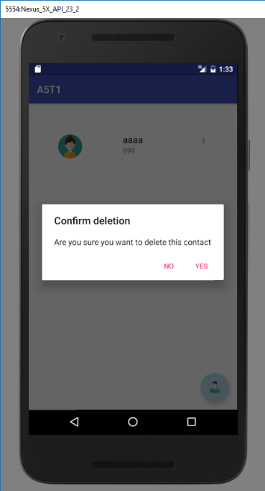

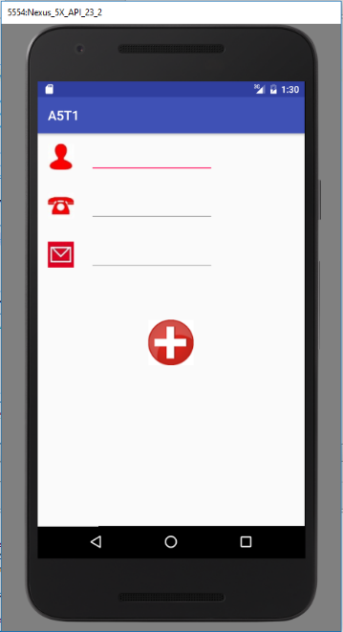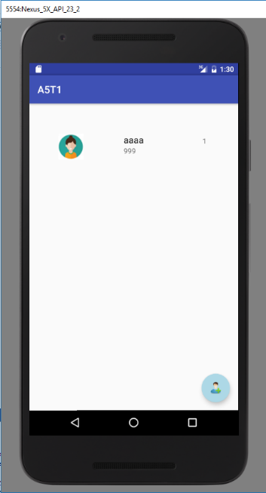

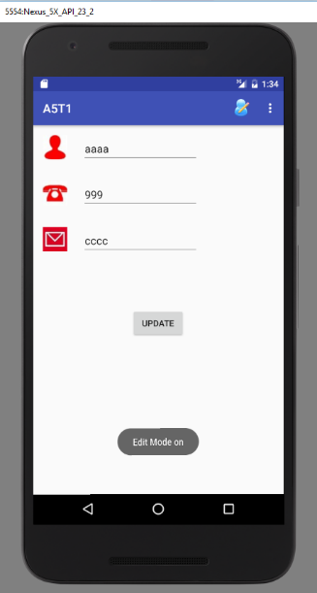

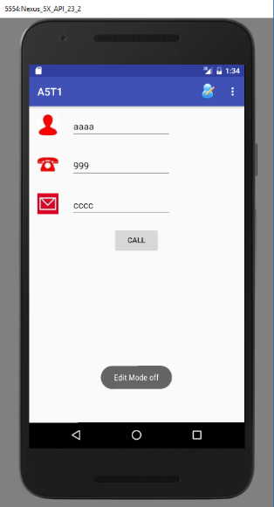

**Task 2**: Create app that loads http pages that renders well on small screen

MainActivity.java

**package** com.example.lesgo.a5t2;  
  
**import** android.support.v7.app.AppCompatActivity;  
**import** android.os.Bundle;  
**import** android.webkit.WebView;  
  
**public class** MainActivity **extends** AppCompatActivity {  
  
 @Override  
 **protected void** onCreate(Bundle savedInstanceState) {  
 **super**.onCreate(savedInstanceState);  
 setContentView(R.layout.***activity_main***);  
  
 WebView web = **new** WebView(**this**);  
 web = (WebView)findViewById(R.id.***webview***);  
 web.loadUrl(**"file:///android_asset/index.html"**);  
 }  
}

index.html

<**html**>  
 <**head**>  
 <**meta charset="UTF-8"**>  
 <**meta name="description" content="Resume"**>  
 <**meta name="keywords" content="HTML,CSS,Resume"**>  
 <**meta name="author" content="xLesterGG"**>  
 <**meta name="viewport" content="width=device-width, initial-scale=1.0"**>  
  
 <**title**> Assignment 5 task 2</**title**>  
  
 <**link rel="stylesheet" type="text/css" href="style.css"**>  
 </**head**>  
  
 <**body**>  
 <**table** >  
 <**tr class="h1"**>  
 <**td colspan="2"** ><**h2**>xLesterGG</**h2**></**td**>  
 </**tr**>  
 <**tr**>  
 <**td colspan="2"**><**img src="kappa.png" height="25%"**></**td**>  
 </**tr**>  
 <**tr class="h1"**>  
 <**td colspan="2"** ><**h2**>Details</**h2**></**td**>  
 </**tr**>  
  
 <**tr**>  
 <**th**>Name:</**th**>  
 <**td class="al"**>Lester</**td**>  
 </**tr**>  
 <**tr class="lhl"**>  
 <**th**>Email:</**th**>  
 <**td class="al"** ><**a href="mailto:lesgoh@hotmail.com"**>lesgoh@hotmail.com</**a**></**td**>  
 </**tr**>  
   
 <**tr**>  
 <**th**>Top subjects </**th**>  
 <**td class="al"**>Mathematics, Chemistry, Physics</**td**>  
 </**tr**>  
 <**tr class="lhl"**>  
 <**th**>Specialty:</**th**>  
 <**td**>Sleeping, wasting time doing something which I shouldn't instead of something like this assignment, and overthinking</**td**>  
 </**tr**>  
   
 <**tr**>  
 <**th**>Facebook </**th**>  
 <**td class="al"**><**a href="https://www.facebook.com/XxPureLucKxX"**>Lester G</**a**></**td**>  
 </**tr**>  
 </**table**>  
 </**body**>  
</**html**>

Style.css

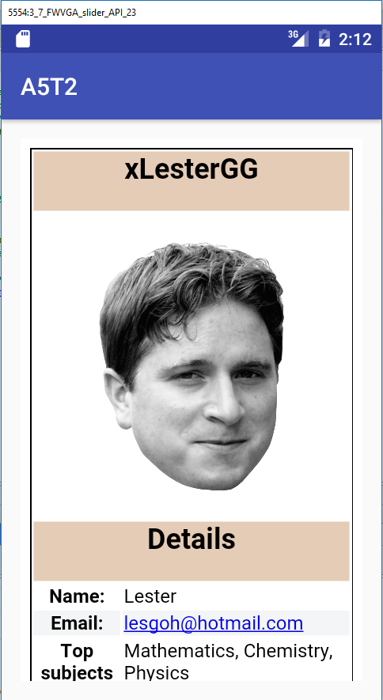h1{  
 text-align:center;  
}  
  
  
table{  
 margin-left: auto;  
 margin-right: auto;  
 border:1px solid black;  
}  
  
table td{  
 text-align: center  
}  
  
.al{  
 text-align:left;  
}  
  
.h1{  
 background: #E5CCB7;  
}  
  
.lhl{  
 background: #F4F5F6;  
}