**Local Web Product QR generator**

This web application is meant to be hosted locally and accessible via WiFi in the first line of the chain (factories, production places etc), and thus is not hosted online.

**Requirements:**

* A running XAMPP server (Apache/PhpMyAdmin).
* A web browser
* Internet connection , and is allowed to access NXT peer (<http://174.140.168.136:6876/>)
* SQL database created

**How to get the app running:**

1. Have Xampp installed on a computer
2. Look for the folder with the name _ from the attached folder.
3. Rename the folder to generate and move them to YourDriveLetter:\xampp\htdocs, the final path should look something like C:\xampp\htdocs\generate or your custom directory should you have one.  
     
   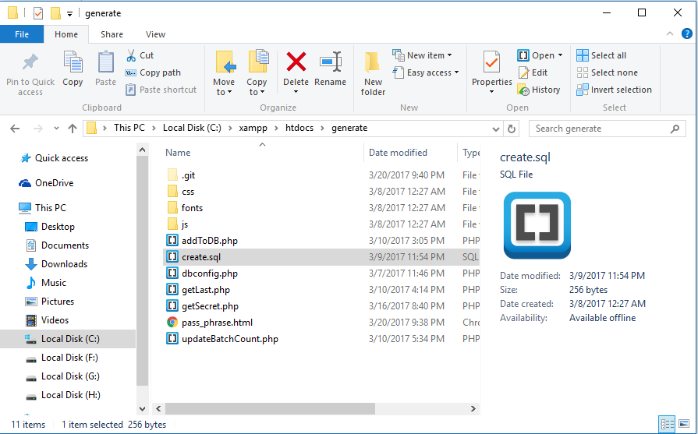
4. Launch Apache and MySQL from Xampp control panel.

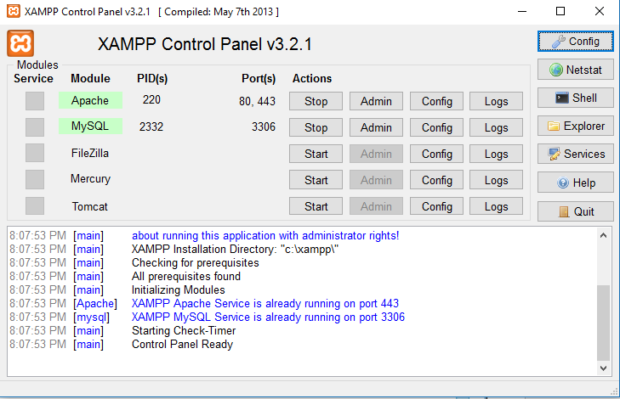

1. Navigate to localhost/phpmyadmin on a browser (on host machine) and click on the SQL tab

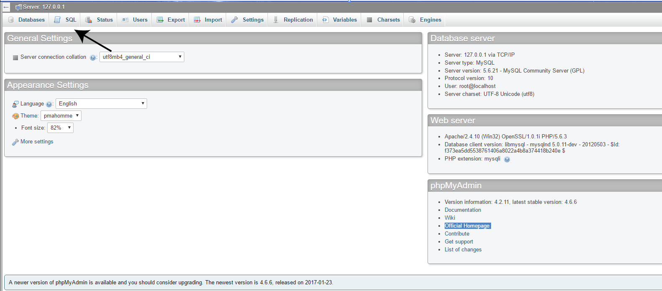

1. Copy the content from C:\xampp\htdocs\generate\create.sql and paste it inside the text field. Then press go to create the database.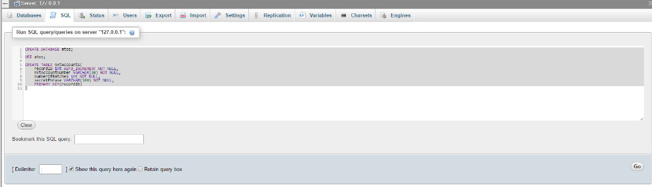
2. Navigate to <http://localhost/generate/pass_phrase.html>. The web application should be loaded and everything should work well.
3. Should the mySQL database have a non-default username and password, change them in dbconfig.php.

**Open source libraries used:**

* Javascypt - <https://www.fourmilab.ch/javascrypt/pass_phrase.html>
* QR generator - <https://davidshimjs.github.io/qrcodejs/>

**External API used:**

* NXT API - <https://nxtwiki.org/wiki/The_Nxt_API>

**Files to take note off:**

* Controller.js in the js folder – It contains most of the logics of the web application. The rest of the JavaScript files are merely dependencies for some libraries to work.

**Use Case:**

1. A worker has 60 apples, and divide them into packs to 6, ending up with 10 packs in total.
2. The worker proceeds to generating the QR for this batch of 60 apples using the ***generate web application*** (FoodChain- Product QR Generator). The QR generated will be printed and placed on each of the 10 packs to signify they are from the same batch.
   * There are two functions of product QR:  
     1. As a vessel to receive transactions made for this particular type of item. In the QR contains a NXT account number, which will receive the transactions made by the PreConsumer mobile application and also the batch ID to show which batch of product is the transaction for  
        .
     2. As the QR contains the NXT account number and also the batch ID, when scanned by the Consumer App will query the all the transactions for that account, and retrieve the relevant ones which will later be displayed to the user.