**Secugen MyKad Manual**

1. The program is developed using Node.js running on Windows. To run the program, make sure the computer is installed with Node.js. This program is developed using Node.js V8.12.0
2. The Secugen reader should be automatically detected by Windows 10 as ‘Smard card reader’  
     
   
3. To run this program, unzip the ‘Secugen’ folder, run command prompt and navigate to unzipped ‘Secugen’ folder. Type ‘node index.js’ to run the program. If the hardware is successfully installed, it should show the response as below.

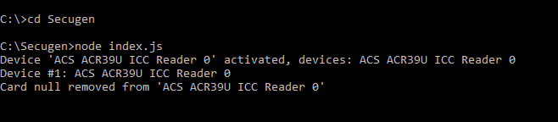

1. At this stage, the program will always wait for a MyKad to be inserted. If read is successful, it should prompt the MyKad holder name.

Reading other information:

The program can be used to read other information stored in MyKad by varying the following:

**Set Length**

The length of the intended information will varies based on the type of information (please refer to data table in the following pages).

For example, ‘Name’ has the length of 40 characters (0x28 in HEX). Therefore, the reader need to issue the command of:

0xC8,0x32,0x00,0x00,0x05,0x08,0x00,0x00,**0x28**,**0x00**

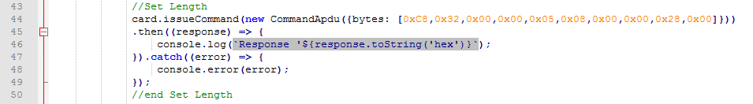

**Set Information**

The reader should tell the card on which block in the memory that it intends to read. The memory block is divided into Page and Address, where one Page contains multiple addresses. Information in MyKad are stored in different pages which can be found in the data table.

For example, ‘Name’ is stored in Page 1-1, in the memory location of 0x00E9. Therefore, the reader need to issue the command of:

0xCC,0x00,0x00,0x00,0x08,**0x01**,**0x00**,**0x01**,**0x00**,**0xE9**,**0x00**,**0x28**,**0x00**

Page 1-1 Addr Len

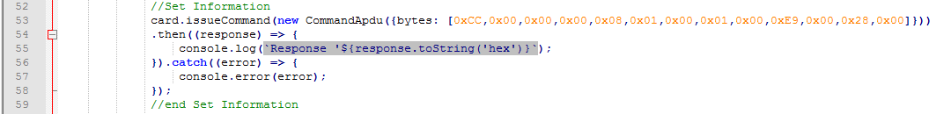

**Read Information**

After setting the intended Length and Information. The reader need to send ‘Read’ command to trigger the reading. This is done by specifying the length of data expected.

For example, ‘Name’ has the length of 0x28. Therefore, the reader need to issue the command of:

0xCC,0x06,0x00,0x00,**0x28**

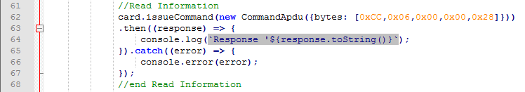

Once the three commands are issue, the MyKad should reply with the correct information stored in the card. To read other information, read call can be made by varying **Set Length**, **Set Information** and **Read Information**.

For example, for reading ‘Address Line 1’:

**Set length:**

0xC8,0x32,0x00,0x00,0x05,0x08,0x00,0x00,**0x1E**,**0x00**

**Set Information:**

0xCC,0x00,0x00,0x00,0x08,**0x04**,**0x00**,**0x01**,**0x00**,**0x03**,**0x00**,**0x1E**,**0x00**

Page 1-4 Addr Len

**Read Information:**

0xCC,0x06,0x00,0x00,**0x1E**

For reading multiple information, repetitive call can be made to **Set Length**, **Set Information** and **Read Information**.

**MyKad Data Table**

**Page 1-1**

Offset Length Length SDK Function Name Description

(Hex) (Dec)

0000 03 3 01 04 24

0003 96 150 JPN_OrgName original name

0099 50 30+30+20 JPN_GMPCName GMPC name

00E9 28 20+20 JPN_KPTName KPT name

0111 0D 13 JPN_IDNum ID number

011E 01 1 JPN_Gender gender

011F 08 8 JPN_OldIDNum old ID number

0127 04 4 JPN_BirthDate date of birth

012B 19 25 JPN_BirthPlace place of birth

0144 04 4 JPN_DateIssued date issued

0148 12 18 JPN_Citizenship citizenship

015A 19 25 JPN_Race race

0173 0B 11 JPN_Religion religion

017E 01 1 JPN_EastMalaysian East Malaysian

017F 02 2 JPN_RJ RJ?

0181 02 2 JPN_KT KT?

0183 0B 11 JPN_OtherID other ID

018E 01 1 JPN_Category category

018F 01 1 JPN_CardVer card version

0190 04 4 JPN_GreenCardExpiry green card expiry date

0194 14 20 JPN_GreenCardNationality green card nationality

01A8 23 35 All 00

**Page 1-2**

0000 03 3 01 40 03

0003 FA0 4000 JPN_Photo JPEG photo

0FA3 08 8 All 00

**Page 1-3**

0000 03 3 01 12 03

0003 14 20 "R1L1",0,0...

0017 256 598 JPN_Thumb1 thumprint 1 (right thumb)

026D 256 598 JPN_Thumb2 thumprint 2 (left thumb)

04C3 08 8 All 00

**Page 1-4**

0000 03 3 01 01 52

0003 1E 30 JPN_Address1 address line 1

0021 1E 30 JPN_Address2 address line 2

003F 1E 30 JPN_Address3 address line 3

005D 03 3 JPN_Postcode postcode

0060 19 25 JPN_City city

0079 1E 30 JPN_State state

0097 14 20 FF 00 00...

**Page 1-5**

0000 03 3 01 12 00

0003 09 9 JPN_SocsoNum socso number

000C 1F 31 All 00

**Page 1-6**

0000 03 3 01 17 00

0003 0A 10 JPN_Locality locality

000D 1E 30 All 00