Xlights/Nutcracker History

xLights was written in 2010 by Matt Brown to create a stable scheduler for his Vixen sequences. LSP, LOR and Vixen users have used xLights to be able to get a full featured, stable scheduler. The scheduler has very little lag and can handle shows with 10's of thousands of channels.

Here is how xLights works today:
a) Setup the hardware you will be using. USB, E1.31 and other hardware are all supported
b) Convert your existing sequences into xLights. The CONVERT tab can read LOR lms or Vixen vix files and create a new xseq xLights file.
- Use the scheduler to play the xseq files in your show.

Note how xLights uses its internal files, xseq, whenever it is playing sequences.

Nutcracker was written by Sean Meighan in Feb 2012 to create massive RGB animations. The flow in Nutcracker is different.
a) Create a target model. Megatree, Matrix .etc.
b) Pick effects and modify them.
- Play the effects and see what they look like on animated gif preview
- Repeat b and c until sastisfied with the effect
e) Export the effect for Vixen, LOR, LSP or HLS

How to setup xLights/Nutcracker.

First launch xLights. The initial launch requires that set a folder where all sequences, export files, xml files will be stored.

Maybe you call it Show2013. I used c:\Vixen2.1.1\Sequences

So set your Show Folder

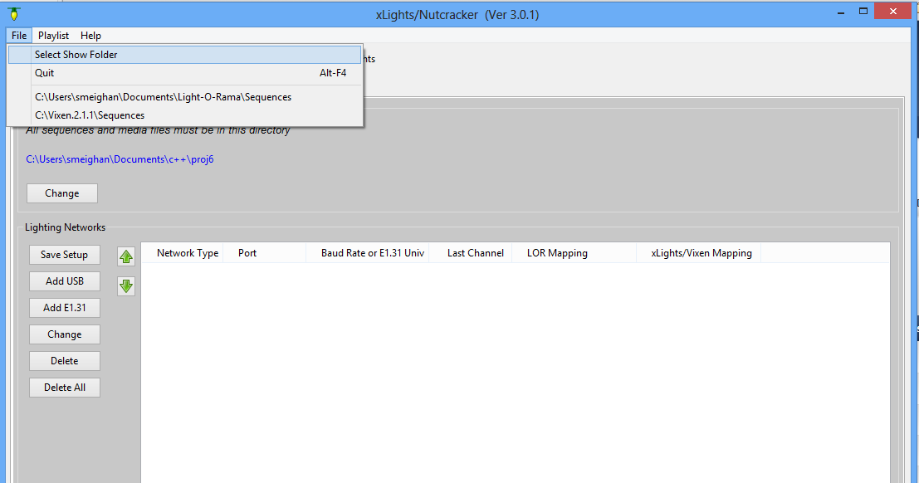

The Next thing we need to do is setup the hardware. If you are just going to be generating Nutcracker effects to be exported for your Sequencer, then setup E1.31. It doesnt matter whether you have E1.31, for the Purpose of the NUTCRACKER tab we need to have enough channels defined here to cover your device.

- Click the SETUP Tab
- Click Add E1.31
- Enter more universes than all of your equipment. I had 12,000 channels , so I used 24 universes (Which give 12,288 channels). Each Universe is 512 channels.
- Click OK
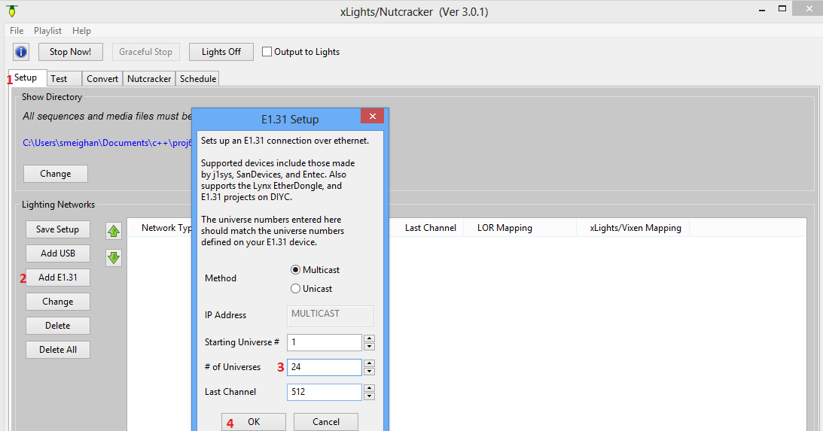

Now save this hardware setup. You will Not need to do these steps in the future.
(6) Save Setup

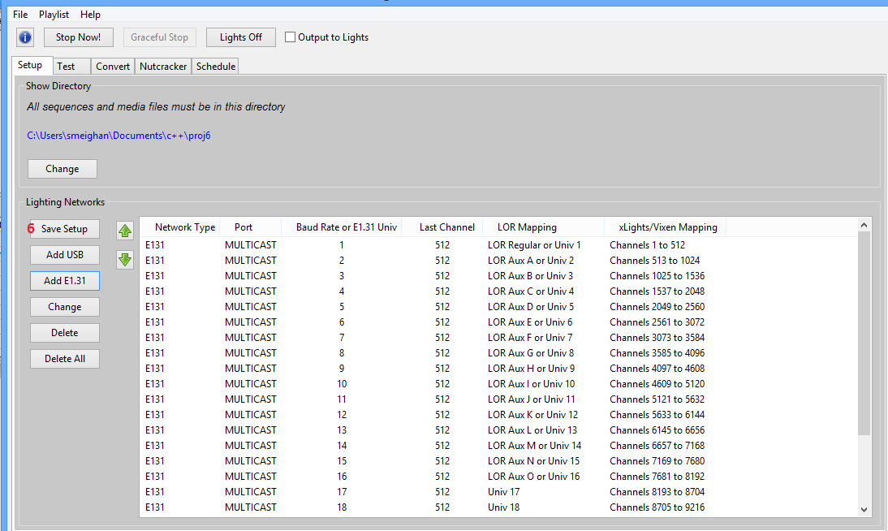
Now, the SETUP TAB is complete. We need to get a xseq file open. You have two choices
- Convert an existing Vixen, LOR file using the CONVERT tab
- Create a blank xseq file.

Lets go through choice 2

First click on the NUTCRACKER tab

- Click on the file open icon
- Select new animation
- Select duration for this new blank, xseq file. NOTE! You cannot put in fractional seconds. 20.5 seconds is illegal, use either 20 or 21. This is an enhancement hat will soon be implemented.
- Click OK to create new sequence

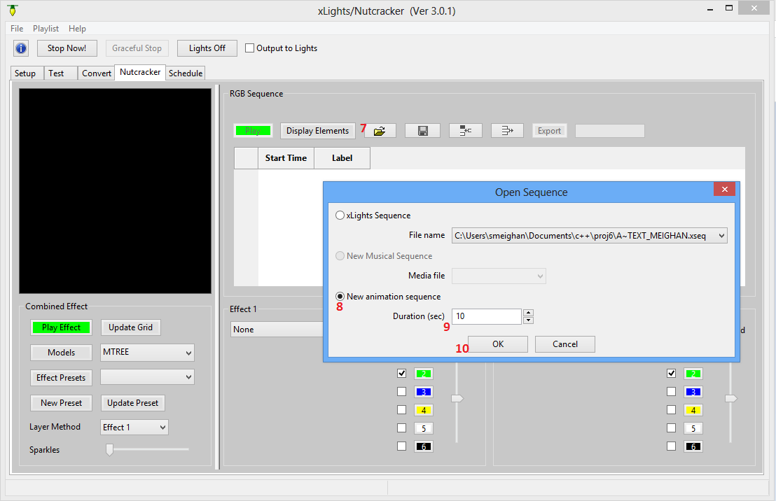

You will see a window pop-up that shows how many channels, the frame timing and the duration of the new sequence file.

Note it created 12,288 channels. This matches what we set in the setup tab. The duration is 12 seconds.

NOTE: frame timing is always 50ms, you currently cannot change it. Xlights ,when it converts Vixen, LOR files into xseq files always changes the frame timing into 50ms. Allowing other frame timing values is on the to do list.
This is not a big deal for my show. Last year I used 100ms frame timing because of how long nutcracker generations took. This year I can use 50ms timing and the generations are faster than last year.

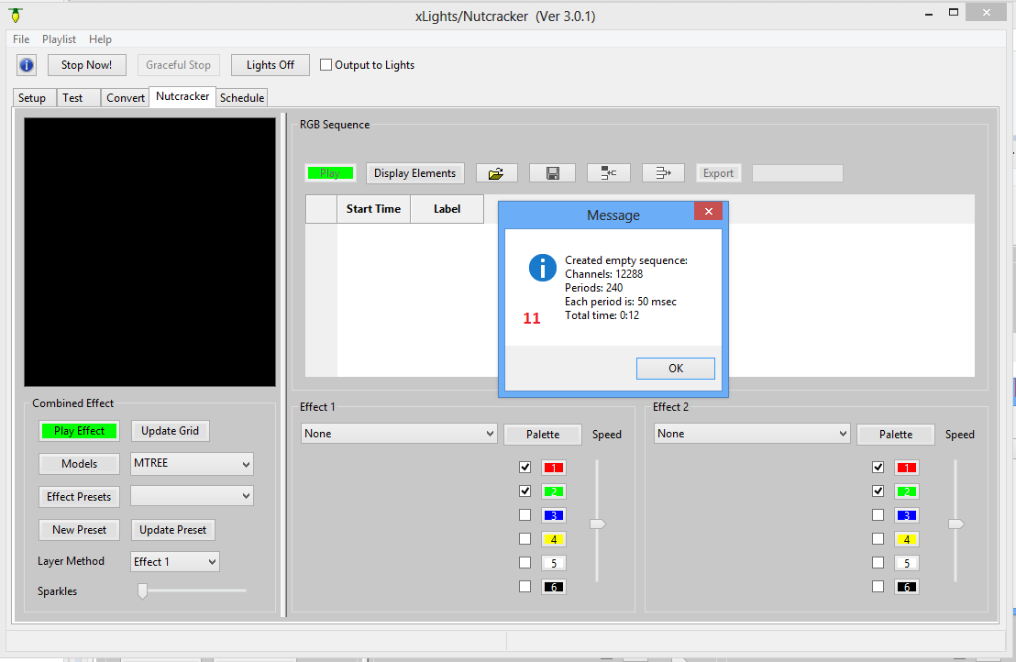
Create a new Target Model

Now we come to the first step you would do if you were using the old Nutcracker software, create a target model.

- Click “Models” to open the Model window
- Click “New”

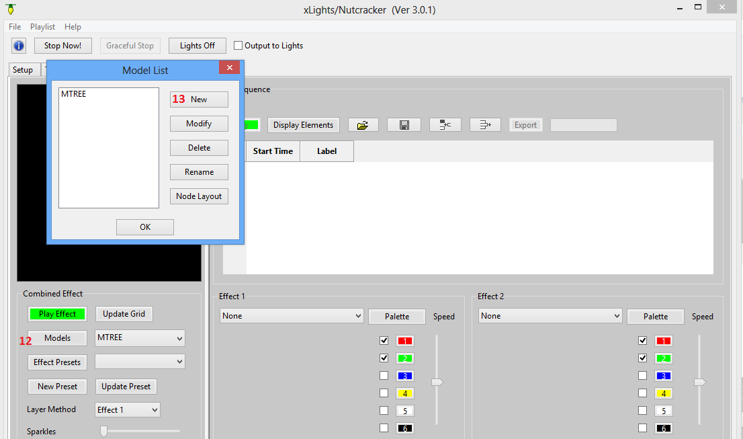

Now we will fill in the parameters

- “Model Name”. This is the same prompt as Nutcracker. Pick a name for this model, no spaces in name please,
- “Display As”. MEGATREE in 360,270,180,90 degrees. Horizontal and Vertical Matrices, Single strand effects. Arches, eaves, Arches.
- “Actual # of Strings” This is the count of the physical strings you will build your target with
- “Number of RGB Nodes per String”.
- “# of Strands per String”. This is where you specify that you will be folding a string. 1 strand per string indicates the string is just being used for its full length. 2 strands per string would indicate you are folding the string in half.
- “Part of my Display” Be sure this is checked. This means that all of the answers to these questions will be stored in your xseq file.
- Click “OK” to save your model
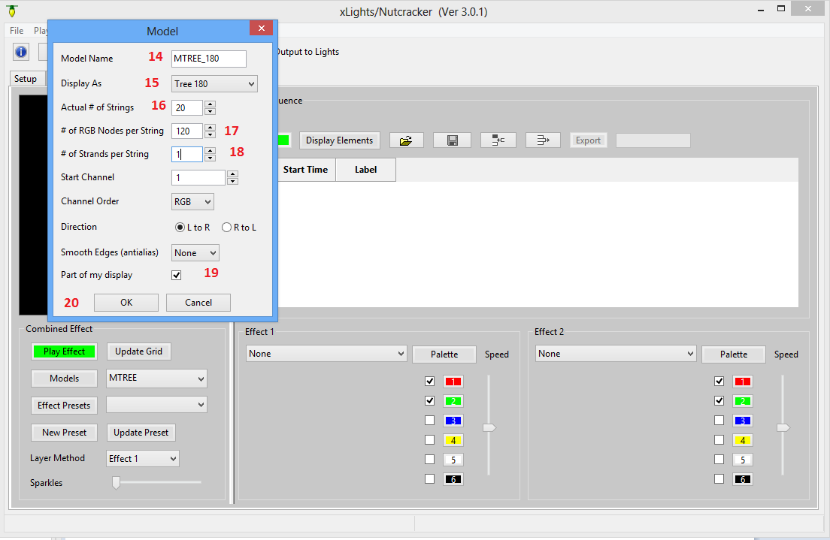
Attach your Model to your sequence

Now we need to attach a model to your current sequence. Remember the sequence is always stored in the xseq format while in xLights/Nutcracker. It is only at the very end that we will export the xseq file as a Vixen,LOR, LSP or HLS file.

To attach a model to the xseq sequence
- Clcik “Display elements”
- Click on the model you want to attach. Note it is legal to attach multiple models to the xseq sequence. For example, maybe my xseq is a 3 minute blank sequence with a Wizards in Winter mp3 file attached. I could , in this step, attach a megatree, a matrix, arches and 2 windows all to the sequence. For now, lets just attach one model.
- Click “OK” to save the model.

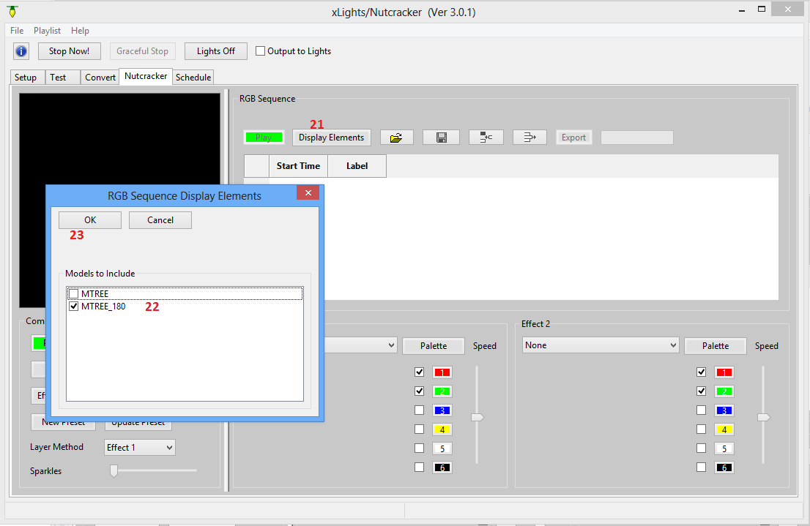
Add Music Phrases to the Sequence

Now we will add the timing marks where you would want to see Nutcracker Effects show up. This is exactly like the projects option in the old Nutcracker. We will add the ability to load up music phrases that have already been marked up for various songs.
For this release you need to enter the timing marks yourself.

- Click on “Insert Row” three times. We will insert three rows of timing marks.
- Type three different start times in the “Start Time” column. The data will automatically be sorted in ascending time order. These times will be where you want the Nutcracker effects to start.
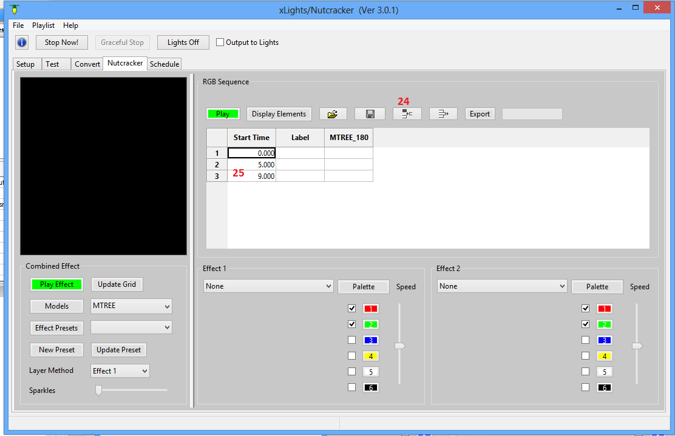
Add Nutcracker Effects

Yeah!, we are now ready to add Nutcracker effects to our xseq sequence. Note, steps 1-25 take less than 60 seconds when you have done it a few times.

- First select a model to be used to preview Nutcracker effects.
- Press “Play Effect” so we can see the effects in the preview window before we attach them to the sequence.
- Select an Effect Class. Lets start with “bars”. Play with the settings until you get the effect just the way you want it.
- When you are satisfied, click on a row and under the model column.
- Click “Update Grid” to have the current Nutcracker effect stored onto that row in the sequence. Repeat steps 28 to 30 filling effects for each music phrase.
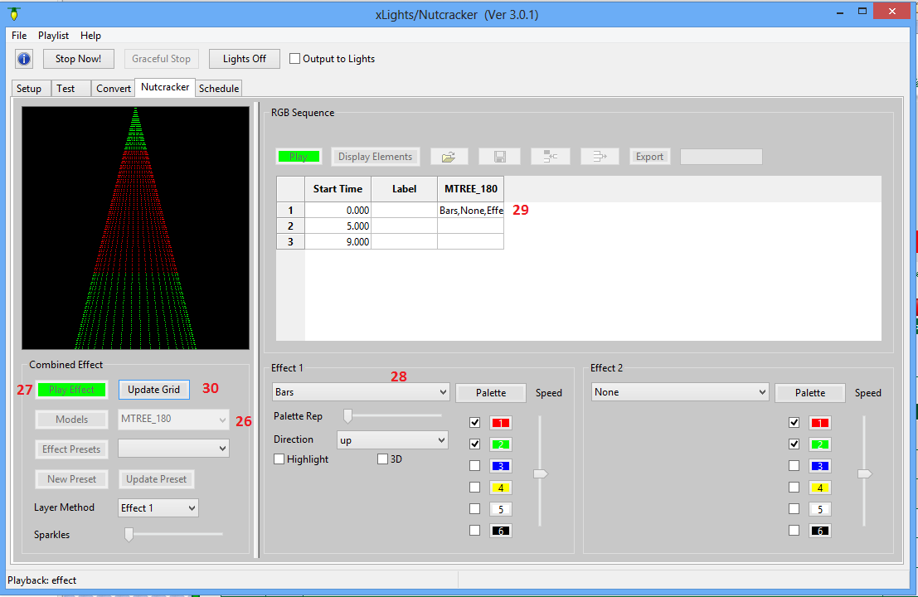

Export your xseq sequence to LOR,Vixen,HLS or LSP

We finally get to export your work for your favorite sequencer.
- First stop your animation preview. This is very important because the save and export buttons are grayed out while you are running a preview animation.
- Click save to save all your changes into your xseq file.
- Click “Export” to now export your current sequence into HLS,LOR,Vixen and LSP files. Currently we create Vixen: *.vix, .vir. LOR: .las,.lms,.lcb. HLS: *.hlsnc. LSP: Not yet.

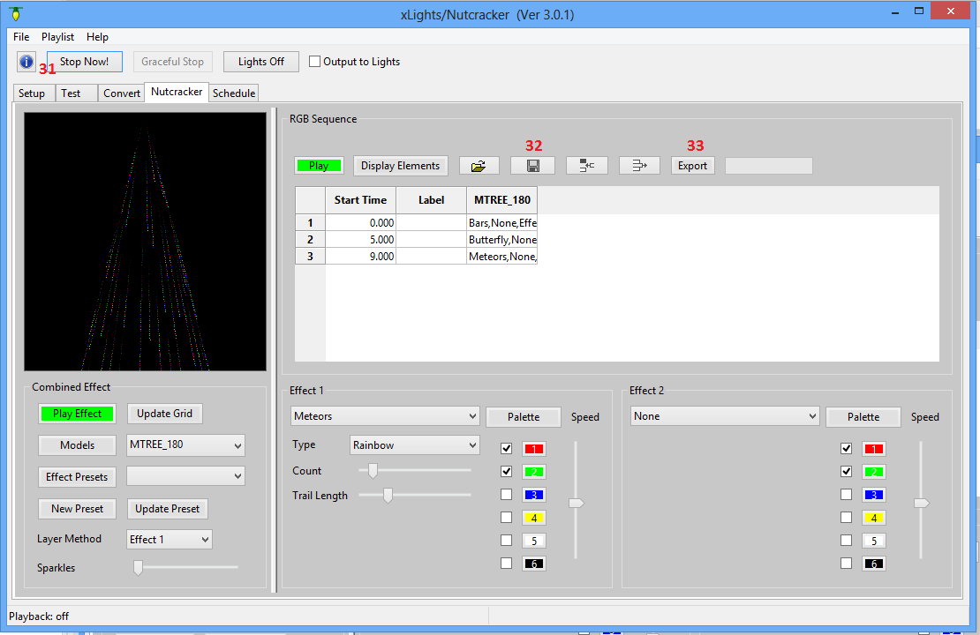

We are done. You have created a Nutcracker sequence!

