Program 33 Mod 032 = 0 (32 mod 16)

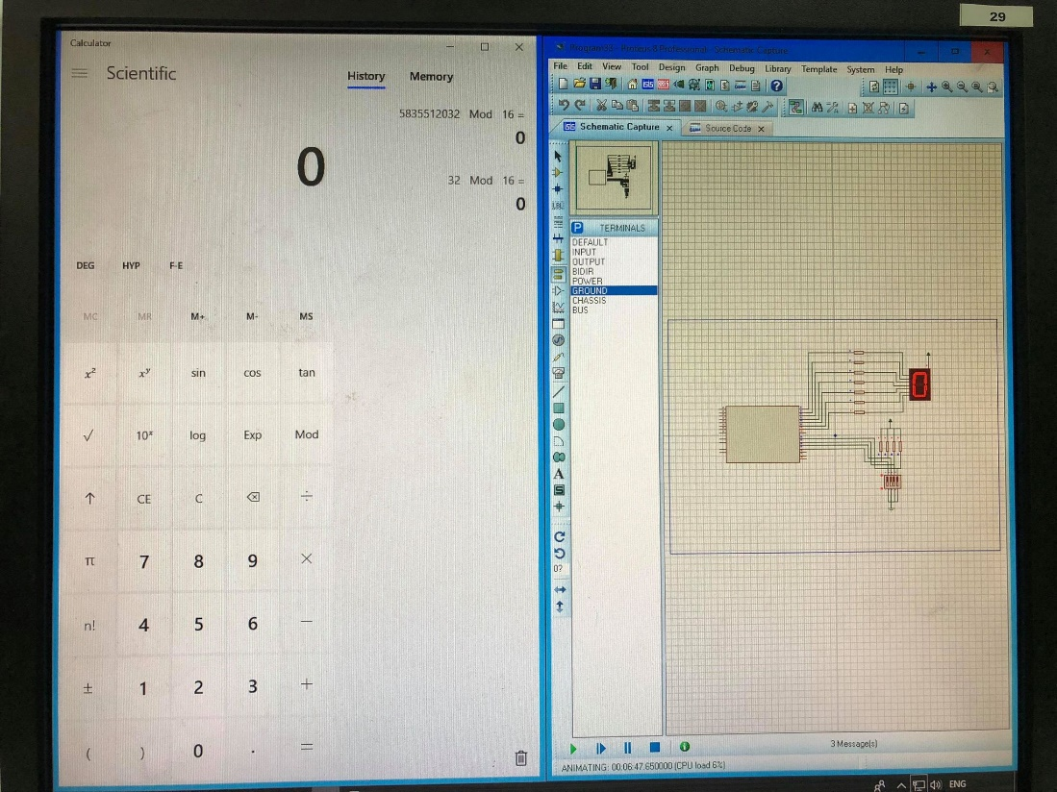

Program 35 Mod 032 = 0 (32 mod 8)