OPTIMIZING SUPPLY CHAIN LOGISTICS
A DATA-DRIVEN APPROACH TO INVENTORY MANAGEMENT AND DEMAND FORECASTING
Project Report Submitted in fulfillment of the Requirements for the Data Science & AI Training Program by IDRA
By: Pratyush Sharma
Institute: [Institute Name]
Institute Roll No.: [Roll Number]
Enrollment No.: IDRA-[Enrollment Number]
Under the Supervision of Dr. Shaheena Salam
INDIA DATA RESEARCH ACADEMY

DECLARATION
I declare that this capstone report represents my own analytical work completed as part of the IDRA Data Science & AI Training Program. The analysis and code were prepared for this project, relevant materials have been acknowledged, and I understand the methods and results presented.

ACKNOWLEDGEMENT
I thank the India Data Research Academy (IDRA), the training faculty and my supervisor for the guidance and learning opportunities provided through the Data Science & AI Training Program. I also acknowledge the project dataset and supporting materials supplied through the LMS.

ABSTRACT
This study investigates supply chain demand patterns and develops a predictive model for daily Units_Sold using the Project 3 dataset provided through the IDRA LMS. The dataset contains 91,250 observations and 15 original variables spanning 2024-01-01 to 2024-12-30. Data-quality checks found no missing values and no duplicate records. Date was converted to datetime format, while calendar, inventory-gap and price-margin features were engineered. Demand_Forecast was strongly associated with actual Units_Sold (r = 0.949), and promoted observations had higher average demand (24.91 versus 19.50 units). A chronological train-test split evaluated later observations. A Ridge regression pipeline combined numerical scaling with one-hot encoding. On unseen data, MAE = 2.32, RMSE = 2.92, and R² = 0.768. The findings demonstrate useful predictive signal for inventory planning while highlighting the need for leakage checks and additional temporal validation before deployment.
Keywords: supply chain analytics; demand forecasting; inventory management; EDA; regression; predictive analytics.

TABLE OF CONTENTS
1. Introduction
2. Problem Statement and Motivation
3. Objectives
4. Research Questions
5. Dataset Description and Data Understanding
6. Data Cleaning
7. Data Preprocessing
8. Exploratory Data Analysis
9. Statistical Analysis
10. Feature Engineering
11. Model Development
12. Model Evaluation
13. Results and Findings
14. Discussion
15. Limitations
16. Conclusion
17. Recommendations and Future Work
18. References
Appendix A. Code
Appendix B. Additional Figures and Tables

1. INTRODUCTION
Supply chains must balance product availability against inventory cost. Reliable demand estimates can support replenishment planning, warehouse allocation and purchasing decisions. This project applies a complete data science workflow to operational supply-chain data to understand demand behaviour and predict daily Units_Sold.

2. PROBLEM STATEMENT AND MOTIVATION
How accurately can daily Units_Sold be predicted using product, warehouse, supplier, regional, inventory, pricing, promotion and demand-forecast information in the supplied dataset? A reliable data-driven estimate can support better inventory decisions.

3. OBJECTIVES
• Understand dataset structure and data quality.
• Clean and validate the dataset.
• Identify demand patterns through EDA and statistics.
• Engineer calendar, inventory and price features.
• Build a regression model to predict Units_Sold.
• Evaluate later-period generalisation and provide evidence-based recommendations.

4. RESEARCH QUESTIONS
• What are the dataset's main characteristics and quality issues?
• How does demand vary across promotion status and regions?
• Which variables are most strongly associated with Units_Sold?
• How accurately can the model predict later observations?
• What recommendations follow from the findings?

5. DATASET DESCRIPTION AND DATA UNDERSTANDING
The file P_3_supply_chain_dataset1.csv was provided through the IDRA LMS for approved Project 3. The guide classifies this topic as a supply-chain regression/forecasting project with demand or sales as the intended target.
Item | Result
Observations | 91,250
Original variables | 15
Period | 2024-01-01 to 2024-12-30
Target | Units_Sold
SKUs | 50
Warehouses | 5
Suppliers | 10
Regions | 4
Table 1. Summary of the dataset.

5.3 Data Dictionary
Variable | Meaning | Type | Role
Date | Observation date | object | Feature/context
SKU_ID | Product identifier | object | Feature/context
Warehouse_ID | Warehouse identifier | object | Feature/context
Supplier_ID | Supplier identifier | object | Feature/context
Region | Geographic region | object | Feature/context
Units_Sold | Actual units sold | int64 | Target
Inventory_Level | Available inventory | int64 | Feature/context
Supplier_Lead_Time_Days | Supplier lead time | int64 | Feature/context
Reorder_Point | Reorder threshold | int64 | Feature/context
Order_Quantity | Quantity ordered | int64 | Feature/context
Unit_Cost | Cost per unit | float64 | Feature/context
Unit_Price | Selling price | float64 | Feature/context
Promotion_Flag | Promotion indicator | int64 | Feature/context
Stockout_Flag | Stockout indicator | int64 | Feature/context
Demand_Forecast | Forecasted demand | float64 | Feature/context

6. DATA CLEANING
All original columns contained zero missing values, and exact duplicate checking returned zero duplicate rows. Date was converted from object to datetime. Identifier variables remained categorical. IQR diagnostics were used to screen numerical extremes, but observations were not automatically deleted because unusual operational values may be meaningful. No rows were removed solely because of outlier status.
Check | Before | Action | After
Missing values | 0 | No imputation needed | 0
Duplicate rows | 0 | None removed | 0
Date type | object | Converted | datetime64
Rows | 91250 | No removal | 91250
Table 3. Data quality before and after cleaning.

7. DATA PREPROCESSING
SKU_ID, Warehouse_ID, Supplier_ID and Region were one-hot encoded. Numerical predictors were standardised inside a Scikit-learn pipeline fitted on training data only. A chronological split used observations through 18 October 2024 for training and later observations for testing. Stockout_Flag was excluded because it was constant. The final feature set also included inventory, lead time, reorder point, order quantity, costs, price, promotion, demand forecast, calendar features, Inventory_Gap, Price_Margin and Markup_Ratio.

8. EXPLORATORY DATA ANALYSIS
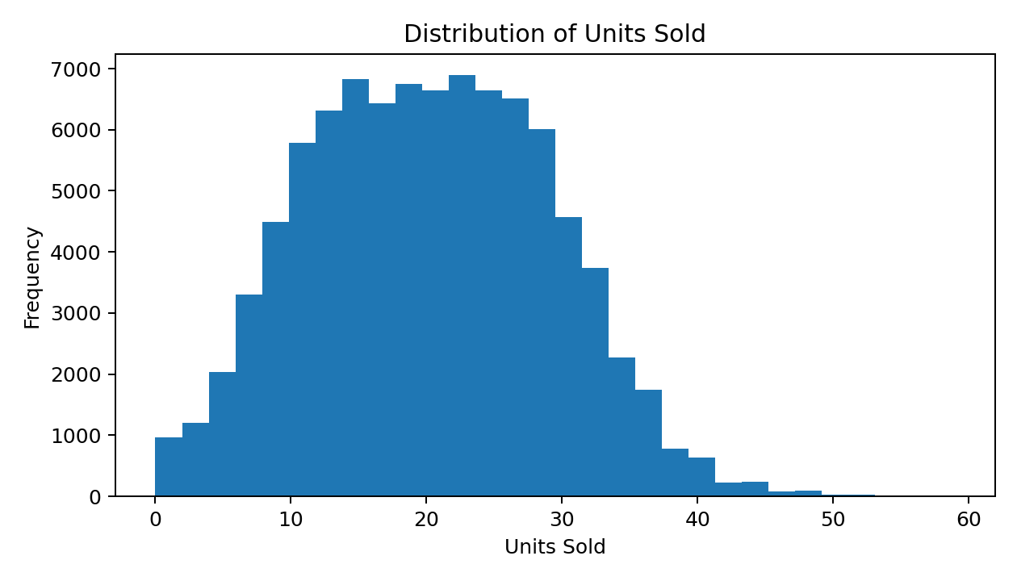
Figure 1. Distribution of Units Sold.
Units_Sold had mean 20.05, median 20 and standard deviation 9.07.
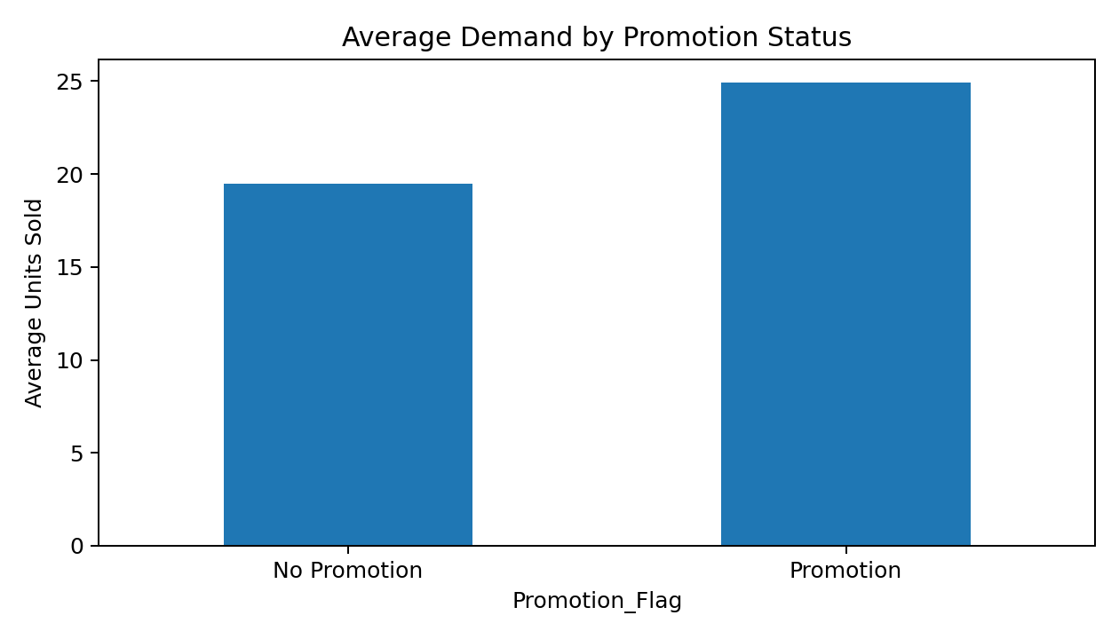
Figure 2. Average demand by promotion status.
Promoted observations averaged 24.91 units versus 19.50 without promotion. This is association rather than causal proof.
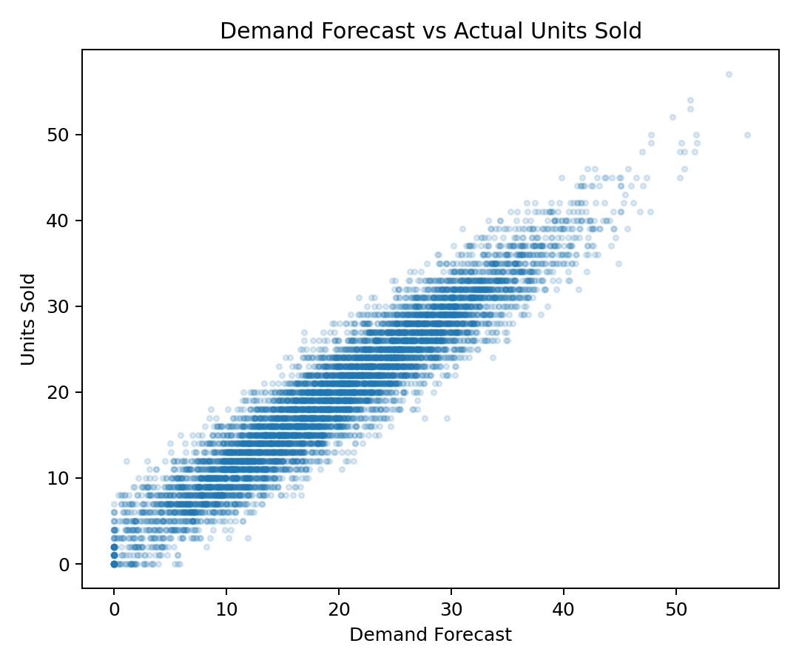
Figure 3. Demand Forecast versus Actual Units Sold.
Demand_Forecast had the strongest numerical relationship with the target (r = 0.949). Its availability at prediction time must be verified in any real deployment.
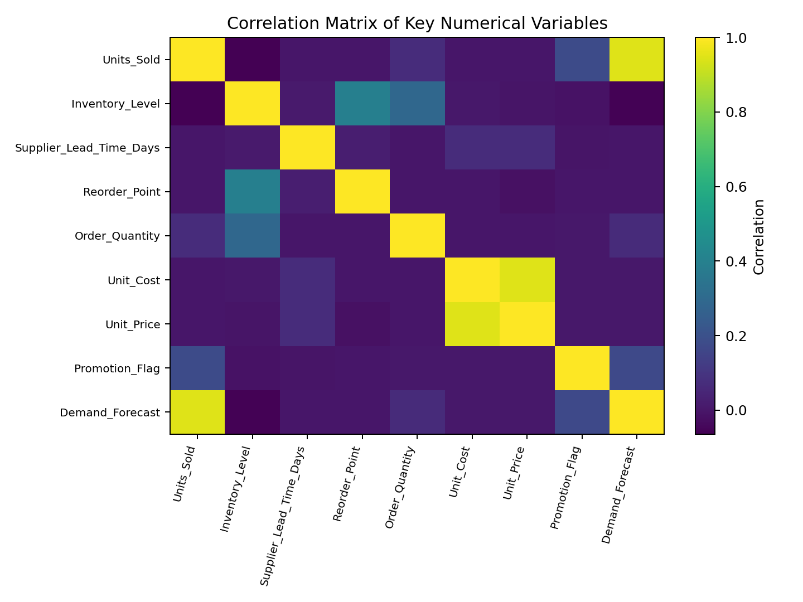
Figure 4. Correlation Matrix of Key Numerical Variables.
The heatmap summarises linear relationships and was used to support feature selection rather than causal claims.

9. STATISTICAL ANALYSIS
Variable | mean | median | std | var | min | max
Units_Sold | 20.055 | 20.0 | 9.069 | 82.24 | 0.0 | 59.0
Inventory_Level | 471.522 | 461.0 | 133.488 | 17819.047 | 168.0 | 990.0
Order_Quantity | 19.272 | 0.0 | 82.341 | 6780.012 | 0.0 | 499.0
Demand_Forecast | 20.082 | 19.95 | 9.504 | 90.325 | 0.0 | 61.42
Table 4. Descriptive statistics. Regional mean demand ranged from 20.02 to 20.11 units, while promoted observations averaged 5.41 more units than non-promoted observations.

10. FEATURE ENGINEERING
Feature | Construction | Purpose
Month | Date month | Calendar pattern
DayOfWeek | Date weekday | Weekly pattern
Quarter | Date quarter | Seasonal period
Inventory_Gap | Inventory - Reorder point | Inventory position
Price_Margin | Price - Cost | Unit margin
Markup_Ratio | Margin / Cost | Relative margin

11. MODEL DEVELOPMENT
The task is supervised regression. Ridge regression was selected as an interpretable regularised baseline suitable for a one-hot encoded feature space. A Pipeline applied StandardScaler to numerical features and OneHotEncoder to categorical features before fitting Ridge(alpha=1.0).

12. MODEL EVALUATION
Metric | Training | Testing
MAE | 2.182 | 2.319
MSE | 7.473 | 8.511
RMSE | 2.734 | 2.917
R² | 0.911 | 0.768
Table 6. Regression performance. On unseen data, average absolute error was approximately 2.32 units. Training R² was 0.911 and test R² was 0.768; the gap indicates some generalisation loss but substantial held-out performance.

13. RESULTS AND FINDINGS
• Demand_Forecast was the strongest numerical correlate (r = 0.949).
• Promoted observations averaged 24.91 units compared with 19.50 without promotions.
• Regional average demand was comparatively stable.
• The final model achieved test MAE 2.32, RMSE 2.92 and R² 0.768.
• Chronological testing was harder than training, reinforcing the importance of future-like evaluation.

14. DISCUSSION
The supplied demand forecast was the dominant signal, and promotion status was associated with higher demand. In a real application, forecast availability must be confirmed before the sales outcome occurs to prevent target leakage. Stable regional averages suggest that broad geography is less informative than product and operational signals. Later-period performance was lower than training performance, so model monitoring and repeated temporal validation are important.

15. LIMITATIONS
• Dataset provenance and generation details are limited to the LMS material.
• Demand_Forecast requires a formal leakage audit.
• Relationships in this study are not causal.
• The reported model is a regularised linear baseline rather than an exhaustive model comparison.
• One year of data may not capture long-term structural changes.

16. CONCLUSION
This capstone completed the required data science workflow for supply-chain demand prediction. The dataset was clean with respect to missing values and duplicates, and feature engineering added calendar, inventory and pricing context. EDA identified a strong forecast-demand relationship and higher average demand during promotion observations. The chronological Ridge model achieved test MAE 2.32, RMSE 2.92, and R² 0.768. The project shows how operational data can support evidence-based inventory planning while requiring careful leakage checks and continued validation.

17. RECOMMENDATIONS AND FUTURE WORK
• Verify that demand forecasts are available before actual sales and use them only when leakage-free.
• Plan additional inventory around promotion periods, supported by higher observed average demand.
• Monitor Inventory_Gap alongside reorder thresholds.
• Re-evaluate the model on new time periods.
• Retain operational extremes unless a clear data-quality reason supports removal.
Future work should compare additional models, add lagged demand and rolling statistics, incorporate holidays or external signals, validate across multiple future periods, and implement formal monitoring.

18. REFERENCES
India Data Research Academy. (2026). Capstone Project Guide 2026. IDRA Data Science & AI Training Program.
India Data Research Academy. (2026). IDRA Capstone Project Template – Sample Project Report.
India Data Research Academy LMS. (2026). P_3_supply_chain_dataset1.csv. Supply Chain Logistics project dataset.
Pedregosa, F., et al. (2011). Scikit-learn: Machine Learning in Python. Journal of Machine Learning Research, 12, 2825–2830.

APPENDIX A. CODE
Complete reproducible code is supplied in Sharma_Pratyush_Capstone_Notebook.ipynb.

APPENDIX B. ADDITIONAL FIGURES AND TABLES
Supporting checks and outputs are available in the notebook. The final cleaned/preprocessed dataset is supplied as Sharma_Pratyush_Capstone_Cleaned_Preprocessed.csv.

